**E-COMMERCE ANALYTICS PLATFORM**

**UIT2311–DATABASE TECHNOLOGY LABORATORY**

**A PROJECT REPORT**

***Submitted by***

|  |  |
| --- | --- |
| **Devanithimaran E** | **3122 23 5002 029** |
| **Dharanikaran S** | **3122 23 5002 030** |

**SSN COLLEGE OF ENGINEERING, KALAVAKKAM**



**SCHEMA DIAGRAM:**

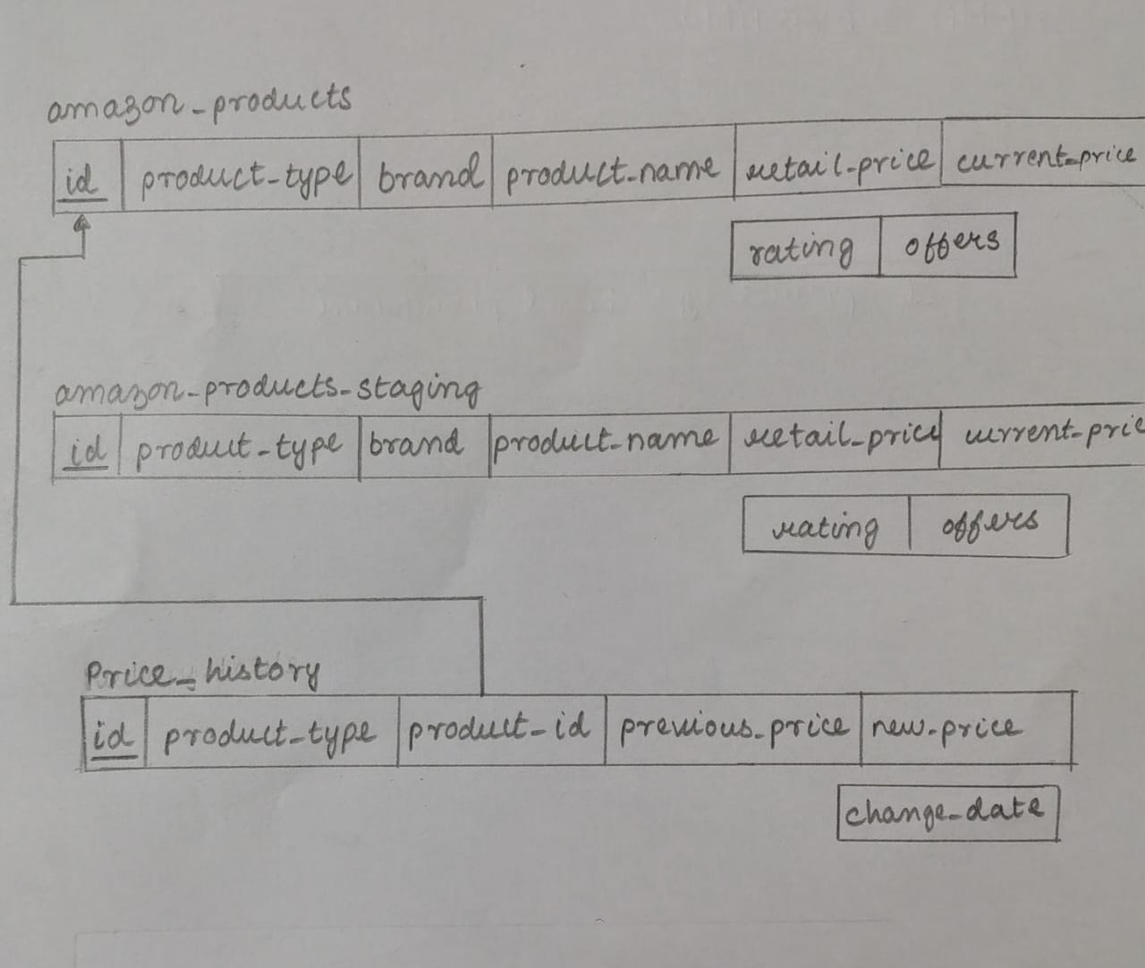

**CODE SNIPPET:**

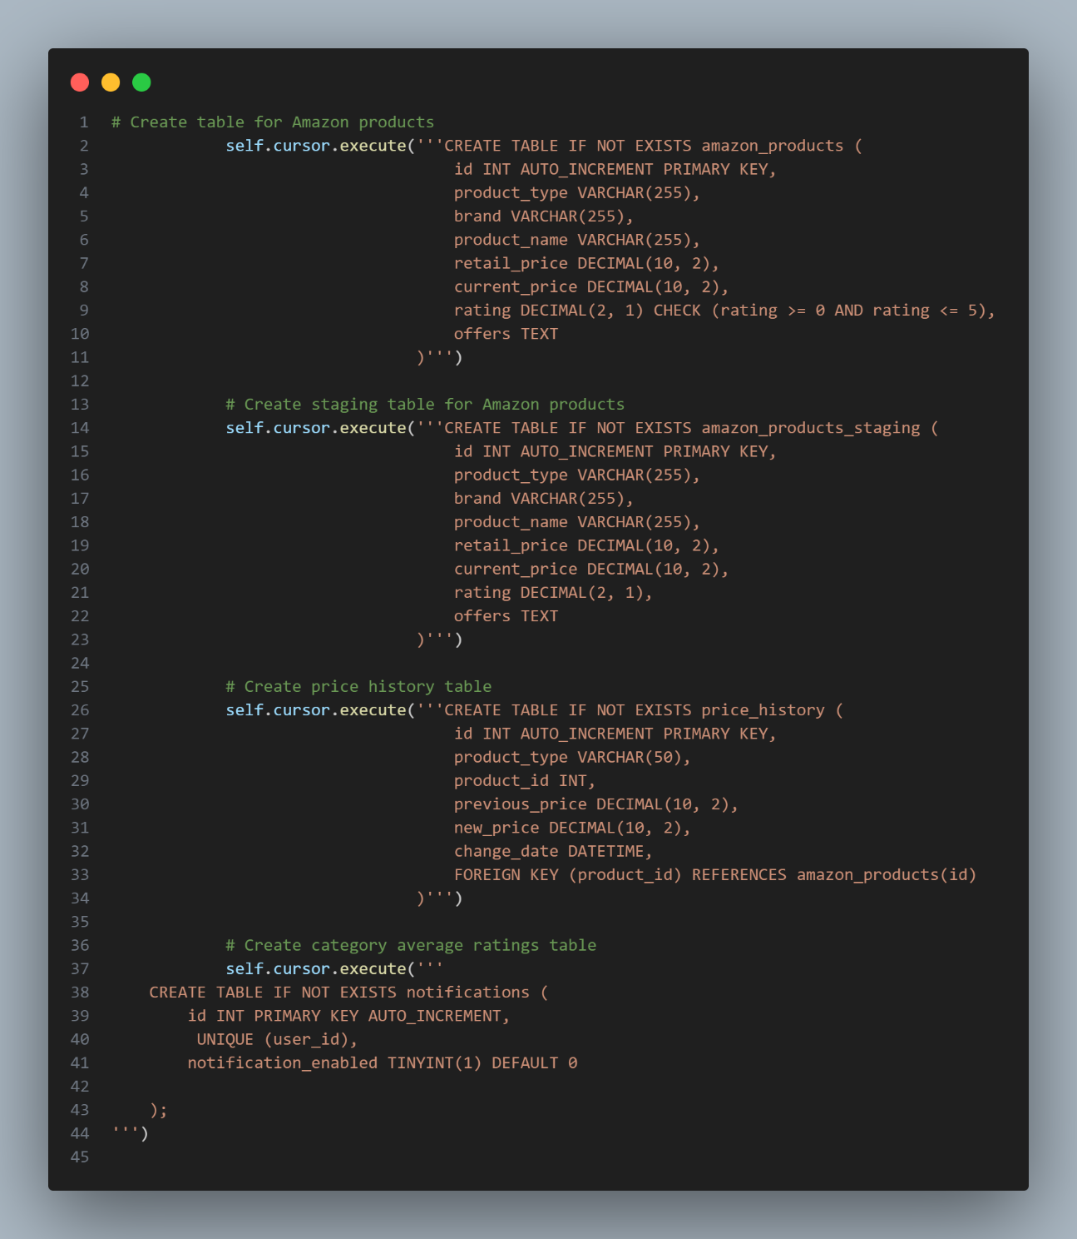

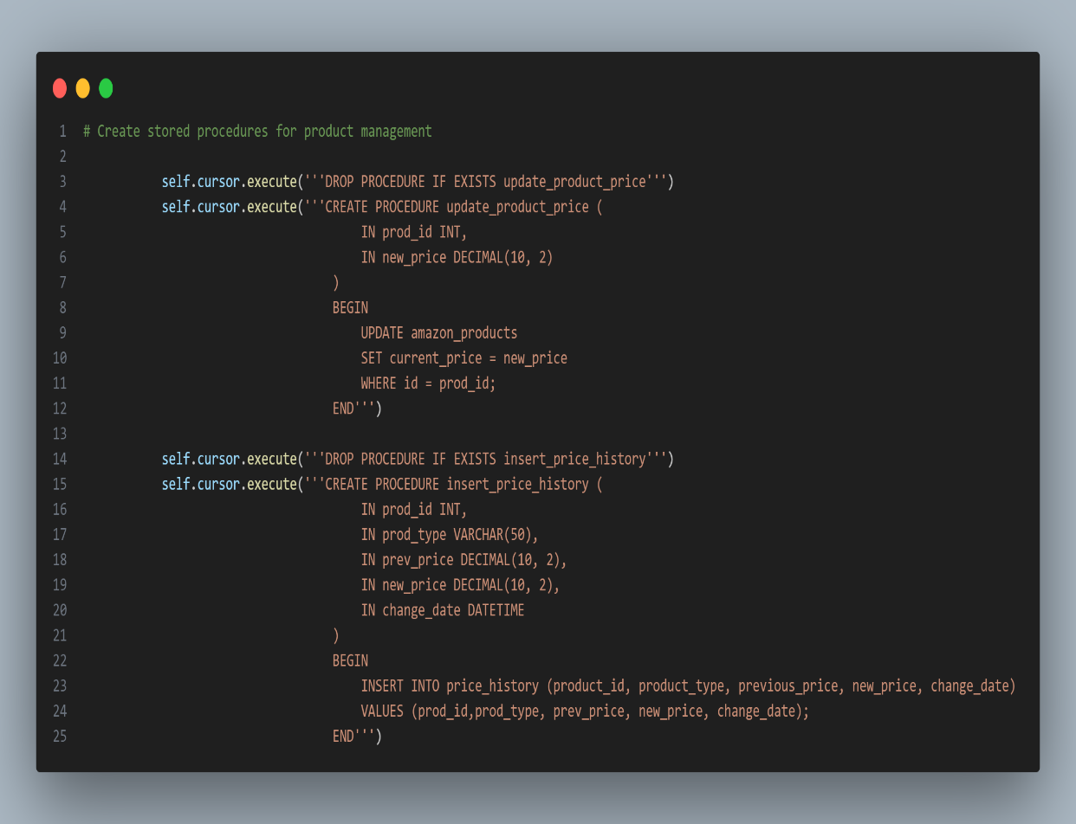

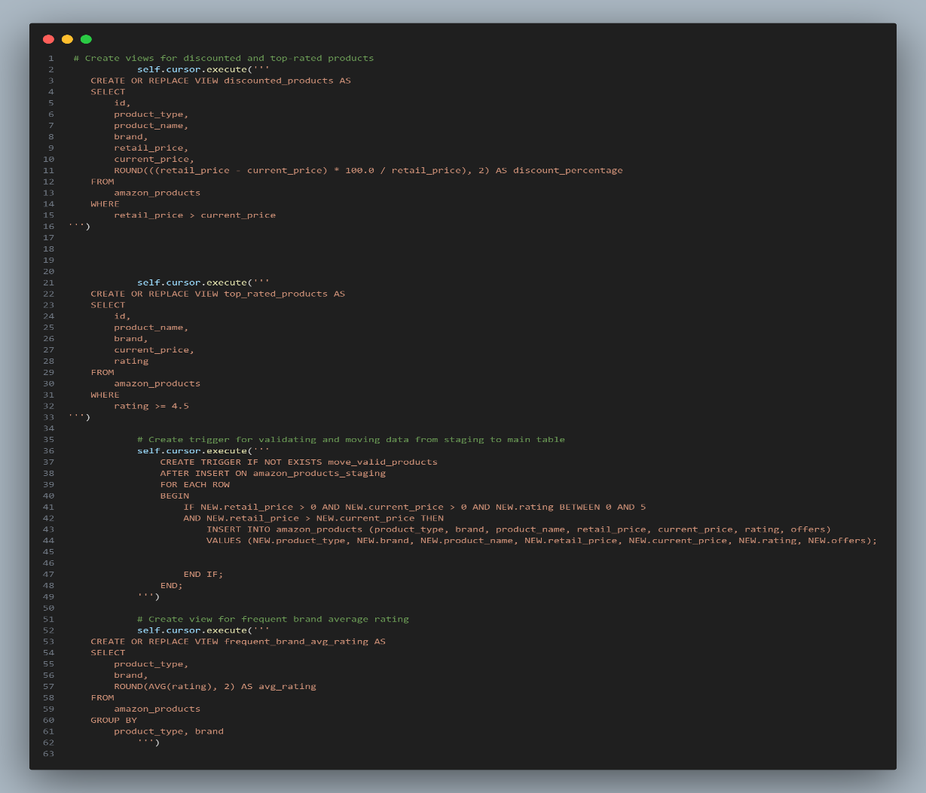

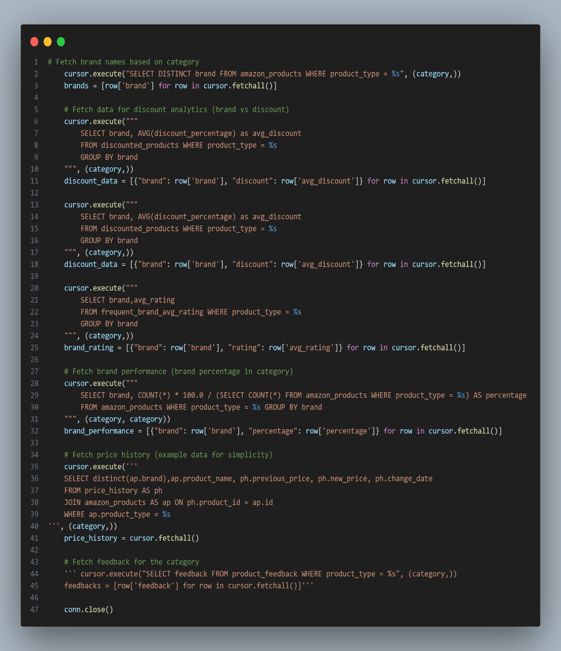

**OUTPUT:**

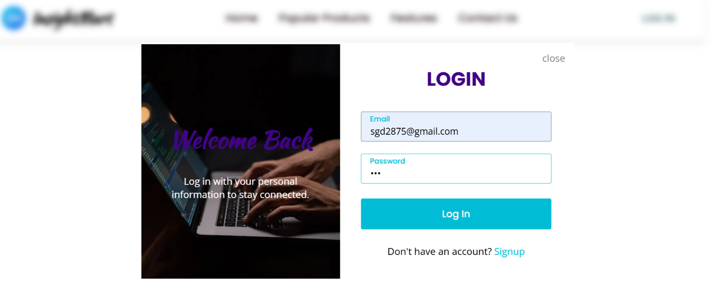

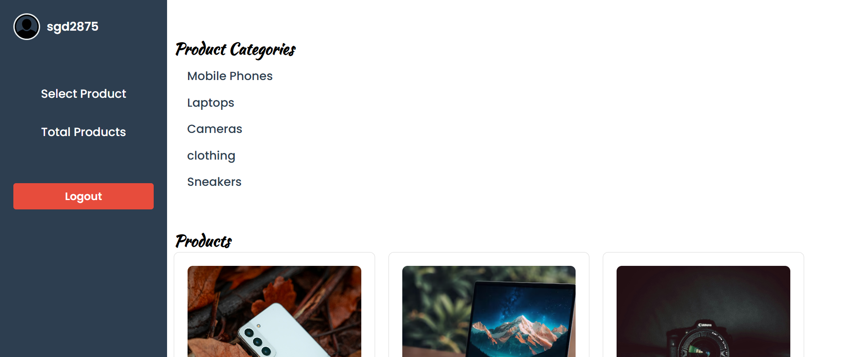

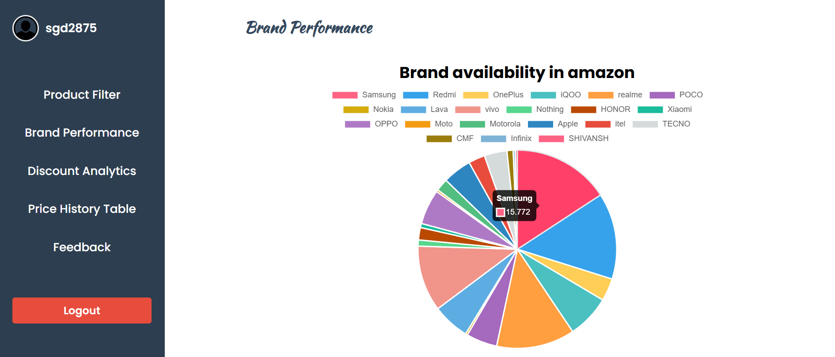

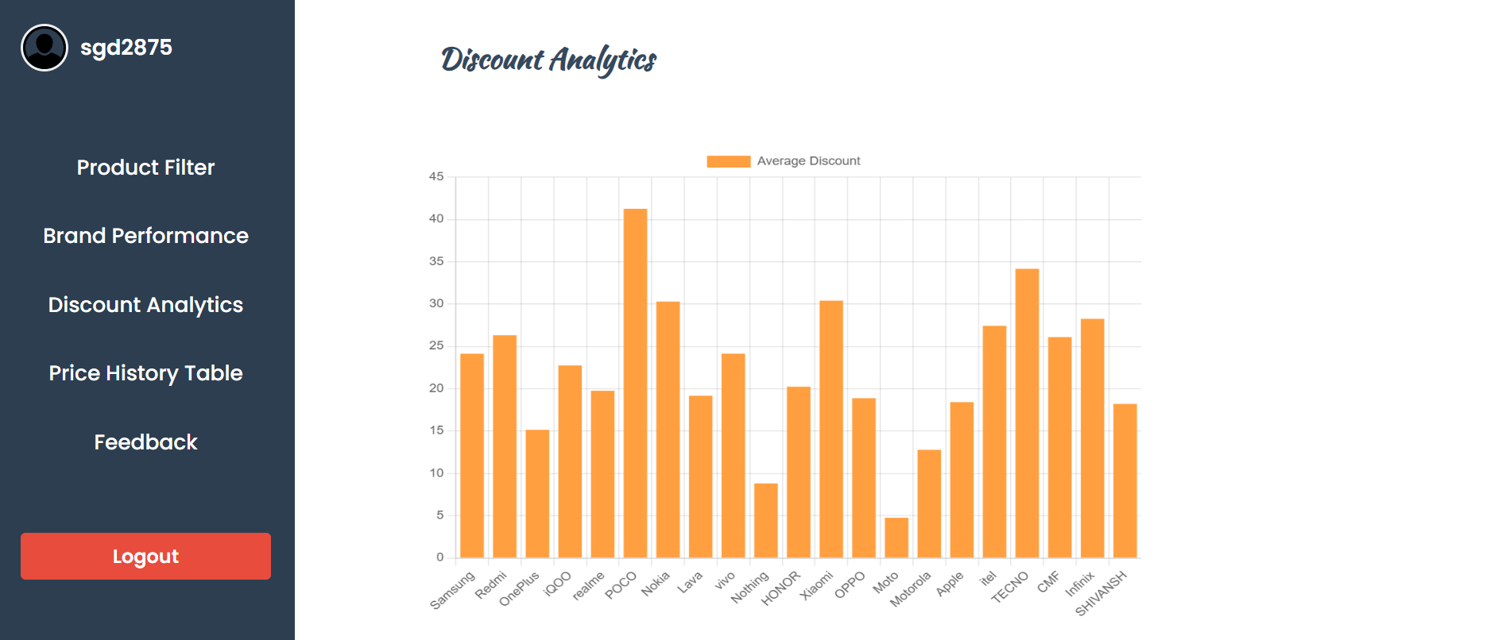

**RESULT:**

The E-commerce Analytics Platform aggregates and analyzes real-time product data from e-commerce website like Amazon Key features include price tracking,filters,brand analysis with user feedback storage with thank-you emails, and a dashboard for easy navigation.