**Assignment-2**

**a)** University database and

**b)** Relation database

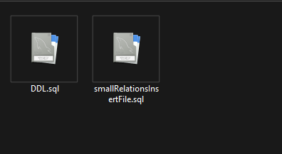

**d)**Displaying the contents of instructor, advisor and student

Prompting a user:

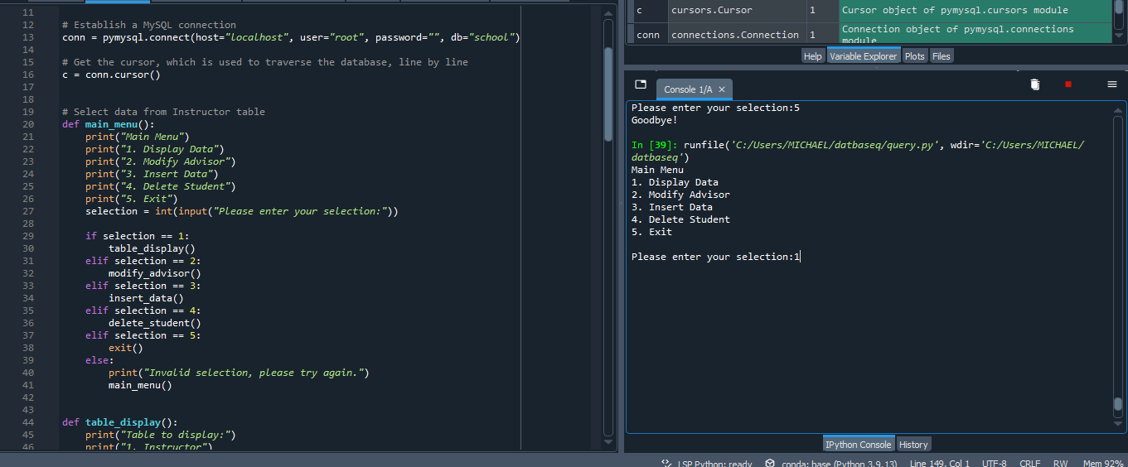

Displaying data:

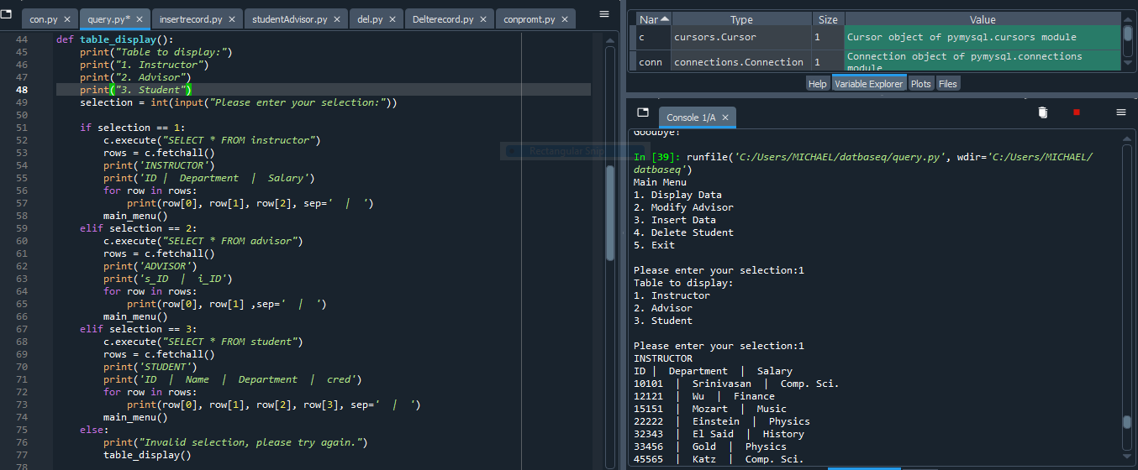

**e)** Function for inserting new data to the student table.

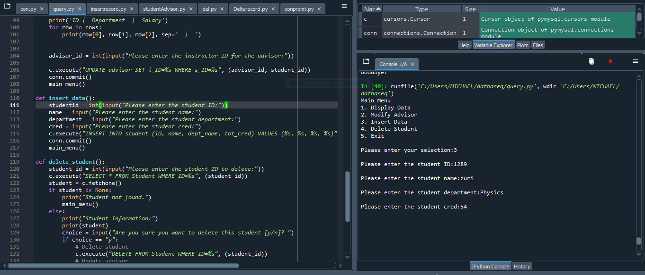

**f)** Function for modifying the advisor for a given student.

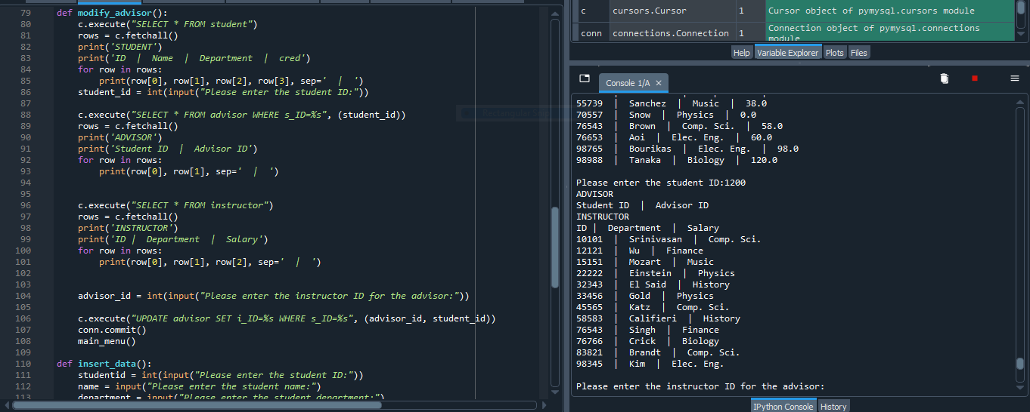

**g)** Function for deleting student’s data in a student table.

