**LIST OF DRAWINGS**

**FIGURE 1:**

**AI-Based Siddha Diet Recommendation Chatbot**

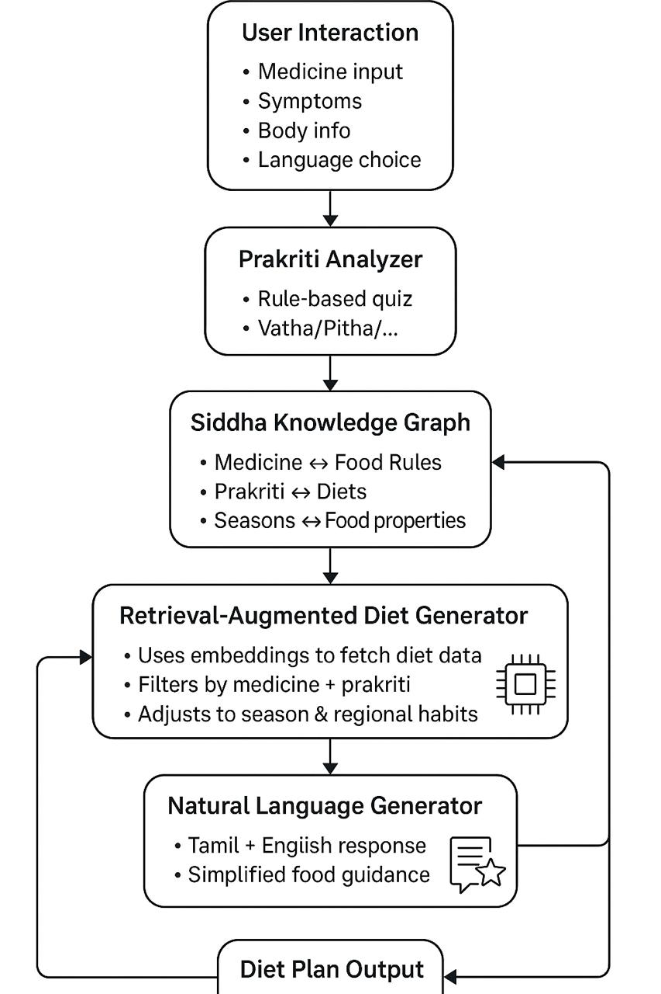

**FIGURE 2: FLOW DIAGRAM**