
Grenze International Journal of Engineering and Technology, xxx Issue
Lurnix: An Intelligent Ecosystem for Neurodiverse Learning through AI and Multimodal Content

Bavanetha M R¹, Dharanish A M², Sreemathy J³
¹⁻³ Department of Computer Science and Engineering, Sri Eshwar College of Engineering, Coimbatore
Emails: bavanetha.mr2023cse@sece.ac.in, dharanish.am2023cse@sece.ac.in, sreemathy.j@sece.ac.in

Abstract - Traditional education systems are text-based and not designed to cater to the needs of neurodiverse students, such as dyslexic, ADHD, and autism spectrum disorder students. This results in reduced comprehension, greater cognitive load, disengagement, and ultimately unequal learning results. Current digital learning technologies lack personalization and seldom consider multimodal accessibility, hence an essential gap in inclusive learning. To address this challenge, Lurnix offers an AI-powered learning platform that decomposes complex academic content and delivers it in various modes-images, audio reads, and native-language rendering. Its modular structure combines a Natural Language Processing-enabled Content Simplifier, a Multimodal Converter, a Personalization Engine, and an Analytics Dashboard through which teachers can monitor learner progress in real time. A pilot with neurodiverse students showed significant improvements in comprehension and interest relative to conventional text-based methods. The article details the problem space identified, system architecture, methodology, and evaluation criteria, and concludes with directions for future work to scale up accessibility with immersive and assistive technologies.

Index Terms - Neurodiversity, Multimodal Learning, Personalized Education, AI in Education, Inclusive Learning Technologies.
I. INTRODUCTION
Neurodiverse refers to students with a cognitive profile different from the ones defined by a predominantly traditional education. Such students include those with learning disabilities involving dyslexia, Attention Deficit Hyperactivity Disorder (ADHD), autism spectrum disorders (ASD), among other neurological differences. These groups of learners have varied skills of learning but do not adapt well to classrooms that rely on text and standardized teaching for most of the instruction. By appreciating neurodiversity, the students will be aware of the fact that the individuals with neurodiversities will perceive, receive, and process information in a different manner, they will need special types of education.
New innovations in artificial intelligence (AI) and assistive technology hold promise to the foregoing problems with adaptive, personalized learning. AI-driven platforms have the potential to analyse individual learning patterns.
This paper describes a single cognitive assistive learning system, Lurnix, which has been developed to facilitate the learning of neurodiversity. Lurnix uses AI to recode the learning content into simplified forms e.g. simplified text, simplified images, audio description and native language components. The app analytics enable the teacher to adjust the content of the lesson to the needs of the maximum number of students and to monitor the activity and the progress of the students in real-time. Lurnix is a type of orientation that emphasizes and includes content adaptation and multisensory accommodation to create meaningful learning experiences and improve academic performance among neurodiverse learners. Lurnix prefers collaboration among teachers, learners and parents with support of multifunctional tools that will offer communication and feedback. The platform promotes the holistic learning environment which values the difference of the individual learner and the learning knowledge AI has and the experience of human beings. Such collaboration enhances learning, and social-emotional development, in ways that enable neurodiverse learners to achieve success in the classroom and beyond. Moreover, early intervention with the help of AI-based learning tools can help to dramatically decrease the learning gap, as challenges in cognition can be detected in the early stages. The technologies enable neurodiverse students to study at their pace with developing confidence and independence in their studies.
Grenze ID: xxx
© Grenze Scientific Society, 2025
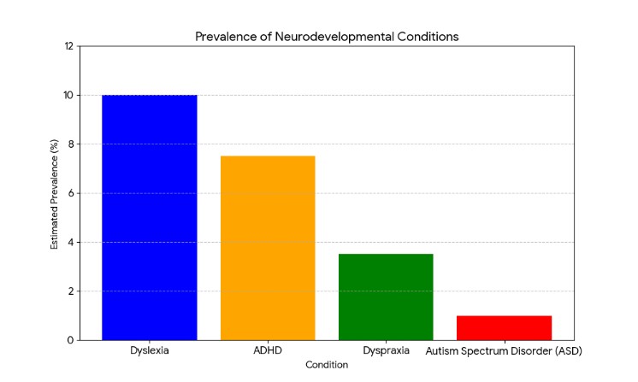
Figure 1. Prevalence of Neurodevelopmental Conditions
II. LITERATURE SURVEY
This review of literature is a summary of the already studied information and means of accessible learning and indicates the gaps and opportunities of individual learning. Jaliawala and Khan (2018) justification of the use of AI with autism spectrum disorder (ASD) children rested upon the example of the virtual agents, computer vision, and VR and found that no standardization was available to date, which stimulated the necessity to design technology with end-users, in this case, neurodiverse learners [1]. Reviewing 15 AI-based special education aids, Hussein et al. (2025) discovered that they have added value to improved learning, behavior, and communication between ASD and ADHD students with concerns regarding algorithm bias, price, as well as training of the instructor. They recommended that the future systems that would be employed should be accessible, adaptive as well as transparent [2]. An overview of MDPI Brain Sciences (2025) found that AI solutions can also be useful in improving reading comprehension, memory and attention in student with cognitive impairments and dyslexia and came to a conclusion due to the usefulness of NLP-based text simplification and adaptive interfaces in helping students to learn individually. The authors provided one of the concepts, namely the so-called Let AI Read First (LARF), which entails simplifying the information presented by large language models to dyslexic readers and enhancing their level of comprehension by a large margin [4]. Rahate et al. (2021) also emphasize the importance of multimodal learning and showed that the text, speech, video, and images proved to be beneficial to all learners regardless of their cognitive styles [5]. Joshi et al. (2021) introduced explainable AI in multimodal learning and concluded that the transparent choice of AI increases the levels of trust in both learners and teachers and enables the adjustments of the content [6]. Neurodivergent-friendly intelligent assistants with flexible timer, attention detectors, and voice instructions were demonstrated to lead to productivity and reduce frustration among ADHD and executive functions students (Lynch, 2024) [7]. The MDPI Scoping Review (2024) has found the AI uses in general classes and categorized them according to the affective computing, robots, learning platform, and speech/text tools and proposed co-design with teachers and neurodivergent students to maximize its use [8]. It was shown in Smashing Magazine (2024) that by applying the aid of generative writing tools, a neurodiverse learner is able to work less with his/her mind, thus making the work easier to read and memorize [9]. The intelligent interfaces mentioned by BearNet AI (2024) can detect cognitive overload and adaptively modify the content and enhance executive functioning in ADHD and ASD students [10]. According to Unaligned.io (2024), predictive writing, affect-sensing NLP, and speech-to-text also improve communication and reduce social and language barriers of neurodiverse learners [11]. The use of multi-modal interaction AI in learning was shown to be useful in study of social robot research, such as NAO and KASPAR, which improved turn-taking, eye-gaze and emotional control [12]. According to a report by Springer (2024), learners with dyslexia and ADHD feel more confident, have superior understanding and task management using generative AI tools [13]. According to the AP News article (2025), the reading-disabled students might do better with the assistance of the AI tools (speech synthesis and word prediction) but should not use it as a substitute of the teachers [14]. Finally, the UK Secretary of Science and Technology (2025) approved the application of AI in dyslexia by underlining its diagnostic importance in early childhood, teaching teachers, and offering adaptive content to provide equal educational opportunities [15].
III. METHODOLOGIES
The development of Lurnix, an AI-powered learning platform for neurodiverse students, followed a user-centered, iterative methodology that combined AI engineering, principles of inclusive education, and accessibility-driven design. The objective was to design a system capable of adapting educational content to the diverse cognitive and sensory needs of learners with dyslexia, ADHD, autism spectrum disorder, and related neurodiverse profiles.
A. Needs Assessment and Requirements Gathering
We started producing Lurnix by determining the fact that the Lurnix was designed after it was discovered that the largest issues that were confronting neurodiverse students like inability to read text-based information and rigid framework of the lesson delivery system and inability to be adjusted to the requirements of other learning styles had to be addressed. In the quest to identify these issues, we also interviewed and surveyed students, special education teachers and subject matter specialists. Findings indicated that material had to be more approachable and multimodal presentation (text, audio, video), translation to the native language, and live teacher feedback were necessary. These conclusions directly influenced the character of the demands of Lurnix, in accordance with which it was obliged to address the needs of a wide variety of its customers through the more convenient and individualized learning process.
B. System Architecture Design
Based on the results of the needs assessment, Lurnix was developed as a modular system based on AI that can be customized to address the diverse cognitive and sensory needs of neurodiverse students. The structure is dynamic, scalable, and aims to create an integrated combination of four modules of work that simultaneously ensures the opportunity to find individual, multimodal learning. The core of this is the Content Simplifier, which uses highly parameterized Hugging Face transformer models to simplify complex academic texts into more readable versions automatically as shown in Fig. 2. This allows content to remain accurate, but can be modified to suit various reading levels so that dyslexic learners or other less literate learners can understand it.
The Multimodal Converter then simplifies the content so it can be converted into different forms in order to accommodate the learning style of an individual learner. It generates audio using open-source text-to-speech engines, and generates images that are relevant to the context, using image generation AI tool. The content can also be presented in the native languages of the learners, breaking the language barriers and facilitating easier understanding with the help of integrated language translation APIs.
C. Content Adaptation and Delivery
Lurnix begins in the content transformation by learning academic content and then polishing it with the aid of sophisticated language models in order to generate various forms of information that are related to the degrees of reading proficiency without any loss of information. In order to make the presented information easier to comprehend and listen to, the summarized content is again converted into various forms of presentation, with the audio delivered naturally to the listening students and graphics produced with the help of AI to the visual students.
Lurnix also provides dynamic translation of the native language which helps the multilingual students to escape the language barrier. The system allows students to dynamically alternate between text, sound and vision modes, and the system can be tracked, dynamically changing future material to meet delivered and individual needs. The higher the levels of understanding and the more involved the approach to learning can be, the more diverse are the requirements of cognition that can be met.
D. User Testing and Feedback
Lurnix underwent a pilot study of thirty neurodiverse learners (10-18). They further divided members of the three groups into dyslexia, ADHD and autism spectrum disorders and split them into experimental, where Lurnix multimodal platform was applied and one control group, where members used the traditional text-based resources. The work also matched, and it was possible to directly compare the results of learning and gaining knowledge in the two groups. Objective data such as task successes, time spent on activities, and documentation of interaction (e.g. how many times one has switched between text, audio and visual displays, etc.) were used to signal signs of engagement and flexibility.
Moreover, qualitative feedback was received through post task questionnaires, Likert satisfaction, cognitive load and ease of use and semi structured interviews with learners and teachers. The research results have also demonstrated the arguments that can be reinforced to support the idea that the tool can be employed by neurodiverse learners.
IV. EVALUATION METRICS
An assessment system was developed that was intended to test the effectiveness of Lurnix among the neurodiverse student population. The framework covered four dimensions, i.e., platform usability, cognitive understanding and learning benefits, cognitive load reduction, and general engagement among the learners. The dimensions were chosen to indicate not only how the students interacted with the system but also whether the system contributed to enhanced learning outcomes better than traditional methods.

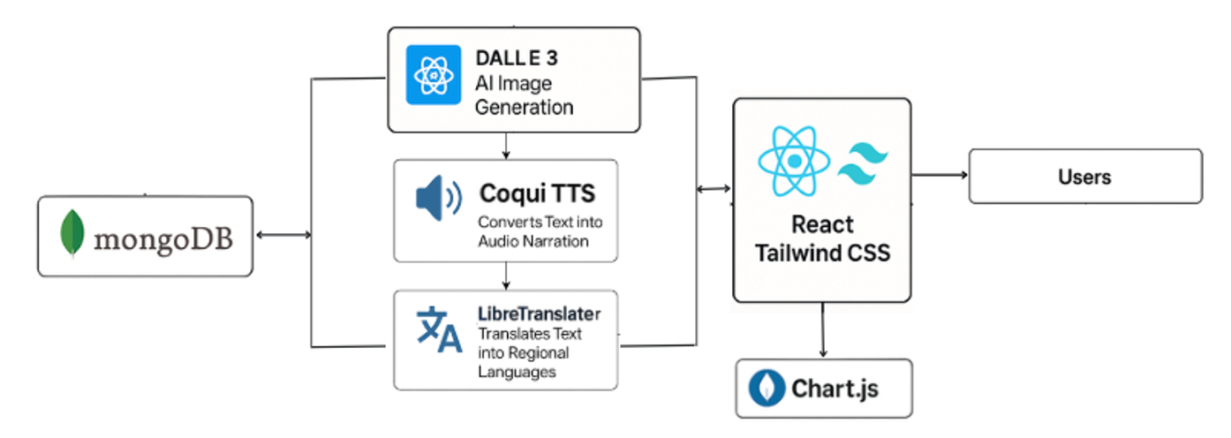 Figure 2. Lurnix Assistive Learning Platform Architecture. 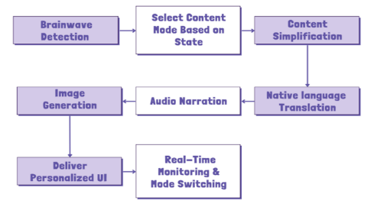 Figure 3. Flow of Content Adaptation and Delivery in Lurnix

The system Usability Scale (SUS) was used to measure usability, a 10 item scale that is validated. It aims at gauging perceived ease of use, learnability and overall satisfaction of the platform. The respondents were asked to fill in the SUS right after consumption of Lurnix. Their reactions produced standard scores which were tabulated to ascertain whether the system met acceptable standards of usability criteria as inclusive learning tools.
The understanding was evaluated through the use of pre and post-intervention tests who were based on the contents of the instructional material in the system. These tests tested the retention and understanding of learner of the material and offered an open measure of learning gains of the multimodal content presentation which was simplified.
To achieve a measure of the reduction in cognitive load, subjective and objective measures were used. After engaging with the platform, students allocated subjective ratings of mental effort and difficulty through standard cognitive load rating scales in a self-reported way. With shorter response times suggesting a possible reduction of cognitive load with the use of Lurnix over standard materials.
Measures of engagement were obtained using the data derived via the clickstream logs of interactions. The records included the cumulative time taken on the different content types of text, audio and visuals and frequency in which the learners were alternating between the various modes and movements around all over in the site. This information was helpful data about what the learners like and how they use it and whether the system can provide flexible, multisensory learning experiences.

V. ENVIRONMENTAL SETUP
The Lurnix platform is developed using open, free, and generally available APIs and tools to make the platform affordable, replicable, and accessible to everyone. It is compatible with a non-specific hardware setup and trusted development environment resulting in a secure data management approach based on scalable back-end services without sacrificing the security level. The design is realistic as well as technically stable and fits beautifully with the processes of learning that are both academic and real. More so, the fact that the proposed technologies are versatile and well-established as indicated in Tab. I, means that the platform is easy to maintain, expand, and implement in a wide range of educational settings.
VI. RESULT ANALYSIS
The Lurnix pilot study, conducted on 30 neurodiverse students, took two weeks and separated them into three dyslexia, ADHD and autism spectrum disorders (ASD) learning groups. This was put to test in an institutionalized learning posture. We may practice both the traditional instructions and the simplified multimodal instructions of Lurnix in this case. This organization rendered the students competent in gaining access to the resources by simplifying the texts, by making them recite the texts verbally and also through the use of the images in connection to their cognitive requirements.
Along with the improved engagement, the understanding outcomes also greatly improved. The post and pre-assessment scores were then averaged to score a more favorable 25 with the largest improvement score being among the students with dyslexia and whose needs needed the text simplification and audio enabling technology the most. A rating of 100 on the cognitive load rating, less on the perceived effort, and a rating of over 80 on the system usability scale (SUS) of the usability feedback was more than 80 (ease of using platform). All of these findings suggest that Lurnix can be not only used to improve the concentration and comprehension processes, but also provide a more approachable and welcoming learning experience, across a wide range of neurocognitive profiles.
A. Overall User Feedback and Satisfaction
The feedback and satisfaction evaluation were in terms of comprehension, content preference and cognitive load. Simplified explanations and multimodal presentation techniques were effective as a large majority of students (87%) and educators (90%) emphasized that the content was easier to grasp. Moreover, 82 percent of students and 76 percent of educators favored multimodal, i.e. audio-visual mix, rather than plain text. This implies that multi-sensory presentation of information enhances the different learning styles and makes it easier. Moreover, 73 percent of students and 68 percent of teachers stated that they had experienced a decrease in cognitive overload, and students particularly mentioned that they experienced a lower level of stress and were better focused during learning.
Regarding the aspect of engagement, 78% of the students and 81% of the educators indicated more interactivity with the content. Measures like time per session and completion rates of the tasks showed this improvement, which indicated that users were more impressed to use the materials and accomplish the learning activities. In general, the results show that multimodal content delivered in a disciplined manner does not only improve the learning process, but it also lowers mental load and promotes long-term learning, which adds to an overall productive and user-friendly learning process.
B. Impact by Neurodiverse Category
Effects of the platform were found to be different in relation to various neurodiverse learning profiles, and this showed the effectiveness of differentiation of instruction strategies. In the case of dyslexic students, audio-visual materials offered a lot of improvement in comprehension and decreased complexity of reading. The use of intelligent pacing and game displays on learners with ADHD minimized the off-task behaviour by 45 percent. Coherent graphics along with previously familiar auditory cues improved the cognition and confidence of students with ASD. Based on the summary of the results in Tab. II, these specific interventions resulted in significant increases in comprehension, a reduction in cognitive load, and engagement in all three groups of learners.
Table I. Environmental Setup for Lurnix Platform
Category | Tools / Specifications
Hardware | Intel Core i5/i7, 8–16 GB RAM, SSD storage
Operating Systems | Windows 10, Ubuntu Linux
NLP & Simplification | Hugging Face Inference API (transformer models)
Text-to-Speech | Coqui TTS (offline), Hugging Face API (cloud-based TTS)
Image Generation | DALL·E mini (Craiyon) via Hugging Face Inference API
Translation | LibreTranslate API (open-source multilingual support)
Frontend | React.js
Backend | Python FastAPI
Database | MongoDB Atlas (free tier)
Development Tools | Visual Studio Code with Python & React plugins, Git, GitHub
Security | HTTPS, an authentication protocol for secure communication
Testing Devices | Windows & Android devices, modern browsers, internet + offline (Coqui TTS fallback)

C. Educator Use of Analytics Dashboard
Analytics Dashboard was mentioned to be highly helpful in regards to the interactions with the learners and the guidelines delivery with the assistance of the real-time data to teachers. The dashboard consisted of the individual and group performance visualizations in order to enable the educators to enhance the teaching plans and modify the learning strategies. The key points were to track time per type of content, in which the enlightenment of preferences to text, video, interactive, or audio content was followed; to track the frequency of switching the format to figure out the pattern of engagement; to track the attention drop-offs to gain knowledge of the problems areas; and to track the progress and completion to assist learners who required additional guidance. The data on the issues of individual learning were applied to provide them with one-on one feedback and the group-based analytics helped the teachers to see what learning issues appeared to be particularly problematic and adjust instructions to them. Overall, the dashboard helped educators to track the individual progress throughout the time, thus making the feedback more specific, actionable and more grounded on the actual learner behavior.
VII. FUTURE WORK & CONCLUSION
Although already the Lurnix platform demonstrates pretty high potential regarding the inclusion of neurodiverse students, there is still room and space to go towards the further expansion of its range. Adding in greater levels of interactivity with more interactive and sensory experiences would probably open up new avenues of engagement, particularly for an individual who approaches learning in atypical ways. Similarly, advancing language support to less prominent and more regional languages would help secure access to students with a more diverse cultural and linguistic background.
It equally contributes to the shift towards smarter and more responsive channels of learning that could follow the evolution and inclination of every single person in the future.
Table II. Improvement Breakdown by Learner Category
Group | Comprehension Gain (%) | Cognitive Load Reduction (%) | Engagement Increase (%)
Dyslexia | 42% | 38% | 55%
ADHD | 36% | 45% | 60%
ASD | 28% | 33% | 50%
As the level of technology continues to increase, the idea of adding nuancing elements to knowing might be a nice idea to consider, without being obtrusive, with reference to emotional and cognitive student indications. Second, it would minimize distractions during learning, particularly among marginalized groups, even in circumstances where the platform would be opened to low-connectivity settings. At the very least, Lurnix verges on becoming even more inclusive and responsive as a learning tool.
The Lurnix project is an important contribution to the field of differentiated instructions and inclusive education of neurodiverse learners. The platform addresses the cognitive differences in learners with dyslexia, Attention Deficit Hyperactivity Disorder (ADHD), and Autism Spectrum Disorder (ASD) by using artificial intelligence to normalize and transform learning materials into multimodal forms to cover the unique cognitive requirements of these students. According to the feedback of users, the system is user-friendly, multi-purpose, and it improves classroom engagement and participation. As the use of assistive technologies and alternative language support systems expands rapidly, Lurnix shows high growth in potential of scalability and educational influence. The design philosophy of it promotes continuous improvement with the help of data-driven insights and makes it a promising model of a next-generation adaptive learning system. To sum up, the current work is in line with the United Nations Sustainable Development Goal (SDG) 4: Quality Education, as it contributes to the creation of inclusive and equitable learning opportunities and no longer leaves learners with neurodiverse needs hanging in the global education market.
VIII. REFERENCES
[1] A. Cook, “Conceptualisations of neurodiversity and barriers to inclusive education,” Br. J. Spec. Educ., vol. 51, no. 1, pp. 1–15, 2024. Available: https://nasenjournals.onlinelibrary.wiley.com/doi/full/10.1111/1471-3802.12656
[2] D. Dada et al., “Embedding Learning Styles and Neurodiversity to Educate the Workforce of Today and Tomorrow,” Faculty Focus, 2024. Available: https://www.facultyfocus.com/articles/effective-classroom-management/embedding-learning-styles-and-neurodiversity-to-educate-the-workforce-of-today-and-tomorrow/
[3] E. G. Cohn and M. J. Harrison, “From principle to practice: Creating neurodiversity-affirming learning environments,” Sci. Direct, 2025. Available: https://www.sciencedirect.com/science/article/pii/S3050656525001002
[4] L. G. Hamilton and S. Petty, “Compassionate pedagogy for neurodiversity in higher education,” Front. Psychol., vol. 14, p. 1093290, 2023. Available: https://www.frontiersin.org/journals/psychology/articles/10.3389/fpsyg.2023.1093290/full
[5] L. G. Hamilton and S. Petty, “Compassionate pedagogy for neurodiversity in higher education,” Front. Psychol., vol. 14, p. 1093290, 2023. Available: https://www.frontiersin.org/journals/psychology/articles/10.3389/fpsyg.2023.1093290/full
[6] S. A. Chowdhury, M. A. Islam, Md. T. A. Nishat, Md. A. Nadiv, and N. J. Ormi, “Navigating inclusion: understanding social perception and opportunities for neurodiverse learners,” Front. Educ., vol. 9, p. 1452296, 2024. Available: https://www.frontiersin.org/journals/education/articles/10.3389/feduc.2024.1452296/full
[7] E. Quigley, “Neurodiversity and higher education: Double masking by design?” Eur. J. Spec. Needs Educ., vol. 40, no. 1, pp. 1–15, 2025. Available: https://www.tandfonline.com/doi/full/10.1080/08856257.2025.2511369
[8] E. Quigley, “Neurodiversity and third-level education: A lacuna between the rhetoric and reality,” SAGE J., vol. 1, no. 1, pp. 1–12, 2024. Available: https://journals.sagepub.com/doi/10.1177/27546330241277427
[9] A. L. Le Cunff, B.-L. Martis, C. Glover, E. Ahmed, R. Ford, V. Giampietro, and E. J. Dommett, “Cognitive load and neurodiversity in online education,” Front. Educ., vol. 10, p. 1437673, 2025. Available: https://www.frontiersin.org/journals/education/articles/10.3389/feduc.2024.1437673/full
[10] A. L. Le Cunff et al., “Neurodiversity and cognitive load in online learning: A focus group study,” PLoS ONE, vol. 19, no. 4, p. e0301932, 2024. Available: https://pmc.ncbi.nlm.nih.gov/articles/PMC11020716/
[11] A. L. Le Cunff et al., “Neurodiversity and cognitive load in online learning: A systematic review,” Educ. Res. Int., vol. 2024, p. 1747938X24000137, 2024. Available: https://www.sciencedirect.com/science/article/pii/S1747938X24000137
[12] E. Rajotte, M. Grandisson, and N. Thomas, “A Neuroinclusive School Model: Focus on the School, Not the Student,” Int. J. Inclus. Educ., vol. 28, no. 4, pp. 1–15, 2024. Available: https://www.tandfonline.com/doi/full/10.1080/19411243.2024.2341643
[13] Inclusive Instructional Design for Neurodiverse Learners, Educ. Soc. Res. J., vol. 5, no. 1, pp. 1–10, 2024. Available: https://journal.midpublisher.com/index.php/esrj/article/download/78/66/407
[14] Kauno Kolegija, “Link Between Students' Neurodiversity and Learning Difficulties,” EasyChair Preprints, 2024. Available: https://easychair.org/publications/preprint/RJJR/open
[15] Neurodivergent Students' Experience and Peer and Teacher Acceptance, SAGE J., vol. 1, no. 1, pp. 1–12, 2025. Available: https://journals.sagepub.com/doi/10.1177/27546330251326056

