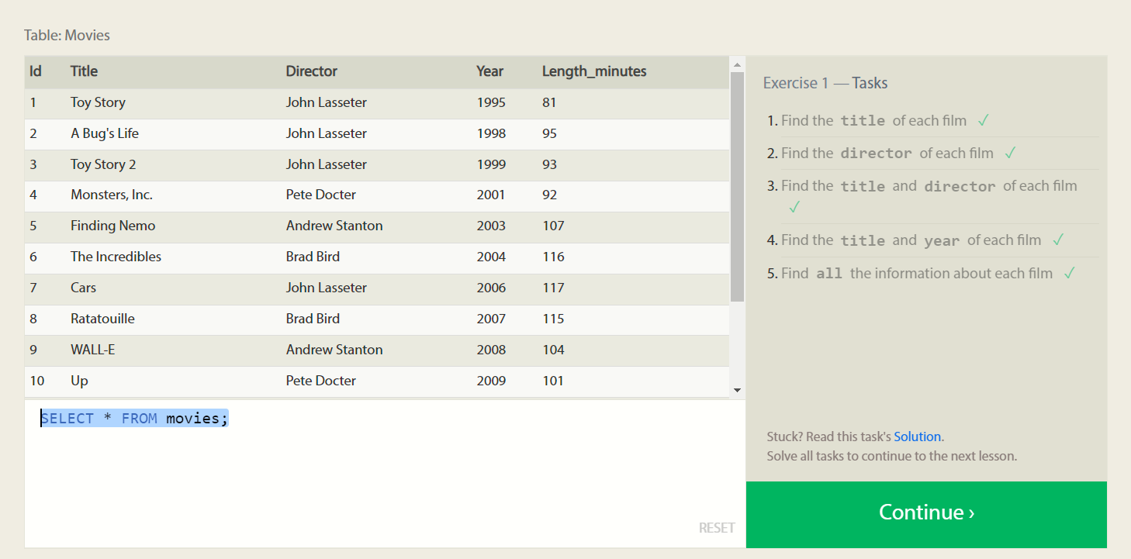

1.SELECT Title FROM movies;

2.SELECT Director FROM movies;

3.SELECT Title , Director FROM movies;

4.SELECT Title , Year FROM movies;

5.SELECT \* FROM movies;

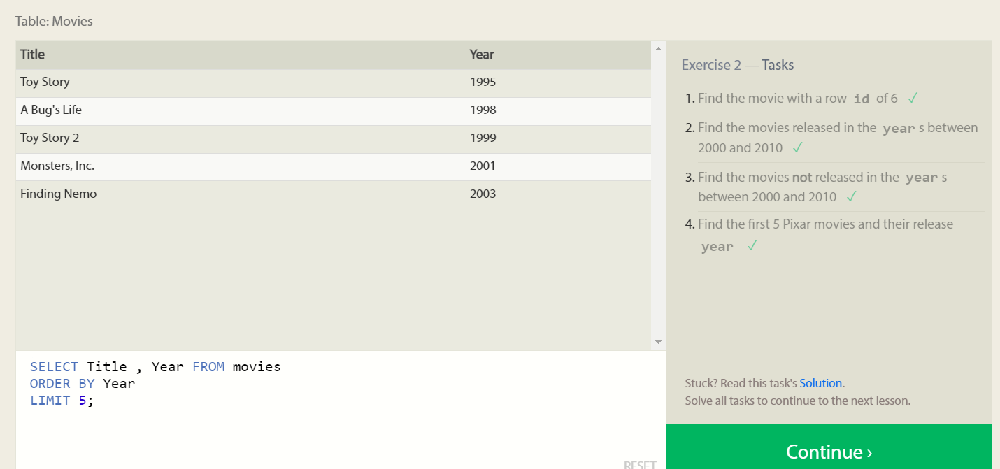

1.SELECT Title FROM movies

WHERE ID is 6

2.SELECT Title FROM movies

WHERE Year BETWEEN 2000 AND 2010;

3.SELECT Title FROM movies

WHERE Year Not BETWEEN 2000 AND 2010;

4.SELECT Title , Year FROM movies

ORDER BY Year

LIMIT 5;

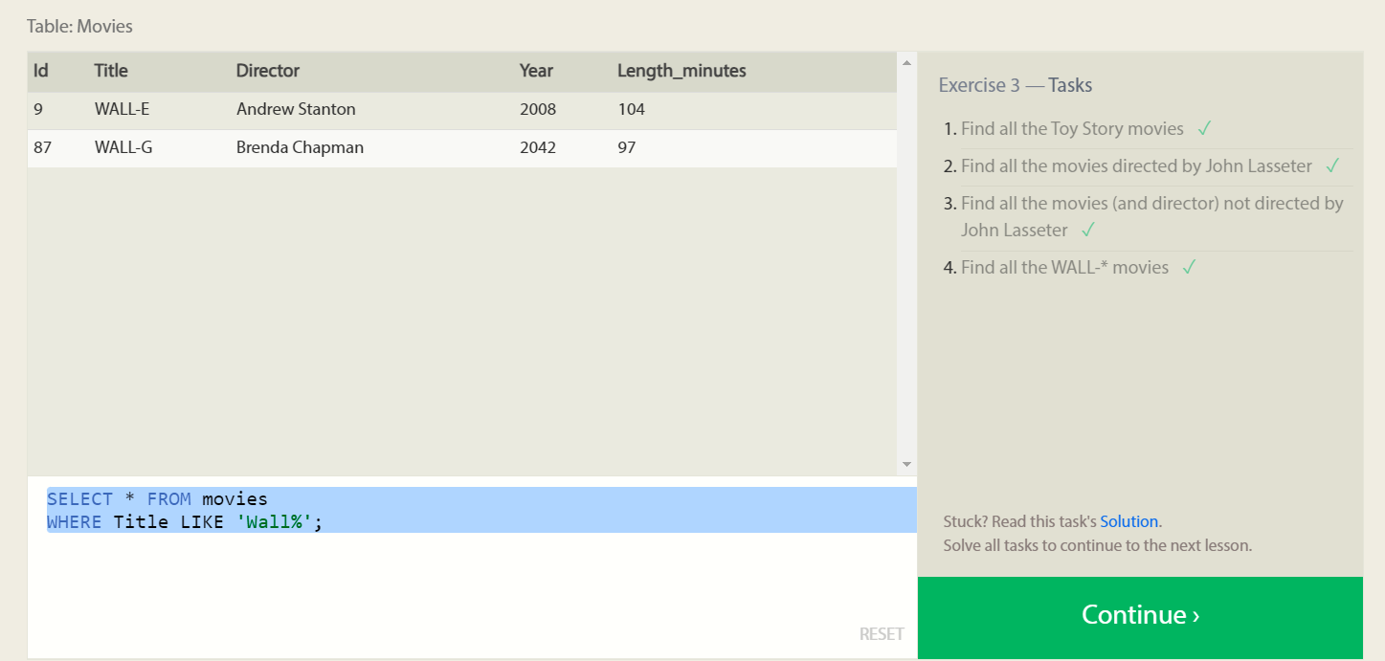

1.SELECT \* FROM movies

WHERE Title LIKE 'Toy Story%';

2.SELECT Title FROM movies

WHERE Director = 'John Lasseter';

3.SELECT Title FROM movies

WHERE Not Director = 'John Lasseter';

4.SELECT \* FROM movies

WHERE Title LIKE 'Wall%';