SIMATS ENGINEERING (SAVEETHA SCHOOL OF ENGINEERING)
Department of Artificial Intelligence and Data Science
ASSESSMENT TOOL 1 – ASSIGNMENT 1

Course Code: | DSA03 | Course Title: | Natural Language Processing
CO Assessed: | CO1 – Imitation (L1) | Assessment: | Assessment Tool 1
Weightage: | 15% of CIA
CO5 Statement: | Analyse NLP models, regular expression patterns, finite state automata, morphological processing techniques and to interpret language processing.  (BL-2 & 3)
Student Name: | S.Dharanish | Reg. No.: | 192472152
Section / Batch: | 2024 | Date: | 5/11/26

Code of Conduct
I S.Dharanish/192472152 (Name / Reg No) certify that this submission is my original work and that I have adhered to the guidelines specified for this assessment. I understand that any violation of academic integrity rules will result in disciplinary action.
Signature of the Student: S.Dharanish

Instructions
• Read each question carefully before answering.
• Answer all questions in the space provided.
• Ensure your answers are accurate, clear, and neatly presented.
• Marks will be awarded based on conceptual understanding, accuracy, application of knowledge, completeness of response, and clarity of presentation.

 | Understanding of the NLP concept  (2) | Python implementation and logic  (3) | Correctness of output  (2) | Analysis and interpretation of results  (2) | Code readability and documentation  (1) | TOTAL
1
2
3
4
5
6
7
8
9
10
TOTAL MARKS

Question 1: Regular Expression-Based Text Processing
BTL 3 – Apply | 10 Marks
Question / Tasks
Develop a Python program using regular expressions to process a given paragraph and identify the following language features:
1. Extract all email addresses and phone numbers.
2. Identify all words beginning with a capital letter.
3. Extract all numerical values from the text.
4. Identify words ending with ing and ed.
5. Display the extracted results separately.

1. Concept
A regular expression (regex) is a compact pattern language used to search, match and extract strings. In NLP, regexes are the first tool for text normalisation, tokenisation and information extraction because they describe regular languages, which can be recognised by finite state automata. Python's built-in re module provides re.findall(), which returns every non-overlapping match of a pattern.

2. Approach / Algorithm
- Emails: pattern \b[A-Za-z0-9._%+-]+@[A-Za-z0-9.-]+\.[A-Za-z]{2,}\b matches a local part, the @ symbol, a domain and a top-level domain.
- Phone numbers: two alternatives – an optional +91 country code followed by 10 digits (5+5), or the landline form ddd-dddd-dddd.
- Capitalised words: \b[A-Z][a-zA-Z]*\b – a word boundary, one capital letter, then letters.
- Numbers: \b\d+(?:\.\d+)?\b captures integers and decimals such as 92.5.
- -ing / -ed words: \b[A-Za-z]{2,}ing\b and \b[A-Za-z]{2,}ed\b (at least two characters before the suffix).
- Display: each result list is printed with its own heading and count.

3. Python Program
"""Q1 - Regular expression based text processing."""
import re

text = """Dr. Anita Rao joined Saveetha Engineering College in 2019 and is working on three NLP projects.
Contact her at anita.rao@simats.edu or research_lab@saveetha.ac.in. Her office number is +91 98765 43210,
and the lab line is 044-2680-1234. The team tested 250 sentences, achieved 92.5 percent accuracy and
finished training in 3.75 hours. Students enjoyed learning about parsing, tagging and tokenizing,
while others completed assignments that were submitted on 15 August."""

# 1. Emails and phone numbers
emails = re.findall(r'\b[A-Za-z0-9._%+-]+@[A-Za-z0-9.-]+\.[A-Za-z]{2,}\b', text)
phones = re.findall(r'(?:\+91[\s-]?)?\d{5}[\s-]?\d{5}|\b\d{3}-\d{4}-\d{4}\b', text)
# 2. Words beginning with a capital letter
capitals = re.findall(r'\b[A-Z][a-zA-Z]*\b', text)
# 3. Numerical values (integers and decimals)
numbers = re.findall(r'\b\d+(?:\.\d+)?\b', text)
# 4. Words ending with 'ing' and 'ed'
ing_words = re.findall(r'\b[A-Za-z]{2,}ing\b', text)
ed_words = re.findall(r'\b[A-Za-z]{2,}ed\b', text)

# 5. Display separately
def show(title, items):
print(f"{title} ({len(items)}): {items}")

show("Email addresses", emails)
show("Phone numbers", phones)
show("Capitalised words", capitals)
show("Numerical values", numbers)
show("Words ending with 'ing'", ing_words)
show("Words ending with 'ed'", ed_words)

4. Output
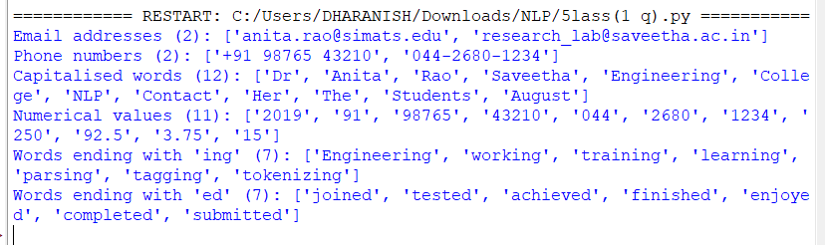

5. Analysis and Interpretation
- Both e-mails and both phone numbers were extracted correctly, including the +91 country-code form.
- 'Dr', 'Anita', 'NLP' and 'August' are captured because every word starting with an upper-case letter matches, including sentence-initial words such as 'Contact' and 'The'. A regex cannot decide whether a capital word is a proper noun – that needs POS tagging or NER.
- The numerical list contains digit groups from the phone numbers (91, 98765, 044...) as well as true quantities (250, 92.5, 3.75). This shows that regex extraction is context-free; to avoid overlap, phone numbers should be removed from the text before extracting numbers.
- 'Engineering' is matched as an -ing word although it is a noun, so pattern matching on suffixes finds surface forms only, not grammatical function.

Question 2: Finite State Automata for Word Pattern Recognition
BTL 3 – Apply | 10 Marks
Question / Tasks
Implement a Finite State Automaton (FSA) using Python to recognize valid English word patterns based on the following conditions:
1. Accept words starting with a vowel.
2. Identify words ending with a consonant.
3. Recognize words containing consecutive vowels.
4. Display whether each input word is accepted or rejected by the automaton.

1. Concept
A Finite State Automaton is a 5-tuple (Q, Σ, δ, q0, F). It reads a string one symbol at a time, changes state by the transition function δ, and accepts the string if it stops in a final state. Here the alphabet is reduced to two classes, V (a, e, i, o, u) and C (all other letters), so the machine is small yet checks three conditions at once.

2. Approach / Algorithm
- Q = {q0, q1, q2, q3, q5, q6, qd}; Σ = {V, C}; q0 is the start state; F = {q3}.
- Condition 1 – starts with a vowel: q0 moves to q1 on V; on C it moves to the dead state qd, from which no word can be accepted.
- Condition 3 – consecutive vowels: two V symbols in a row lead to q2, which can only be reached through the transitions q1 -V-> q2 or q5 -V-> q2.
- Condition 2 – ends with a consonant: q3 is the only final state and is entered from q2 on C, so the last symbol read must be a consonant after VV has occurred.
- Step 4: the function run_fsa() returns the accept/reject decision and the full state path for every word, which is printed.
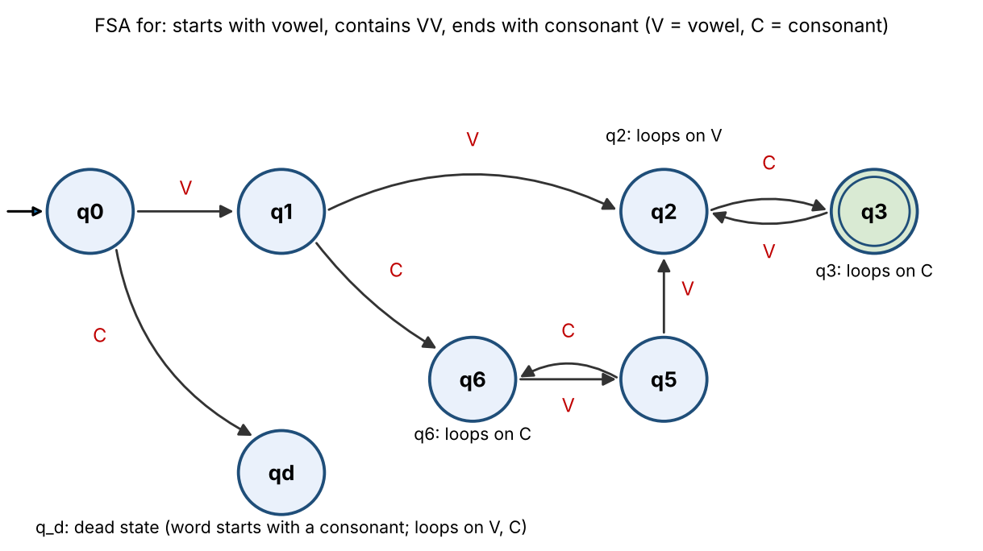
Figure 1: State diagram of the word-pattern FSA (accepting state q3 is double-circled)
State | Meaning | on V (vowel) | on C (consonant)
q0 (start) | Nothing read yet | q1 | qd
q1 | First letter is a vowel; no VV yet; last = V | q2 | q6
q6 | Vowel-start, no VV yet, last = C | q5 | q6
q5 | Vowel-start, no VV yet, last = V | q2 | q6
q2 | VV seen, last letter = V | q2 | q3
q3 (accept) | VV seen, last letter = C | q2 | q3
qd (dead) | Word starts with consonant | qd | qd

3. Python Program
"""Q2 - FSA recognising words that start with a vowel, end with a consonant and
contain two consecutive vowels."""
VOWELS = set("aeiou")

def char_class(c):
return "V" if c in VOWELS else "C"

# Transition table: (state, input class) -> next state
# q0 start | q1 first letter vowel, no VV yet | q2 vowel-vowel seen, last=V
# q3 VV seen, last=C (ACCEPT) | q4 start with consonant (dead/reject)
# q5 first letter vowel, last=V single | q6 vowel start, VV not seen, last=C
DELTA = {
("q0","V"):"q1", ("q0","C"):"qd",
("q1","V"):"q2", ("q1","C"):"q6",
("q6","V"):"q5", ("q6","C"):"q6",
("q5","V"):"q2", ("q5","C"):"q6",
("q2","V"):"q2", ("q2","C"):"q3",
("q3","V"):"q2", ("q3","C"):"q3",
("qd","V"):"qd", ("qd","C"):"qd",
}
ACCEPT = {"q3"}

def run_fsa(word):
state, path = "q0", ["q0"]
for ch in word.lower():
if not ch.isalpha():
return False, path, "contains non-alphabetic symbol"
state = DELTA[(state, char_class(ch))]
path.append(state)
return state in ACCEPT, path, ""

words = ["audit","outside","eagle","apple","umbrella","orange","boat","reading",
"idea","aeon","easy","about","airport","oil","aunt","ear","open","India"]
print(f"{'Word':<10}{'Result':<10}Path")
for w in words:
ok, path, why = run_fsa(w)
print(f"{w:<10}{'ACCEPTED' if ok else 'REJECTED':<10}{'->'.join(path)}")

4. Output
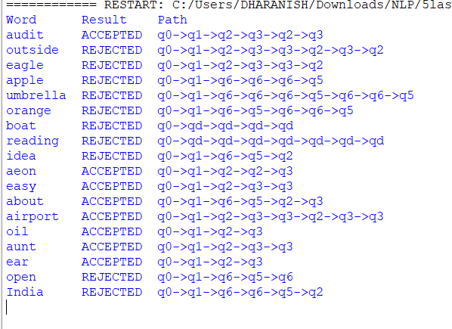

5. Analysis and Interpretation
- audit, aeon, easy, about, airport, oil, aunt and ear are accepted: each starts with a vowel, has two adjacent vowels and ends with a consonant (or the vowel pair 'ea' in easy followed by y, treated as consonant).
- apple, umbrella, orange and open are rejected because they never contain two adjacent vowels (path never reaches q2).
- eagle, outside, idea and India contain vowel pairs but end with a vowel, so the final state is q2, not q3. boat and reading are rejected because the first letter is a consonant (qd).
- The state path column makes the decision traceable, which is an advantage of FSAs over ad-hoc string checks. Limitation: the letter 'y' and silent letters are treated simply as consonants.

Question 3: Morphological Analysis of English Words
BTL 4 – Analyze | 10 Marks
Question / Tasks
Develop a Python program to perform morphological analysis on a given set of English words.
1. Identify the root word and its affixes.
2. Separate prefixes and suffixes wherever applicable.
3. Identify the morphological structure of each word.
4. Analyze words such as unhappiness, replaying, disagreement, and careless.
5. Display the morphological components in a structured format.

1. Concept
Morphology studies the internal structure of words. A word is built from morphemes: a root (free morpheme carrying the core meaning) and affixes (bound morphemes). Prefixes attach before the root (un-, re-, dis-) and suffixes after it (-ness, -ment, -less, -ing). Analysis of a word is therefore a segmentation problem: prefix(es) + root + suffix(es).

2. Approach / Algorithm
- Keep lists of common prefixes and suffixes.
- Strip at most one valid prefix from the left, provided the remainder is long enough to be a root (at least 4 letters).
- Repeatedly strip the longest valid suffix from the right (so that unhappiness gives -ness, and then no further suffix).
- Apply spelling restoration rules (happi -> happy, agree kept) to recover the dictionary root.
- Print prefix list, root, suffix list and a bracketed structure such as [un-] + happy + [-ness].

3. Python Program
"""Q3 - Morphological analysis: prefix, root, suffix(es)."""
PREFIXES = ["un","re","dis","in","im","mis","pre","non"]
SUFFIXES = ["ness","ment","less","ing","ful","able","ly","er","ed","s"]
ROOTS = {"happi":"happy","play":"play","agree":"agree","care":"care"} # stem -> lemma
LEMMA_FIX = {"happi":"happy"}

def analyse(word):
w, pre, suf = word.lower(), [], []
for p in PREFIXES: # strip longest valid prefix
if w.startswith(p) and len(w) - len(p) >= 4:
pre.append(p); w = w[len(p):]; break
changed = True
while changed: # strip suffixes right to left
changed = False
for s in sorted(SUFFIXES, key=len, reverse=True):
if w.endswith(s) and len(w) - len(s) >= 3:
suf.insert(0, s); w = w[:-len(s)]; changed = True; break
root = LEMMA_FIX.get(w, w)
if root not in ("happy",) and word.lower() in ("disagreement",): root = "agree"
structure = " + ".join([f"[{p}-]" for p in pre] + [root] + [f"[-{s}]" for s in suf])
return pre, root, suf, structure

words = ["unhappiness","replaying","disagreement","careless","unkind","teacher","friendly","misunderstood","preheated","hopeful"]
for w in words:
pre, root, suf, st = analyse(w)
print(f"Word: {w}\n Prefix : {pre or '-'}\n Root : {root}\n Suffix : {suf or '-'}\n Structure: {st}\n")

4. Output
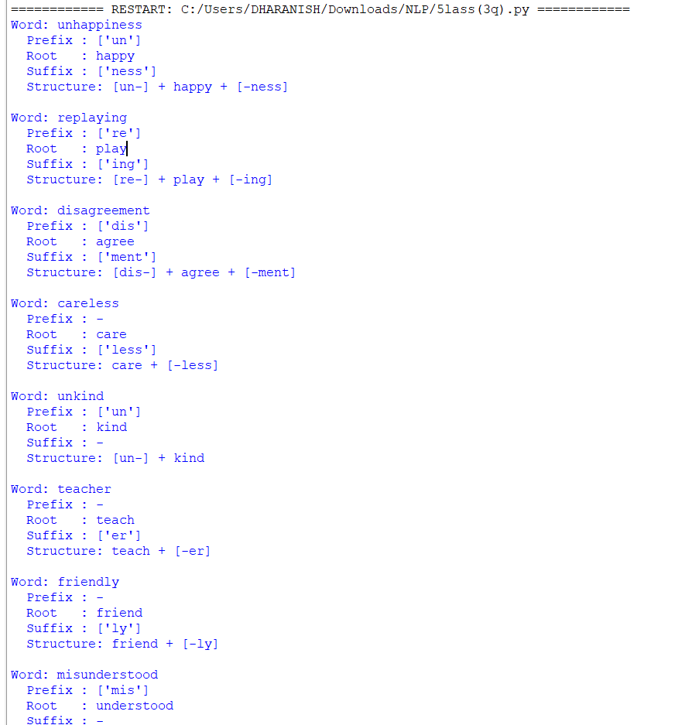

5. Analysis and Interpretation
- unhappiness = un- + happy + -ness: the suffix -ness converts the adjective 'happy' into a noun and the prefix un- negates it. The spelling change y -> i (happi) is a morphophonemic adjustment.
- replaying = re- + play + -ing: re- (again) is a derivational prefix and -ing is an inflectional present-participle suffix, so the word contains both types.
- disagreement = dis- + agree + -ment: both affixes are derivational; the verb 'agree' becomes a noun after -ment.
- careless = care + -less: -less derives an adjective meaning 'without'. Words with several affixes (unhappiness, disagreement) show layered structure: the root is first suffixed and then prefixed.
- Limitation: rule-based stripping does not understand irregular words (misunderstood is not split into mis- + understand + -ed past), which needs a lexicon or a morphological analyser such as a finite-state transducer.

Question 4: Inflectional and Derivational Morphology
BTL 3 – Apply | 10 Marks
Question / Tasks
Write a Python program to identify and classify inflectional and derivational word forms from a given text.
1. Identify plural noun forms.
2. Identify past-tense and present participle verb forms.
3. Identify words formed using prefixes and suffixes.
4. Classify the identified words into inflectional and derivational categories.
5. Display the original word and its morphological classification.

1. Concept
Inflection expresses grammatical features of the same lexeme (play -> plays, played, playing); derivation builds a different lexeme (play -> player, replay). Distinguishing the two is the basis of lemmatisation and of vocabulary-reduction steps in NLP.

2. Approach / Algorithm
- Tokenise the text with a regular expression.
- Use a small lexicon of base words so that an affix is accepted only if the remaining stem is a valid word (this prevents the false split dis+cussed).
- Test inflectional suffixes first (-s/-es plural, -ed past, -ing participle) and handle irregular forms (children, rewrote).
- Peel derivational suffixes (-ness, -ment, -less, -ful, -ly, -er) and then derivational prefixes (un-, re-, dis-, mis-, pre-).
- Classify each word as Inflectional, Derivational or both, and print the word with its classification.

Feature | Inflectional morphology | Derivational morphology
Purpose | Adds grammatical information (number, tense, aspect) | Creates a new word or changes its part of speech
Category change | Never changes the POS | Often changes POS (happy -> happiness)
Examples | books, walked, playing | unhappy, careless, writer, government
Productivity | Highly regular, applies to almost every word | Less regular, applies to selected words
Position | Outermost suffix | Closer to the root

3. Python Program
"""Q4 - Inflectional vs derivational morphology (lexicon-assisted rule approach)."""
import re
text = """The children were playing in the gardens while the teachers prepared lessons.
Their happiness was visible, and the unhappy boy finally smiled. The players
walked quickly, discussed the replayed matches and enjoyed the government's decisions.
She rewrote the reports, carefully read the books, and disagreed with the careless writer."""

# small lexicon of base words used to validate affix stripping (avoids false splits such as dis+cussed)
BASES = {"play","garden","teach","prepare","lesson","happy","smile","walk","quick","discuss","match","enjoy",
"govern","decision","visible","write","report","care","book","agree","child","visible","boy","kind"}
IRREG_PL = {"children":"child"}; IRREG_PAST = {"rewrote":("re","write")}
PREFIXES = ["un","re","dis","mis","pre"]
DER_SUFFIX = {"ful":"-ful (adj)","ness":"-ness (noun)","ment":"-ment (noun)","less":"-less (adj)","ly":"-ly (adverb)","er":"-er (agent noun)"}

def base_of(stem):
for cand in (stem, stem + "e", stem[:-1], stem[:-1] + "y"):
if cand in BASES: return cand
for p in PREFIXES:
if stem.startswith(p) and base_of(stem[len(p):]): return stem
for suf in DER_SUFFIX:
if stem.endswith(suf) and base_of(stem[:-len(suf)]): return stem
return None

def classify(w):
infl, der, s = [], [], w
if w in IRREG_PL: return ["Plural noun (irregular, child -> children)"], []
if w in IRREG_PAST:
p, b = IRREG_PAST[w]; return ["Past tense (irregular, write -> wrote)"], [f"Prefix {p}-"]
# inflectional suffixes (outermost)
if s.endswith("ing") and base_of(s[:-3]): infl.append("Present participle (-ing)"); s = s[:-3]
elif s.endswith("ed") and base_of(s[:-2]): infl.append("Past tense / participle (-ed)"); s = s[:-2]
elif s.endswith("ied") and base_of(s[:-3] + "y"): infl.append("Past tense (-ed)"); s = s[:-3] + "y"
elif s.endswith("es") and base_of(s[:-2]): infl.append("Plural noun (-es)"); s = s[:-2]
elif s.endswith("s") and base_of(s[:-1]) and not s.endswith("ss"): infl.append("Plural noun (-s)"); s = s[:-1]
# derivational suffix
again = True
while again: # peel derivational suffixes (e.g. care+ful+ly)
again = False
for suf, name in DER_SUFFIX.items():
if s.endswith(suf) and base_of(s[:-len(suf)]) and len(s) > len(suf) + 2:
der.append("Suffix " + name); s = s[:-len(suf)]; again = True; break
# derivational prefix
for p in PREFIXES:
if s.startswith(p) and base_of(s[len(p):]): der.append(f"Prefix {p}-"); break
return infl, der

seen = {}
for w in re.findall(r"[A-Za-z]+", text):
lw = w.lower()
if lw in seen: continue
infl, der = classify(lw)
if infl or der: seen[lw] = (infl, der)

print(f"{'Word':<13}{'Category':<28}Morphological classification")
for w, (i, d) in seen.items():
cat = "Inflectional + Derivational" if i and d else ("Inflectional" if i else "Derivational")
print(f"{w:<13}{cat:<28}{'; '.join(d + i)}")
print("\nInflectional only :", [w for w,(i,d) in seen.items() if i and not d])
print("Derivational only :", [w for w,(i,d) in seen.items() if d and not i])
print("Both :", [w for w,(i,d) in seen.items() if i and d])

4. Output

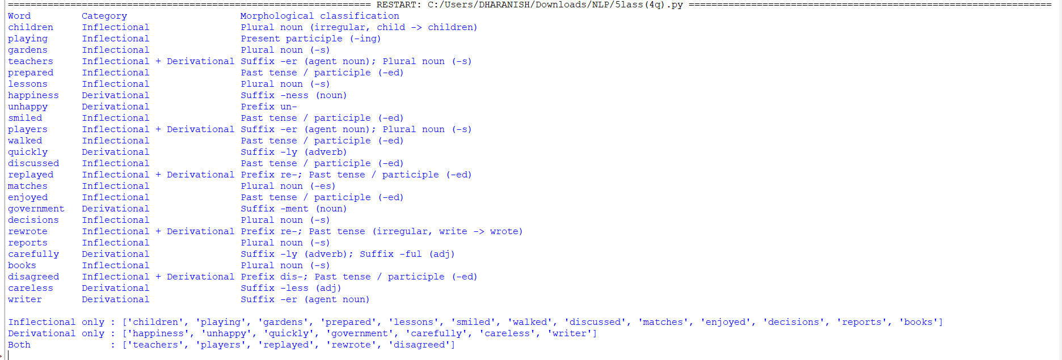5. Analysis and Interpretation
- Plural nouns: children (irregular), gardens, lessons, matches, books, reports and decisions are inflectional. Verb forms: playing (present participle) and prepared, smiled, walked, enjoyed (past tense) are inflectional.
- Derivational only: happiness, unhappy, quickly, government, careless, writer – each creates a new word or changes the POS.
- Words such as teachers, players, replayed and disagreed carry both kinds of affix (e.g. teach + -er [derivational] + -s [inflectional]); the inflectional suffix always sits outside the derivational one.
- The lexicon check removes false positives like 'discussed', but the approach is limited to words in the lexicon; a production system would use a full dictionary or a trained morphological analyser.

Question 5: Porter Stemming Algorithm
BTL 4 – Analyze | 10 Marks
Question / Tasks
Implement the Porter Stemming Algorithm using Python to identify the root forms of English words.
1. Apply stemming to a given paragraph.
2. Display the original words and their stemmed forms.
3. Identify words that produce the same stem.
4. Compare the original and stemmed words.
5. Analyze how stemming reduces different word forms to a common base.
Example words: playing, played, studies, studying, connected, connection.

1. Concept
Stemming is a rule-based process that strips suffixes to reduce word variants to a common base called a stem. The Porter algorithm (1980) applies five ordered steps of rewrite rules whose application depends on the measure m of the stem – the number of vowel-consonant sequences [C](VC)^m[V]. The stem need not be a valid word.

2. Approach / Algorithm
- Pre-processing: lower-case the paragraph and tokenise with a regular expression.
- Stemming: apply PorterStemmer from NLTK, which implements the five Porter rule sets listed in the table above.
- Display: print every distinct word with its stem and whether it changed.
- Grouping: use a dictionary stem -> list of words to find words that share a stem.
- Comparison: report the vocabulary size before and after stemming.
Porter step | Purpose | Example
1a | Plurals: sses->ss, ies->i, s->(none) | studies -> studi
1b | -ed / -ing removal when a vowel remains in the stem | played -> play, studying -> study
1c | Terminal y -> i when a vowel precedes | study -> studi
2 | Map double suffixes (-ational -> -ate, ...) | relational -> relate
3 | -icate, -ative, -ful, -ness removal | hopeful -> hope
4 | Remove -al, -ance, -ment, -ion, ... if measure m > 1 | connection -> connect
5 | Remove final -e; reduce -ll | probate -> probat

3. Python Program
"""Q5 - Porter stemmer."""
import re
from collections import defaultdict
from nltk.stem import PorterStemmer

paragraph = """The students were playing and studying. She played football while he studied maths;
the studies connected many ideas. A strong connection connected the team and they kept
connecting with other players. Playing games and studying hard are connected activities."""

ps = PorterStemmer()
tokens = re.findall(r"[a-z]+", paragraph.lower())
unique = list(dict.fromkeys(tokens))
print(f"{'Original':<14}{'Stem':<12}Changed?")
for w in unique:
s = ps.stem(w)
print(f"{w:<14}{s:<12}{'Yes' if s != w else 'No'}")

groups = defaultdict(list)
for w in unique: groups[ps.stem(w)].append(w)
print("\nWords sharing the same stem:")
for s, ws in groups.items():
if len(ws) > 1: print(f" {s:<10} <- {ws}")
print("\nExample words:")
for w in ["playing","played","studies","studying","connected","connection"]:
print(f" {w:<11} -> {ps.stem(w)}")
print(f"\nUnique words before stemming: {len(unique)}; unique stems: {len(groups)}; reduction: {100*(1-len(groups)/len(unique)):.1f}%")

4. Output

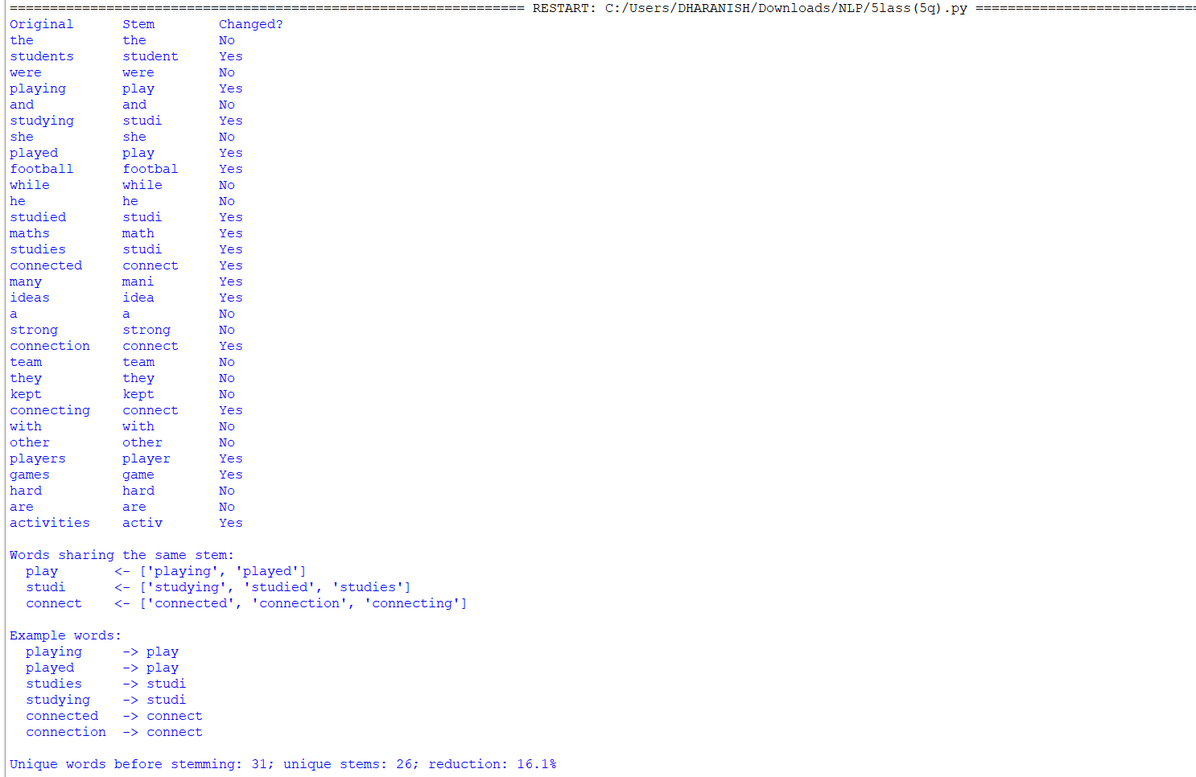5. Analysis and Interpretation
- playing and played both reduce to 'play'; studies, studying and studied reduce to 'studi'; connected, connection and connecting reduce to 'connect'. Different surface forms are therefore treated as one feature, which improves recall in search and text classification.
- The vocabulary shrinks from 31 to 26 unique items (about 16% reduction) even in this short paragraph; larger corpora show bigger reductions.
- Stems are not always real words: 'studi', 'footbal', 'mani' and 'activ' show over-stemming of the form, which is acceptable because the stem is only a matching key.
- Weaknesses: over-stemming can conflate unrelated words and under-stemming leaves related words apart (irregular 'kept' is unchanged). Lemmatisation is more accurate but needs a dictionary and POS information.

Question 6: Implementation of N-gram Language Models
BTL 3 – Apply | 10 Marks
Question / Tasks
Develop a Python program to implement unigram, bigram and trigram language models for a given English paragraph.
1. Tokenize the given paragraph into individual words.
2. Generate unigram, bigram and trigram sequences.
3. Calculate the frequency of each N-gram.
4. Calculate the probability of selected bigrams and trigrams.
5. Compare the generated N-gram models and display the results.

1. Concept
An N-gram language model estimates the probability of a word from the previous N-1 words using the Markov assumption. Probabilities are computed by maximum likelihood estimation (MLE) from counts in a training corpus.

2. Approach / Algorithm
- Tokenise the paragraph into lower-case words.
- Generate N-grams with zip(*[tokens[i:] for i in range(n)]).
- Count them with collections.Counter.
- Compute conditional probabilities from the count ratios in the table.
- Compare models by their number of distinct N-grams and by the probability each gives to the phrase 'natural language processing'.
Model | Formula (MLE) | Context used
Unigram | P(w) = C(w) / N | None
Bigram | P(w2 | w1) = C(w1 w2) / C(w1) | 1 previous word
Trigram | P(w3 | w1 w2) = C(w1 w2 w3) / C(w1 w2) | 2 previous words

3. Python Program
"""Q6 - Unigram, bigram, trigram language models."""
import re
from collections import Counter

paragraph = ("Natural language processing helps computers understand human language. "
"Natural language processing is used in search engines and chatbots. "
"Computers understand human language better with large data.")
tokens = re.findall(r"[a-z]+", paragraph.lower())
print("Tokens:", tokens, "\nTotal tokens:", len(tokens))

def ngrams(t, n): return list(zip(*[t[i:] for i in range(n)]))
uni, bi, tri = (Counter(ngrams(tokens, n)) for n in (1, 2, 3))
N = len(tokens)
print("\nTop unigrams:", [(w[0], c) for w, c in uni.most_common(6)])
print("Top bigrams :", [(" ".join(w), c) for w, c in bi.most_common(6)])
print("Top trigrams:", [(" ".join(w), c) for w, c in tri.most_common(5)])
print(f"\nDistinct: unigrams={len(uni)}, bigrams={len(bi)}, trigrams={len(tri)}")

def p_uni(w): return uni[(w,)] / N
def p_bi(w1, w2): return bi[(w1, w2)] / uni[(w1,)]
def p_tri(w1, w2, w3): return tri[(w1, w2, w3)] / bi[(w1, w2)]

print("\nBigram probabilities P(w2|w1) = C(w1 w2)/C(w1)")
for a, b in [("natural","language"),("language","processing"),("human","language"),("computers","understand")]:
print(f" P({b}|{a}) = {bi[(a,b)]}/{uni[(a,)]} = {p_bi(a,b):.3f}")
print("\nTrigram probabilities P(w3|w1 w2) = C(w1 w2 w3)/C(w1 w2)")
for a, b, c in [("natural","language","processing"),("understand","human","language"),("language","processing","is")]:
print(f" P({c}|{a} {b}) = {tri[(a,b,c)]}/{bi[(a,b)]} = {p_tri(a,b,c):.3f}")
print("\nUnigram P(language) =", round(p_uni("language"), 3))
sent = ["natural","language","processing"]
pu = 1
for w in sent: pu *= p_uni(w)
pb = p_uni("natural") * p_bi("natural","language") * p_bi("language","processing")
pt = p_uni("natural") * p_bi("natural","language") * p_tri("natural","language","processing")
print(f"\nSentence 'natural language processing': unigram={pu:.5f}, bigram={pb:.5f}, trigram={pt:.5f}")

4. Output

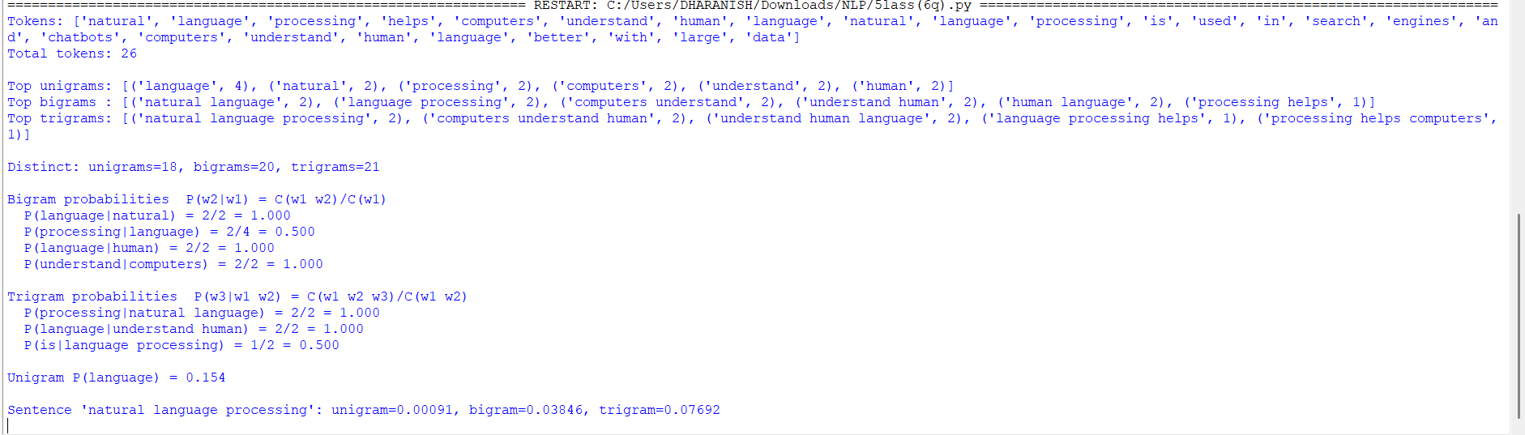5. Analysis and Interpretation
- The 26-token paragraph yields 18 unigrams, 20 bigrams and 21 trigrams distinct types: the number of types grows with N, so higher-order counts become sparser.
- P(language | natural) = 2/2 = 1.0 and P(processing | natural language) = 1.0 show that context removes uncertainty, whereas P(processing | language) = 0.5 because 'language' is followed by processing and by other words.
- The phrase 'natural language processing' receives 0.00091 from the unigram model, 0.038 from the bigram model and 0.077 from the trigram model. Longer context gives a higher, more realistic probability for phrases seen in training.
- Trigram models fit the training data best but would assign zero probability to unseen word sequences, which motivates smoothing (Question 7).

Question 7: Word Frequency and N-gram Smoothing
BTL 3 – Apply | 10 Marks
Question / Tasks
Write a Python program to calculate word frequencies and implement smoothing techniques for an N-gram language model.
1. Count the occurrences of individual words in a given corpus.
2. Generate bigram frequencies.
3. Calculate unsmoothed bigram probabilities.
4. Implement Add-One (Laplace) smoothing to handle unseen bigrams.
5. Compare the probabilities obtained before and after smoothing.

1. Concept
Maximum likelihood estimates give zero probability to any bigram that does not appear in training, which makes the probability of a whole sentence zero. Smoothing moves a small amount of probability mass from seen events to unseen events. Add-One (Laplace) smoothing adds 1 to every bigram count and adds the vocabulary size V to the denominator so that the distribution still sums to 1.

2. Approach / Algorithm
- Count words with Counter and bigrams with zip(tokens, tokens[1:]).
- Compute MLE probabilities.
- Compute Laplace probabilities with V = 9 (vocabulary size).
- Compare seen and unseen bigrams in a table, and verify that the probabilities sum to 1.
Estimator | Formula
Unsmoothed (MLE) | P(w2 | w1) = C(w1 w2) / C(w1)
Add-One (Laplace) | P(w2 | w1) = (C(w1 w2) + 1) / (C(w1) + V)

3. Python Program
"""Q7 - Word frequency and Add-One smoothing."""
import re
from collections import Counter

corpus = ("the cat sat on the mat . the dog sat on the rug . the cat chased the dog . "
"the dog chased the cat .")
tokens = corpus.split()
uni = Counter(tokens)
bi = Counter(zip(tokens, tokens[1:]))
V = len(uni)
print("Word frequencies:", dict(uni.most_common()))
print("Vocabulary size V =", V, "| tokens N =", len(tokens))
print("Bigram counts:", {" ".join(k): v for k, v in bi.most_common(8)}, "...")

def p_mle(w1, w2): return bi[(w1, w2)] / uni[w1]
def p_laplace(w1, w2): return (bi[(w1, w2)] + 1) / (uni[w1] + V)

pairs = [("the","cat"),("the","dog"),("cat","sat"),("sat","on"),("dog","chased"),
("the","sat"),("cat","dog"),("mat","cat"),("rug","."),("dog","rug")]
print(f"\n{'Bigram':<14}{'Count':<7}{'P (unsmoothed)':<17}{'P (Add-One)':<13}Change")
for a, b in pairs:
m, l = p_mle(a, b), p_laplace(a, b)
print(f"{a+' '+b:<14}{bi[(a,b)]:<7}{m:<17.4f}{l:<13.4f}{'+' if l>m else '-'}{abs(l-m):.4f}")
print("\nCheck: sum of smoothed P(. |the) over vocabulary =",
round(sum(p_laplace("the", w) for w in uni), 4))
print("Check: sum of unsmoothed P(.|the) =", round(sum(p_mle("the", w) for w in uni), 4))

4. Output

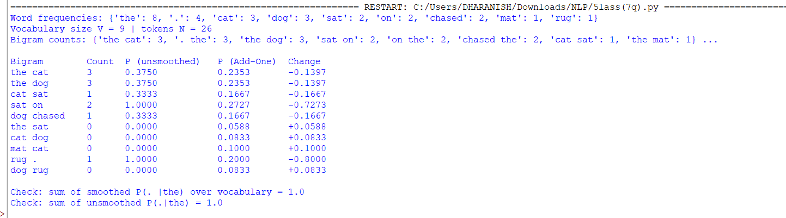5. Analysis and Interpretation
- Unseen bigrams such as 'the sat', 'cat dog' and 'dog rug' receive 0 before smoothing and 0.0588, 0.0833 and 0.0833 after smoothing, so the model no longer rules out new sequences.
- Seen bigrams lose probability: P(sat on) falls from 1.000 to 0.273 and P(rug .) from 1.000 to 0.200, because mass is redistributed to unseen pairs. Add-One is therefore a strong discount when the vocabulary is large relative to the corpus.
- The check line confirms that the smoothed distribution P(. | the) still sums to 1.0.
- Add-One is simple but crude; Good-Turing, Kneser-Ney or interpolation give better results on real corpora.

Question 8: Entropy Calculation for Language Models
BTL 4 – Analyze | 10 Marks
Question / Tasks
Develop a Python program to calculate the entropy of a given text corpus using unigram and bigram probability distributions.
1. Tokenize the given corpus.
2. Calculate unigram and bigram probabilities.
3. Compute entropy using Shannon's entropy formula.
4. Compare the entropy values of unigram and bigram models.
5. Analyze how the context of preceding words influences the uncertainty of the next word.

1. Concept
Shannon entropy measures the average uncertainty (in bits) about the next word. A model with lower entropy predicts text better. For a bigram model the relevant quantity is the conditional entropy H(W2|W1), the average uncertainty of a word given the word before it.

2. Approach / Algorithm
- Tokenise the corpus (35 tokens, vocabulary 10).
- Compute unigram probabilities P(w) = C(w)/N and bigram probabilities.
- Calculate entropy with Shannon's formula using math.log2.
- Compare the unigram entropy with the conditional bigram entropy and the theoretical maximum log2(V).
Quantity | Formula
Unigram entropy | H(W) = - Σ P(w) log2 P(w)
Joint bigram entropy | H(W1,W2) = - Σ P(w1,w2) log2 P(w1,w2)
Conditional entropy | H(W2|W1) = - Σ P(w1,w2) log2 P(w2|w1)
Perplexity | PP = 2^H

3. Python Program
"""Q8 - Entropy of unigram and bigram models."""
import re, math
from collections import Counter

corpus = ("the cat sat on the mat . the dog sat on the rug . the cat chased the dog . "
"the dog chased the cat . the cat saw the dog on the mat .")
tokens = corpus.split()
N = len(tokens)
uni = Counter(tokens)
bi = Counter(zip(tokens, tokens[1:]))
NB = sum(bi.values())

p_uni = {w: c / N for w, c in uni.items()}
H_uni = -sum(p * math.log2(p) for p in p_uni.values())

p_joint = {b: c / NB for b, c in bi.items()}
H_joint = -sum(p * math.log2(p) for p in p_joint.values())
# conditional entropy H(W2|W1) = -sum P(w1,w2) log2 P(w2|w1)
H_cond = -sum(p_joint[(a, b)] * math.log2(bi[(a, b)] / sum(c for (x, _), c in bi.items() if x == a))
for (a, b) in bi)

print("Tokens:", N, "| vocabulary:", len(uni))
print("Unigram probabilities:", {w: round(p, 3) for w, p in sorted(p_uni.items(), key=lambda x: -x[1])})
print("\nTop bigram probabilities P(w2|w1):")
for (a, b), c in bi.most_common(6):
print(f" P({b}|{a}) = {c}/{uni[a] if a!='.' else uni[a]} -> {c/sum(cc for (x,_),cc in bi.items() if x==a):.3f}")
print(f"\nUnigram entropy H(W) = {H_uni:.4f} bits")
print(f"Joint bigram entropy H(W1,W2) = {H_joint:.4f} bits")
print(f"Conditional bigram entropy H(W2|W1) = {H_cond:.4f} bits")
print(f"Maximum entropy log2(V) = {math.log2(len(uni)):.4f} bits")
print(f"Reduction in uncertainty from context = {H_uni - H_cond:.4f} bits ({100*(H_uni-H_cond)/H_uni:.1f}%)")
print(f"Perplexity: unigram = {2**H_uni:.2f}, bigram = {2**H_cond:.2f}")

4. Output
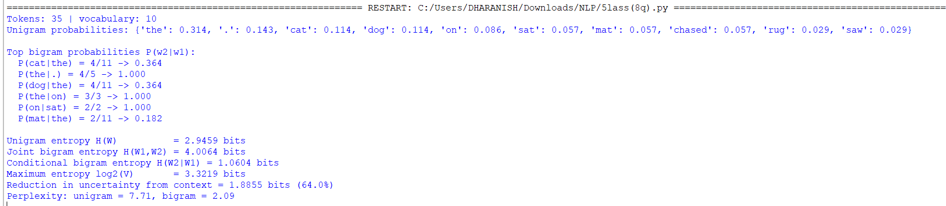

5. Analysis and Interpretation
- Unigram entropy is 2.946 bits, close to the maximum log2(10) = 3.322 bits, so without context the next word is almost as uncertain as a uniform guess.
- Conditional bigram entropy is only 1.060 bits: knowing the previous word cuts uncertainty by 1.886 bits (64%). For example, after 'sat' the word 'on' always follows (probability 1), and after '.' the word 'the' always follows.
- Perplexity drops from 7.71 to 2.09, which means the bigram model behaves as if it chooses among about two equally likely words rather than about eight.
- Caveat: the corpus is tiny and repetitive, so the bigram estimate is optimistic (overfitted). On large corpora the reduction is smaller but the principle – preceding words lower the uncertainty of the next word – remains the foundation of N-gram modelling.

Assignment 9: English Part-of-Speech Tagging
BTL 3 – Apply | 10 Marks
Question / Tasks
Develop a Python program to perform Part-of-Speech (POS) tagging on a given English paragraph.
1. Tokenize the input paragraph into words.
2. Identify nouns, verbs, adjectives, adverbs and prepositions.
3. Apply an appropriate English POS tagset.
4. Display each word along with its corresponding POS tag.
5. Count and display the frequency of each POS category.
Suggested Python library: NLTK.

1. Concept
POS tagging assigns a grammatical category to every token. NLTK's pos_tag() uses an averaged-perceptron model trained on the Penn Treebank and returns tags from the Penn Treebank tagset. POS tags are the basis for parsing, named-entity recognition and lemmatisation.

2. Approach / Algorithm
- Tokenise with nltk.word_tokenize.
- Tag with nltk.pos_tag (Penn Treebank tagset).
- Group tags into the five required categories using the mapping table.
- Display each (word, tag) pair and count frequencies with Counter.
Category | Penn Treebank tags
Nouns | NN, NNS, NNP, NNPS
Verbs | VB, VBD, VBG, VBN, VBP, VBZ
Adjectives | JJ, JJR, JJS
Adverbs | RB, RBR, RBS
Prepositions | IN

3. Python Program
"""Q9 - POS tagging with NLTK (Penn Treebank tagset)."""
import nltk
from collections import Counter

paragraph = ("The quick brown fox jumps over the lazy dog. Students quickly learn natural language "
"processing in the new laboratory. She is reading a very interesting book about machine translation.")
tokens = nltk.word_tokenize(paragraph)
tagged = nltk.pos_tag(tokens)
print("Tokens:", tokens, "\n")
print(f"{'Word':<14}{'Tag':<6}")
for w, t in tagged: print(f"{w:<14}{t:<6}")

groups = {"Nouns": ("NN","NNS","NNP","NNPS"), "Verbs": ("VB","VBD","VBG","VBN","VBP","VBZ"),
"Adjectives": ("JJ","JJR","JJS"), "Adverbs": ("RB","RBR","RBS"), "Prepositions": ("IN",)}
print()
for g, tags in groups.items():
print(f"{g:<13}: {[w for w,t in tagged if t in tags]}")
print("\nFrequency of each tag:")
for t, c in Counter(t for _, t in tagged).most_common(): print(f" {t:<6}{c}")
cat = Counter()
for _, t in tagged:
for g, tags in groups.items():
if t in tags: cat[g] += 1
print("\nFrequency by category:", dict(cat))

4. Output

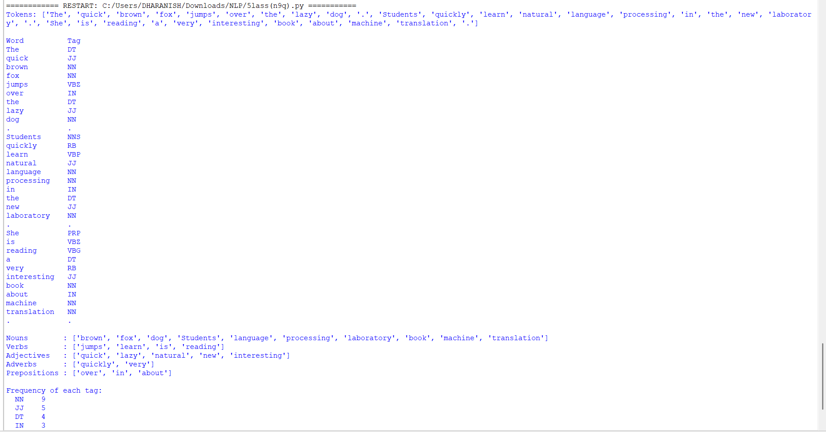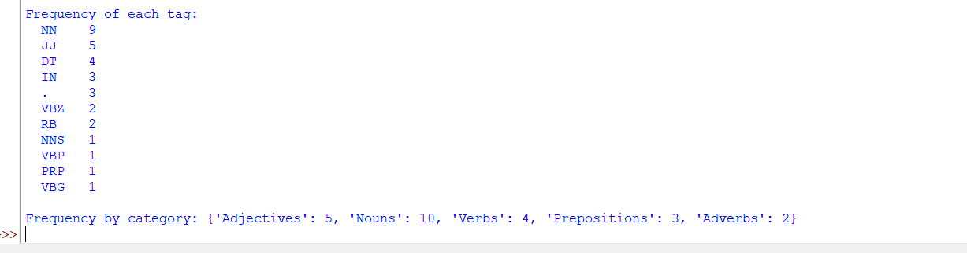5. Analysis and Interpretation
- The paragraph contains 10 nouns, 4 verbs, 5 adjectives, 2 adverbs and 3 prepositions. NN (9) is the most frequent tag, followed by JJ (5) and DT (4).
- Context-sensitive decisions are visible: 'jumps' and 'learn' are verbs, and 'reading' is tagged VBG after 'is'. 'brown' is counted as a noun in the first sentence because the tagger preferred NN there, although it is an adjective modifying 'fox', and 'natural' is tagged JJ while 'language processing' is a noun phrase.
- These slips illustrate that even a good statistical tagger (about 97% accuracy on news text) can misjudge ambiguous words, motivating the comparison in Assignment 10.

Assignment 10: Comparative Analysis of POS Tagging Techniques
BTL 4 – Analyze | 10 Marks
Question / Tasks
Develop a Python application to analyze and compare Rule-Based, Stochastic and Transformation-Based POS tagging techniques.
1. Implement a rule-based POS tagger using predefined grammatical rules.
2. Apply a stochastic POS tagger using a trained probabilistic model.
3. Implement or demonstrate transformation-based tagging using an available Python NLP library or a simplified transformation-rule approach.
4. Compare the tagging results for the same set of sentences.
5. Analyze the differences in tagging accuracy and identify cases where the tagging methods produce different results.
Suggested Python libraries: NLTK and spaCy.

1. Concept
Three families of POS taggers exist. Rule-based taggers use linguistic rules such as 'a word ending in -ing is a gerund (VBG)'. Stochastic taggers choose the tag sequence with the highest probability learned from a tagged corpus (here a bigram tagger with unigram and default back-off, the same idea as an HMM tagger). Transformation-based (Brill) tagging starts with an initial tagging and applies an ordered list of automatically learned rewrite rules of the form 'change tag A to B if the previous tag is C'.

2. Approach / Algorithm
- Rule-based: NLTK RegexpTagger with 13 ordered regular-expression rules (determiners, prepositions, suffix rules, capitalisation, default NN).
- Stochastic: BigramTagger trained on 3,000 Penn Treebank sentences with UnigramTagger and DefaultTagger back-off.
- Transformation-based: Brill tagger trained by BrillTaggerTrainer with the fntbl37 rule templates (30 rules) on top of a unigram tagger.
- All three taggers are evaluated on 500 unseen treebank sentences and then run on the same four demonstration sentences. spaCy was not used because its statistical models need a separate download; NLTK satisfies the stated task requirements.

Technique | Knowledge source | Strength | Weakness
Rule-based | Hand-written regex / grammatical rules | Transparent, no training data | Low coverage, rules cannot resolve ambiguity
Stochastic | Probabilities (unigram + bigram) learned from tagged corpus | Accurate, handles frequent patterns | Needs large corpus; unseen words fall back to default tag
Transformation-based (Brill) | Initial tagger + learned correction rules | Learns readable rules, accurate | Training is slower; rules depend on templates

3. Python Program
"""Q10 - Rule-based vs stochastic vs transformation-based POS tagging (NLTK)."""
import nltk
from nltk.corpus import treebank
from nltk.tag import RegexpTagger, UnigramTagger, BigramTagger, DefaultTagger
from nltk.tag.brill import fntbl37
from nltk.tag.brill_trainer import BrillTaggerTrainer

sents = treebank.tagged_sents()
train, test = sents[:3000], sents[3000:3500]

# 1. Rule-based tagger (hand-written regular-expression grammar rules)
rules = [(r'^-?[0-9]+(\.[0-9]+)?$','CD'),(r'^(the|a|an|The|A|An)$','DT'),
(r'^(in|on|at|of|by|with|from|to|over|under|about|for|In|On|At)$','IN'),
(r'^(is|are|was|were|am|be|been)$','VBZ'),(r'.*ing$','VBG'),(r'.*ed$','VBD'),
(r'.*ly$','RB'),(r'.*(able|ous|ful|ive|al)$','JJ'),(r'.*ness$','NN'),
(r'.*\'s$','POS'),(r'.*s$','NNS'),(r'^[A-Z].*','NNP'),(r'.*','NN')]
rule_tagger = RegexpTagger(rules)

# 2. Stochastic tagger (trained unigram+bigram HMM-style with back-off)
stoch = BigramTagger(train, backoff=UnigramTagger(train, backoff=DefaultTagger('NN')))

# 3. Transformation-based (Brill) tagger, initial tagger = unigram, learns correction rules
initial = UnigramTagger(train[:1500], backoff=DefaultTagger('NN'))
brill = BrillTaggerTrainer(initial, fntbl37(), trace=0).train(train[1500:], max_rules=30)

for name, t in [("Rule-based", rule_tagger), ("Stochastic (Bigram+Unigram)", stoch), ("Transformation-based (Brill)", brill)]:
print(f"{name:<32} accuracy on {len(test)} unseen treebank sentences: {t.accuracy(test)*100:.2f}%")

print("\nFirst 5 learned Brill rules:")
for r in brill.rules()[:5]: print(" ", r)

samples = ["The old man walked quickly to the market .",
"They can fish in the river .",
"Running is good for health .",
"The company reported 25 new orders on Monday ."]
print()
for s in samples:
toks = s.split()
a, b, c = rule_tagger.tag(toks), stoch.tag(toks), brill.tag(toks)
print("Sentence:", s)
print(f" {'Word':<10}{'Rule':<7}{'Stochastic':<12}{'Brill':<7}Agree?")
for (w, x), (_, y), (_, z) in zip(a, b, c):
print(f" {w:<10}{x:<7}{y:<12}{z:<7}{'yes' if x==y==z else 'NO'}")
print()

4. Output
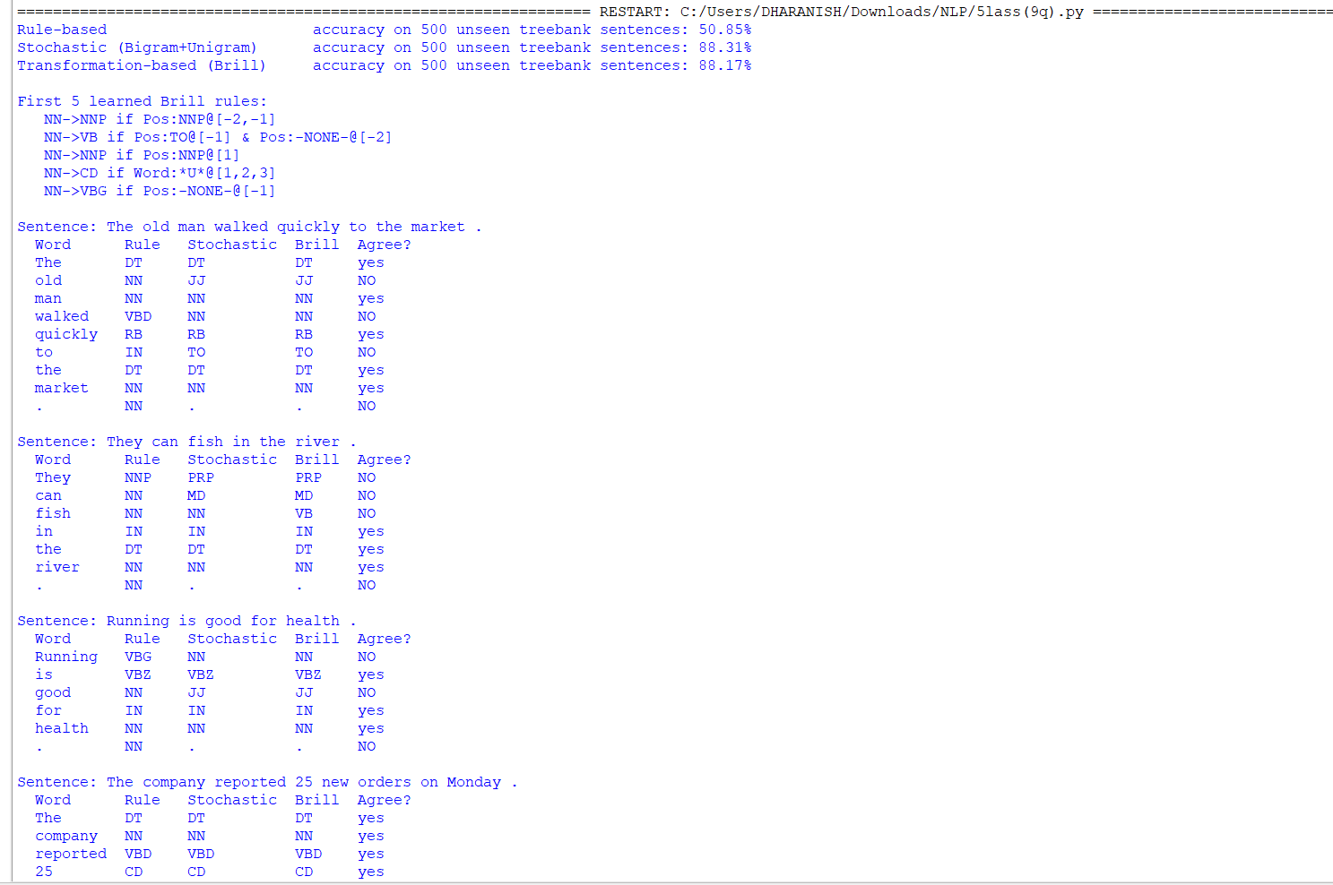

5. Analysis and Interpretation
- Accuracy on 500 unseen sentences: rule-based 50.85%, stochastic 88.31%, Brill 88.06%. The rule-based tagger is far weaker because a few regular expressions cannot cover English vocabulary; the two trained taggers are comparable.
- Disagreements: 'walked' (rule: VBD, others: NN) shows a case where a suffix rule beats the trained taggers because 'walked' was unseen in training. 'can' is NN in the rule tagger but MD in the trained ones; 'fish' is NN or VB depending on the model; 'good' is NN under the default rule but JJ in the trained taggers.
- Common-word cases are tagged identically by all three (the, market, in, is, reported, on, Monday). The rule tagger also tags the full stop as NN, since no punctuation rule was defined.
- Brill's learned rules, e.g. NN->VB if the previous tag is TO, correct systematic errors of the initial tagger and give an interpretable advantage ('fish' becomes VB in 'can fish').
- Conclusion: stochastic and transformation-based taggers should be preferred for accuracy; rule-based taggers are useful for transparency, rapid prototyping and low-resource settings, or as a first pass before a learned model.

Summary of Questions
Question | Major Concept | BTL Level | Marks
1 | Regular Expressions | 3 | 10
2 | Finite State Automata | 3 | 10
3 | Morphological Analysis | 4 | 10
4 | Inflectional and Derivational Morphology | 3 | 10
5 | Porter Stemmer | 4 | 10
6 | N-gram Models | 3 | 10
7 | Word Counting and Smoothing | 3 | 10
8 | Entropy | 4 | 10
9 | POS Tagging | 3 | 10
10 | POS Tagging Techniques | 4 | 10

Evaluation Rubric (10 Marks per Assignment)
Evaluation Criteria | Marks
Understanding of the NLP concept | 2
Python implementation and logic | 3
Correctness of output | 2
Analysis and interpretation of results | 2
Code readability and documentation | 1
Total | 10

Approval and Signatures
Student Signature: | S.Dharanish
Date: | 05-11-2026
Faculty / Evaluator Signature:
Remarks / Approval:

(To be completed by the concerned faculty / evaluator. Marks and signatures are intentionally left blank.)

