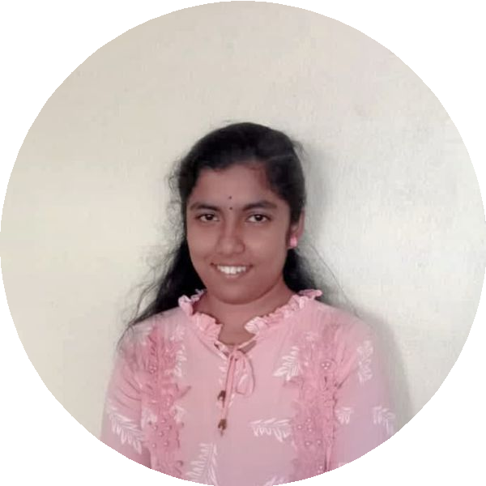
DHARANI SRINIVASAN
Web Developer | UI/UX Designer | Aspiring Full-Stack Developer
​ 9943260551 @ dharanisrinivasan1234@gmail.com
​ https://linfiedin.com/in/dharani-srinivasan-8399892a4/

SUMMARY
I am a motivated Web Developer with strong expertise in HTML, CSS,

SKILLS
Gmail GitHub HTML CSS

JavaScript, and UI/UX design. My experience includes a Full Stack
Development internship where I honed my technical skills and

collaborative abilities. Passionate about building dynamic web applications and continuously learning new technologies, I am eager to develop my full-stack skills further

EXPERIENCE

Full Stack Development Intern

WSPL Hosting Solution (OPC) Pvt Ltd
09/2025 - 10/2025
Internship focused on full stack development
- Hands-on frontend development using HTML, CSS, and JavaScript
- Worked on real-time project workflows with team collaboration
- Demonstrated strong problem-solving skills and learning mindset

EDUCATION

B.E. Computer Science Engineering

SSM College of Engineering

LANGUAGES
JavaScript Python Figma
Microsoft Power BI Canva

PROJECTS

Various Projects
Various web development projects demonstrating skills in HTML, CSS, JavaScript, and UI/UX design
- Developed a calculator app using HTML, CSS, and JavaScript
- Created a mini dictionary utilizing JavaScript and DOM manipulation
- Built a responsive to-do list task manager
- Designed an interactive music player app with media controls
- Implemented a unit converter for multi-unit conversions
- Designed an SOS app UI/UX in Figma

Tamil
Native

Japanese
Intermediate

English
Proficient

INTERESTS

​ Hobbies G Interests
Enjoys listening to music, reading books, and learning new technologies

