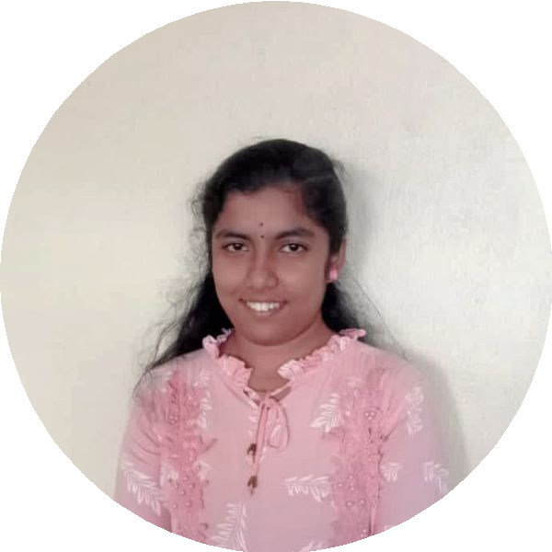
DHARANI SRINIVASAN
Web Developer | UI/UX Designer | Aspiring Full-Stack Developer
​ 9943260551 @ dharanisrinivasan1234@gmail.com
​ https://linfiedin.com/in/dharani-srinivasan-8399892a4/

SUMMARY
I am a motivated Web Developer with strong expertise in HTML, CSS,

SKILLS
Gmail GitHub HTML CSS

JavaScript, and UI/UX design. My experience includes a Full Stack
Development internship where I honed my technical skills and

collaborative abilities. Passionate about building dynamic web applications and continuously learning new technologies, I am eager to develop my full-stack skills further

EXPERIENCE

Full Stack Development Intern

WSPL Hosting Solution (OPC) Pvt Ltd
09/2025 - 10/2025
Internship focused on full stack development
- Hands-on frontend development using HTML, CSS, and JavaScript
- Worked on real-time project workflows with team collaboration
- Demonstrated strong problem-solving skills and learning mindset

EDUCATION

B.E. Computer Science Engineering

SSM College of Engineering
08/2023

LANGUAGES
JavaScript Python Figma
Microsoft Power BI Canva

PROJECTS

Various Projects
Various web development projects demonstrating skills in HTML, CSS, JavaScript, and UI/UX design
- Developed a calculator app using HTML, CSS, and JavaScript
- Created a mini dictionary utilizing JavaScript and DOM manipulation
- Built a responsive to-do list task manager
- Designed an interactive music player app with media controls
- Implemented a unit converter for multi-unit conversions
- Designed an SOS app UI/UX in Figma

Tamil
Native

Japanese
Intermediate

English
Proficient

INTERESTS

​ Hobbies G Interests
Enjoys listening to music, reading books, and learning new technologies

