The Giant Panda

The giant panda, which only lives in China outside of captivity, has captured the hearts of people of all ages across the globe. From their furry black and white bodies to their shy and docile nature, they are considered one of the world's most loved animals.

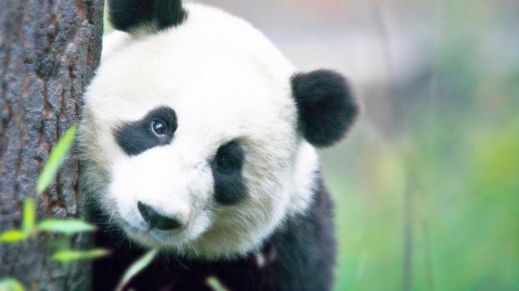

**Quick Fact** The estimated number of giant pandas in the wild varies between 1,500 and 3,000.

|  |  |
| --- | --- |
| **Bear** | **Red Panda** |
| Shape | Diet |
| Size | Paws |
| Shaggy fur | Eyes |
| Gait | Nose and teeth |

### Cat-like features

While the body of a giant panda looks like that of a bear and the dark circles around its eyes resemble those of a red panda or raccoon, its pupils have vertical slits like the eyes of a cat. Because of their unusual eyes, a popular Chinese name for panda is ‘big bear cat’ or大‍熊‍貓 /dà xióng māo, pronounced as dah-sshyong-maow.

### DNA results

DNA analysis has put one mystery to rest. It has revealed that while the red panda is a distant relation, the giant panda's closest relative is the spectacled bear from South America.

# Intriguing Giant Panda Mysteries

While most adore their fluffy fur and round heads, which help give them their cuddly bear quality, others are fascinated by the many mysteries of the giant panda. Did you know that the giant panda may actually be a raccoon, they have an opposable pseudo thumb, and that they’re technically a carnivore even though their diet is primarily vegetarian? These things and more have baffled scientists and naturalists for hundreds of years.

## Opposable Pseudo Thumb

A characteristic of the giant panda that has mystified scientists is their movable, elongated wrist bone that acts like an opposable thumb. This human-like quality that helps give them even more of a cuddly-bear appearance enables the giant panda to pick up objects and even eat sitting up.

**Quick Fact** Giant pandas have five clawed toes and one pseudo thumb.

Their pseudo thumb, along with pads of skin, help the giant panda strip the more nutritious small bamboo shoots and leaves while holding the stalk in their mouth.

## Small Bear or Large Raccoon?

Giant pandas are generally referred to as bears and are typically called panda bears rather than giant pandas. Though we may think they look like bears, there has been a great deal of discussion for decades about where giant pandas fit in the animal kingdom. Much of the debate has been whether they are more closely related to the red panda, once thought to be a member of the raccoon family, than the bear family.

While a giant panda has a body that resembles a small bear and climbs trees like a bear, it also has several characteristics in common with the red panda. For example, both giant pandas and red pandas eat bamboo and have the same pseudo thumb. The table below lists the main characteristics the giant panda shares with bears and red pandas.

## Mostly Vegetarian Diet

Giant pandas love bamboo! In fact, their diet is 99% bamboo. Along with bamboo, they eat other plants, small rodents, and occasionally fish. The mystery behind their diet is they have the digestive system of a carnivore.

Their ability to digest bamboo is attributed to tiny microbes that live within their digestive system. As they can only digest about 20% of what they eat, the average giant panda consumes around 14 kilograms (30 pounds) of bamboo a day. In comparison, humans eat about 2 kilograms (5 pounds) of food a day. This enormous diet means the giant panda spends more than 12 hours a day eating to stay nourished.

**Quick Fact** As the seasons change, the giant panda prefers different species and parts of bamboo.

## Tiny Cubs

An infant giant panda cub is about the size of a croissant, weighs less than a teacup and is about 900 times smaller than its mother. An average adult mother weighs around 91 kilograms (200 pounds) while newborn weighs only 83 to 190 grams (3 to 4 ounces).

# Other Fun Giant Panda Facts

* Researchers have recently discovered that the gene responsible for tasting savory or umami flavors, such as meat, is inactive in giant pandas.
* For many centuries, giant pandas were thought to be a mythical creature, like a dragon or unicorn.
* Unlike other bears in the region, giant pandas don’t hibernate.
* Giant pandas can stand erect on their hind legs but rarely walk.
* The Qinling panda, another giant panda species with a dark brown and light brown coat, lives only in the mountains of Shaanxi.
* Giant pandas have very sensitive hearing and smell, but they have poor eyesight.
* A newborn giant panda is blind and looks like a tiny, pink, hairless mouse.