Machine Learning – R/Python _ Mini Projects / POC

POC 1:

Source data : Crime.csv

The crime data contain the overall crime rate, and other information for each of fifty (n = 50) cities for past 2 years (2016-2017). One objective of the study is to model the crime rate (Y ) based on other predictor variables (X 1 –X 5 ). A short variable description is given below.

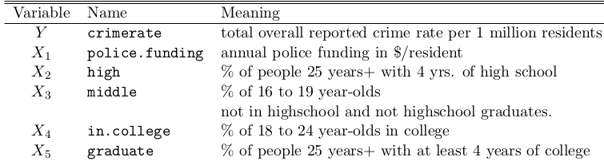
X6 City City name

1. Use the best subset selection procedure to find your best linear regression model.

Note: Train the model using 70% of the given the data set and test the model using the remaining 30% data set.

