Machine Learning – R /Python_ Mini Projects / POC

POC 2:

Source data : users and Tweets files in Tweete input data folder

For every tweet, the following
information is maintained.
● Text of the tweet.
● Screen name of user who tweeted.
● Follower Count of the user.

This data is stored locally on files. Each such file contain 10000 tweets

Cleaning:

Write a custom R/Python application TweetCleaner takes each of the above mentioned files as input and for every line (tweet) therein, removes punctuations , stop words and extra spaces.

Stop words: is, the, a, an, you, I, me, she, he, his, her, it, was, ...etc... ( like this and other articles and pronouns)

Requirements:

1. Write the R application to do the word count operation (number of times , each word is present)
to find out the most trending words, hashtags and mentions.

Sample output:

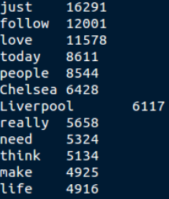

2. Form a word cloud of top 20 trending words as shown below,

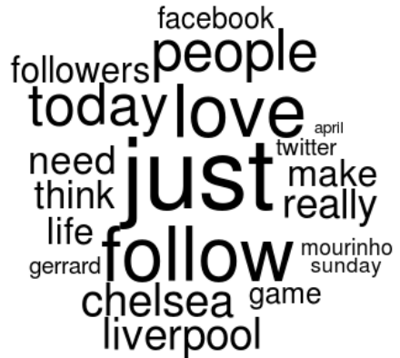

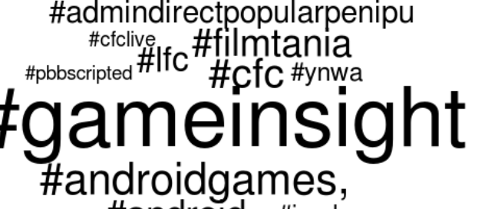
3. Form a word cloud of top 20 trending hashtags as shown below,

Requirement 2 : Kmeans Clustering:

Requirement Specification:

We are required to cluster the tweeters based on the number of followers they have, into three sets . In a real world scenario, this information may be used by advertising agencies.

+++++++++++++++++++++++++++++++++++++++++++++++++++++++++++++++++++++++

