

Operations Support Manual

|  |  |
| --- | --- |
| Service Name: | *Technical Reporting Solution* |
| Teams Involved: | *Team 1*  *Team 2* |
| Document Status: | *DRAFT* |
| Document Version: | *1.0* |
| Date: | *Dec 2014* |

# Control

## Document Owner

| Service |  |
| --- | --- |
| **Document Owner** | <ASM> |
| **Issue** |  |
| **Issue Date** |  |
| **Author** |  |

## Document Location

*URL where this document is stored. To be completed by the ASM once handed over*

## Document History

|  |  |  |  |
| --- | --- | --- | --- |
| Author | Date | Version | Comment |
|  |  |  |  |

## Document Review & Sign-off

| Name | BU / Organisation | Role | Version signed-off | Review/Sign Off* |
| --- | --- | --- | --- | --- |
|  |  |  |  | Review and Sign-Off |

1 Control 2

1.1 Document Owner 2

1.2 Document Location 2

1.3 Document History 2

1.4 Document Review & Sign-off 3

1.5 Bibliography 5

1.6 Table of acronyms 5

1.7 Standard Concepts 5

1.8 Terminology 5

1.9 Further reading 5

1.10 Application Support Requirements 5

2 System Overview and Architecture 6

2.1 System Overview and Purpose 6

2.2 System Description 6

Batch generation of reports 6

User access to reports 10

2.3 System Owners 10

2.4 Interfaces (new or existing) 10

2.5 System Topology Map 10

3 Specification – Physical 13

4 Specification - Software 14

4.1 Application Summary 14

4.2 Software Installation & Distribution 14

4.3 Start-up and shut-down procedures 15

5 Specifications - Databases 16

5.1 Database descriptions 16

5.2 Backup and Restore 16

5.3 Database Data Maintenance 16

5.4 Interface Design 16

5.5 Scheduled Import 16

5.6 Product Import 16

6 Service Desk Support Tasks 17

6.1 Service Desk Contact Details 17

6.2 First Line Fixes 17

6.3 Known Errors 17

6.4 User Admin 17

6.5 Incident Logging 17

7 Release Management – 18

8 2nd/3rd Line Support Tasks 19

8.1 2nd/3rd Line Support Teams Contacts 19

8.2 Control-M – Scheduling 19

8.3 Reboot / restart maintenance tasks 19

8.4 Message Queue Management 19

8.5 Service Checks 19

8.6 Additional maintenance tasks 19

9 Monitoring and Alerting 20

9.1 Monitoring batch processing 20

Batch Logging 20

*9.2* Security 24

9.3 Network Security 24

9.4 Solution Security 24

10 Disaster Recovery and Failover Information. 25

11 Appendix A 26

## Bibliography

|  |  |  |  |
| --- | --- | --- | --- |
| **Reference** | **Document Name** | **Description** | **Sharepoint Location** |
|  |  |  |  |
|  |  |  |  |
|  |  |  |  |
|  |  |  |  |
|  |  |  |  |
|  |  |  |  |

## Table of acronyms

|  |  |
| --- | --- |
| **Acronym** | **Description** |
| MP/ EP | Merchandise Planning/ Enterprise Planning |
| BRD | Business Requirements Definition |
| HLD | High Level Design |
| EKB | Enterprise Knowledge Base |
| PSU | Planning Structure Update |
| PSE | Planning Structure Engine |
| EPSAW | Enterprise Planning Server Administrator Workbench |
| EKBCS | Enterprise Knowledge Base Configuration Service |

## Standard Concepts

There are no standard concepts used in this document

## Terminology

## Further reading

## Application Support Requirements

The checklist attached is a requirement from the support teams for taking on new projects from the development teams. The information in this document is also included in the Service Acceptance criteria. This document can be used as a guide if necessary.

# System Overview and Architecture

## System Overview and Purpose

The MP Tactical Reporting Solution was initiated as a result of delays to the delivery of MP Strategic reporting, to allow EP range forecast functionality to be rolled out to the business for the SS15 super season. It is a short term solution to provide the operational reporting required by the business.

It will provide a pre-defined set of weekly reports that primarily supports in-season planning within the GM business. These reports are created weekly (Sunday night/Monday morning) as excel files and stored in a secure central location for the business to collect. Data is sourced solely from the core Enterprise Planning(EP) system and as such is limited to the data available in EP at time of report creation.

## System Description

## Batch generation of reports

### Logical View

The diagram below shows a logical view of the Tactical Report Generation System and its primary interactions with other systems. The process is controlled by a Batch Orchestration component, which provides and integration point for ControlM scheduling, provides a wrapper for the Report Generator (excel/VBA) and is also responsible for implementing requirements outside of the report generation (for example temporary file clean up).

The Report Generator gets the Report Payload (list of reports to generate) from a file specified by the Batch Orchestration Component.

For each report in its payload it retrieves data from the CORE JDA EP system view a PA View (a standard mechanism provided by the EP System for retrieving data) which integrates with the EP Mid-Tier. It then processes this data to populate pre-defined reports and store them in a defined location.



### Scaling Tactical Reporting Solution

To allow the reports to be generated within the available time-window the tactical reporting solution needed to allow for scale horizontally, allowing multiple Report Generators to run in parallel. This will be done within the constraint of only 1 report generator running on each server.

This meant that whilst reports may be generated on multiple servers that a single, central location for reports output would be needed that allows the users to access all reports in one place.

To allow this the report generator will output reports defined in its payload locally and the Batch Orchestration Component will be responsible for copying these reports to the central location.

### Prioritisation of Reports

The report scope can be split into 2 levels of priority

* High Priority reports (must have Monday morning)
* Low Priority reports

The design is for both sets of reports to be run prior to 7am on Monday morning but High Priority Reports will be run first. If the time window is exceeded then Low Priority Reports will not run in this window and will be initiated manually at a suitable time.

To support this, the report payload will be split into 2. The batch orchestration component will be parameterised to either run high or low priority reports and will be triggered twice from control, once for high priority and once for low priority. There are 2 significant differences in running in high priority or low priority. Firstly it will determine the report payload for the report generator; secondly when running high priority reports it assumes that it needs to clear-down temporary files (i.e. the reports that have been generated locally).

The report payloads are stored in 2 excel files

* ControlFile.xslm : high priority reports
* Low-ControlFile.xslm : low priority reports

### Integration with control M

ControlM will be used to initiate and control the batch processing, taking into account the need for prioritisation and scaling.

The process can be seen [TRS Batch Orchestration](https://mnscorp.sharepoint.com/sites/GM4ProgrammeTeamsite/02_MP/03%20Detailed%20Design/06%20Reporting/01%20Requirements/Plan%20B/Solution%20Outline/TRS%20Batch%20Orchestration.vsd) document.

### Understanding Control Files

Primarily the control files specify the report payload for the report generator on a server and record progress of report generation. They can also be used to manually run report generation (i.e. not via batch). In production 2 control files will be deployed on each server (one for high priority and one for low priority). These files will be specific to each server, as they will have that server’s pre-determined report payload.

The Control File is an excel spreadsheet and the Control tab within the workbook is used by the report generator to determine which reports are required and defines the relevant information needed to generate the report.

The control tab is split into 2 sections.

The header section defined global values required by the report generator, see below. This not be changed after deployment as it is used to specify how Tactical Reports have been deployed in an environment. It also contains the “Manual” button, which if clicked will run report generation manually and generate reports based on the main section (see below)

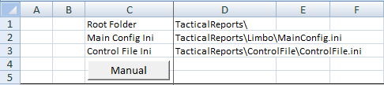

* Root Folder – relative location of where the TacticalReport suite has been stored
* Main Config ini – relative location of the EP config file
* Control File ini – relative location of the ini file associated with the ControlFile spreadsheet.

The ControlFile.ini referenced in the headers contains three settings:  
a) A flag to set logging levels (Yes for full, No for errors only)  
b) Finished – this is set by the macro and is used to indicate the success or failure of the report generation process  
c) AutoRun – this defines the macro which should be run when the spreadsheet is opened – normally this would be set to LaunchApp but it can be blanked to enable the spreadsheet to be opened for debugging or a manual run.

The main section of the control file specifies which reports should be created and the information that is need for each report by the report generator.

|  |  |  |
| --- | --- | --- |
| Column Name | Description | Allowed values |
| Auto | This is used to control which reports are run as part of automatic batch execution. If a row contains a ** **the report generator will create a report for that row. | ** **Or blank |
| Manual | This is used to control which reports are run as part of manual execution. If a row contains a ** **the report generator will create a report for that row. | ** **Or blank |
| Report Name | This defines the type of report to be generated for that row. They are a set of “well known” values that the report generator will use to determine the logic to apply to the generation. | |  | | --- | | MNSCom | | OTBMA | | OTBMB | | OTBMC | | MMTA | | MMTB | | MMTC | | RRSA | | RRSB | | RRSC | |
| Report Description | Report description used in headers, etc |  |
| Data Loaded | Indicator that the Data Load step has been completed during report generation |  |
| Report Created | Indicator that the report has been created during report generation |  |
| Report Distributed | Indicator that the report has been saved during report generation. (Note: this does not indicate that it has been copied to the central location) |  |
| Severity | Determines what error level be reported if this report is not generated. E for error and W for warning. | E or W |
| PA View Folder | The location of the PA View relative to the root folder defined in the header. | Note: trailing “\” is required |
| Season | The super season that the report is executed for |  |
| Plan Name | Plan Name |  |
| Module Name | Module Name |  |
| View Folder | Folder containing the scoping view, relative to the root folder |  |
| View Name | Name of the scoping view to be applied |  |
| Export | Defines whether data should be processed using an export process. | Note: all reports should use the mechanism at this point. |
| Export Folder | Name of the folder where the data will be exported to, relative to the root folder |  |
| Export Name | Name of the file created as part of the export. |  |
| Template Folder | The location of the template, relative to the root folder |  |
| Template Name | Name of the template to be applied to the report |  |
| Measures | ?? |  |
| Versions | The version of measure to be used | **Need list** |
| Time Group | Comma separated list of time groups be applied | **Need list** |
| Time Members |  |  |
| Product Group | The level of the product hierarchy that are relevant to report (as a comma separated list) | **Need list** |
| Product Members | The ID of the highest level product (e.g. if BU to Department then would be the ID of the BU) |  |
| Location Group | The location groups that should be included in the report |  |
| Location Members | The location groups that should be included in the report |  |
| Destination Folder | The folder where the report will be stored prior to copying to the central location |  |
| Destination Name | Name of the report (note: this is the root name – dates, etc will be added to ensure it is unique |  |
| Processing Summary | Indicates the overall status of the report generation. |  |

## User access to reports

Users will access the central location that reports are outputted to as a file-share, meaning that they will be able to user a standard file explorer to access their reports. The central location will be published to end users on the GM Portal.

Read-only access to the file-share and underlying folders (and therefore reports) will be controlled using active-directory permissions. This solution will re-use existing AD Groups set up for MP Strategic Reporting.

## System Owners

## Interfaces (new or existing)

No new interfaces will be created as part of this solution.

## System Topology Map

The tactical reporting solution will use the existing EP infrastructure to run. The diagram below is taken from the MP Infrastructure DLD. The tactical reporting solution will be deployed on the “Admin Client + Batch Processing” Servers shown below. This means that report generation will be scaled out over those 12 servers. Each of these will access the CORE EP System on the primary server (which may scale traffic over the secondary servers).

The central report output location will be located on Secondary 1 (to minimise traffic to primary server).

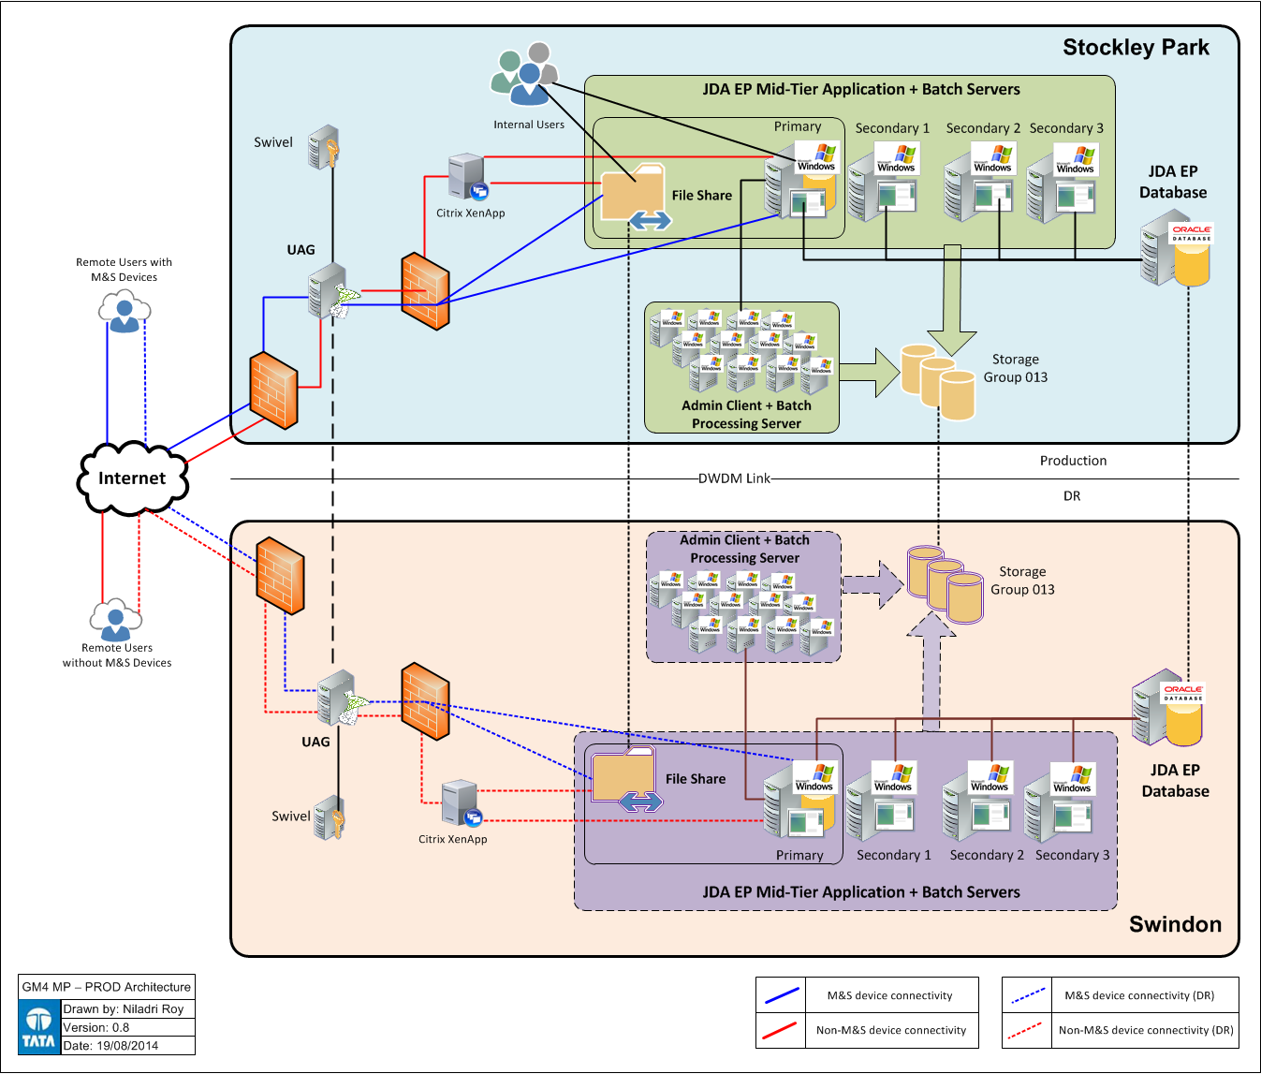

By co-locating on the existing MP Infrastructure it means that the solution will be covered by MPs DR and backup processes.

# Specification – Physical

There are no changes to physical infrastructure as a result of deployment of the tactical reporting solution. (Note: may need to update after PT if additional hard disk space is required).

A file-share will be created on Secondary 1 Server to provide access to reports; access will be controlled by active-directory groups.

Existing Y-Accounts (currently set up for EP Batch) will be used to execute batch processing. These account will require access to file-share to manipulate report outputs (create, change, delete). These accounts will also need access to the primary EP Server (this will already be set up as part of EP Batch processing).

# Specification - Software

## Application Summary

### Tactical Report Generation System

The tactical report generation system will be installed on all “Admin Client + Batch Processing” Servers.

The components installed are detailed in the xxxxx (support doc being written).

Batch Orchestration Component

In order to be installed and execute the following pre-requisites are needed.

* Excel 2007
* EP Client Install (already installed on target servers).

### ControlM components

The TRS batch is incorporated within the generic MP Batch schedule. The following jobs have been added to process tactical reporting

* TBD

### Report distribution element

A folder structure will be deployed onto EP secondary server 1, which will act as the repository for reports allowing users to access them. The folder structure will be pre-defined with Active Directory permissions applied to limit access based on user’s profile.

A simple link will be added to the GM Portal to provide access to end users.

## Software Installation & Distribution

### Server Installation

### Client Installation

No changes to end users’ devices are required. To access they will require appropriate active directory groups to be added to their profiles.

## Start-up and shut-down procedures

# Specifications - Databases

## Database descriptions

There is no specific database install for the tactical reporting solution. It will integrate with the EP System EKB database via the EP Primary Server.

## Backup and Restore

No specific database backup and restore process is required.

## Database Data Maintenance

No specific database data maintenance process is required.

## Interface Design

No specific database interface is required, the data is provided via standard EP mid-tier functionality via PA Views.

## Scheduled Import

N/A

## Product Import

N/A

* 1. **Master Data Maintenance :-**

The reporting config (which reflects BU->Department Master Data) should be aligned with the core EP master data.

If major restructures occur then the report configuration would have to reflect

* Creation of new departments
* Removal of departments
* Moving departments between BUs

# Service Desk Support Tasks

## Service Desk Contact Details

## First Line Fixes

Only first line fixes will be related to access (see User Admin)

## Known Errors

None

## User Admin

The only specific user admin required for Tactical Reporting is assignment of Relevant Active Directory Groups (see 9.3). As this utilises the groups for MP Strategic Reporting the majority of users will have been set up.

A small group of users that require access but have not been set up for MP Strategic Reporting have been identified and will be set up as part of cutover.

BAU process will follow that of MP Strategic Reporting for new users.

## Incident Logging

Incident logging will be incorporated in the standard EP Process.

# Release Management –

All source code is stored in SVN at the following location:

<https://mshsvn/GM/JDA/EnterprisePlanning/trunk/TacticalReportingSolution>

# 2nd/3rd Line Support Tasks

## 2nd/3rd Line Support Teams Contacts

## Control-M – Scheduling

### Sunday Schedule

The batch jobs for tactical reporting will follow EP batch processing on Sunday Night/Monday Morning.

## Reboot / restart maintenance tasks

N/A – covered by EP

## Message Queue Management

N/A

## Service Checks

TBC

## Additional maintenance tasks

### Run Archiving Job for report repository

<description of how to run>

### Monitor hard Disk usage across server estate

Hard Disk memory usage should be monitored across the following locations

* Secondary 1 Server File Share (tactical reporting repository)
  + We would expect this to increase as reports are generated over time.
  + There is a batch job which will archive (compress) historic reports older than 1 month (see above)
* Each “Admin Client + Batch Processing” server where the tactical reporting software is installed.
  + There will be an initial increase as logs are created.
  + This will level out with some variation depending on log size.
* Each “Admin Client + Batch Processing” server where the temporary report output is specified.
  + This will increase following first run (the reports will stay in this temporary location until the next batch run)

# Monitoring and Alerting

## Monitoring batch processing

### Control-M Alerting

The batch orchestration components will return completion codes to control-M

0 – Success

1 – Error/Failure

3 – Warning

The control-M jobs will interpret these codes and raise appropriate alerts via standard M&S mechanisms to the support team.

Control-M jobs will also be configured for late running/late starting alerting where appropriate.

Full details of control-M alerting for the Tactical Reporting Jobs can be found in the MP AMS.

Where alert are raised from Control-M these will indicate that an issue has occurred whilst running that job, production support will need to analyse the issue directly on the server, see section xxx

## Batch Logging

Each component within the Tactical Reporting Solution will log errors.

The components within Batch Orchestration will log errors to

D:\Batch\Logs

The report generation component log errors to a file in the install directory.

### Support activity

As part of managing/monitoring the tactical report generation process, production support may need to understand what is happening on one of the servers to ensure smooth operation or respond to an alert. This section should answer some of the common questions they may ask and provide instructions to perform common actions.

#### How do we know if Report Generation is processing?

#### How do I understand what reports have been generated and whether there are issues?

#### How do I interrupt Report Generation if it is processing and we need to stop it?

#### How can I restart report generation if it has failed mid-processing?

#### How can I re-run report generation for reports that have failed?

If control-M reports a warning or error on a server then we will need to investigate what has failed on the server.

If you log in to the server you can review the ControlFile to determine which reports have succeeded / failed. In the example below all reports would have been included in the automatic batch, but OTBMB, OTBMC, MMTB and RRSB have not completed (they do not have ticks in the “Data Loaded”, Report Created, Report Distributed Column.

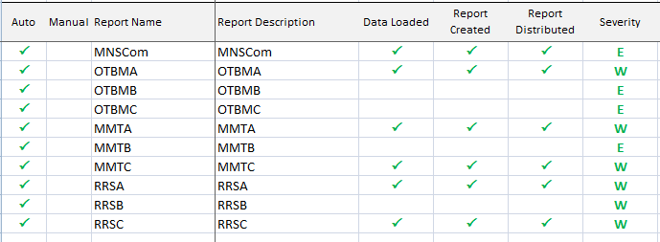

The simplest way to attempt to run these again is to try and run it manually for these reports. To do this you will need to add ticks into the “Manual” column and then click on the “Manual” button. See example below. (Note: this can be done on this server or copied to another and run it there, if you believe there is an issue with this server).

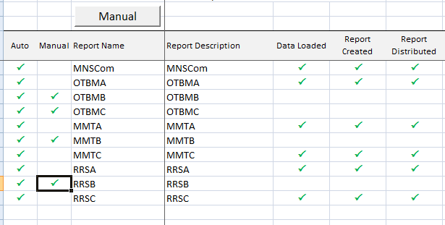

If this does not work then a lower level of investigation will be required to diagnose the issue. You will need to review the available logs to determine the issue.

#### What should we do if one or more of the reports servers is not operational?

In the event of a planned outage for a server, this server’s report payload will need to be manually distributed across the operational servers. Reports can be added to another server’s payload by adding a “tick” to the Auto column. It is intended that each server will have a full list of reports, with the Auto column ticked for the reports it will have to process. This will make it easier to re-distribute load.

Once the non-operational server is returned then we will need to untick the relevant reports from other servers.

# Security

## Network Security

Access to reports will be controlled by Active Directory Groups. The root share and each folder in the centralised report repository will have specific permissions applied based on these activity directory group to allow users read-only access to these groups

The following active group are applicable :-

* IT APP BO MP MENSWEAR USERS
* IT APP BO MP WOMENSWEAR USERS
* IT APP BO MP CHILDRENSWEAR USERS
* IT APP BO MP BEAUTY USERS
* IT APP BO MP LINGERIE USERS
* IT APP BO MP HOME USERS
* IT APP BO MP MENSWEAR PLANNERS
* IT APP BO MP WOMENSWEAR PLANNERS
* IT APP BO MP CHILDRENSWEAR PLANNERS
* IT APP BO MP BEAUTY PLANNERS
* IT APP BO MP LINGERIE PLANNERS
* IT APP BO MP HOME PLANNERS
* IT APP BO MP ECOM USERS
* IT APP BO MP CENTRAL PLANNERS
* IT APP BO MP FINANCE USERS

The embedded spreadsheet shows the design against the directories.



## Solution Security

N/A

# Disaster Recovery and Failover Information.

Disaster recovery process is covered by standard EP process.

There are no automatic fail-over within the solution. Manual steps for failure scenarios are in monitoring and alerting section.

# Appendix A

*This appendix should contain all links to forms and or procedures in support of the solution.*