Assignment 3 : Internship Portal

PROJECT DESCRIPTION

Internship Portal is a modern, responsive web application designed to showcase various internship opportunities in a visually appealing and user-friendly interface. The portal enables students to explore different internship programs, view essential details such as duration, location, stipend, and start date, and access additional information through interactive buttons. Built using HTML and CSS, the project emphasizes responsive design, intuitive navigation, and an engaging user experience while demonstrating modern web design principles.

KEY FEATURES

- Modern and responsive user interface.
- Attractive glassmorphism-inspired card design
- Mobile-friendly and fully responsive layout
- Displays multiple internship categories
- Detailed internship information
- Search bar for internship exploration (UI)
- Statistics section highlighting opportunities
- Internship ratings and skill badges
- Interactive hover effects and animations
- Functional "View Details" buttons
- Professional icons using Font Awesome
- Gradient backgrounds and modern color palette
- Smooth transitions and user-friendly design

TECHNOLOGIES USED

Frontend

- HTML5
- CSS3

Libraries

- Font Awesome (Icons)
- Google Fonts (Poppins)

Web design techniques

- Flexbox
- CSS Grid
- Glassmorphism UI
- CSS Gradients
- CSS Animations
- CSS Transitions
- Responsive Web Design
- Media Queries

OUTPUT

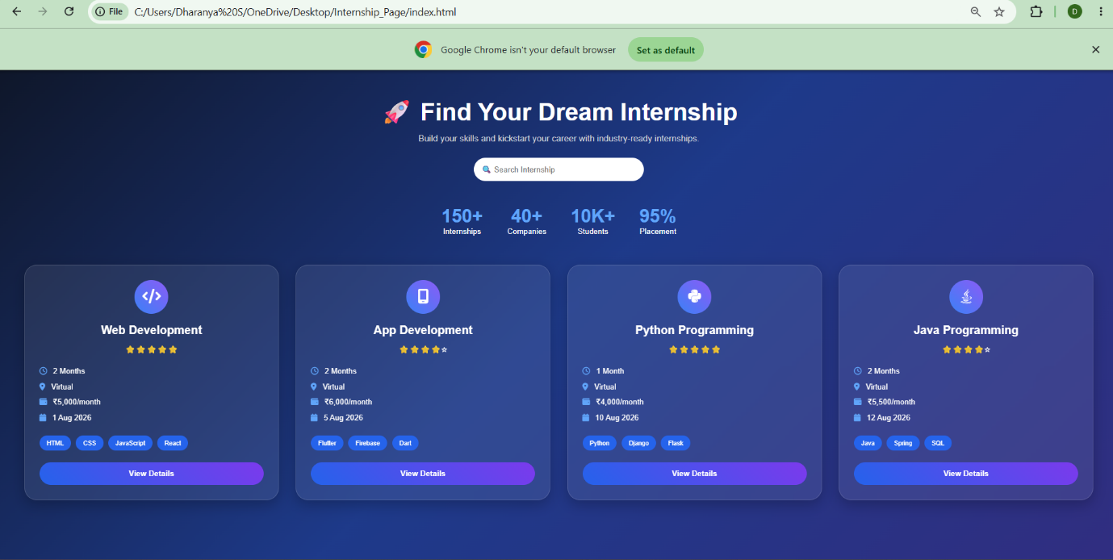

index.html

<!DOCTYPE html>
<html lang="en">
<head>
<meta charset="UTF-8">
<meta name="viewport" content="width=device-width, initial-scale=1.0">
<title>Internship Portal</title>

<link rel="stylesheet" href="style.css">

<link rel="stylesheet"
href="https://cdnjs.cloudflare.com/ajax/libs/font-awesome/6.5.2/css/all.min.css">

</head>

<body>

<div class="hero">

<h1>🚀 Find Your Dream Internship</h1>

<p>Build your skills and kickstart your career with industry-ready internships.</p>

<input type="text" placeholder="🔍 Search Internship">

</div>

<div class="stats">

<div>
<h2>150+</h2>
<p>Internships</p>
</div>

<div>
<h2>40+</h2>
<p>Companies</p>
</div>

<div>
<h2>10K+</h2>
<p>Students</p>
</div>

<div>
<h2>95%</h2>
<p>Placement</p>
</div>

</div>

<section class="cards">

<div class="card">

<div class="icon">
<i class="fa-solid fa-code"></i>
</div>

<h2>Web Development</h2>

<div class="rating">
⭐⭐⭐⭐⭐
</div>

<ul>

<li><i class="fa-regular fa-clock"></i> 2 Months</li>

<li><i class="fa-solid fa-location-dot"></i> Virtual</li>

<li><i class="fa-solid fa-wallet"></i> ₹5,000/month</li>

<li><i class="fa-solid fa-calendar"></i> 1 Aug 2026</li>

</ul>

<div class="skills">

<span>HTML</span>

<span>CSS</span>

<span>JavaScript</span>

<span>React</span>

</div>

<a href="https://vaultofcodes.in/" target="_blank">
View Details
</a>

</div>

<div class="card">

<div class="icon">
<i class="fa-solid fa-mobile-screen"></i>
</div>

<h2>App Development</h2>

<div class="rating">
⭐⭐⭐⭐☆
</div>

<ul>

<li><i class="fa-regular fa-clock"></i> 2 Months</li>

<li><i class="fa-solid fa-location-dot"></i> Virtual</li>

<li><i class="fa-solid fa-wallet"></i> ₹6,000/month</li>

<li><i class="fa-solid fa-calendar"></i> 5 Aug 2026</li>

</ul>

<div class="skills">

<span>Flutter</span>

<span>Firebase</span>

<span>Dart</span>

</div>

<a href="https://vaultofcodes.in/" target="_blank">
View Details
</a>

</div>

<div class="card">

<div class="icon">
<i class="fa-brands fa-python"></i>
</div>

<h2>Python Programming</h2>

<div class="rating">
⭐⭐⭐⭐⭐
</div>

<ul>

<li><i class="fa-regular fa-clock"></i> 1 Month</li>

<li><i class="fa-solid fa-location-dot"></i> Virtual</li>

<li><i class="fa-solid fa-wallet"></i> ₹4,000/month</li>

<li><i class="fa-solid fa-calendar"></i> 10 Aug 2026</li>

</ul>

<div class="skills">

<span>Python</span>

<span>Django</span>

<span>Flask</span>

</div>

<a href="https://vaultofcodes.in/" target="_blank">
View Details
</a>

</div>

<div class="card">

<div class="icon">
<i class="fa-brands fa-java"></i>
</div>

<h2>Java Programming</h2>

<div class="rating">
⭐⭐⭐⭐☆
</div>

<ul>

<li><i class="fa-regular fa-clock"></i> 2 Months</li>

<li><i class="fa-solid fa-location-dot"></i> Virtual</li>

<li><i class="fa-solid fa-wallet"></i> ₹5,500/month</li>

<li><i class="fa-solid fa-calendar"></i> 12 Aug 2026</li>

</ul>

<div class="skills">

<span>Java</span>

<span>Spring</span>

<span>SQL</span>

</div>

<a href="https://vaultofcodes.in/" target="_blank">
View Details
</a>

</div>

</section>

</body>
</html>

Style.css

*{
margin:0;
padding:0;
box-sizing:border-box;
font-family:'Poppins',sans-serif;
}

body{

background:linear-gradient(135deg,#0f172a,#1e3a8a,#312e81);

min-height:100vh;

color:white;

padding:50px;

}

.hero{

text-align:center;

margin-bottom:50px;

}

.hero h1{

font-size:50px;

margin-bottom:15px;

}

.hero p{

color:#d1d5db;

margin-bottom:30px;

font-size:18px;

}

.hero input{

width:350px;

max-width:90%;

padding:15px;

border:none;

outline:none;

border-radius:50px;

font-size:16px;

}

.stats{

display:flex;

justify-content:center;

gap:50px;

margin-bottom:60px;

flex-wrap:wrap;

}

.stats div{

text-align:center;

}

.stats h2{

font-size:38px;

color:#60a5fa;

}

.cards{

display:grid;

grid-template-columns:repeat(auto-fit,minmax(300px,1fr));

gap:35px;

}

.card{

background:rgba(255,255,255,.08);

backdrop-filter:blur(15px);

border:1px solid rgba(255,255,255,.15);

border-radius:25px;

padding:30px;

transition:.4s;

box-shadow:0 10px 30px rgba(0,0,0,.25);

}

.card:hover{

transform:translateY(-15px);

box-shadow:0 25px 50px rgba(0,0,0,.45);

}

.icon{

width:70px;

height:70px;

background:linear-gradient(45deg,#3b82f6,#8b5cf6);

border-radius:50%;

display:flex;

justify-content:center;

align-items:center;

font-size:30px;

margin:auto;

margin-bottom:20px;

}

.card h2{

text-align:center;

margin-bottom:15px;

}

.rating{

text-align:center;

margin-bottom:20px;

}

.card ul{

list-style:none;

line-height:2;

margin-bottom:20px;

}

.card li i{

color:#60a5fa;

margin-right:8px;

}

.skills{

display:flex;

flex-wrap:wrap;

gap:10px;

margin-bottom:25px;

}

.skills span{

background:#2563eb;

padding:8px 15px;

border-radius:25px;

font-size:13px;

}

.card a{

display:block;

text-align:center;

padding:14px;

background:linear-gradient(45deg,#2563eb,#7c3aed);

color:white;

text-decoration:none;

border-radius:50px;

font-weight:bold;

transition:.3s;

}

.card a:hover{

transform:scale(1.05);

box-shadow:0 10px 25px rgba(37,99,235,.5);

}

@media(max-width:768px){

.hero h1{

font-size:36px;

}

.stats{

gap:25px;

}

}

