Assignment Submission: Personal Portfolio Website
Submitted By: S. Dharanya
Github link : https://github.com/Dharanyasri/portfolio

PROJECT DESCRIPTION & FEATURES
This project is a responsive personal portfolio website built to present my profile, education, technical skills, projects, certifications, internships, achievements, and contact details in a modern dark-themed interface. The application uses a component-based React and TypeScript structure with Tailwind-style utility classes and custom styling, and is designed for clear navigation across portfolio sections.
The main features implemented in this portfolio are:
- Responsive Navigation: A fixed navigation bar links to Home, About, Skills, Projects, Certifications, Internships, Achievements, and Contact sections.
- Modern Hero Section: Introduces Dharanya as an aspiring Full Stack Developer with calls to view work and download the resume.
- About & Education Presentation: Summarizes academic background, interests in Full Stack Development and AI, passion, and career goal.
- Structured Technical Skills: Groups programming, web technologies, frameworks, databases, tools, and core skills into visual cards.
- Project Showcase: Presents projects such as the AI-Powered BMI Wellness Web App, Employee Salary Prediction, Virtual Herbal Garden, Voice Translator Web App, and Password Strength Checker with technology tags.
- Credentials & Experience: Displays certifications and internship experience in dedicated sections.
- Achievements Section: Highlights the Special Achievement Award 2026, HackIndia 2025 Round 2 qualification, and National Space Day 2025 participation.
- Interactive Contact Area: Provides contact and social-link actions through reusable React components.

OUTPUT EVIDENCE (SCREENSHOTS)
Below are the actual screenshots of the rendered personal portfolio website:

Screenshot 1: Desktop Hero Section

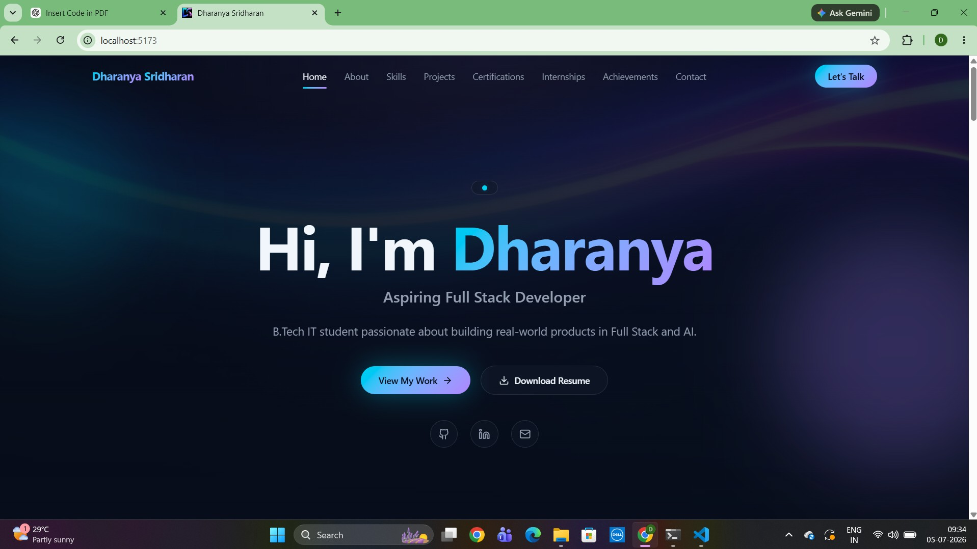

Screenshot 2: About Me Section

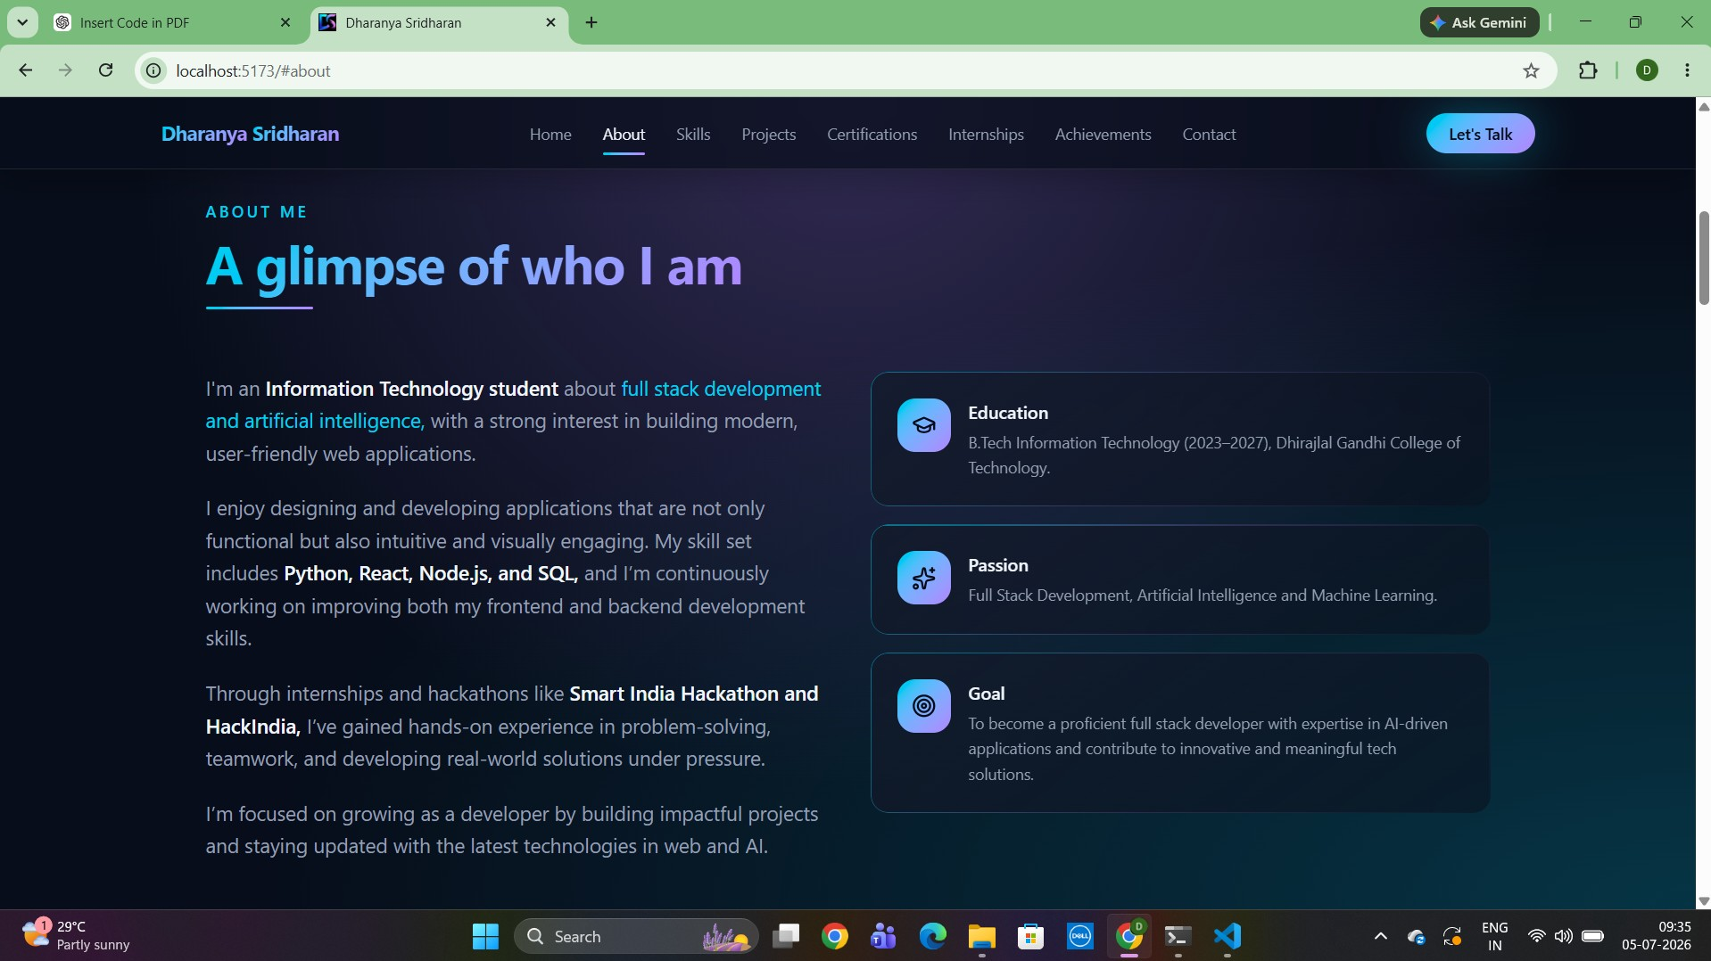
Screenshot 3: Technical Skills Section

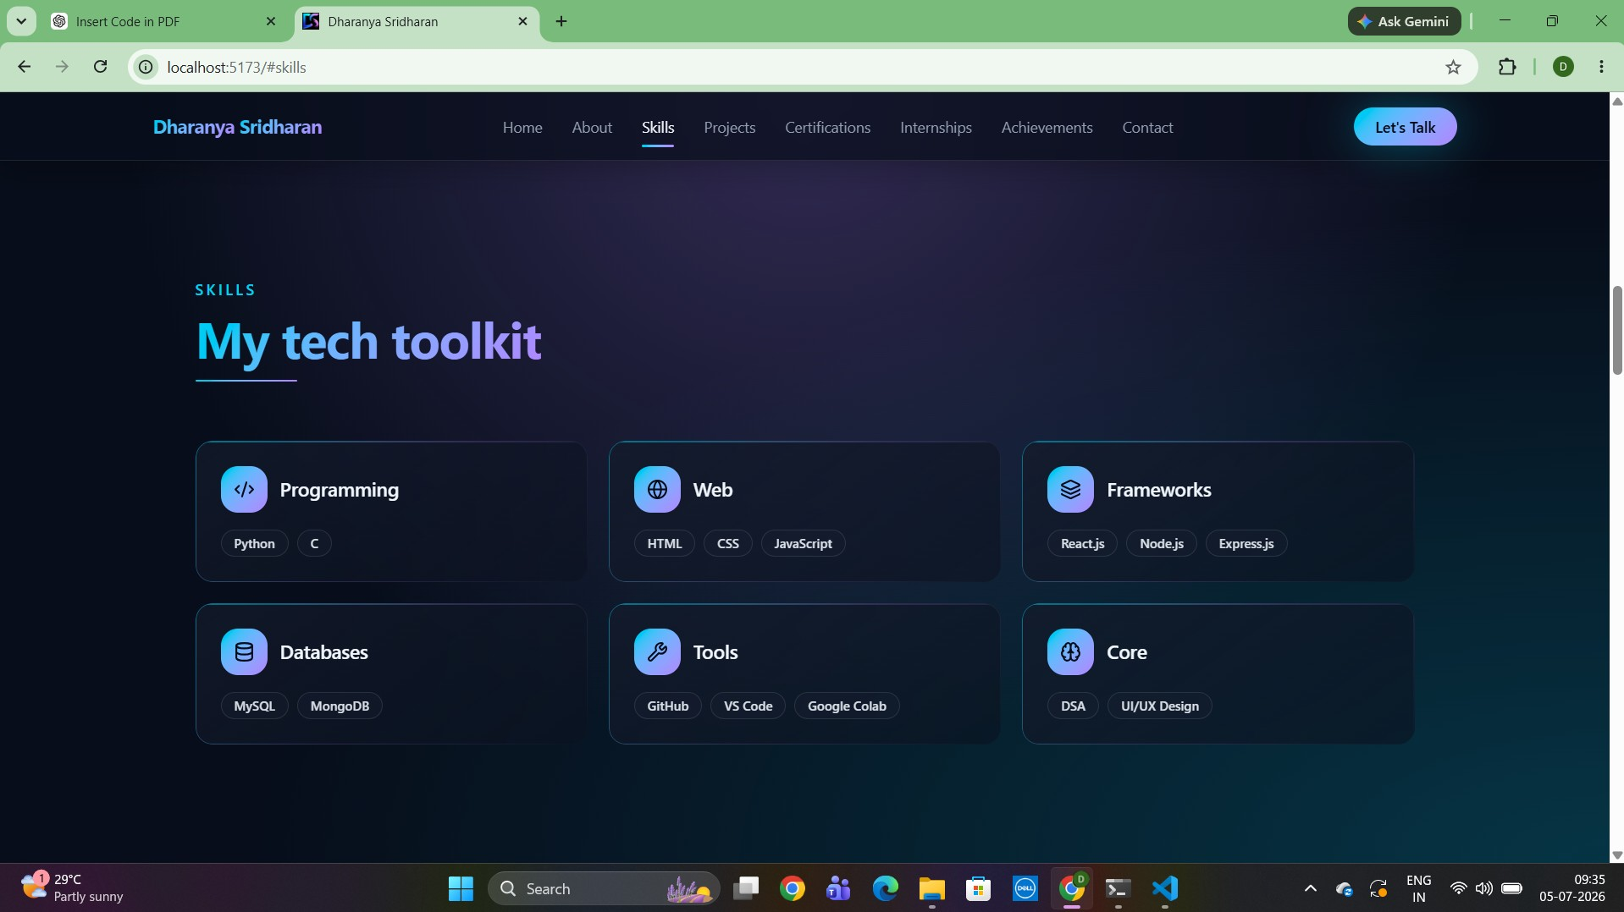
Screenshot 4: Projects Section

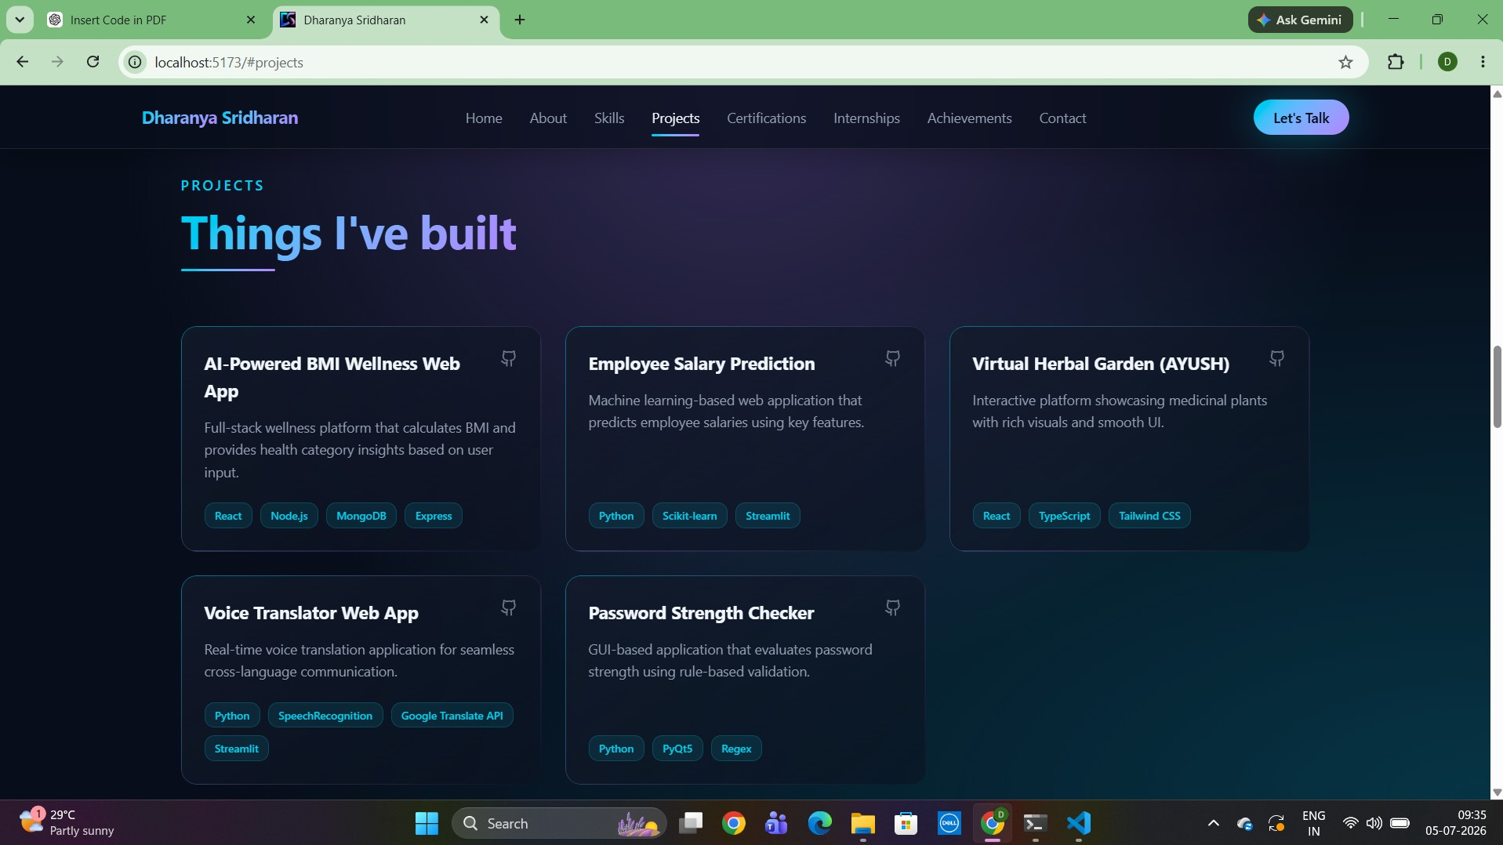
Screenshot 5: Certifications Section

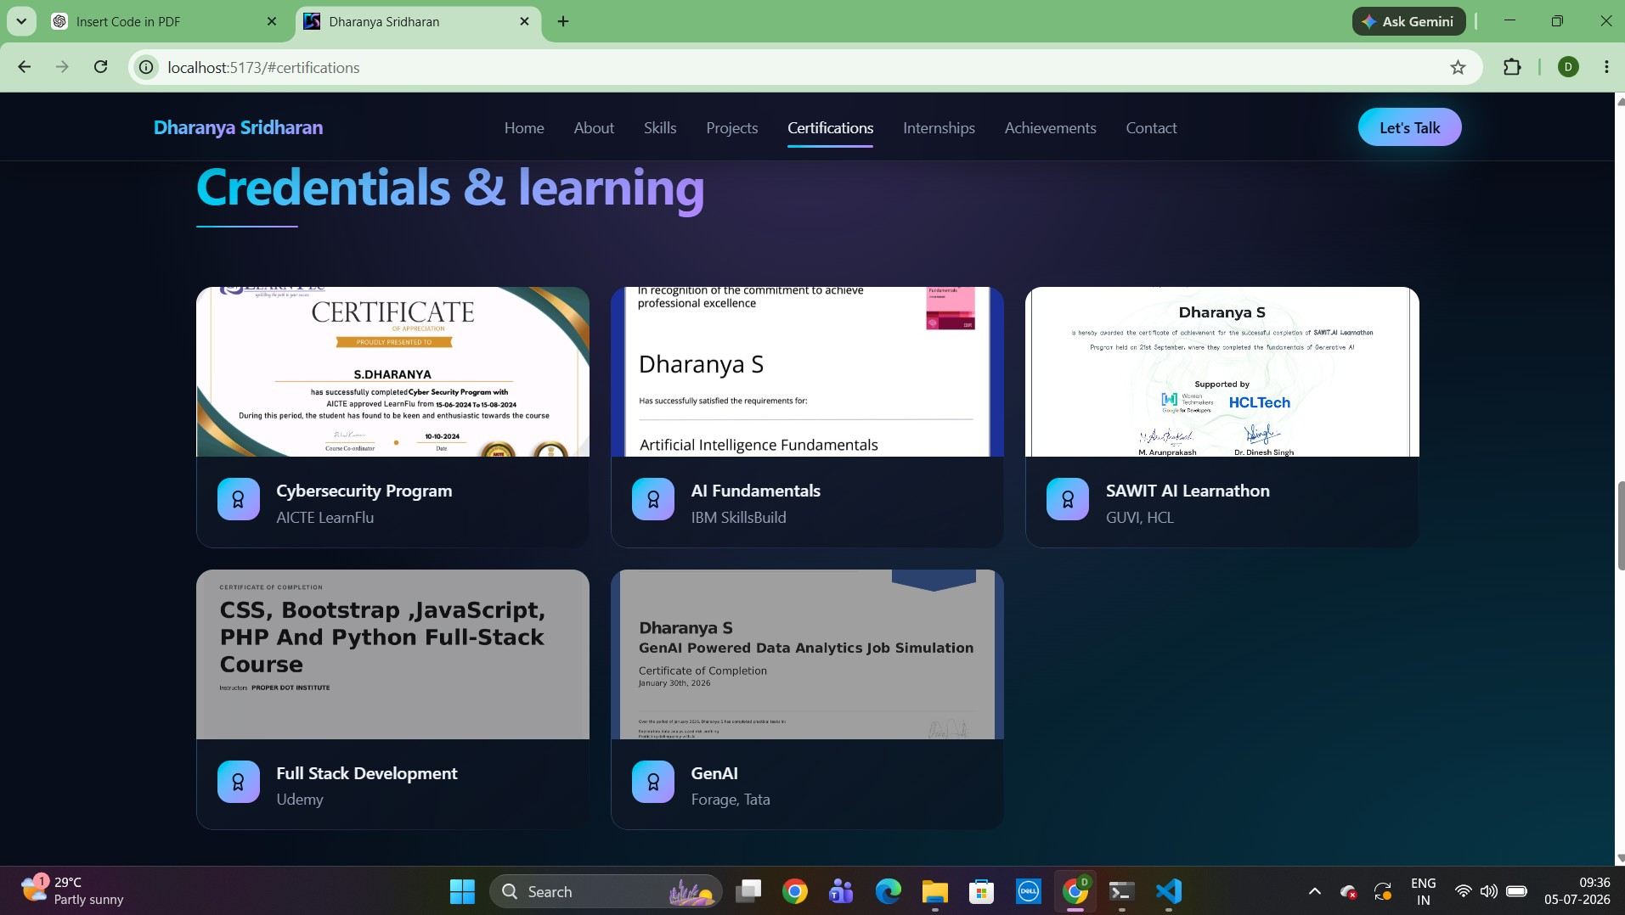
Screenshot 6: Internships / Experience Section

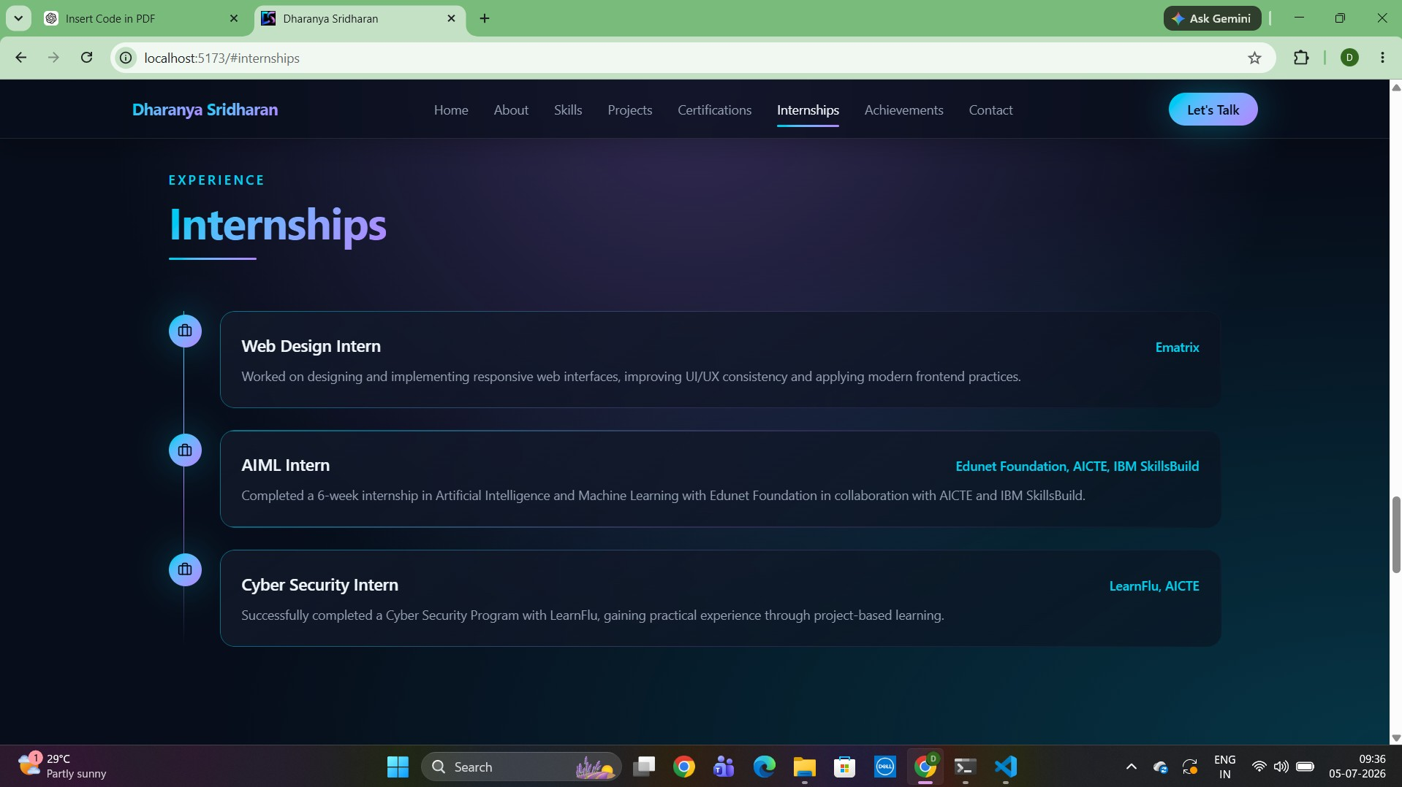
Screenshot 7: Achievements Section

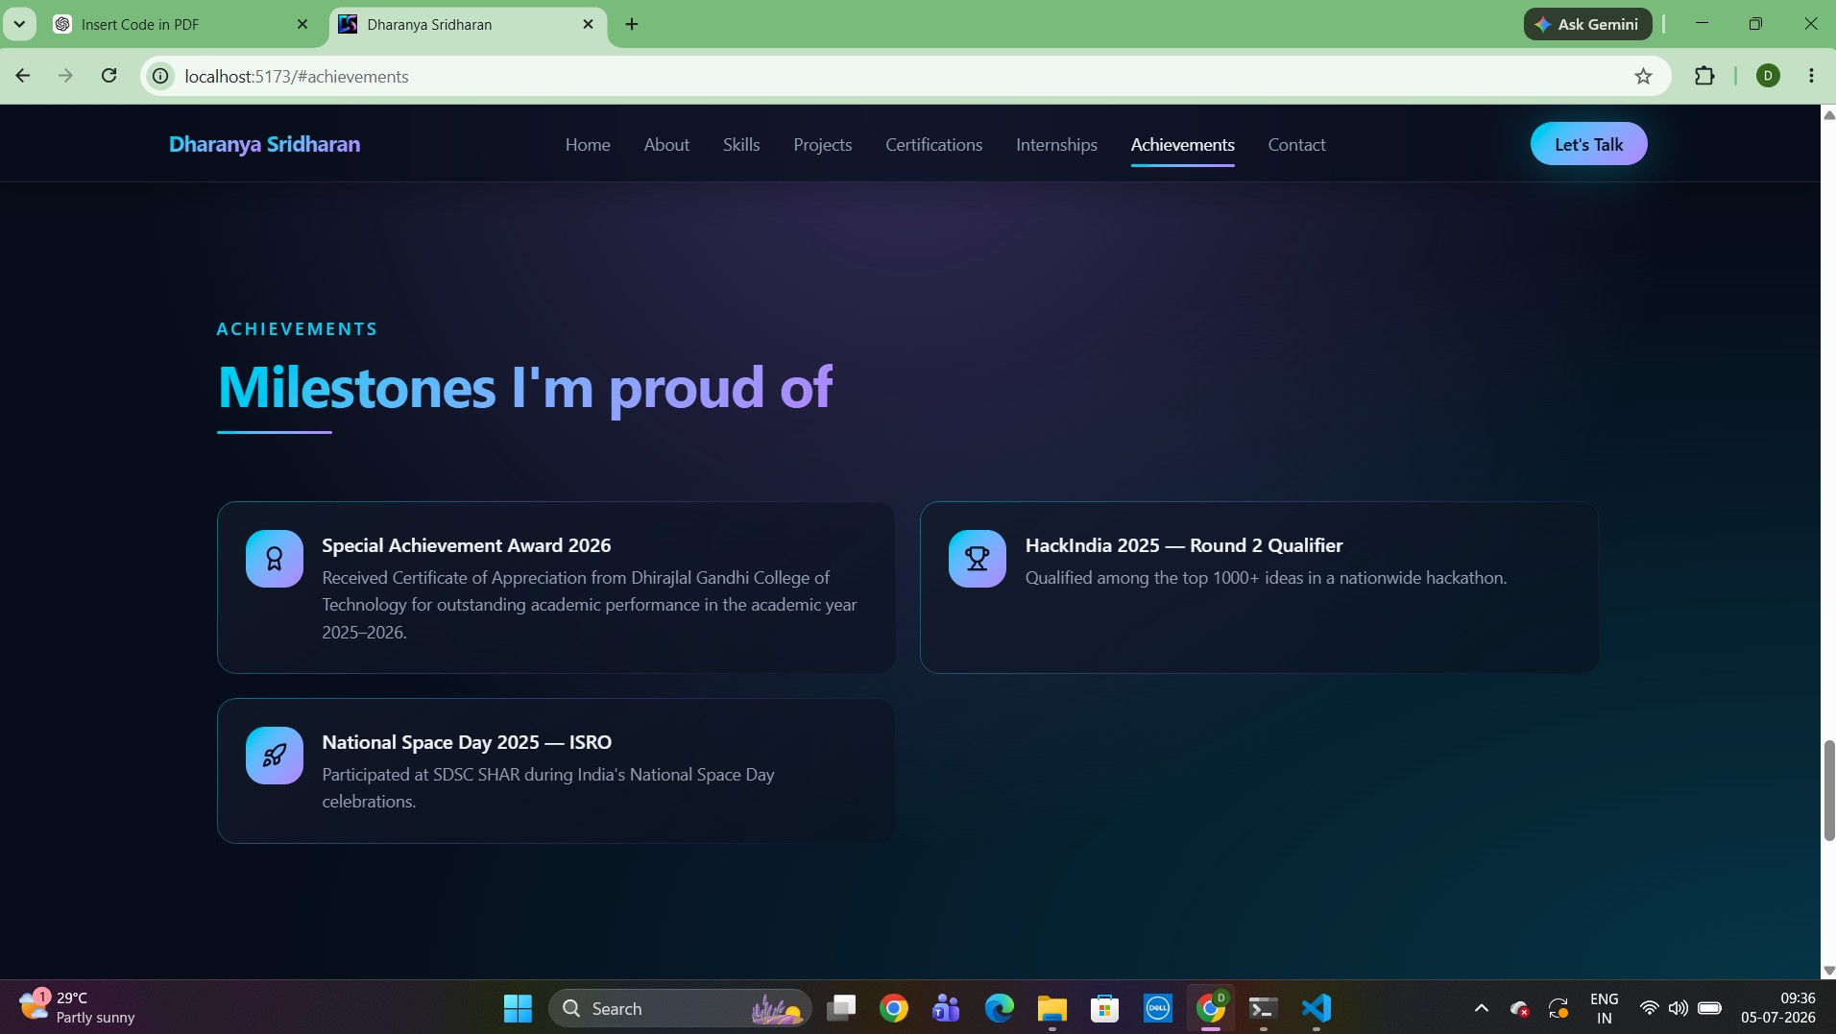

SOURCE CODE
The following pages contain the main custom source files used to build the portfolio. Generated files, dependency lock files, and generic third-party UI boilerplate are omitted so the submission focuses on project-specific implementation.

File 1: frontend/src/main.tsx
import React from "react"; import ReactDOM from "react-dom/client"; import { RouterProvider } from "@tanstack/react-router"; import { getRouter } from "./router"; import "./styles.css";
const router = getRouter();
ReactDOM.createRoot(document.getElementById("root")!).render(
<React.StrictMode>
<RouterProvider router={router} />
</React.StrictMode>
);

File 2: frontend/src/router.tsx
import { createRouter, useRouter } from "@tanstack/react-router"; import { routeTree } from "./routeTree.gen";
function DefaultErrorComponent({ error, reset }: { error: Error; reset: () => void }) { const router = useRouter();
return ( <div className="flex min-h-screen items-center justify-center bg-background px-4">
<div className="max-w-md text-center">
<div className="mx-auto mb-6 flex h-16 w-16 items-center justify-center rounded-full bg-destructive/10"> <svg xmlns="http://www.w3.org/2000/svg" className="h-8 w-8 text-destructive" fill="none" viewBox="0 0 24 24" stroke="currentColor" strokeWidth={2} > <path strokeLinecap="round" strokeLinejoin="round" d="M12 9v3.75m-9.303 3.376c-.866 1.5.217 3.374 1.948 3.374h14.71c1.73 0 2.813-1.874 1.948-3.374L13.949 3.378c-.866-1.5-3.032-1.5-3.898 0L2.697 16.126ZM12 15.75h.007v.008H12v-.008Z"
/>
</svg>
</div>
<h1 className="text-2xl font-bold tracking-tight text-foreground">Something went wrong</h1>
<p className="mt-2 text-sm text-muted-foreground"> An unexpected error occurred. Please try again.
</p>
{import.meta.env.DEV && error.message && ( <pre className="mt-4 max-h-40 overflow-auto rounded-md bg-muted p-3 text-left font-mono text-xs text destructive"> {error.message}
</pre>
)}
<div className="mt-6 flex items-center justify-center gap-3"> <button onClick={() => { router.invalidate(); reset(); }} className="inline-flex items-center justify-center rounded-md bg-primary px-4 py-2 text-sm font-medium text-primary-foreground transition-colors hover:bg-primary/90" >
Try again
</button> <a href="/" className="inline-flex items-center justify-center rounded-md border border-input bg-background px-4 py-2 text-sm font-medium text-foreground transition-colors hover:bg-accent" >
Go home
</a>
</div>
</div>
</div>
); }
export const getRouter = () => { const router = createRouter({

File 2: frontend/src/router.tsx (continued)
routeTree, context: {}, scrollRestoration: true, defaultPreloadStaleTime: 0, defaultErrorComponent: DefaultErrorComponent, });
return router;
};

File 3: frontend/src/routes/__root.tsx
import { Outlet, Link, createRootRoute, HeadContent, Scripts } from "@tanstack/react-router";
import appCss from "../styles.css?url"; import favicon from "@/assets/favicon.jpeg"; function NotFoundComponent() { return ( <div className="flex min-h-screen items-center justify-center bg-background px-4">
<div className="max-w-md text-center">
<h1 className="text-7xl font-bold text-foreground">404</h1>
<h2 className="mt-4 text-xl font-semibold text-foreground">Page not found</h2>
<p className="mt-2 text-sm text-muted-foreground"> The page you're looking for doesn't exist or has been moved.
</p>
<div className="mt-6"> <Link to="/" className="inline-flex items-center justify-center rounded-md bg-primary px-4 py-2 text-sm font-medium text-primary-foreground transition-colors hover:bg-primary/90" >
Go home
</Link>
</div>
</div>
</div>
); }
export const Route = createRootRoute({ head: () => ({ meta: [ { charSet: "utf-8" },
{ name: "viewport", content: "width=device-width, initial-scale=1" },
{ title: "Dharanya Sridharan | Portfolio" },
{ name: "description", content: "Full-stack developer & AI enthusiast" },
{ name: "author", content: "Dharanya Sridharan" },
{ property: "og:title", content: "Dharanya Sridharan | Portfolio" },
{ property: "og:description", content: "Full-stack developer & AI enthusiast" },
{ property: "og:type", content: "website" },
{ name: "twitter:card", content: "summary" },
], links: [ { rel: "stylesheet", href: appCss, }, { rel: "icon", type: "image/png", href: favicon, },
], }), shellComponent: RootShell, component: RootComponent, notFoundComponent: NotFoundComponent, });
function RootShell({ children }: { children: React.ReactNode }) { return ( <html lang="en">
<head>

File 3: frontend/src/routes/__root.tsx (continued)
<HeadContent />
</head>
<body>
{children}
<Scripts />
</body>
</html>
); }
function RootComponent() { return <Outlet />;
}

File 4: frontend/src/routes/index.tsx
import { createFileRoute } from "@tanstack/react-router"; import { Navbar } from "@/components/portfolio/Navbar"; import { Hero } from "@/components/portfolio/Hero"; import { About } from "@/components/portfolio/About"; import { Skills } from "@/components/portfolio/Skills"; import { Projects } from "@/components/portfolio/Projects"; import { Certifications } from "@/components/portfolio/Certifications"; import { Internships } from "@/components/portfolio/Internships"; import { Achievements } from "@/components/portfolio/Achievements"; import { Contact } from "@/components/portfolio/Contact"; import { Footer } from "@/components/portfolio/Footer"; import { useReveal } from "@/hooks/use-reveal";
export const Route = createFileRoute("/")({ head: () => ({ meta: [ { title: "Dharanya Sridharan" }, { name: "description", content: "Portfolio of Dharanya Sridharan - B.Tech IT student passionate about full stack development and AI.",
}, { property: "og:title", content: "Dharanya Sridharan - Portfolio", }, { property: "og:description", content: "Showcasing projects, skills, and achievements in full stack development and AI.",
},
{ property: "og:type", content: "website" },
],
// ■ This removes Lovable favicon completely links: [ { rel: "icon", href: "data:,", },
], }),
component: Index, });
function Index() { useReveal();
return ( <div className="min-h-screen">
<Navbar />
<main>
<Hero />
<About />
<Skills />
<Projects />
<Certifications />
<Internships />
<Achievements />
<Contact />

File 4: frontend/src/routes/index.tsx (continued)
</main>
<Footer />
</div>
);
}

File 5: frontend/src/styles.css
@import "tailwindcss";
@import "tw-animate-css";
@custom-variant dark (&:is(.dark *));
@theme inline {
--radius-sm: calc(var(--radius) - 4px);
--radius-md: calc(var(--radius) - 2px);
--radius-lg: var(--radius);
--radius-xl: calc(var(--radius) + 4px);
--color-background: var(--background);
--color-foreground: var(--foreground);
--color-card: var(--card);
--color-card-foreground: var(--card-foreground);
--color-popover: var(--popover);
--color-popover-foreground: var(--popover-foreground);
--color-primary: var(--primary);
--color-primary-foreground: var(--primary-foreground);
--color-primary-glow: var(--primary-glow);
--color-secondary: var(--secondary);
--color-secondary-foreground: var(--secondary-foreground);
--color-muted: var(--muted);
--color-muted-foreground: var(--muted-foreground);
--color-accent: var(--accent);
--color-accent-foreground: var(--accent-foreground);
--color-destructive: var(--destructive);
--color-destructive-foreground: var(--destructive-foreground);
--color-border: var(--border);
--color-input: var(--input);
--color-ring: var(--ring);
--animate-fade-in: fade-in 0.7s ease-out both;
--animate-fade-up: fade-up 0.8s ease-out both;
--animate-scale-in: scale-in 0.5s ease-out both;
--animate-float: float 6s ease-in-out infinite;
--animate-glow-pulse: glow-pulse 4s ease-in-out infinite;
@keyframes fade-in { from { opacity: 0; } to { opacity: 1; } } @keyframes fade-up { from { opacity: 0; transform: translateY(24px); } to { opacity: 1; transform: translateY(0); } } @keyframes scale-in { from { opacity: 0; transform: scale(0.95); } to { opacity: 1; transform: scale(1); } }
@keyframes float {
0%, 100% { transform: translateY(0); }
50% { transform: translateY(-12px); }
}
@keyframes glow-pulse {
0%, 100% { opacity: 0.5; }
50% { opacity: 0.9; }
}
}
:root {
--radius: 0.75rem;
/* Dark portfolio theme (default) */

File 5: frontend/src/styles.css (continued)
--background: oklch(0.16 0.03 265);
--foreground: oklch(0.97 0.01 250);
--card: oklch(0.21 0.035 265);
--card-foreground: oklch(0.97 0.01 250);
--popover: oklch(0.21 0.035 265);
--popover-foreground: oklch(0.97 0.01 250);
--primary: oklch(0.78 0.16 210);
--primary-foreground: oklch(0.15 0.03 265);
--primary-glow: oklch(0.72 0.2 295);
--secondary: oklch(0.27 0.04 265);
--secondary-foreground: oklch(0.97 0.01 250);
--muted: oklch(0.24 0.035 265);
--muted-foreground: oklch(0.7 0.03 260);
--accent: oklch(0.72 0.2 295);
--accent-foreground: oklch(0.15 0.03 265);
--destructive: oklch(0.65 0.22 27);
--destructive-foreground: oklch(0.98 0 0);
--border: oklch(1 0 0 / 10%);
--input: oklch(1 0 0 / 12%);
--ring: oklch(0.78 0.16 210);
--gradient-primary: linear-gradient(135deg, oklch(0.78 0.16 210), oklch(0.72 0.2 295)); --gradient-hero: radial-gradient(ellipse at top, oklch(0.72 0.2 295 / 0.25), transparent 60%), radial-gradient(ellipse at bottom right, oklch(0.78 0.16 210 / 0.2), transparent 60%); --gradient-card: linear-gradient(145deg, oklch(0.22 0.035 265 / 0.8), oklch(0.18 0.03 265 / 0.6));
--shadow-glow: 0 0 40px oklch(0.78 0.16 210 / 0.35);
--shadow-card: 0 10px 40px -10px oklch(0.1 0.03 265 / 0.6);
--shadow-elegant: 0 20px 60px -20px oklch(0.72 0.2 295 / 0.4);
}
@layer base { * { border-color: var(--color-border); }
html { scroll-behavior: smooth; }
body { background-color: var(--color-background); color: var(--color-foreground); font-family: "Inter", ui-sans-serif, system-ui, sans-serif; background-image: var(--gradient-hero); background-attachment: fixed; }
::selection { background: var(--primary); color: var(--primary-foreground); }
section {
scroll-margin-top: 5rem; }
}
@layer utilities {

File 5: frontend/src/styles.css (continued)
.gradient-text { background: var(--gradient-primary); -webkit-background-clip: text; background-clip: text; color: transparent; } .gradient-border { position: relative; background: var(--gradient-card); backdrop-filter: blur(12px); } .gradient-border::before { content: ""; position: absolute; inset: 0; border-radius: inherit; padding: 1px; background: linear-gradient(135deg, oklch(0.78 0.16 210 / 0.5), oklch(0.72 0.2 295 / 0.2), transparent); mask: linear-gradient(#000 0 0) content-box, linear-gradient(#000 0 0); -webkit-mask: linear-gradient(#000 0 0) content-box, linear-gradient(#000 0 0); -webkit-mask-composite: xor; mask-composite: exclude; pointer-events: none; } .glow { box-shadow: var(--shadow-glow); } .reveal { opacity: 0; transform: translateY(24px); transition: opacity 0.8s ease-out, transform 0.8s ease-out; } .reveal.is-visible { opacity: 1; transform: translateY(0); }
}

File 6: frontend/src/components/portfolio/Navbar.tsx
import { useEffect, useState } from "react"; import { Menu, X } from "lucide-react";
const LINKS = [ { href: "#home", label: "Home" },
{ href: "#about", label: "About" },
{ href: "#skills", label: "Skills" },
{ href: "#projects", label: "Projects" },
{ href: "#certifications", label: "Certifications" },
{ href: "#internships", label: "Internships" },
{ href: "#achievements", label: "Achievements" },
{ href: "#contact", label: "Contact" }, ];
export function Navbar() { const [scrolled, setScrolled] = useState(false); const [open, setOpen] = useState(false); const [active, setActive] = useState("home");
useEffect(() => { const onScroll = () => { setScrolled(window.scrollY > 20); const sections = LINKS.map((l) => document.getElementById(l.href.slice(1))); for (const s of sections) { if (!s) continue; const r = s.getBoundingClientRect(); if (r.top <= 120 && r.bottom >= 120) { setActive(s.id); break; }
} }; onScroll(); window.addEventListener("scroll", onScroll, { passive: true }); return () => window.removeEventListener("scroll", onScroll); }, []);
return ( <header className={`fixed top-0 left-0 right-0 z-50 transition-all duration-300 ${ scrolled ? "bg-background/70 backdrop-blur-xl border-b border-border shadow-[0_4px_30px_rgba(0,0,0,0.3)]"
: "bg-transparent"
}`}
>
<nav className="mx-auto max-w-7xl px-6 h-16 flex items-center justify-between">
<a href="#home" className="font-bold text-lg tracking-tight">
<span className="gradient-text">Dharanya</span>
<span className="gradient-text"> Sridharan</span>
</a>
<ul className="hidden lg:flex items-center gap-1">
{LINKS.map((l) => (
<li key={l.href}> <a href={l.href}
className={`relative px-3 py-2 text-sm rounded-md transition-colors ${ active === l.href.slice(1) ? "text-foreground"
: "text-muted-foreground hover:text-foreground"
}`}
>

File 6: frontend/src/components/portfolio/Navbar.tsx (continued)
{l.label}
{active === l.href.slice(1) && ( <span className="absolute left-3 right-3 -bottom-0.5 h-0.5 rounded-full bg-linear-to-r from primary to-accent" /> )}
</a>
</li>
))}
</ul>
<a href="#contact" className="hidden lg:inline-flex items-center rounded-full px-5 py-2 text-sm font-medium text-primary foreground transition-transform hover:scale-105" style={{ background: "var(--gradient-primary)", boxShadow: "var(--shadow-glow)" }} >
Let's Talk
</a>
<button className="lg:hidden p-2 rounded-md text-foreground" onClick={() => setOpen((o) => !o)} aria-label="Toggle menu" >
{open ? <X size={22} /> : <Menu size={22} />}
</button>
</nav>
{open && ( <div className="lg:hidden bg-background/95 backdrop-blur-xl border-t border-border animate-[fade in_0.2s_ease-out]"> <ul className="px-6 py-4 flex flex-col gap-1">
{LINKS.map((l) => (
<li key={l.href}> <a href={l.href} onClick={() => setOpen(false)} className={`block px-3 py-2 rounded-md text-sm ${ active === l.href.slice(1) ? "text-foreground bg-muted"
: "text-muted-foreground hover:text-foreground hover:bg-muted/50"
}`}
>
{l.label}
</a>
</li>
))}
</ul>
</div>
)}
</header>
);
}

File 7: frontend/src/components/portfolio/Hero.tsx
import { ArrowRight, Download, Github, Linkedin, Mail } from "lucide-react"; import heroBg from "@/assets/hero-bg.jpg"; import resume from "@/assets/Dharanya_resume.pdf";
export function Hero() { return ( <section id="home" className="relative min-h-screen flex items-center justify-center overflow-hidden pt-20" > <div className="absolute inset-0 -z-10 opacity-30" style={{ backgroundImage: `url(${heroBg})`, backgroundSize: "cover", backgroundPosition: "center", }}
/>
<div className="absolute inset-0 -z-10 bg-linear-to-b from-background/50 via-background/80 to-background" />
{/* Floating orbs */} <div className="absolute top-20 -left-20 w-72 h-72 rounded-full blur-3xl animate-glow-pulse" style={{ background: "oklch(0.78 0.16 210 / 0.3)" }} /> <div className="absolute bottom-20 -right-20 w-96 h-96 rounded-full blur-3xl animate-glow-pulse delay-1000" style={{ background: "oklch(0.72 0.2 295 / 0.3)" }} />
<div className="mx-auto max-w-5xl px-6 text-center"> <div className="inline-flex items-center gap-2 px-4 py-1.5 rounded-full border border-border bg-card/50 backdrop-blur-sm text-xs text-muted-foreground animate-[fade-up_0.6s_ease-out]"> <span className="relative flex h-2 w-2">
<span className="absolute inline-flex h-full w-full rounded-full bg-primary opacity-75 animate-ping" />
<span className="relative inline-flex h-2 w-2 rounded-full bg-primary" />
</span>
</div>
<h1 className="mt-8 text-5xl md:text-7xl lg:text-8xl font-bold tracking-tight animate-[fade-up_0.8s_ease out_0.1s_both]"> Hi, I'm <span className="gradient-text">Dharanya</span>
</h1> <p className="mt-4 text-xl md:text-2xl text-muted-foreground font-medium animate-[fade-up_0.8s_ease out_0.2s_both]"> Aspiring Full Stack Developer
</p> <p className="mt-6 max-w-2xl mx-auto text-base md:text-lg text-muted-foreground leading-relaxed animate-[fade-up_0.8s_ease-out_0.3s_both]"> B.Tech IT student passionate about building real-world products in Full Stack and AI.
</p>
<div className="mt-10 flex flex-wrap items-center justify-center gap-4 animate-[fade-up_0.8s_ease out_0.4s_both]"> <a href="#projects" className="inline-flex items-center gap-2 rounded-full px-7 py-3 text-sm font-semibold text-primary foreground transition-transform hover:scale-105" style={{ background: "var(--gradient-primary)", boxShadow: "var(--shadow-glow)" }} >
View My Work <ArrowRight size={16} />
</a> <a href={resume} download className="inline-flex items-center gap-2 rounded-full px-7 py-3 text-sm font-semibold border border-

File 7: frontend/src/components/portfolio/Hero.tsx (continued)
border bg-card/60 backdrop-blur-sm text-foreground transition-colors hover:bg-card" >
<Download size={16} /> Download Resume
</a>
</div>
<div className="mt-10 flex items-center justify-center gap-5 animate-[fade-up_0.8s_ease-out_0.5s_both]">
{[
{ href: "https://github.com/Dharanyasri", icon: Github, label: "GitHub" },
{ href: "https://www.linkedin.com/in/dharanya-s-7b41222b7", icon: Linkedin, label: "LinkedIn" },
{ href: "mailto:dharanyasri3@gmail.com", icon: Mail, label: "Email" },
].map(({ href, icon: Icon, label }) => ( <a key={label} href={href} target="_blank" rel="noreferrer" aria-label={label} className="p-3 rounded-full border border-border bg-card/50 backdrop-blur-sm text-muted-foreground hover:text-primary hover:border-primary transition-all hover:-translate-y-0.5" >
<Icon size={18} />
</a>
))}
</div>
</div>
</section>
);
}

File 8: frontend/src/components/portfolio/About.tsx
import { GraduationCap, Target, Sparkles } from "lucide-react"; import { Section } from "./Section";
export function About() { const highlights = [ { icon: GraduationCap, title: "Education", text: "B.Tech Information Technology (2023-2027), Dhirajlal Gandhi College of Technology.", }, { icon: Sparkles, title: "Passion", text: "Full Stack Development, Artificial Intelligence and Machine Learning.", }, { icon: Target, title: "Goal", text: "To become a proficient full stack developer with expertise in AI-driven applications and contribute to innovative and meaningful tech solutions.", }, ];
return ( <Section id="about" eyebrow="About Me" title="A glimpse of who I am">
<div className="grid md:grid-cols-2 gap-10 items-start">
<div className="reveal space-y-5 text-muted-foreground leading-relaxed text-lg">
<p> I'm an <span className="text-foreground font-medium">Information Technology student</span> about <span className="text-primary">full stack development and artificial intelligence,</span> with a strong interest in building modern, user-friendly web applications. </p>
<p> I enjoy designing and developing applications that are not only functional but also intuitive and visually engaging. My skill set includes <span className="text-foreground font-medium"> Python, React, Node.js, and SQL,</span> and I'm continuously working on improving both my frontend and backend development skills. </p>
<p>
Through internships and hackathons like <span className="text-foreground font-medium">Smart India Hackathon and HackIndia,</span> I've gained hands-on experience in problem-solving, teamwork, and developing real-world solutions under pressure. </p>
<p> I'm focused on growing as a developer by building impactful projects and staying updated with the latest technologies in web and AI. </p>
</div>
<div className="grid gap-4">
{highlights.map((h, i) => ( <div key={h.title} className="reveal gradient-border rounded-2xl p-6 flex gap-4 items-start hover:-translate-y-1 transition-transform"
style={{ transitionDelay: `${i * 80}ms` }} > <div className="shrink-0 w-12 h-12 rounded-xl flex items-center justify-center text-primary-foreground" style={{ background: "var(--gradient-primary)" }} >
<h.icon size={22} />

File 8: frontend/src/components/portfolio/About.tsx (continued)
</div>
<div>
<h3 className="font-semibold text-foreground">{h.title}</h3>
<p className="mt-1 text-sm text-muted-foreground leading-relaxed">{h.text}</p>
</div>
</div>
))}
</div>
</div>
</Section>
);
}

File 9: frontend/src/components/portfolio/Skills.tsx
import { Code2, Globe, Layers, Database, Wrench, Brain } from "lucide-react"; import { Section } from "./Section";
const GROUPS = [ { icon: Code2, title: "Programming", items: ["Python", "C"] },
{ icon: Globe, title: "Web", items: ["HTML", "CSS", "JavaScript"] },
{ icon: Layers, title: "Frameworks", items: ["React.js", "Node.js", "Express.js"] },
{ icon: Database, title: "Databases", items: ["MySQL", "MongoDB"] },
{ icon: Wrench, title: "Tools", items: ["GitHub", "VS Code", "Google Colab"] },
{ icon: Brain, title: "Core", items: ["DSA", "UI/UX Design"] }, ];
export function Skills() { return ( <Section id="skills" eyebrow="Skills" title="My tech toolkit">
<div className="grid sm:grid-cols-2 lg:grid-cols-3 gap-5">
{GROUPS.map((g, i) => ( <div key={g.title} className="reveal gradient-border rounded-2xl p-6 group hover:-translate-y-1 transition-all" style={{ transitionDelay: `${i * 60}ms` }} >
<div className="flex items-center gap-3 mb-4"> <div className="w-11 h-11 rounded-xl flex items-center justify-center text-primary-foreground transition-transform group-hover:scale-110" style={{ background: "var(--gradient-primary)" }} >
<g.icon size={20} />
</div>
<h3 className="font-semibold text-lg">{g.title}</h3>
</div>
<div className="flex flex-wrap gap-2">
{g.items.map((it) => ( <span key={it} className="px-3 py-1 text-xs font-medium rounded-full border border-border bg-muted/40 text foreground/90" >
{it}
</span>
))}
</div>
</div>
))}
</div>
</Section>
);
}

File 10: frontend/src/components/portfolio/Projects.tsx
import { ExternalLink, Github } from "lucide-react"; import { Section } from "./Section";
const PROJECTS = [ { title: "AI-Powered BMI Wellness Web App", description: "Full-stack wellness platform that calculates BMI and provides health category insights based on user input.", stack: ["React", "Node.js", "MongoDB", "Express"], github: "https://github.com/Dharanyasri/BMI.git", gradient: "from-sky-400/30 to-cyan-400/20", }, { title: "Employee Salary Prediction", description: "Machine learning-based web application that predicts employee salaries using key features.", stack: ["Python", "Scikit-learn", "Streamlit"], github: "https://github.com/Dharanyasri/Edunet.git", gradient: "from-fuchsia-400/30 to-purple-400/20", }, { title: "Virtual Herbal Garden (AYUSH)", description: "Interactive platform showcasing medicinal plants with rich visuals and smooth UI.", stack: ["React", "TypeScript", "Tailwind CSS"], github: "https://github.com/Dharanyasri/Herbal_Garden.git", gradient: "from-emerald-400/30 to-teal-400/20", }, { title: "Voice Translator Web App", description: "Real-time voice translation application for seamless cross-language communication.", stack: ["Python", "SpeechRecognition", "Google Translate API", "Streamlit"], github: "https://github.com/Dharanyasri/voice_translator-.git", gradient: "from-indigo-400/30 to-blue-400/20", }, { title: "Password Strength Checker", description: "GUI-based application that evaluates password strength using rule-based validation.", stack: ["Python", "PyQt5", "Regex"], github: "https://github.com/Dharanyasri/password_strength.git", gradient: "from-rose-400/30 to-pink-400/20", }, ];
export function Projects() { return ( <Section id="projects" eyebrow="Projects" title="Things I've built">
<div className="grid md:grid-cols-2 lg:grid-cols-3 gap-6">
{PROJECTS.map((p, i) => ( <article key={p.title} className="reveal group relative gradient-border rounded-2xl p-6 flex flex-col hover:-translate-y-2 transition-all duration-300" style={{ transitionDelay: `${i * 80}ms` }} > {/* Hover Gradient */} <div
className={`absolute inset-0 rounded-2xl bg-linear-to-br ${p.gradient} opacity-0 group hover:opacity-100 transition-opacity pointer-events-none`}

File 10: frontend/src/components/portfolio/Projects.tsx (continued)
/>
<div className="relative flex-1">
<div className="flex items-start justify-between gap-3 mb-3">
<h3 className="font-bold text-lg text-foreground">{p.title}</h3>
{/* ■ Links */}
<div className="flex gap-2 opacity-70 group-hover:opacity-100 transition-opacity">
{p.github && ( <a href={p.github} target="_blank" rel="noopener noreferrer" title="GitHub" >
<Github className="text-muted-foreground hover:text-primary transition" size={18} />
</a>
)}
</div>
</div>
<p className="text-sm text-muted-foreground leading-relaxed">
{p.description}
</p>
</div>
{/* Tech Stack */}
<div className="relative mt-5 flex flex-wrap gap-2">
{p.stack.map((s) => ( <span key={s} className="px-2.5 py-1 text-[11px] font-medium rounded-md bg-primary/10 text-primary border border-primary/20" >
{s}
</span>
))}
</div>
</article>
))}
</div>
</Section>
);
}

File 11: frontend/src/components/portfolio/Certifications.tsx
import { Award } from "lucide-react"; import { Section } from "./Section"; import { useState } from "react";
import cyberImg from "../../assets/cybersecurity.png"; import aiImg from "../../assets/ai-fundamentals.png"; import sawitImg from "../../assets/sawit.png"; import fullstackImg from "../../assets/fullstack.png"; import genaiImg from "../../assets/genai.png";
const CERTS = [ { title: "Cybersecurity Program", issuer: "AICTE LearnFlu", image: cyberImg, }, { title: "AI Fundamentals", issuer: "IBM SkillsBuild", image: aiImg, }, { title: "SAWIT AI Learnathon", issuer: "GUVI, HCL", image: sawitImg, }, { title: "Full Stack Development", issuer: "Udemy", image: fullstackImg, }, {
title: "GenAI", issuer: "Forage, Tata", image: genaiImg, }, ];
export function Certifications() { const [selectedImage, setSelectedImage] = useState<string | null>(null);
return ( <> <Section id="certifications" eyebrow="Certifications" title="Credentials & learning" >
<div className="grid sm:grid-cols-2 lg:grid-cols-3 gap-5">
{CERTS.map((c, i) => ( <div key={c.title} className="reveal gradient-border rounded-2xl overflow-hidden hover:-translate-y-1 transition transform" style={{ transitionDelay: `${i * 80}ms` }} >
{/* Clickable Image */} <img src={c.image} alt={c.title}
onClick={() => setSelectedImage(c.image)} className="w-full h-40 object-cover cursor-pointer hover:scale-105 transition duration-300"

File 11: frontend/src/components/portfolio/Certifications.tsx (continued)
/>
{/* Content */}
<div className="p-5 flex gap-4 items-start"> <div className="shrink-0 w-10 h-10 rounded-lg flex items-center justify-center text-primary foreground" style={{ background: "var(--gradient-primary)" }} >
<Award size={18} />
</div>
<div>
<h3 className="font-semibold text-foreground leading-snug">
{c.title}
</h3>
<p className="mt-1 text-sm text-muted-foreground">
{c.issuer}
</p>
</div>
</div>
</div>
))}
</div>
</Section>
{/* ■ Modal OUTSIDE Section */}
{selectedImage && ( <div className="fixed inset-0 bg-black/80 flex items-center justify-center z-50" onClick={() => setSelectedImage(null)} > <img src={selectedImage} alt="Certificate" className="max-w-[90vw] max-h-[90vh] rounded-xl shadow-lg" />
</div>
)}
</>
);
}

File 12: frontend/src/components/portfolio/Internships.tsx
import { Briefcase } from "lucide-react"; import { Section } from "./Section";
export function Internships() { const items = [ { role: "Web Design Intern", company: "Ematrix", summary: "Worked on designing and implementing responsive web interfaces, improving UI/UX consistency and applying modern frontend practices.", }, { role: "AIML Intern", company: "Edunet Foundation, AICTE, IBM SkillsBuild", summary: "Completed a 6-week internship in Artificial Intelligence and Machine Learning with Edunet Foundation in collaboration with AICTE and IBM SkillsBuild.", }, { role: "Cyber Security Intern", company: "LearnFlu, AICTE", summary: "Successfully completed a Cyber Security Program with LearnFlu, gaining practical experience through project-based learning.", }, ];
return ( <Section id="internships" eyebrow="Experience" title="Internships">
<div className="relative">
<div className="absolute left-4 top-0 bottom-0 w-px bg-linear-to-b from-primary via-accent to-transparent"
/>
<div className="space-y-6">
{items.map((it, i) => ( <div key={it.role} className="reveal relative pl-14" style={{ transitionDelay: `${i * 80}ms` }} > <div className="absolute left-0 top-1 w-9 h-9 rounded-full flex items-center justify-center text primary-foreground" style={{ background: "var(--gradient-primary)", boxShadow: "var(--shadow-glow)" }} >
<Briefcase size={16} />
</div>
<div className="gradient-border rounded-2xl p-6">
<div className="flex flex-wrap items-baseline justify-between gap-2">
<h3 className="font-semibold text-lg">{it.role}</h3>
<span className="text-sm text-primary font-medium">{it.company}</span>
</div>
<p className="mt-2 text-sm text-muted-foreground leading-relaxed">{it.summary}</p>
</div>
</div>
))}
</div>
</div>
</Section>
);
}

File 13: frontend/src/components/portfolio/Achievements.tsx
import { Trophy, Rocket, Award } from "lucide-react"; import { Section } from "./Section";
const ITEMS = [ { icon: Award, title: "Special Achievement Award 2026", text: "Received Certificate of Appreciation from Dhirajlal Gandhi College of Technology for outstanding academic performance in the academic year 2025-2026.", }, { icon: Trophy, title: "HackIndia 2025 - Round 2 Qualifier", text: "Qualified among the top 1000+ ideas in a nationwide hackathon.", }, { icon: Rocket, title: "National Space Day 2025 - ISRO", text: "Participated at SDSC SHAR during India's National Space Day celebrations.", }, ];
export function Achievements() { return ( <Section id="achievements" eyebrow="Achievements" title="Milestones I'm proud of">
<div className="grid md:grid-cols-2 gap-5">
{ITEMS.map((a, i) => ( <div key={a.title} className="reveal gradient-border rounded-2xl p-6 flex gap-4 items-start hover:-translate-y-1 transition-transform" style={{ transitionDelay: `${i * 80}ms` }} >
{/* Icon */} <div className="shrink-0 w-12 h-12 rounded-xl flex items-center justify-center text-primary-foreground" style={{ background: "var(--gradient-primary)" }} >
<a.icon size={22} />
</div>
{/* Content */}
<div>
<h3 className="font-semibold text-foreground">{a.title}</h3>
<p className="mt-1 text-sm text-muted-foreground leading-relaxed">
{a.text}
</p>
</div>
</div>
))}
</div>
</Section>
);
}

File 14: frontend/src/components/portfolio/Contact.tsx
import { useState } from "react"; import { Mail, Phone, Github, Linkedin, Send } from "lucide-react"; import { Section } from "./Section";
export function Contact() { const [formData, setFormData] = useState({ name: "", email: "", subject: "", message: "", });
const [loading, setLoading] = useState(false);
const channels = [ { icon: Mail, label: "Email", value: "dharanyasri3@gmail.com", href: "mailto:dharanyasri3@gmail.com", }, { icon: Phone, label: "Phone", value: "+91 90255 72658", href: "tel:+919025572658", }, { icon: Github, label: "GitHub", value: "Dharanyasri", href: "https://github.com/Dharanyasri", }, { icon: Linkedin, label: "LinkedIn", value: "dharanya-s", href: "https://www.linkedin.com/in/dharanya-s-7b41222b7", }, ];
const handleChange = ( e: React.ChangeEvent<HTMLInputElement | HTMLTextAreaElement> ) => { setFormData({ ...formData,
[e.target.name]: e.target.value,
}); };
const handleSubmit = async (e: React.FormEvent<HTMLFormElement>) => {
e.preventDefault();
setLoading(true);
try {
const response = await fetch("https://portfolio-kctw.onrender.com/contact", { method: "POST", headers: { "Content-Type": "application/json",
},

body: JSON.stringify(formData), });
const data = await response.json();
if (data.success) { alert("Message sent successfully!");
setFormData({ name: "", email: "", subject: "", message: "", }); } else { alert("Failed to send message"); } } catch (error) { console.log(error); alert("Something went wrong"); }
setLoading(false); };
return ( <Section id="contact" eyebrow="Contact" title="Let's build something together" >
<div className="grid md:grid-cols-2 gap-10 items-start">
{/* Left Side */}
<div className="reveal space-y-5">
<p className="text-lg text-muted-foreground leading-relaxed"> Have an opportunity, project idea, or just want to say hi? My inbox is always open - I'll do my best to get back to you quickly. </p>
<div className="grid gap-3">
{channels.map((c) => ( <a key={c.label} href={c.href} target={c.href.startsWith("http") ? "_blank" : undefined} rel="noreferrer" className="gradient-border rounded-xl p-4 flex items-center gap-4 hover:-translate-y-0.5 transition-transform" > <div className="w-10 h-10 rounded-lg flex items-center justify-center text-primary-foreground shrink-0" style={{ background: "var(--gradient-primary)" }} >
<c.icon size={18} />
</div>
<div className="min-w-0">
<p className="text-xs uppercase tracking-wider text-muted-foreground">
{c.label}
</p>
<p className="text-sm text-foreground truncate">
{c.value}
</p>
</div>
</a>
))}
</div>
</div>
{/* Right Side Form */} <form onSubmit={handleSubmit} className="reveal gradient-border rounded-2xl p-6 md:p-8 space-y-4" >
<div className="grid sm:grid-cols-2 gap-4"> <Field name="name" label="Name" placeholder="Your name" value={formData.name} onChange={handleChange} />
<Field name="email" label="Email" placeholder="you@email.com" type="email" value={formData.email} onChange={handleChange} />
</div>
<Field name="subject" label="Subject" placeholder="What's this about?" value={formData.subject} onChange={handleChange} />
<div>
<label className="block text-xs uppercase tracking-wider text-muted-foreground mb-1.5">
Message
</label>
<textarea name="message" rows={5} required value={formData.message} onChange={handleChange} placeholder="Tell me more..." className="w-full rounded-lg bg-input/40 border border-border px-4 py-3 text-sm text-foreground placeholder:text-muted-foreground/60 focus:outline-none focus:ring-2 focus:ring-primary focus:border-transparent transition" />
</div>
<button type="submit" disabled={loading} className="w-full inline-flex items-center justify-center gap-2 rounded-lg px-6 py-3 text-sm font semibold text-primary-foreground transition-transform hover:scale-[1.02]" style={{ background: "var(--gradient-primary)", boxShadow: "var(--shadow-glow)", }}
>
{loading ? "Sending..." : "Send Message"}
<Send size={16} />
</button>
</form>
</div>
</Section>
); }
function Field({ name, label, placeholder, type = "text", value, onChange, }: { name: string; label: string; placeholder: string; type?: string; value: string; onChange: ( e: React.ChangeEvent<HTMLInputElement> ) => void; }) { return ( <div>
<label className="block text-xs uppercase tracking-wider text-muted-foreground mb-1.5">
{label}
</label>
<input name={name} type={type} required value={value} onChange={onChange} placeholder={placeholder} className="w-full rounded-lg bg-input/40 border border-border px-4 py-3 text-sm text-foreground placeholder:text-muted-foreground/60 focus:outline-none focus:ring-2 focus:ring-primary focus:border transparent transition" />
</div>
);
}

File 15: frontend/src/components/portfolio/Footer.tsx
import { Github, Linkedin, Mail, Heart } from "lucide-react";
export function Footer() { return ( <footer className="border-t border-border mt-10">
<div className="mx-auto max-w-6xl px-6 py-10 flex flex-col md:flex-row items-center justify-between gap-6">
<div>
<p className="font-bold text-lg">
<span className="gradient-text">Dharanya</span>
<span className="gradient-text">Sridharan</span>
</p>
</div>
<div className="flex items-center gap-4">
{[
{ href: "https://github.com/Dharanyasri", icon: Github, label: "GitHub" },
{ href: "https://www.linkedin.com/in/dharanya-s-7b41222b7", icon: Linkedin, label: "LinkedIn" },
{ href: "mailto:dharanyasri3@gmail.com", icon: Mail, label: "Email" },
].map(({ href, icon: Icon, label }) => ( <a key={label} href={href} target="_blank" rel="noreferrer" aria-label={label} className="p-2.5 rounded-full border border-border text-muted-foreground hover:text-primary hover:border-primary transition-all hover:-translate-y-0.5" >
<Icon size={16} />
</a>
))}
</div>
</div>
</footer>
);
}

File 16: frontend/src/components/portfolio/Section.tsx
import type { ReactNode } from "react";
export function Section({ id, eyebrow, title, children, className = "", }: { id: string; eyebrow?: string; title: string; children: ReactNode; className?: string; }) { return ( <section id={id} className={`py-24 px-6 ${className}`}>
<div className="mx-auto max-w-6xl">
<div className="mb-14 reveal">
{eyebrow && (
<p className="text-sm font-medium tracking-[0.2em] uppercase text-primary mb-3">
{eyebrow}
</p>
)}
<h2 className="text-4xl md:text-5xl font-bold tracking-tight">
<span className="gradient-text">{title}</span>
</h2>
<div className="mt-4 h-0.5 w-24 rounded-full bg-linear-to-r from-primary to-accent" />
</div>
{children}
</div>
</section>
);
}

File 17: frontend/src/hooks/use-reveal.ts
import { useEffect } from "react";
export function useReveal() { useEffect(() => { const els = document.querySelectorAll<HTMLElement>(".reveal"); const io = new IntersectionObserver( (entries) => { entries.forEach((e) => { if (e.isIntersecting) {
e.target.classList.add("is-visible"); io.unobserve(e.target); }
});
},
{ threshold: 0.12 }, ); els.forEach((el) => io.observe(el)); return () => io.disconnect(); }, []);
}

File 18: backend/server.js
import express from "express"; import cors from "cors"; import nodemailer from "nodemailer"; import dotenv from "dotenv";
dotenv.config();
const app = express();
app.use(cors()); app.use(express.json());
app.post("/contact", async (req, res) => { const { name, email, message } = req.body;
try { const transporter = nodemailer.createTransport({ service: "gmail", auth: { user: process.env.EMAIL, pass: process.env.PASSWORD, }, });
await transporter.sendMail({ from: email, to: process.env.EMAIL, subject: "New Portfolio Message", text: ` Name: ${name}
Email: ${email}
Message:
${message}
`, });
res.status(200).json({ success: true, message: "Message sent successfully", }); } catch (error) { console.log(error);
res.status(500).json({ success: false, message: "Something went wrong", });
} });
app.listen(5000, () => { console.log("Server running on port 5000");
});

File 19: frontend/package.json
{
"name": "tanstack_start_ts",
"private": true,
"sideEffects": false,
"type": "module",
"scripts": {
"dev": "vite dev",
"build": "vite build",
"build:dev": "vite build --mode development",
"preview": "vite preview",
"lint": "eslint .",
"format": "prettier --write ."
},
"dependencies": {
"@cloudflare/vite-plugin": "^1.25.5",
"@hookform/resolvers": "^5.2.2",
"@radix-ui/react-accordion": "^1.2.12",
"@radix-ui/react-alert-dialog": "^1.1.15",
"@radix-ui/react-aspect-ratio": "^1.1.8",
"@radix-ui/react-avatar": "^1.1.11",
"@radix-ui/react-checkbox": "^1.3.3",
"@radix-ui/react-collapsible": "^1.1.12",
"@radix-ui/react-context-menu": "^2.2.16",
"@radix-ui/react-dialog": "^1.1.15",
"@radix-ui/react-dropdown-menu": "^2.1.16",
"@radix-ui/react-hover-card": "^1.1.15",
"@radix-ui/react-label": "^2.1.8",
"@radix-ui/react-menubar": "^1.1.16",
"@radix-ui/react-navigation-menu": "^1.2.14",
"@radix-ui/react-popover": "^1.1.15",
"@radix-ui/react-progress": "^1.1.8",
"@radix-ui/react-radio-group": "^1.3.8",
"@radix-ui/react-scroll-area": "^1.2.10",
"@radix-ui/react-select": "^2.2.6",
"@radix-ui/react-separator": "^1.1.8",
"@radix-ui/react-slider": "^1.3.6",
"@radix-ui/react-slot": "^1.2.4",
"@radix-ui/react-switch": "^1.2.6",
"@radix-ui/react-tabs": "^1.1.13",
"@radix-ui/react-toggle": "^1.1.10",
"@radix-ui/react-toggle-group": "^1.1.11",
"@radix-ui/react-tooltip": "^1.2.8",
"@tanstack/react-query": "^5.83.0",
"@tanstack/react-router": "^1.168.0",
"@tanstack/react-start": "^1.167.14",
"@tanstack/router-plugin": "^1.167.10",
"class-variance-authority": "^0.7.1",
"clsx": "^2.1.1",
"cmdk": "^1.1.1",
"date-fns": "^4.1.0",
"embla-carousel-react": "^8.6.0",
"input-otp": "^1.4.2",
"lucide-react": "^0.575.0",
"react": "^19.2.0",
"react-day-picker": "^9.14.0",
"react-dom": "^19.2.0",
"react-hook-form": "^7.71.2",
"react-resizable-panels": "^4.6.5",
"recharts": "^2.15.4",
"sonner": "^2.0.7",
"tailwind-merge": "^3.5.0",
"tw-animate-css": "^1.3.4",

File 19: frontend/package.json (continued)
"vaul": "^1.1.2",
"vite-tsconfig-paths": "^6.0.2",
"zod": "^3.24.2"
},
"devDependencies": {
"@eslint/js": "^9.32.0",
"@lovable.dev/vite-tanstack-config": "^1.4.0",
"@tailwindcss/vite": "^4.3.0",
"@types/node": "^22.16.5",
"@types/react": "^19.2.0",
"@types/react-dom": "^19.2.0",
"@vitejs/plugin-react": "^5.2.0",
"eslint": "^9.32.0",
"eslint-config-prettier": "^10.1.1",
"eslint-plugin-prettier": "^5.2.6",
"eslint-plugin-react-hooks": "^5.2.0",
"eslint-plugin-react-refresh": "^0.4.20",
"globals": "^15.15.0",
"prettier": "^3.7.3",
"tailwindcss": "^4.3.0",
"typescript": "^5.8.3",
"typescript-eslint": "^8.56.1",
"vite": "^7.3.1"
}
}

File 20: backend/package.json
{
"name": "backend",
"version": "1.0.0",
"description": "",
"main": "server.js",
"type": "module",
"scripts": {
"test": "echo \"Error: no test specified\" && exit 1",
"start": "node server.js"
},
"keywords": [],
"author": "",
"license": "ISC",
"dependencies": {
"cors": "^2.8.6",
"dotenv": "^17.4.2",
"express": "^5.2.1",
"nodemailer": "^8.0.7"
}
}

