SCEMAS Deliverable #2
SE 3A04: Software Design II – Large System Design
Tutorial Number: T01 Group Number: G8 Group Members:
Ali Zain
Sachika Saxena
Colin Chambachan
Dharav Shah

1 Introduction
1.1 Purpose
This document provides a high-level overview of the analysis and architectural design of the Smart City Environmental Monitoring & Alert System (SCEMAS). Its purpose is to show how the requirements identified in Deliverable 1 are translated into a structured software design, including the system’s analysis classes, architectural organization, major agents, and class responsibilities. In addition, this document helps explain how the proposed design supports the core goals of SCEMAS, such as real-time environmental monitoring, rule-based alert generation, secure access control, public data access, and the delivery of zone-based safety guidance. By presenting these design decisions clearly, the document serves as a foundation for later detailed design and implementation work.
This document is intended for internal SCEMAS stakeholders, including the project team, course staff, and any other readers involved in the design and development of the system. Deliverable 1 should be read before this document, since it defines the system scope, functional requirements, non-functional requirements, terminology, and assumptions that this design is based on. Reading Deliverable 1 first will make the design decisions in this document easier to understand and follow. More specifically, this document is meant to help readers understand how SCEMAS has been decomposed into major functional areas, how those areas interact with one another, and how the overall structure of the system supports maintainability, extensibility, and clear separation of responsibilities.

1.2 System Description
SCEMAS is a cloud-native environmental monitoring and alerting platform designed to support smart city operations through the continuous collection, processing, and presentation of environmental telemetry data. The system receives telemetry from distributed sensors using Message Queuing Telemetry Transport (MQTT), validates incoming readings, stores accepted data, computes zone-based aggregates, and evaluates those results against administrator-defined alert rules. These capabilities allow SCEMAS to support real-time monitoring, historical review, and timely alert generation when environmental conditions become unsafe.
SCEMAS serves several different stakeholder groups. City Operators and System Administrators use secured dashboards to monitor current conditions, review alerts, manage alert rules, and observe system health. Public Users and Third-Party Developers access non-sensitive aggregated information through public-facing views and a read-only REST API. The system also includes the project’s innovative feature, the Incident Response Team, which provides zone-based safety guidance and support information alongside active alerts.
The system follows an Interaction-Oriented Software Architecture using the Presentation Abstraction Control (PAC) architectural style. This style was chosen because SCEMAS is made up of several distinct but highly interactive domains, such as telemetry ingestion, dashboard management, alert management, authorization management, developer access, and safety notification management. PAC allows each of these areas to be organized as its own agent with separate presentation, abstraction, and control responsibilities, while still supporting coordination across the overall system. SCEMAS also depends on the external Third-Party Authentication Service (3PAS) for authentication and uses Role-Based Access Control (RBAC) to manage access to protected functions. Consistent with Deliverable 1, SCEMAS follows a privacy-by-design approach by not collecting or storing personally identifiable information (PII) and by exposing only aggregated, non-sensitive public data.

1.3 Overview
The rest of this document is organized to move from analysis into architectural design and then into class-level responsibilities.
Section 2 presents the Analysis Class Diagram for SCEMAS. This diagram identifies the main classes in the system and shows the key relationships between them at a high level. It helps establish the major structural elements that are later reflected in the architecture and CRC cards.
Section 3 presents the Architectural Design of SCEMAS. It explains the selected architectural style, the reasoning behind that choice, the structural architecture diagram, and the major agents and subsystems that make up the platform. This section shows how the overall system is decomposed into smaller functional parts while maintaining clear coordination between them.
Section 4 contains the Class Responsibility Collaboration (CRC) Cards for the identified classes. These cards describe what each class is responsible for and which other classes it works with, helping connect the analysis model to the architectural design in a more concrete way.
Finally, Appendix A contains the Division of Labour, which outlines the contributions made by each group member to the deliverable.

2 Analysis Class Diagram
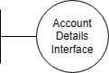
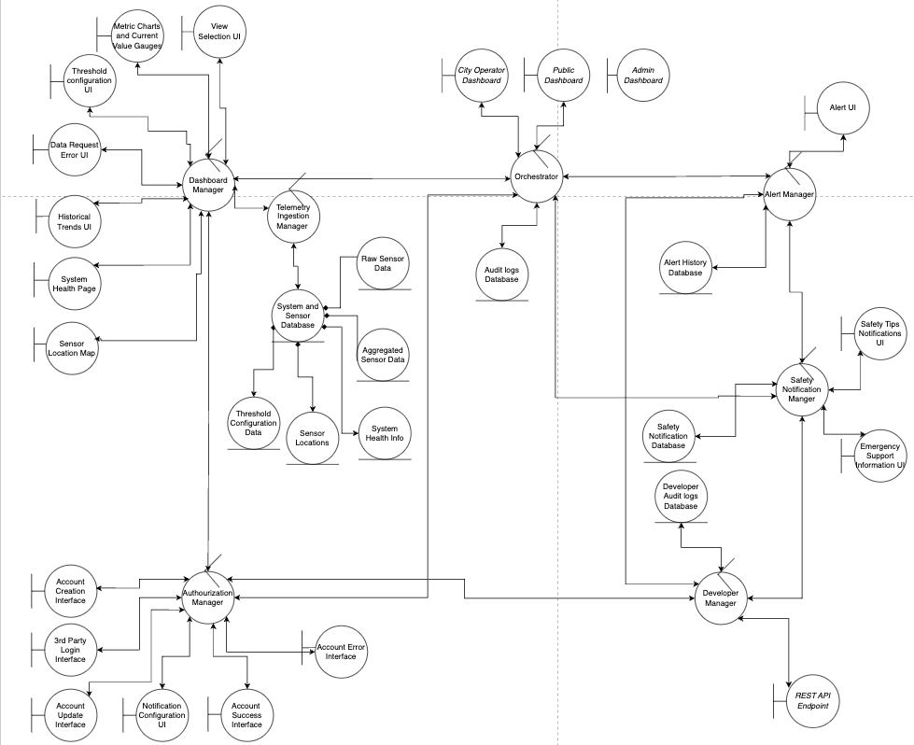
Figure 1: Analysis Class Diagram of SCEMAS

3 Architectural Design

3.1 System Architecture

The architectural design for SCEMAS was reached by analysing the elicited system requirements from deliverable 1, observing how they naturally decomposed into functionally distinct domains, and selecting the architectural style that best reflected that decomposition. The project requirements align itself well with Interaction-Oriented Software Architecture, and the group proposed specifically the PAC architectural style.
During requirements elicitation, the system capabilities grouped into several clearly separable domains, i.e. telemetry ingestion and processing (MQTT data streams, validation, time-series storage, zone-based aggregation), alert management (threshold rule definition, near real-time evaluation, alert lifecycle tracking, subscriber notification), operator and administrator dashboards (real-time maps, metric charts, system health, alert configuration, audit logs), public and third-party data access (read-only REST API with rate-limiting and aggregated zone-level data), and authentication and authorization (3rd party authentication, RBAC enforcement). The critical observation is that each domain does not merely represent a data partition or a user interface (UI) screen – each one combines its own presentation, abstraction, and control logic. This is the defining characteristic of a PAC agent.
An interaction-oriented architecture was clearly needed because SCEMAS is fundamentally interactive, with continuous user navigation, real-time data updates, and multiple stakeholder-facing interfaces. Within the interaction-oriented family, MVC-II and PAC were the primary candidates. MVC-II assumes a single shared Model, and centralized Controller that routes all requests, and a View layer that presents information. This works well when a system has one primary user context interacting with one coherent data model. However, requirements elicitation revealed that SCEMAS has multiple independent user-facing contexts (operator dashboard, admin dashboard, public API, alert notification system) each interacting with different data subsets through different interfaces with different coordination rules. Under MVC-II, the Controller would become a monolithic routing bottleneck coordinating all these separate flows, and the shared Model would blur boundaries between data that should remain separated. The single-Controller assumption does not reflect the structure of the requirements demand.
PAC decomposes the system into a hierarchy of agents, each containing its own Presentation, Abstraction, and Control triad. The functional domains identified during elicitation map directly to this structure: each becomes a PAC agent with its own interface, data model, and coordination logic. Inter-agent communication flows exclusively through Control components, enforcing low coupling between domains while preserving high cohesion within each agent. At the top level, the Orchestrator agent coordinates system-wide concerns including authentication flow and high-level routing. Mid-level agents correspond to the major functional domains: Dashboard Manager, Alert Manager, Developer Access, Safety Notification Manager, and Authorization Manager. Lower-level agents represent specific interface components and data stores. This hierarchy also supports the Open-Close principle — new functional domains such as a mobile notification agent can be introduced into the hierarchy through existing Control interfaces without modifying any existing agent's internal logic. Figure 2 outlines the design architecture using the PAC model.

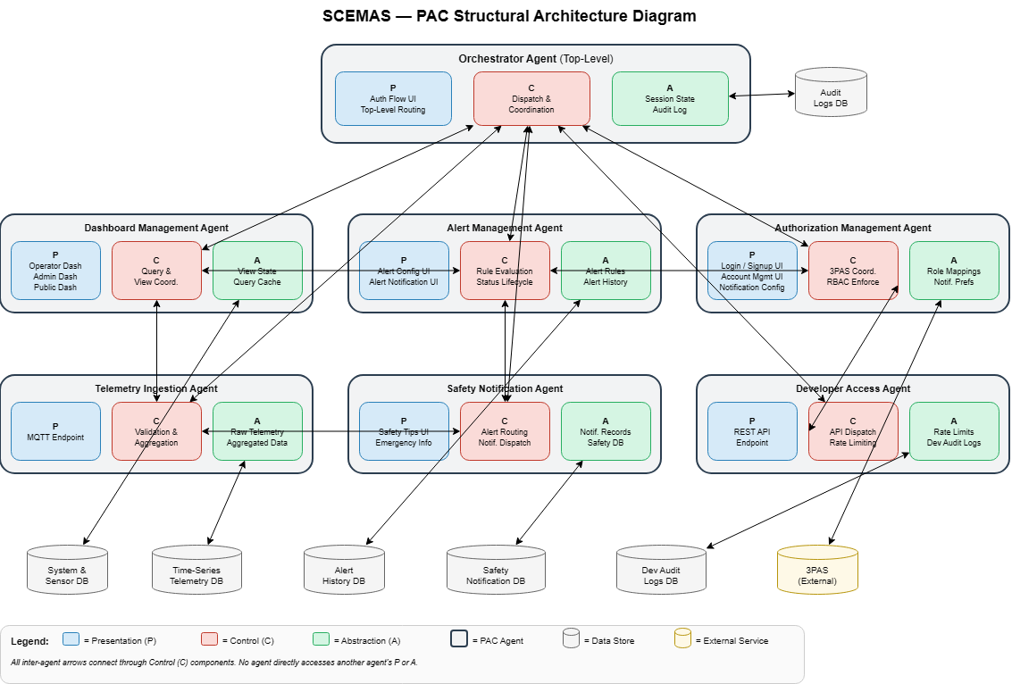
Figure 2: Structural Architecture Diagram of SCEMAS using PAC

Several additional architectural styles were considered. Repository architecture was rejected because repository architectures focus on shared data access and do not naturally support the interactive flow between users and the system. Additionally, the repository architecture is susceptible to a single point of failure, meaning downtime to the datastore could prevent civilians from receiving updated environmental information. Blackboard architecture was considered for its suitability to complex problem-solving with multiple knowledge sources, but SCEMAS requires predictable, deterministic responses when environmental thresholds are exceeded. The opportunistic control structure of blackboard systems makes behavior harder to trace and debug, which is inappropriate for a monitoring and alert system requiring clear execution paths.
Overall, PAC provides a modular, hierarchical architecture that directly reflects the functional decomposition emerging from SCEMAS's requirements, supporting multi-stakeholder interaction, real-time monitoring, and extensibility while maintaining high cohesion within agents and low coupling between them.

3.2 Subsystems
The system is structured into 7 main controllers. These include the Orchestrator, Telemetry Ingestion Manager, Dashboard Manager, Alert Manager, Safety Notification Manager, Authorization Manager and Developer Manager.

The Orchestrator subsystem is responsible to provide different dashboard views according to users (city operator, public user, system administrator). The subsystem communicates with Dashboard, Alert and Safety Notification Manager to retrieve aggregated sensor data, alert and safety notifications to populate on dashboard views. The Orchestrator also receives and processes different user requests through different dashboard presentations and communicates with corresponding subsystems. The Orchestrator also coordinates with the Authorization Manager to determine appropriate dashboard access based on RBAC. The subsystem also contains a database that keeps audit of all logs and activity within the subsystem. This adheres to the PAC architectural style as the controllers associated with each agent communicate with each other and the audit log database represents the abstraction.

The Telemetry Ingestion subsystem is tasked with collecting and processing system and sensor data. System health information, sensor location data, aggregated sensor and raw sensor data are stored within system and sensor database. The Telemetry Ingestion controller collects, processes and sends data to Dashboard manager.
The Dashboard subsystem is responsible for presenting multiple user interfaces that display system health, historical trends, location map, data fetch error and threshold configurations. The Dashboard Manager communicates with Telemetry Ingestion Manager to fetch relevant data for these UIs. Moreover, the subsystem communicates with the Orchestrator to provide requested user interfaces views for the user dashboards. In addition, the subsystem also communicates with the Alert Manager to provide alert monitoring information from sensor data. Furthermore, the subsystem also communicates to Authorization Manager

The Alert Manager is responsible to provide alert notifications to the Orchestrator. The subsystem also maintains a past record through the alert history database. As previously stated, the subsystem also communicates with Dashboard Manager to retrieve sensor data and alert management configurations. The subsystem also connects to Dashboard Manager, to display alert notifications to external systems through a REST API endpoint. In addition, Alert Manager interacts with the Safety Notification Manager.

Safety Notification subsystem is responsible for generating safety tips and emergency support. These are then communicated to the Orchestrator and Developer Manager. The subsystem also keeps track of all safety tips sent through the safety notification database. Moreover, the subsystem also interacts with the Alert Manager to provide alert notification data that supports generating relevant safety notifications.

The Authorization subsystem manages account creation, login and account updates. The subsystem also redirects users to 3PAS to verify authentication. Furthermore, the system interacts with Dashboard and Orchestrator Managers to implement RBAC for displaying data and permissions to access certain system features such as threshold configuration. It also communicates with the Developer Manager to handle secure REST API access to third party developers.

The Developer subsystem oversees providing access to REST API endpoints for third-party developers. The subsystem interacts with Authorization Manager to ensure secure access. The subsystem also communicates with the Alert Manager and Safety Notification Manager to display alert and safety notifications to external systems through the REST API endpoint. The subsystem also keeps records for developer audit logs in a database.

4 Class Responsibility Collaboration (CRC) Cards

Class Name: Orchestrator (Controller Class)
Responsibility: | Collaborators:
Allows access to appropriate dashboard based on user role, user access is determined through Authorization Manager. (1)  Receives and manages requests from different dashboard views (City Operator, Public View and System Admin). (2)  Stores records of system activity in Audit log database. (3)  Receives alert information from alert manger and routes information back to different dashboard views. (4)  Receives data from Dashboard manager. (5)  Communicates with Authorization Manager regarding account access requests (ex. login and sign up).(6)  Displays safety notifications sent by safety notification manager to different user dashboards. (7) | Authorization Manager (1)  City Operator Dashboard, Public Dashboard, Admin Dashboard (2)  Audit Logs Database (3)  Alert Manager (4)  Dashboard Manager (5)  Authorization Manager (6)  Safety Notification Manager (7)

Class Name: City Operator Dashboard (Boundary Class)
Responsibility: | Collaborators:
Displays dashboard view for City Operators .(1)  Processes user requests to view real time collected data, data visuals and active alerts. (2)  Processes user requests to view historical trends and system health. (3) | Orchestrator (1)  Orchestrator (2)  Orchestrator (3)

Class Name: Public Dashboard (Boundary Class)
Responsibility: | Collaborators:
Display dashboard view for public users. (1)  Processes user requests to view aggregated data and active alerts. (2)  Displays safety notifications. (3) | Orchestrator (1)  Orchestrator (2)  Orchestrator (3)

Class Name: System Administrator Dashboard (Boundary Class)
Responsibility: | Collaborators:
Displays dashboard view for system administrators. (1)  Presents alerts, system health and system data. (2)  Receives user input for alert manager (such as defining and updating alerts). (3) | Orchestrator (1)  Orchestrator (2)  Orchestrator (3)

Class Name: Audit Logs Database (Entity Class)
Responsibility: | Collaborators:
Responsible to record all system activity and events. (1) | Orchestrator (1)

Class Name: Alert Manager (Controller Class)
Responsibility: | Collaborators:
Send out alert notification to all subscribed users if a threshold violation occurs. (1)  Saves all information regarding ongoing or previous alerts. (2)  Provides information regarding ongoing alerts for Safety Notification Manager. (3) | Orchestrator, Alert UI (1)  Alert History Database (2)  Safety Notification Manager (3)

Class Name: Alert History Database (Entity Class)
Responsibility: | Collaborators:
Contains all data regarding previous alerts. (1) | Dashboard Manager (1)

Class Name: Alert UI (Boundary Class)
Responsibility: | Collaborators:
Format and display all information regarding alert. (1)  Collects user input for sizing/close. (2) | Alert Manager (1)  Alert Manager (2)

Class Name: Safety Notification Manager (Controller Class)
Responsibility: | Collaborators:
Communicates with alert manager, receives active alert notifications. (1)  Responsible to send safety notifications and Emergency Support to orchestrator and developer manager. (2)  Records all safety notifications activity to safety notification database. (3)  Communicates non-alert related safety tips to Orchestrator. (4) | Alert Manager (1)  Orchestrator, Developer Manager, Safety Tips Notifications UI, Emergency Support Information UI (2)  Safety Notification Database (3)  Orchestrator (4)

Class Name: Safety Tips Notifications UI (Boundary Class)
Responsibility: | Collaborators:
Responsible to send safety tips created by the Incident Response Team. (1)  Responsible to display a UI which contains the safety notifications. (2) | Safety Notification Manager (1)  Safety Notification Manager (2)

Class Name: Emergency Support Information UI (Boundary Class)
Responsibility: | Collaborators:
Responsible to provide a view which contains supplementary supporting information during an active alert or emergency. (1) | Safety Notification Manager (1)

Class Name: Safety Notification Database (Entity Class)
Responsibility: | Collaborators:
Records events related to safety tips and emergency support (creation, updates and notification sent). (1) | Safety Notification Manager (1)

Class Name: Developer Manager (Controller Class)
Responsibility: | Collaborators:
Manage the SCEMAS public and third-party data access workflow.  Handle requests made to the REST API endpoint. (2)  Verify that third-party developer requests are authorized through Authorization Manager and the Third-Party Authentication Service (3PAS). (3)  Apply request limiting to protect the availability of public endpoints. (4)  Return aggregated, non-sensitive, zone-level data to external clients. (5)  Return appropriate errors for invalid, unauthorized, or rate-limited requests. (6)  Record developer API access activity, failures, and relevant alert or safety notification information for accountability. (7) | REST API Endpoint (2)  Authorization Manager (3)  REST API Endpoint (4)  REST API Endpoint (5)  REST API Endpoint (6)  Developer Audit Logs Database (7)  Alert Manager(7)  Safety Notification Manager (7)

Class Name: REST API Endpoint (Boundary Class)
Responsibility: | Collaborators:
Serve as the external access point for the SCEMAS public read-only API.  Receive public and third-party developer requests for SCEMAS data.  Pass incoming requests to the Developer Manager for processing. (3)  Return aggregated, non-sensitive, zone-level data to external clients. (4)  Return appropriate responses for invalid, unauthorized, or rate-limited requests. (5) | Developer Manager (3)  Developer Manager (4)  Developer Manager (5)

Class Name: Developer Audit Logs Database (Entity Class)
Responsibility: | Collaborators:
Store records of developer API access activity. (1)  Store records of developer API failures, including invalid, unauthorized, and rate-limited requests. (2)  Maintain developer access records for accountability and later review. (3) | Developer Manager (1)  Developer Manager (2)  Developer Manager (3)

Class Name: Authorization Manager (Controller Class)
Responsibility: | Collaborators:
Manage account creation, login, and account update workflows for SCEMAS users. (1)  Redirect users to the Third-Party Authentication Service (3PAS) and handle the returned authentication result. (2)  Map authenticated users to the correct SCEMAS role and enforce role-based access control decisions. (3)  Communicate authorization outcomes to the system for dashboard and API access. (4)  Store and update user notification and subscription preferences within SCEMAS after authentication. (5)  Return account success or account error outcomes to the user-facing workflow. (6) | Account Creation Interface (1)  Account Update Interface (1)  Third-Party Login Interface (2)  Orchestrator (3)  Dashboard Manager (4)  Orchestrator (4)  Developer Manager (4)  Notification Configuration (5)  Account Success Interface (6)  Account Error Interface (6)

Class Name: Account Creation Interface (Boundary Class)
Responsibility: | Collaborators:
Display the account creation interface for SCEMAS users.  Collect required registration information from the user.  Send account creation information to Authorization Manager for processing. (3) | Authorization Manager (3)

Class Name: Account Update Interface (Boundary Class)
Responsibility: | Collaborators:
Display the account update interface for authenticated users.  Collect updated account or preference information from the user.  Send account update requests to Authorization Manager for processing. (3) | Authorization Manager (3)

Class Name: Third-Party Login Interface (Boundary Class)
Responsibility: | Collaborators:
Support user authentication through the Third-Party Authentication Service (3PAS).  Collect user login credentials during redirected authentication workflows.  Return authentication results to Authorization Manager. (3) | Authorization Manager (3)

Class Name: Notification Configuration UI (Boundary Class)
Responsibility: | Collaborators:
Display notification and subscription preference options to the user.  Collect selected notification settings from the user.  Send notification preference updates to Authorization Manager. (3) | Authorization Manager (3)

Class Name: Account Success Interface (Boundary Class)
Responsibility: | Collaborators:
Display successful account-related outcomes to the user. (1)  Indicate that the user may proceed in the SCEMAS workflow. (2) | Authorization Manager (1)  Authorization Manager (2)

Class Name: Account Error Interface (Boundary Class)
Responsibility: | Collaborators:
Display account-related errors to the user. (1)  Prompt the user to retry or correct submitted information. (2) | Authorization Manager (1)  Authorization Manager (2)

Class Name: Dashboard Manager (Controller Class)
Responsibility: | Collaborators:
Apply view selections. (1)  Query sensor readings. (2)  Query and display system health related information. (3)  Query and display sensor locations. (4)  Gracefully handle data request errors and provide feedback to users. (5)  Organize displays and manage dashboard views. (6)  Display queried data through wanted interface. (7)  Save and Intake Threshold configuration data. (8) | View Selection UI (1)  Telemetry Ingestion Manager (2)  Telemetry Ingestion Manager and System Health Page (3)  Telemetry Ingestion Manager and Sensor Location Map (4)  Data Request Error UI (5)  Orchestrator (6)  Historical Trends UI and Metrics Charts and Current Value Gauges (7)  Threshold Configuration Data and Threshold Configuration UI (8)

Class Name: System and Sensor Database (Entity Class)
Responsibility: | Collaborators:
Contains sensor data segmented by zones.  Contains raw sensor readings. (1)  Contains aggregated sensor data. (2)  Contains sensor locations. (3)  Contains system health information. (4)  Contains threshold configuration data. (5) | Raw Sensor Data (1)  Aggregated Sensor Data (2)  System Health Info (3)  Sensor Locations (4)  Threshold Configuration Data (5)

Class Name: Raw Sensor Database (Entity Class)
Responsibility: | Collaborators:
Contains raw time-series data from sensor data streams.

Class Name: Aggregated Sensor Data (Entity Class)
Responsibility: | Collaborators:
Contains aggregated sensor metrics.

Class Name: System Health Info Database (Entity Class)
Responsibility: | Collaborators:
Contains information regarding the health of the entire system.

Class Name: Sensor Locations Database (Entity Class)
Responsibility: | Collaborators:
Contains coordinates of all sensors installed.

Class Name: Threshold Configuration Data (Entity Class)
Responsibility: | Collaborators:
Contains all data range thresholds.

Class Name: System Health Page (Boundary Class)
Responsibility: | Collaborators:
Formats and displays system health information (1)  Collect user input regarding view sizing/close. (2) | Dashboard Manager (1)  Dashboard Manager (2)

Class Name: Historical Trends UI (Boundary Class)
Responsibility: | Collaborators:
Formats and displays historical trends (1)  Collect user input regarding view sizing/close. (2) | Dashboard Manager (1)  Dashboard Manager (2)

Class Name: Sensor Location Map UI (Boundary Class)
Responsibility: | Collaborators:
Formats and displays sensor coordinates into an easy to navigate map. (1)  Collect user input regarding view sizing/close. (2) | Dashboard Manager (1)  Dashboard Manager (2)

Class Name: Threshold Configuration UI (Boundary Class)
Responsibility: | Collaborators:
Provide option to delete old thresholds.  Provide option to add more thresholds.  Display Threshold configuration UI. (1)  Collect user input regarding view sizing/close. (2) | Dashboard Manager (1)  Dashboard Manager (2)

Class Name: Metric Charts and Current Value Gauges (Boundary Class)
Responsibility: | Collaborators:
Present current data in metric charts and current value gauges. (1)  Collect user input regarding view sizing/close. (2) | Dashboard Manager (1)  Dashboard Manager (2)

Class Name: Data Fetch Error UI (Boundary Class)
Responsibility: | Collaborators:
Present info regarding data query errors. (1)  Collect user input regarding view closing. (2) | Dashboard Manager (1)  Dashboard Manager (2)

Class Name: View Selection UI (Boundary Class)
Responsibility: | Collaborators:
Display options for view preferences and what views should be visible/hidden. (1)  Accept view selections input from user. (1) | Dashboard Manager (1)  Dashboard Manager (2)

Class Name: Telemetry Ingestion Manager (Controller)
Responsibility: | Collaborators:
Processes and stores aggregated and raw sensor data. (1)  Processes and stores sensor location data and system health information. (2)  Keeps track and checks data against stored thresholds. (3)  Provides data when data requested from Dashboard Manager. (4) | System and Sensor Database (1)  System and Sensor Database (2)  System and Sensor Database (3)  Dashboard Manager (4)

A Division of Labour
Include a Division of Labour sheet which indicates the contributions of each team member. This sheet must be signed by all team members.

Ali Zain
- Wrote 1 (1.1–1.3).
- Helped align the document with the updated PAC architectural style.
- Contributed to Section 4 (CRC Cards), specifically Developer Manager, Authorization Management, and related supporting classes.
- Helped ensure consistency between the Analysis Class Diagram, Architectural Design, and CRC Cards.
- Fixed formatting and consistency issues across the document and completed a full document revision with the team.

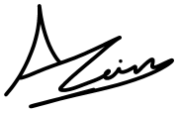

Sachika Saxena
- Completed section 3.2
- Revised and updates section 3.2 after changes to Analysis Class Diagram
- Contributed to Section 4 (CRC Cards) - Orchestrator Manager, Telemetry Ingestion Manager Safety Notifications Manager and their corresponding entities and boundary classes.
- Contributed to final full document review



Colin Chambachan
- Wrote section 3.1
- Pitched PAC architectural design
- Completed Architectural Design Diagram
- Worked as group to come up with Analysis class diagram
- Contributed in final full document review



Dharav Shah
- Completed the Analysis Class Diagram (Section 2)
- Contributed to Section 4 (CRC Cards) - Dashboard Manager, Alert Manger, and all connected entity and boundry class
- Made sure all of section 4 had a similar format
- Re-visited and edited entire doc with the team

