DBMS MINI PROJECT
HOTEL ROOM BOOKING SYSTEM

Database Management System (DBMS)

Submitted by: Dharika Sharma
UID : 24BCD10089
Course : BCA hons( Data science and research)
Section: 25 BCD 2B
Submitted to: Ms. Harkamal Kaur

1. Introduction
The Hotel Room Booking System is a database-driven mini project designed to manage hotel rooms, guest details, reservations, payments/charges, and cancellations. It stores information in related tables so that records can be searched and updated accurately. The project uses Python for the application logic and SQLite as the relational database.
The system demonstrates core DBMS concepts such as tables, primary keys, foreign keys, constraints, SQL INSERT/SELECT/UPDATE operations, and joins. It is a small console-based prototype suitable for learning and demonstration; it is not intended for production hotel operations.

2. Objectives / Problem Statement
Problem statement:
Manual hotel booking records can lead to duplicate entries, difficulty checking room availability, and errors in calculating room charges. A simple computerized system is needed to keep guest and booking data organized and to update room status when a booking is created or cancelled.
Objectives:
- Store room, guest, and booking details in structured relational tables.
- Display available and booked rooms.
- Create a booking and calculate the total amount from the nightly rate and number of nights.
- View all bookings using SQL JOIN operations.
- Cancel a confirmed booking and make the room available again.
- Apply integrity rules using primary keys, foreign keys, UNIQUE, NOT NULL, and CHECK constraints.

3. Modules, Tools and Technologies Used

3.1 Modules
- Room Management: Displays room ID, room type, nightly price, and availability status.
- Guest Management: Stores each guest's name and unique phone number.
- Booking Management: Creates reservations, calculates nights and total charges, and assigns a booking ID.
- Booking Register: Shows reservation details by joining bookings, guests, and rooms.
- Cancellation: Marks a booking as cancelled and changes the room status back to Available.

3.2 Tools and technologies
Tool / Technology | Purpose
Python 3 | Application logic and menu-driven interface
SQLite 3 | Relational database; included with Python
sqlite3 module | Connects Python to the database and executes SQL
VS Code / IDLE | Editor and environment for running the program
SQL | CREATE, INSERT, SELECT, UPDATE, JOIN, and constraints

3.3 Database design
The project uses three related tables:
- rooms(room_id PRIMARY KEY, room_type, price_per_night, status)
- guests(guest_id PRIMARY KEY, name, phone UNIQUE)
- bookings(booking_id PRIMARY KEY, guest_id FOREIGN KEY, room_id FOREIGN KEY, check_in, check_out, total_amount, booking_status)
Relationship: one guest can make multiple bookings over time; each booking references one guest and one room. For simplicity, this prototype allows only one active booking per room at a time.

4. Code with Outputs
Save the following program as hotel_booking.py. On the first run, it creates hotel_booking.db and initializes the tables and three sample rooms. Run it using: python hotel_booking.py

4.1 Source code
main()
if __name__ == "__main__":

print("Invalid choice. Please try again.")
else:
break
print("Thank you for using the system.")
elif choice == "5":
print("Please enter a valid booking ID.")
except ValueError:
cancel_booking(int(input("Booking ID to cancel: ")))
try:
elif choice == "4":
show_bookings()
elif choice == "3":
print(f"Input/database error: {error}")
except (ValueError, sqlite3.IntegrityError) as error:
book_room(name, phone, room_id, check_in, check_out)
check_out = input("Check-out (YYYY-MM-DD): ").strip()
check_in = input("Check-in (YYYY-MM-DD): ").strip()
room_id = int(input("Room ID: "))
phone = input("Phone: ").strip()
name = input("Guest name: ").strip()
try:
elif choice == "2":
show_rooms()
if choice == "1":
choice = input("Enter choice: ").strip()
print("5. Exit")
print("4. Cancel booking")
print("3. View bookings")
print("2. Book a room")
print("1. View rooms")
print("\\n=== HOTEL ROOM BOOKING SYSTEM ===")
while True:
setup_database()
def main():

print(f"Booking {booking_id} cancelled successfully.")
conn.execute("UPDATE rooms SET status = 'Available' WHERE room_id = ?", (row[0],))
)
(booking_id,)
"UPDATE bookings SET booking_status = 'Cancelled' WHERE booking_id = ?",
conn.execute(
return
print("Cancellation failed: confirmed booking not found.")
if row is None:
).fetchone()
(booking_id,)
"SELECT room_id FROM bookings WHERE booking_id = ? AND booking_status = 'Confirmed'",
row = conn.execute(
with connect_db() as conn:
def cancel_booking(booking_id):

print("-" * 100)
print("No bookings found.")
if not rows:
print(f"{row[0]:<5}{row[1]:<18}{row[2]:<8}{row[3]:<10}{row[4]:<13}{row[5]:<13}₹{row[6]:<11.2f}{row[7]}")
for row in rows:
print(f"{'ID':<5}{'Guest':<18}{'Room':<8}{'Type':<10}{'Check-in':<13}{'Check-out':<13}{'Amount':<12}{'Status'}")
print("-" * 100)
print("\nBOOKING REGISTER")
""").fetchall()
ORDER BY b.booking_id
JOIN rooms r ON b.room_id = r.room_id
JOIN guests g ON b.guest_id = g.guest_id
FROM bookings b
b.check_in, b.check_out, b.total_amount, b.booking_status
SELECT b.booking_id, g.name, r.room_id, r.room_type,
rows = conn.execute("""
with connect_db() as conn:
def show_bookings():

print(f"Total : ₹{total:.2f}")
print(f"Stay : {check_in} to {check_out} ({nights} night(s))")
print(f"Room : {room_id}")
print(f"Guest : {name}")
print(f"Booking ID : {booking_id}")
print("\nBOOKING CONFIRMED")

booking_id = cursor.lastrowid
conn.execute("UPDATE rooms SET status = 'Booked' WHERE room_id = ?", (room_id,))
""", (guest_id, room_id, check_in, check_out, total))
VALUES (?, ?, ?, ?, ?)
INSERT INTO bookings(guest_id, room_id, check_in, check_out, total_amount)
cursor = conn.execute("""
total = room[0] * nights
).fetchone()[0]
"SELECT guest_id FROM guests WHERE phone = ?", (phone,)
guest_id = conn.execute(
)
(name, phone)
"INSERT OR IGNORE INTO guests(name, phone) VALUES (?, ?)",
conn.execute(

return
print("Booking failed: room is already booked.")
if room[1] != "Available":
return
print("Booking failed: room does not exist.")
if room is None:
).fetchone()
(room_id,)
"SELECT price_per_night, status FROM rooms WHERE room_id = ?",
room = conn.execute(
with connect_db() as conn:

raise ValueError("Check-out date must be after check-in date.")
if nights <= 0:
nights = (end - start).days
end = date.fromisoformat(check_out)
start = date.fromisoformat(check_in)
def book_room(name, phone, room_id, check_in, check_out):

print("-" * 54)
print(f"{row[0]:<10}{row[1]:<12}₹{row[2]:<15.0f}{row[3]}")
for row in rows:
print(f"{'Room ID':<10}{'Type':<12}{'Price/Night':<16}{'Status'}")
print("-" * 54)
print("\nROOM AVAILABILITY")
""").fetchall()
FROM rooms ORDER BY room_id
SELECT room_id, room_type, price_per_night, status
rows = conn.execute("""
with connect_db() as conn:
def show_rooms():

])
(201, "Deluxe", 4000)
(102, "Double", 2500),
(101, "Single", 1500),
""", [
VALUES (?, ?, ?, 'Available')
INSERT OR IGNORE INTO rooms(room_id, room_type, price_per_night, status)
conn.executemany("""
""")
)
CHECK(check_out > check_in)
FOREIGN KEY (room_id) REFERENCES rooms(room_id),
FOREIGN KEY (guest_id) REFERENCES guests(guest_id),
booking_status TEXT NOT NULL DEFAULT 'Confirmed',
total_amount REAL NOT NULL CHECK(total_amount > 0),
check_out TEXT NOT NULL,
check_in TEXT NOT NULL,
room_id INTEGER NOT NULL,
guest_id INTEGER NOT NULL,
booking_id INTEGER PRIMARY KEY AUTOINCREMENT,
CREATE TABLE IF NOT EXISTS bookings (
conn.execute("""
""")
)
phone TEXT NOT NULL UNIQUE
name TEXT NOT NULL,
guest_id INTEGER PRIMARY KEY AUTOINCREMENT,
CREATE TABLE IF NOT EXISTS guests (
conn.execute("""
""")
)
CHECK(status IN ('Available', 'Booked'))
status TEXT NOT NULL DEFAULT 'Available'
price_per_night REAL NOT NULL CHECK(price_per_night > 0),
room_type TEXT NOT NULL,
room_id INTEGER PRIMARY KEY,
CREATE TABLE IF NOT EXISTS rooms (
conn.execute("""
with connect_db() as conn:
def setup_database():

return conn
conn.execute("PRAGMA foreign_keys = ON")
conn = sqlite3.connect(DB_NAME)
def connect_db():

DB_NAME = "hotel_booking.db"

from datetime import date
import sqlite3

4.2 Output screenshots
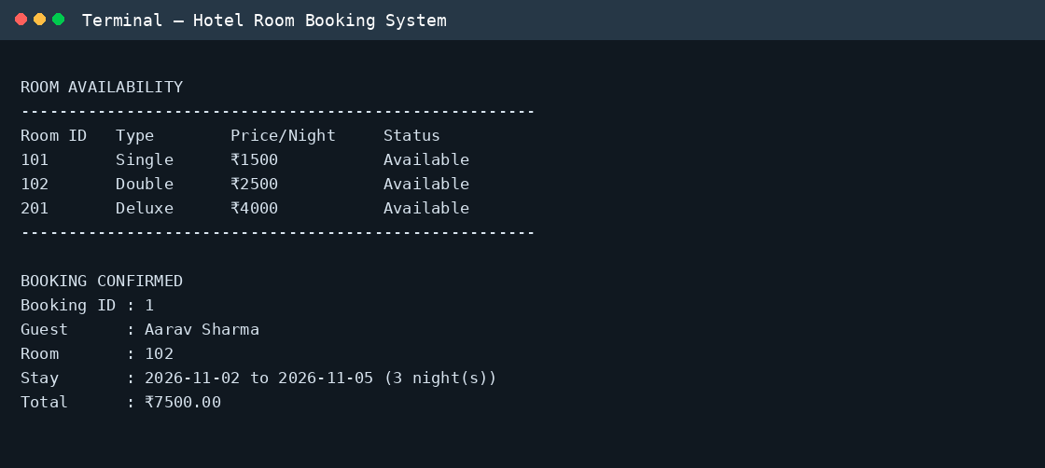
Figure 1: Room availability and booking confirmation.
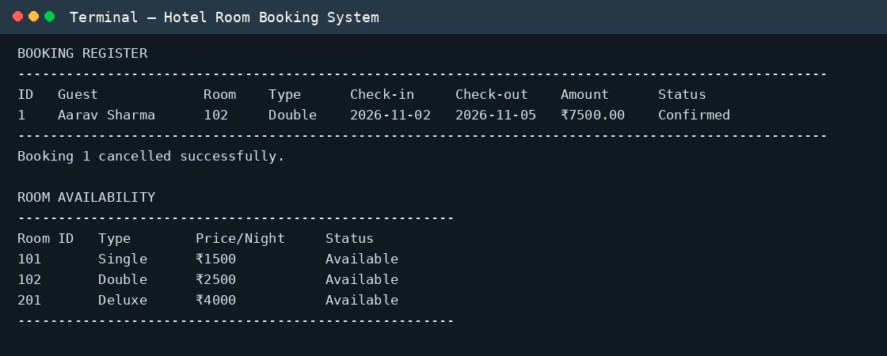
Figure 2: Booking register, cancellation, and updated room availability.
The screenshots below show a sample demonstration run: room availability, successful booking, booking register, cancellation, and the updated room status. They are terminal-style screenshots of the program output.

4.3 Sample test cases
Test | Input / Action | Expected result
1 | View rooms | Three sample rooms are displayed as Available.
2 | Book room 102 for 3 nights | Booking is confirmed; amount = ₹7,500.
3 | View bookings | The booking register shows guest, room, dates, amount, and status.
4 | Cancel booking 1 | Booking becomes Cancelled and room 102 becomes Available.

5. Conclusion
The Hotel Room Booking System demonstrates how a relational database can organize hotel information and support common operations such as viewing rooms, making bookings, displaying joined records, and cancelling reservations. Primary keys, foreign keys, uniqueness rules, and checks help maintain data integrity. The project can be extended with date-overlap checking, user authentication, payment records, a graphical interface, and reports for a more complete hotel management solution.
Note: Replace the cover-page blanks with your own details. The output screenshots use sample data and dates for demonstration. Run the program on your computer if your instructor requires screenshots captured from your own environment.

