

M505 INTRO TO AI AND MACHINE LEARNING

MACHINE LEARNING-BASED LOAN APPROVAL PREDICTION
Table of Contents
1. Introduction and Business Problem 3
1.1 Business Context 3
1.2 Problem Definition 3
1.3 Business Value 4
2. Dataset Description and Data Exploration 4
2.1 Dataset Overview 4
2.2 Data Quality Assessment 5
2.3 Exploratory Data Analysis Findings 6
2.4 Evaluation Metric Selection 9
3. Data Preprocessing and Feature Engineering 11
3.1 Outlier Treatment 11
3.2 Feature Encoding 11
3.3 Feature Scaling 11
3.4 Feature Selection 12
3.5 Pipeline Architecture 12
4. Model Training and Hyperparameter Tuning 12
4.1 Train-Test Split 12
4.2 Model Selection Rationale 13
4.3 Hyperparameter Tuning Approach 13
4.4 Logistic Regression Tuning 13
4.5 Random Forest Tuning 13
5. Model Evaluation and Results Analysis 14
6. Final Discussion and Business Recommendations 17
6.1 Overall Pipeline Evaluation and Strengths 17
6.2 Business Implications of Results 18
6.3 Model Explainability and Important Features 18
6.4 Limitations of the Proposed Solution 18
6.5 Data-Driven Recommendations and Deployment Consideration 18
7. Conclusion 19
References 20

1. Introduction and Business Problem

1.1 Business Context
Loan approval is a high-impact process for financial institutions because lending decisions In the financial sector, the loan application process can have a significant impact on an institution's profitability, credit exposure, and customer acquisition. Financial access has been growing and there is pressure on lenders to develop scalable assessment systems. In 2021, the World Bank reported that 76% of adults hold a financial account globally compared with 51% in 2011, marking strong progress in the representation of adults in financial services, and greater demand for the credit assessment process to be more efficient (World Bank, 2022). Traditional lending workflows involve officers manually assessing applicant earnings, employment status, credit history and loan needs; this can be time-consuming when dealing with high-volume applications. The evaluation results may also vary because of human judgment inconsistencies (Nureni and Adekola, 2022). Thus, this project aims to create a machine learning-based loan approval prediction system that uses historical data of the loan applicants to find the patterns of loan approval. The approach enables financial institutions to manage lending risk and have human oversight while providing faster pre-screening and a consistent decision.

1.2 Problem Definition
The goal of this project is to build a machine learning model that can predict if a loan application is going to be approved based on the financial and demographic data of the person applying for the loan. A business problem is stated as a supervised binary classification problem as there are labelled examples in the historical loan applications with details of the applicant and the corresponding outcome of the loan application (Sinap, 2024).
Table 1: Machine Learning Problem Formulation
Component | Description
Learning approach | Supervised learning
Task type | Binary classification
Target variable | Loan approval status
Prediction output | Approved or Rejected
Input data | Financial and demographic applicant attributes
The model data will be obtained from the past loan applications of the borrower, such as income, loan features, credit history, employment data, and previous loan application decisions. The labelled historical data helps the model identify patterns in successful and failed loan applications. The trained model can then be used to make predictions on unseen applications, thereby aiding the faster and consistent preliminary decision-making process.

1.3 Business Value
The proposed machine learning solution offers a number of business benefits. Automated preliminary screening saves time, which cuts down on the amount of manual screening required and allows for quicker response to customers. By having a consistent analytical approach for all applications, the model provides consistency in decision making (Chouksey et al., 2023). It also enables the more effective targeting of resources through ensuring that loan officers are able to attend to those more complicated cases that call for expert judgment. Furthermore, recognizing key approval factors can aid financial institutions comprehend the factors that impact lending choices, and inform improved risk administration methods.

2. Dataset Description and Data Exploration

2.1 Dataset Overview
This project makes use of the Loan Approval Classification Dataset which is publicly available on Kaggle. A tabular data structure that holds financial and demographic information of real-life loan applicants, tailored for binary classification. The data was retrieved directly as a CSV file from the Kaggle repository and imported into the Jupyter Notebook with the help of 'pd.read_csv("loan_data.csv")'.
Table 2: Dataset Characteristics
Category | Description
Dataset Type | Structured tabular dataset
Machine Learning Problem | Binary classification
Number of Records | 45,000 applicant records
Number of Features | 13 input features + 1 target variable
Target Variable | loan_status 0 = Rejected, 1 = Approved
Numerical Features | Age, income, employment experience, loan amount, interest rate, loan-to-income ratio, credit history length, credit score
Categorical Features | Gender, education level, home ownership type, loan intent, previous loan default history
The data has two types of features: numeric and categorical. Numerical features are financial metrics that can be measured, such as the person's income (person_income), loan amount (loan_amnt), interest rate (loan_int_rate), income-to-loan ratio (loan_percent_income), credit history length and credit score (Shi et al., 2022). Categorical features are the characteristics of the applicant, including education level, home ownership, loan purpose and previous loan defaults. These attributes, combined, give financial/demographic details for supervised loan approval classification.

2.2 Data Quality Assessment
A data quality assessment was performed in a structured way to check if the data had to be cleaned prior to building the model. The analysis included checking input data for missing values, duplicated records, and suitability of features. The missing values were explored using df.isnull().sum(), and the notebook showed that there were no missing values in all 14 features. Even though imputation was not necessary, SimpleImputer was added into the pre-processing pipeline for robustness with future unseen data (Shinde et al., 2022).
Using df.duplicated().sum(), the analysis was repeated to identify any duplicate records: there were no duplicate records, which means that all 45,000 loan applications were unique observations. A numerical and categorical variable were found in the feature assessment. Some numerical attributes (person_income, credit_score) had different scales, so they needed to be standardised for models like Logistic Regression (Rainio et al., 2024). The categorical features were encoded using OneHotEncoder (loan_intent, person_education) and binary encoding (previous_loan_defaults_on_file). Person_age (144 years) and person_emp_exp (125 years) were found to be skewed by outliers and were trimmed at the 99th percentile to minimize the impact of the outliers without losing data records.

2.3 Exploratory Data Analysis Findings
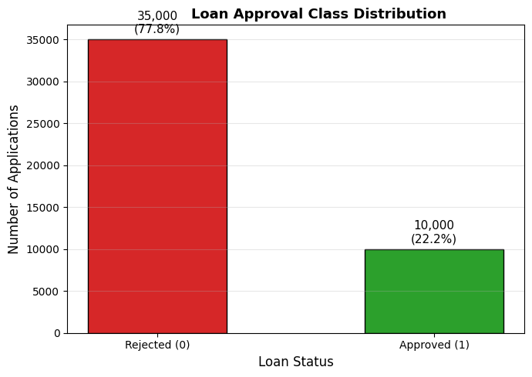
Figure 1: Loan Approval Class Distribution
(Source: Google Colab)
The distribution of the target variable shows an imbalance as displayed in Figure 1: 35,000 (77.8%) are labelled as rejected (0) and 10,000 (22.2%) are labelled as approved (1). This imbalance is consequential – a naïve classifier that always classifies as rejection would have obtained 77.8% accuracy without learning anything meaningful. The choice of class_weight='balanced' for the three models and the choice of evaluation metrics of all models, F1-score and ROC-AUC, was directly informed by this finding.
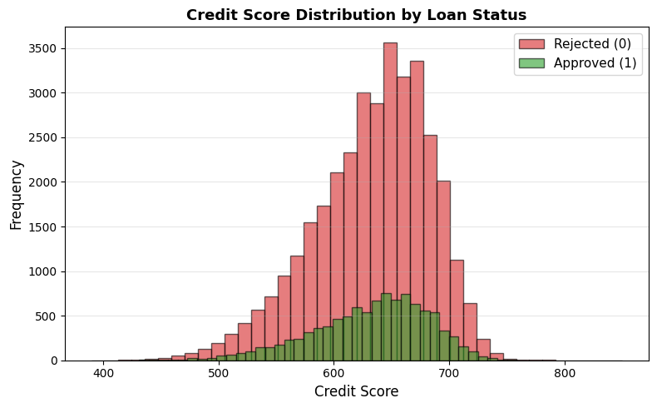
Figure 2: Credit Score Distribution by Loan Status
(Source: Google Colab)
As shown in figure 2, credit scores of approved applicants tend to be around high ranges and rejected applicants around low ranges. The distributions are not completely disjointed, and hence, a single feature is not enough to classify them (Shinde et al., 2022).
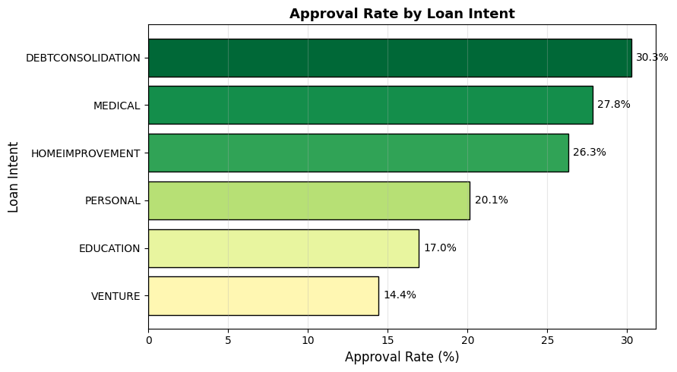
Figure 3: Approval Rate by Loan Intent
(Source: Google Colab)
As shown in Figure 3, education loans and home improvement loans were the most likely to be approved, and venture loans were the least likely. This indicates that loan purpose is seen as a risk indicator along with financial indicators.
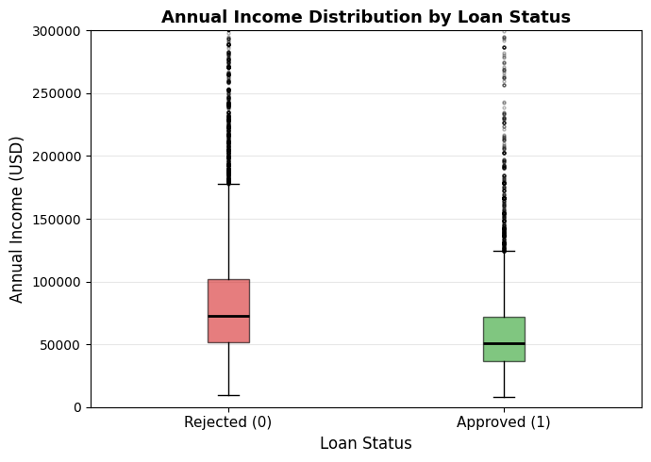
Figure 4. Annual Income Distribution by Loan Status
(Source: Google Colab)
Figure 4 illustrates that rejected and approved applicants have overlapping income distributions with a similar median income range. This is an indication that income alone is not a good individual indicator of loan approval success.
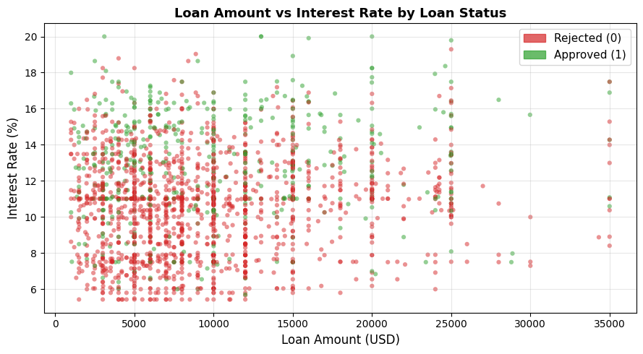
Figure 5: Loan Amount vs Interest Rate by Loan Status
(Source: Google Colab)
Figure 5 illustrates that the number of applications rejected is concentrated at higher interest rates for all loan amounts, whereas the number of applications approved is consistently concentrated at lower interest rates, indicating that interest rate is a good separation signal between the two classes (Rainio et al., 2024).

2.4 Evaluation Metric Selection
Table 3: Evaluation Metrics
Metric | Business Importance
Accuracy | Overall prediction correctness across all applications
Precision | Reduces incorrect approvals — protects lender from high-risk loans
Recall | Identifies all suitable applicants — reduces missed lending opportunities
F1-score | Balances precision and recall under class imbalance
ROC-AUC | Measures the model's ability to separate approved from rejected applications across all classification thresholds
Accuracy is not enough here, as the dataset is imbalanced (77.8% / 22.2%). A model that predicts rejection of all applicants would achieve 77.8% accuracy, but no use in the real world. F1-score and ROC-AUC are therefore used as the primary metrics, since they not only consider the performance of the minority class, but also the ranking ability of the model at different decision thresholds (Rainio et al., 2024).

3. Data Preprocessing and Feature Engineering

3.1 Outlier Treatment
Extreme values in the numerical features were determined to be unrealistic because they may adversely affect the learning of the model, and these were removed from the data using data preprocessing (Verdonck et al., 2024). The maximum age of the person was 144 years, and the maximum of person_emp_exp was 125 years, which were far too high for loan applicants and employment experience. Instead of removing affected records, percentile-based capping was applied using .clip(upper=df["column"].quantile(0.99)). This method preserved all 45,000 records while limiting extreme observations that could distort model patterns. The approach reduced the impact of abnormal values on decision boundaries, particularly for Logistic Regression and tree-based models.

3.2 Feature Encoding
Categorical features were encoded into numeric values before model training. There were two categories for the binary variable previous_loan_defaults_on_file, which was directly encoded with Yes coded as a 1 and No coded as a 0. The variables person_gender, person_education, person_home_ownership and loan_intent were one-hot-encoded with OneHotEncoder(handle_unknown="ignore") (Haque and Hassan, 2024). This resulted in binary indicator variables without causing prediction errors for unseen categories when deployed. To avoid data leakage, encoding was carried out within the pipeline.

3.3 Feature Scaling
The numerical variables had very large range differences; person_income had high-value monetary amounts, and loan_int_rate had percentage amounts. For numerical features, therefore, StandardScaler was used to scale the values to have the mean equal to 0 and the standard deviation equal to 1 (Shinde et al., 2022). Scaling was especially significant for Logistic Regression, as large-scale variables can have an impact on the coefficients of the model and regularisation. The process was applied to tree-based algorithms, which were less affected by scaling, but ensured consistency between models.

3.4 Feature Selection
SelectKBest with the f_classif scoring method was used for feature selection. The ANOVA F-statistic found the features that were most closely related to the target variable. The top 10 were chosen to eliminate low-information variables, such as irrelevant one-hot encoded categories (Verdonck et al., 2024). This lowered noise and also enhanced running efficiency. It is applied after the preprocessing and before training the model.

3.5 Pipeline Architecture
Pipeline and ColumnTransformer were used to create a complete machine learning pipeline. The numerical features were subjected to median imputation, followed by scaling; categorical features were subjected to most-frequent imputation, followed by one-hot encoding. The last workflow used was column transformer/ SelectKBest/classifier. This architecture ensured that there was no data leakage since it was only the parameters which were learned for the preprocessing during training (Salman et al., 2024). It also enhanced reproducibility, allowed for joint optimisation with GridSearchCV, and helped to design an optimised deployment workflow that can convert raw applicant data to predictions in a single process.

4. Model Training and Hyperparameter Tuning

4.1 Train-Test Split
The dataset was split into 80% train and 20% test with train_test_split, resulting in 36,000 training records and 9,000 testing records. The parameter random_state=42 was used to guarantee reproducibility of the running of the code (Barbierato and Gatti, 2024). The proportion of approved applications to rejected applications was the same for both subsets, with 77.8% rejected and 22.2% approved, as was the original class distribution, using stratified sampling with stratify=y. This was needed because class imbalance can affect model learning and lead to incorrect evaluation if it is not maintained.

4.2 Model Selection Rationale
The three algorithms were chosen to represent various learning approaches. An interpretable linear baseline model, Logistic Regression, was used for binary classification. Random Forest was chosen as a non-linear ensemble method which combines several decision trees and can capture feature interactions and provide feature importance analysis (Jui and Rivas, 2024). Gradient Boosting was added as it is a method of sequential tree learning that addresses previous prediction mistakes and works well on structured tabular data.

4.3 Hyperparameter Tuning Approach
The model optimisation was done by optimising the model using GridSearchCV with 5-fold cross-validation, and the evaluation metric was F1-score. F1-score was chosen as the metric since it provides a trade-off between precision and recall, which is crucial for the credit decision. To avoid data leakage, the test data was not used in the tuning phase. Best_estimator_ was used to fine-tune the best configuration.

4.4 Logistic Regression Tuning
The C regularisation parameter was tuned using values [0.01, 0.1, 1, 10, 100]. Smaller values apply stronger regularisation and may cause underfitting, while larger values allow greater complexity and increase overfitting risk. penalty="l2" was fixed to reduce excessive coefficient values and improve model stability (Hanson, 2022).

4.5 Random Forest Tuning
Random Forest tuning evaluated n_estimators values [50, 100, 200] and max_depth values [None, 10, 20]. More trees improve stability but increase computation, while deeper trees may overfit. The best combination was selected through cross-validation F1-score across all nine parameter combinations (Ferrer, 2022).

5. Model Evaluation and Results Analysis
Table 4: Model Performance Comparison
Model | Class | Precision | Recall | F1-score | Accuracy
Logistic Regression | Rejected (0) | 0.97 | 0.83 | 0.90 | 0.85
 | Approved (1) | 0.61 | 0.92 | 0.73
Random Forest | Rejected (0) | 0.94 | 0.97 | 0.95 | 0.93
 | Approved (1) | 0.88 | 0.78 | 0.83
Gradient Boosting | Rejected (0) | 0.94 | 0.97 | 0.95 | 0.93
 | Approved (1) | 0.89 | 0.77 | 0.83
The three models had varying degrees of predictive power. Logistic Regression had the lowest accuracy of 85% and was a good model for rejected applications, with less precision for approved applications of 0.61. Random Forest and Gradient Boosting gave the best accuracy of 93% with a better balance between the two classes. Random Forest performed slightly better in terms of recall for approved applications (0.78), and the same for recall for rejected applications (0.97), but Gradient Boosting had the same F1-scores (0.83). Thus, Random Forest was chosen as it yielded good overall performance, greater accuracy in the identification of approved applicants and greater suitability for loan approval decision-making.

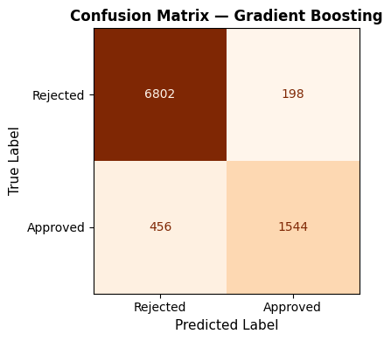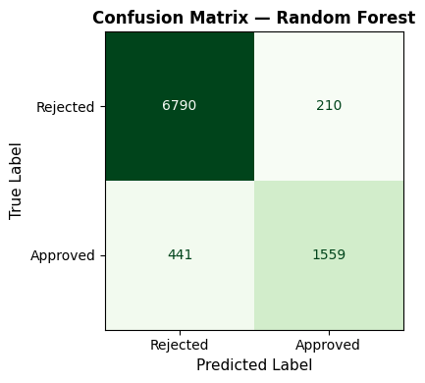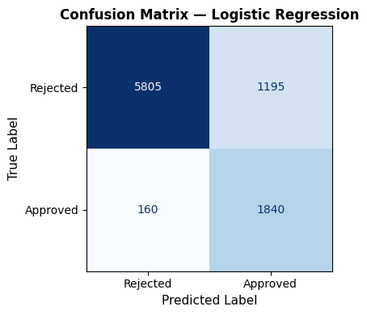
Figure 6: Confusion Matrix
(Source: Google Colab)
The confusion matrices reveal distinct error patterns for the three models. Logistic Regression accurately identified 5,805 rejected and 1,840 approved applications, but failed to recognise 1,195 rejected applications as such, resulting in the greatest risk of lending. Random Forest cut down the number of erroneous approvals to 210, while correctly identifying 6,790 rejected and 1,559 approved applications, but 441 eligible applicants were rejected incorrectly. Gradient Boosting had the lowest number of incorrect approvals (198) and the highest number of correctly rejected applicants (6,802), but rejected applicants who were actually approved (456). For this reason, the best practical compromise between limiting the number of risky approvals and keeping good borrowers is Random Forest (Salman et al., 2024).
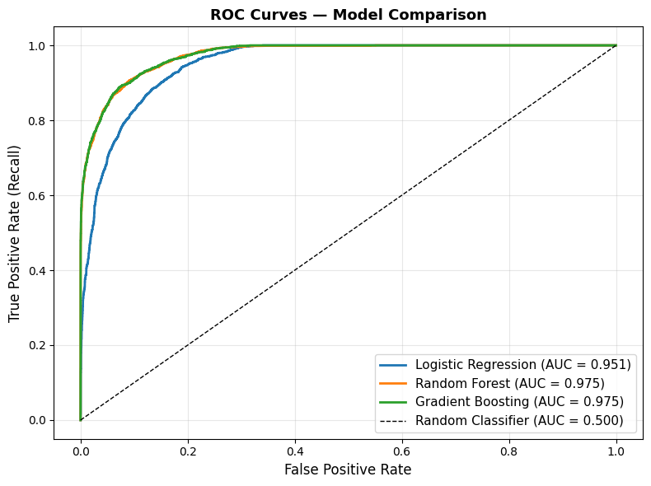
Figure 7: ROC curve
(Source: Google Colab)
The ROC curve comparison shows the classification power of each model at various decision thresholds. The AUC value for Logistic Regression was 0.951, with good separation between the approved and rejected loan applications. Both the Random Forest and Gradient Boosting had an AUC of 0.975, which is better than either of the two. The curves of these ensemble models are still in the top-left corner, meaning that for each of these models, the proportion of true positives is higher while the proportion of false positives is lower (Hanson, 2022). So, the most discriminatory in terms of the approved class recall and lowest false approved rate are Random Forest and Gradient Boosting, which is why Random Forest was chosen with a slight difference.
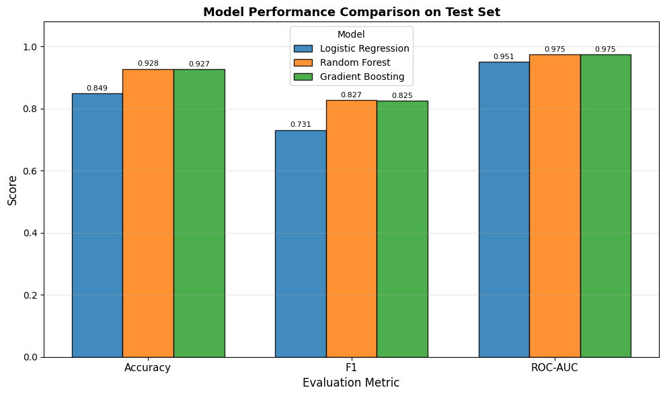
Figure 8: Model Performance Comparison plot
(Source: Google Colab)
The accuracy, F1-score and ROC-AUC of the three classification models are compared in Figure 7. Logistic Regression has an accuracy of 84.9%, whereas the accuracy of Random Forest and Gradient Boosting is 92.8% and 92.7%, respectively. Random Forest had a better F1 score (0.827) than Gradient Boosting (0.825), which suggests that the classification accuracy for approved and rejected applications was higher and better balanced. The ensemble models had the same ROC-AUC score of 0.975, indicating good classification performance. Random Forest was chosen as the best model as it achieved a marginally higher F1 score and performed well with other evaluation measures.

6. Final Discussion and Business Recommendations

6.1 Overall Pipeline Evaluation and Strengths
The completed pipeline provides a reproducible end-to-end workflow covering outlier capping, encoding, scaling, feature selection, model training, tuning and unseen-test evaluation. Random Forest was selected because it achieved 92.8% accuracy, an F1-score of 0.827 and ROC-AUC of 0.975, outperforming Logistic Regression and marginally exceeding Gradient Boosting on F1-score. Pipeline-based preprocessing also reduces leakage risk and supports consistent future scoring.

6.2 Business Implications of Results
These findings show that machine learning has the potential to have a tangible positive impact on initial loan screening. For the rejected applications, the Random Forest model correctly classified 6,790 applications and misclassified 441 applications; for the approved applications, the model correctly classified 1,559 applications and misclassified 210 applications. This lower false-approval volume is directly beneficial to credit-risk control (Haque and Hassan, 2024). But 441 serious applicants were rejected, demonstrating that automated decisions have the potential to eliminate viable business opportunities.

6.3 Model Explainability and Important Features
Random Forest feature-importance analysis identified the main variables influencing loan approval predictions. The strongest predictor was previous_loan_defaults_on_file, followed by loan_int_rate and loan_percent_income, showing the importance of repayment history and affordability (Amit and Gur, 2024). Financial attributes including person_income, loan_amnt and credit_score also contributed significantly, improving model transparency and supporting explainable lending decisions.

6.4 Limitations of the Proposed Solution
The performance depends on the representativeness of the 45,000 historical applications. Generalisability may be impacted by existing lending bias, by changes in the economic profile and future applicant profile. In addition, the class imbalance issue is also applicable since the number of approved cases constitutes 22.2% of observations. Fairness checks, drift monitoring and periodic retraining are therefore needed and should be done continuously.

6.5 Data-Driven Recommendations and Deployment Consideration
The model has to be used as a preliminary service to assist decision making, rather as a standalone approval system. Predictions should be combined with expert review, particularly for borderline cases. After deployment monitoring should be done for false approvals, false rejections, F1 score and ROC AUC and re-training should be considered if performance falls below (Haque and Hassan, 2024). This will ensure efficiency without losing out on accountability of important lending decisions in the human review process.

7. Conclusion
This project developed an end-to-end machine learning pipeline for loan approval prediction. The solution involved preparing the data, engineering features, comparing models, optimising models and evaluating. Overall, Random Forest was the most successful model, showing that machine learning can complement human expertise to make quick, reliable and explainable lending decisions with suitable human supervision.

References
Amit, G. and Gur, S., 2024, January. eXplainable random forest. In European conference on artificial intelligence. CEUR Workshop Proceedings (Vol. 3765). https://ceur-ws.org/Vol-3765/Camera_Ready_Paper-10.pdf
Barbierato, E. and Gatti, A., 2024. The challenges of machine learning: A critical review. Electronics, 13(2), p.416. https://www.mdpi.com/2079-9292/13/2/416
Chouksey, A., Shovon, M.S.S., Tannier, N.R., Bhowmik, P.K., Hossain, M., Rahman, M.S., Rahman, M.K. and Hossain, M.S., 2023. Machine learning-based risk prediction model for loan applications: Enhancing decision-making and default prevention. Journal of Business and Management Studies, 5(6), pp.160-176. https://alkindipublisher.com/index.php/jbms/article/view/8806
Ferrer, L., 2022. Analysis and comparison of classification metrics. arXiv preprint arXiv:2209.05355. https://arxiv.org/abs/2209.05355
Hanson, R.K., 2022. Logistic regression. Prediction Stat. Psychol. Assess, pp.195-220. https://people.stat.sc.edu/hansont/stat705/chapter14.pdf
Haque, F.M. and Hassan, M.M., 2024. Bank loan prediction using machine learning techniques. arXiv preprint arXiv:2410.08886. https://arxiv.org/abs/2410.08886
Jui, T.D. and Rivas, P., 2024. Fairness issues, current approaches, and challenges in machine learning models. International Journal of Machine Learning and Cybernetics, 15(8), pp.3095-3125. https://link.springer.com/article/10.1007/s13042-023-02083-2
Nureni, A.A. and Adekola, O.E., 2022. Loan approval prediction based on machine learning approach. Fudma Journal of Sciences, 6(3), pp.41-50. https://fjs.fudutsinma.edu.ng/index.php/fjs/article/view/830
Rainio, O., Teuho, J. and Klén, R., 2024. Evaluation metrics and statistical tests for machine learning. Scientific reports, 14(1), p.6086. https://www.nature.com/articles/s41598-024-56706-x
Salman, H.A., Kalakech, A. and Steiti, A., 2024. Random forest algorithm overview. Babylonian Journal of Machine Learning, 2024, pp.69-79. https://journals.mesopotamian.press/index.php/BJML/article/view/417
Shi, S., Tse, R., Luo, W., D’Addona, S. and Pau, G., 2022. Machine learning-driven credit risk: a systemic review. Neural Computing and Applications, 34(17), pp.14327-14339. https://link.springer.com/article/10.1007/s00521-022-07472-2
Shinde, A., Patil, Y., Kotian, I., Shinde, A. and Gulwani, R., 2022, January. Loan prediction system using machine learning. In ITM Web of Conferences (Vol. 44, p. 03019). EDP Sciences. https://www.itm-conferences.org/articles/itmconf/abs/2022/04/itmconf_icacc2022_03019/itmconf_icacc2022_03019.html
Sinap, V., 2024. A comparative study of loan approval prediction using machine learning methods. Gazi Üniversitesi Fen Bilimleri Dergisi Part C: Tasarım ve Teknoloji, 12(2), pp.644-663. https://dergipark.org.tr/en/pub/gujsc/article/1455978
Verdonck, T., Baesens, B., Óskarsdóttir, M. and vanden Broucke, S., 2024. Special issue on feature engineering editorial. Machine learning, 113(7), pp.3917-3928. https://link.springer.com/article/10.1007/s10994-021-06042-2
World Bank, 2022. The Global Findex Database 2021: Financial Inclusion, Digital Payments, and Resilience in the Age of COVID-19. Washington, DC: World Bank. Available at: https://www.worldbank.org/en/publication/globalfindex (Accessed: 1 September 2026).

