**Hotel Reservation System – Servlet Assignment**

Welcome to <Your Assignment Application/Portal/System> <h1>

<table - well formatted>

Emp No: Textbox with 40102044

Emp Name: Textbox with Anbu

Age: Textbox with 45

Date Of Birth:Textbox 01/01/1975

Salary ($): Textbox with 1000

Submit Button, Reset Button

</table>

Thanks!  Visit Again !!! <h1>

Screen Proof: Show the output in a browser, Tomcat - deployment of your assignment.

**Coding part: HotelReservationServlet.java**

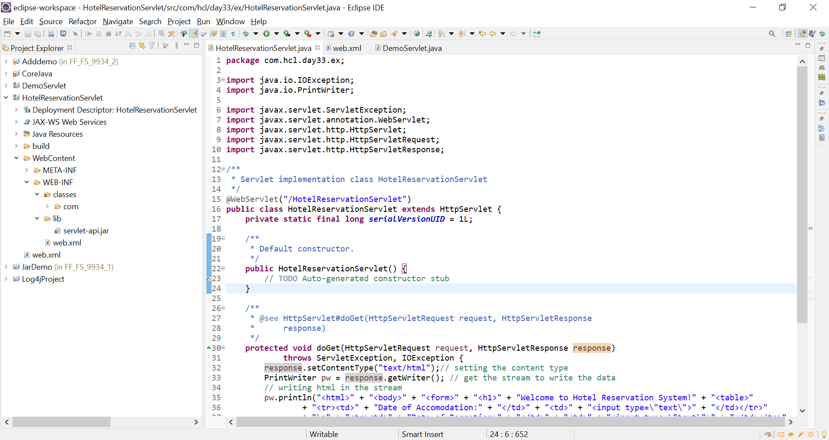

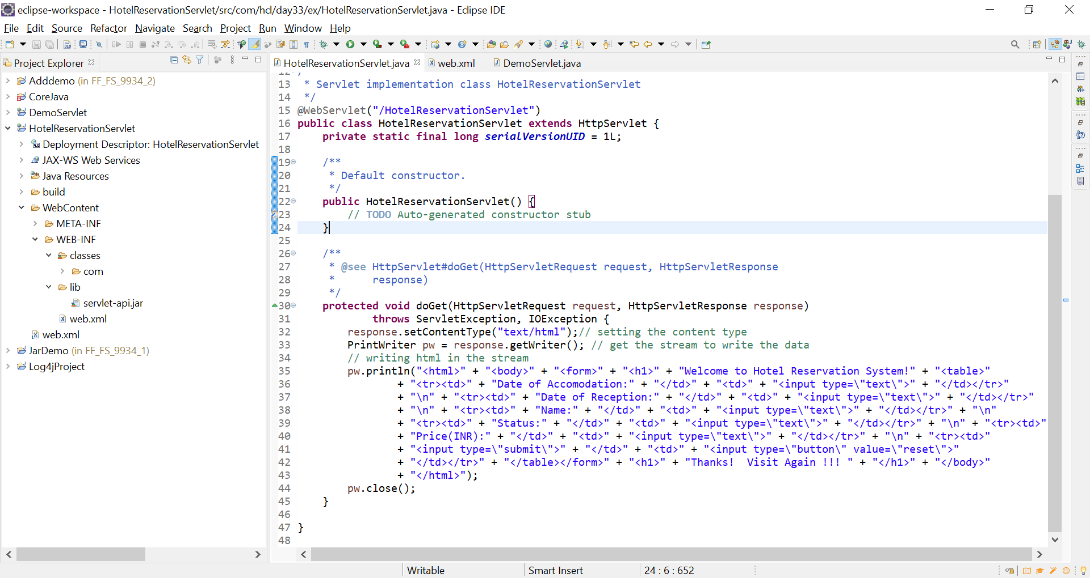

**Web.xml:**

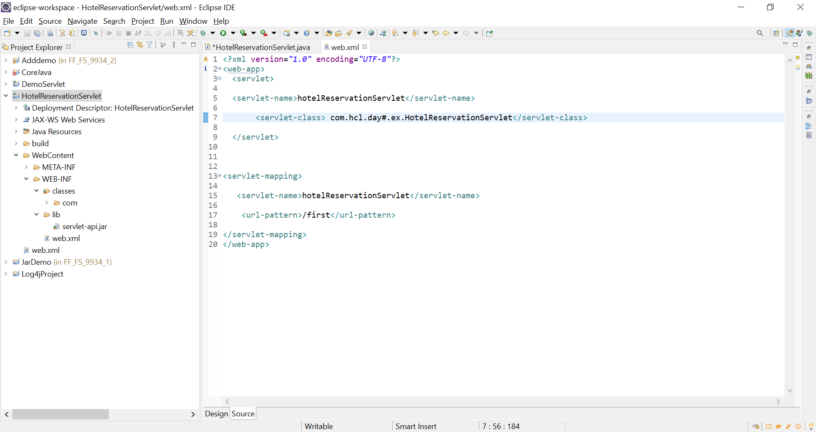

**Tomcat deployment:**

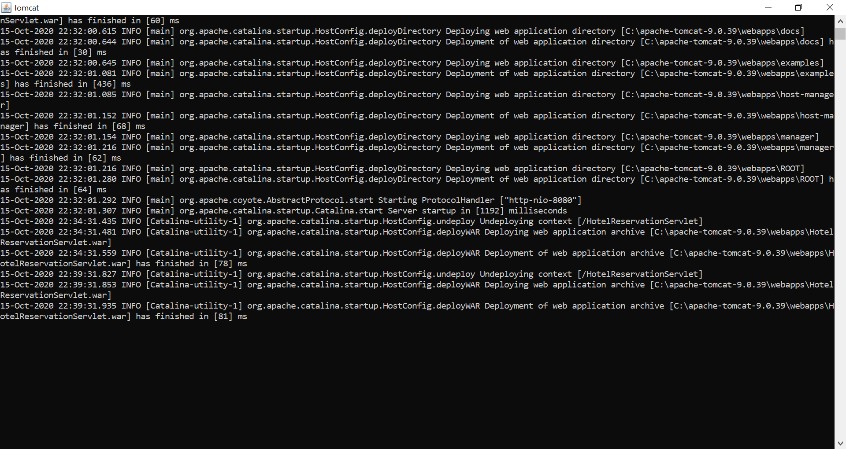

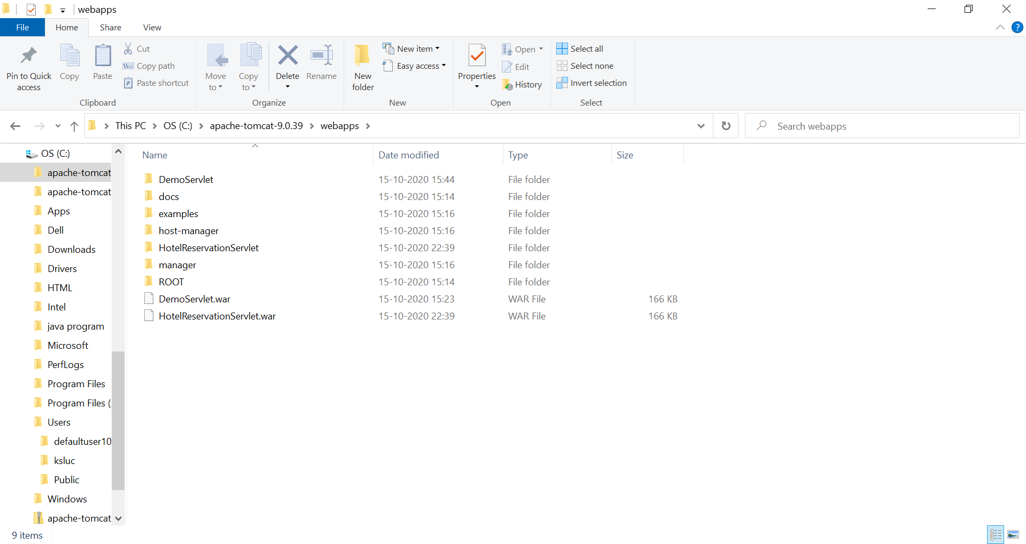

**OUTPUT :**