**HOTEL RESERVATION SYSTEM**

HotelReservation - 2

FromDate

ToDate

Name

Status:Booked/NotBooked

price

Sample Input/Output (log file & console)

<Date Time> main com.hcl.day31.<> main Welcome to <Your Assignment>

Enter: (5 user inputs)

<Date Time> main com.hcl.day31.<> add Successfully created

<Date Time> main com.hcl.day31.<> read Reading the details

<Date Time> main com.hcl.day31.<> read sop (5 details with well formatted output)

<Date Time> main com.hcl.day31.<> update Update the details

Enter Status:

Enter Date:

<Date Time> main com.hcl.day31.<> update Successfully updated

<Date Time> main com.hcl.day31.<> read Reading the details

<Date Time> main com.hcl.day31.<> read sop (5 details with well formatted output)

<Date Time> main com.hcl.day31.<> main Thanks and Visit Again!!!

**Coding:**

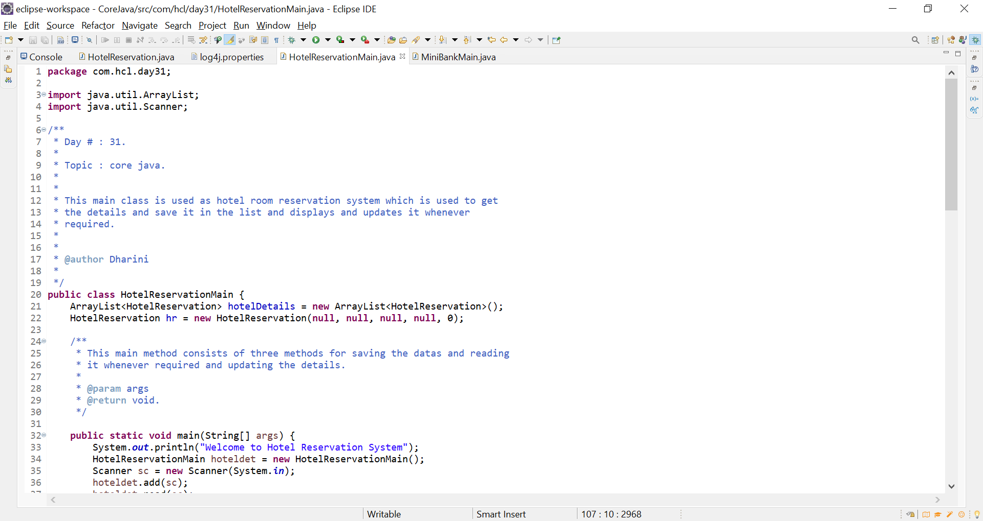

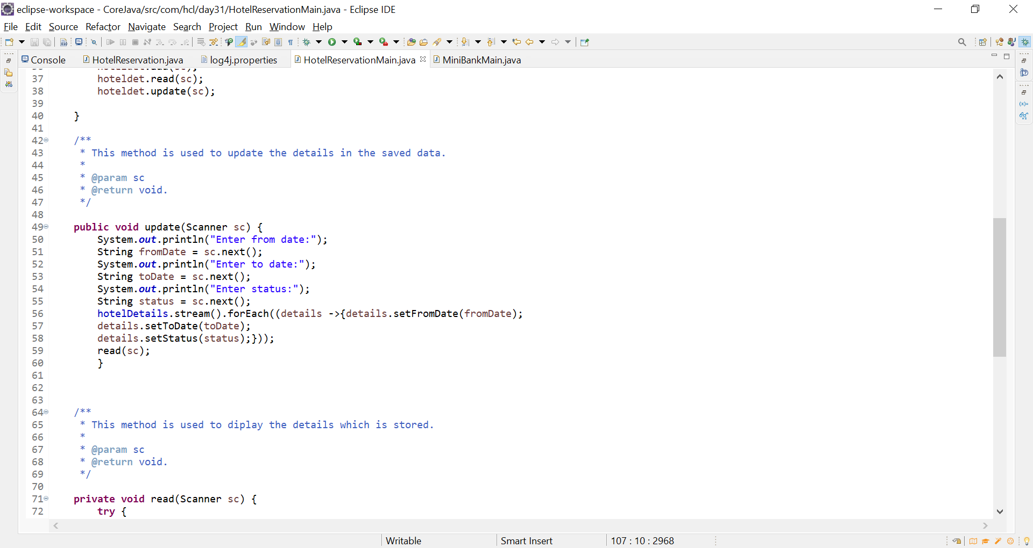

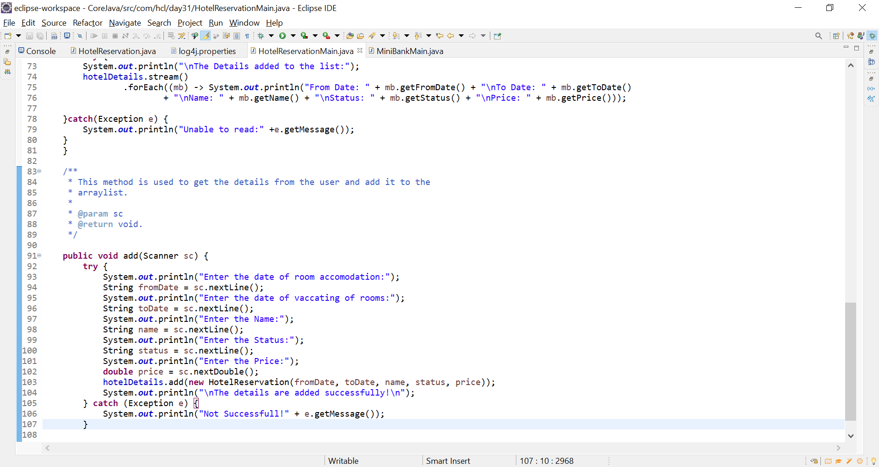

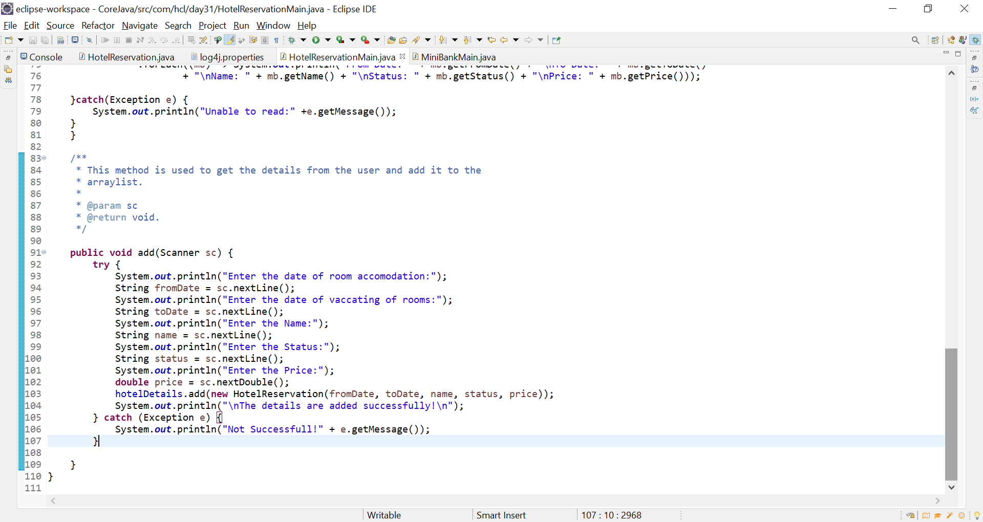

**Output:**

