FINCORE DIGITAL BANKING
MANAGEMENT
PLATFORM
MILESTONE 3
Core Modules
Fraud Detection
Settlement Engine
Notification Service
Team Members
Bharati Bhat
Ramya Chava
Janhvi Pandey
Indu Patil
Shanmukha Sai
Raziya

1. Abstract
FinCore Digital Banking Management Platform is a full-stack banking application designed to support secure and efficient digital banking operations. Milestone 3 extends the platform into transaction-risk control, payment settlement, and customer/event notification workflows. The milestone focuses on Fraud Detection, Settlement Engine, and Notification Service as the three core functional modules, supported by an integrated banking dashboard and existing account, loan, payment, and KYC workspaces.
The frontend is implemented using Angular 18 and TypeScript. The backend is implemented using Java and Spring Boot with Spring Data JPA and a controller-service-repository structure. H2 is used as the relational database for the supplied Milestone 3 backend, with Spring Mail providing email delivery support. The milestone provides REST APIs, domain entities, repositories, business services, fraud scoring, velocity checks, payment allocation, settlement processing, notification history, and a responsive banking-oriented user interface.
The milestone also introduces a transaction-centric relational data model connecting loans, transactions, fraud events, and settlements. The notification model separately stores recipient, notification type, message, status, and creation time. The frontend presents these capabilities through dedicated module views, action dialogs, tables, dashboards, and event-oriented monitoring screens.

2. Introduction
Transaction processing in a digital banking platform must combine financial correctness with risk control and timely communication. A payment that is technically valid may still require fraud screening before settlement, while completed or blocked transactions may need to generate notifications and audit information.
FinCore Milestone 3 addresses these requirements through a connected operational workspace. The Fraud Detection module evaluates transactions using amount and recent-transaction velocity rules and records a FraudEvent. The Settlement Engine invokes fraud detection before processing a transaction, allocates a payment across penalty, interest, and principal, updates outstanding loan balances, and records the settlement. The Notification Service sends email notifications and maintains notification history for recipients.
The frontend additionally provides operational screens for fraud alerts, interbank settlement batches, notifications, dashboard monitoring, payments, accounts, and KYC verification. Some dashboard values and event-stream content are demonstration-oriented UI data, while the backend services provide the implemented transactional logic described in this report.

3. Problem Statement
Financial transactions are often processed through separate risk, payment, settlement, and communication workflows. Without a connected control layer, a high-risk transaction may reach settlement before being reviewed, loan balances may not be updated consistently after payment, and customers or operational teams may not receive a traceable notification.
FinCore Milestone 3 provides an integrated transaction-management layer that connects fraud evaluation with settlement processing and notification history. The system applies business rules in the service layer, persists fraud and settlement outcomes, and exposes REST endpoints through Spring Boot so the frontend can interact with the backend.

4. Objectives
- Implement a transaction fraud-detection service using transaction amount and recent transaction velocity.
- Calculate a fraud score and classify transactions as SAFE, SUSPICIOUS, UNDER_REVIEW, or BLOCKED.
- Record fraud events with customer, transaction, score, status, reason, and creation time.
- Integrate fraud screening into settlement processing before financial allocation is completed.
- Prevent settlement of transactions that are blocked or require manual fraud review.
- Implement payment allocation in the order penalty, interest, and principal.
- Update loan outstanding balances after successful settlement and record the settlement result.
- Provide RESTful APIs through Spring Boot for fraud checking and settlement operations.
- Implement an email notification service using Spring Mail.
- Persist notification delivery status and provide recipient-based notification history.
- Provide interactive Angular interfaces for fraud monitoring, settlement operations, and notifications.
- Provide supporting dashboards for transaction, account, payment, KYC, and event-stream visibility.

5. Scope of Milestone 3
The scope of Milestone 3 consists of three core functional modules, supported by an integrated banking operations workspace.
Module | Main Functionality
Fraud Detection | Transaction risk scoring, large-amount detection, recent-transaction velocity checking, status classification, fraud-event persistence, and operational alert actions.
Settlement Engine | Fraud pre-check, transaction status control, payment allocation, loan outstanding balance updates, settlement creation, and transactional processing.
Notification Service | Email notification dispatch, delivery status tracking, notification persistence, and recipient-based notification history.
Supporting Banking Workspace | Dashboard, payments, accounts, KYC, loans, and audit-oriented views that provide context around the three core modules.

The milestone focuses on fraud control, settlement processing, and notification functionality. Existing account, loan, payment, and KYC screens are treated as supporting platform capabilities and are not redefined as the core modules of Milestone 3.

6. Technology Stack
Category | Technology / Component
Frontend | Angular 18, TypeScript, HTML, CSS
Backend | Java, Spring Boot
Persistence | Spring Data JPA, Hibernate
Database | H2 in-memory database for the supplied Milestone 3 backend
Email | Spring Boot Mail / JavaMailSender
API Style | RESTful HTTP APIs
Build / Package | Maven, npm
Frontend Support | Angular Forms, RxJS, standalone components
Documentation / API Support | Springdoc OpenAPI
Development | Angular CLI / Maven-compatible Java project

The frontend project declares Angular 18 packages with TypeScript and standalone Angular components. The backend uses Spring Boot, Spring Data JPA, Spring Web MVC, Lombok, H2, Spring Mail, and Springdoc OpenAPI. The supplied backend configuration creates the H2 schema from the JPA entities and initializes sample loan and transaction data.

7. System Architecture
FinCore Milestone 3 follows a layered full-stack architecture. The Angular frontend provides module navigation and operational screens. REST requests are handled by Spring Boot controllers, which delegate business operations to service classes. Spring Data JPA repositories provide persistence access, while the H2 database stores the milestone transaction data.
The overall flow is:
Angular UI → REST API → Spring Boot Controllers → Service Layer → JPA Repositories → H2 Database
Layer | Milestone 3 Responsibility
Presentation | Angular components for fraud detection, settlement engine, notification service, and supporting banking views.
API Layer | REST controllers under /api/fraud, /api/settlements, and /api/notification.
Business Layer | Fraud scoring, fraud-event creation, settlement validation, payment allocation, loan balance updates, and notification dispatch.
Persistence Layer | Spring Data JPA repositories for Loan, Transaction, Settlement, FraudEvent, and NotificationEntity.
Database | H2 relational tables generated from JPA entities, with sample loan and transaction records initialized at startup.
External Service | SMTP-based email delivery through JavaMailSender.

8. Module 1 – Fraud Detection
The Fraud Detection module evaluates an individual transaction before settlement. The backend FraudDetectionController exposes a transaction-check endpoint. The FraudDetectionService loads the loan associated with the transaction, obtains the customer identifier, evaluates transaction risk conditions, classifies the result, and persists a FraudEvent.

8.1 Fraud Detection Inputs
- Transaction ID supplied to the fraud-check endpoint.
- Transaction amount.
- Transaction creation time used for recent-transaction velocity analysis.
- Loan associated with the transaction, from which the customer ID is obtained.
- Recent transactions belonging to the same customer.

8.2 Fraud Scoring Logic
The implemented backend applies two primary rules. A transaction amount greater than or equal to ₹1,00,000 contributes 30 points to the fraud score. If five or more transactions for the same customer have occurred within the previous five minutes, the service contributes another 25 points and records a velocity-related reason.
Condition | Score Contribution | Recorded Reason
Transaction amount ≥ ₹1,00,000 | +30 | Large transaction amount
5 or more recent transactions within 5 minutes | +25 | Too many transactions in short time

The service classifies the resulting score using the following thresholds: 80 or above as BLOCKED, 50–79 as UNDER_REVIEW, 25–49 as SUSPICIOUS, and below 25 as SAFE.

8.3 Fraud Event Persistence
Each fraud check is persisted as a FraudEvent containing user ID, transaction ID, fraud score, status, reason, and creation timestamp. This provides a durable record of the fraud decision independent of the immediate API response.

8.4 Backend Implementation
- FraudDetectionController exposes POST /api/fraud/check/{transactionId}.
- FraudDetectionService performs score calculation, status classification, and event persistence.
- FraudEvent represents the persisted risk decision.
- FraudEventRepo provides Spring Data JPA persistence.
- TransactionRepo provides the recent-transaction count query used by the velocity rule.
- LoanRepo resolves the customer associated with the transaction.
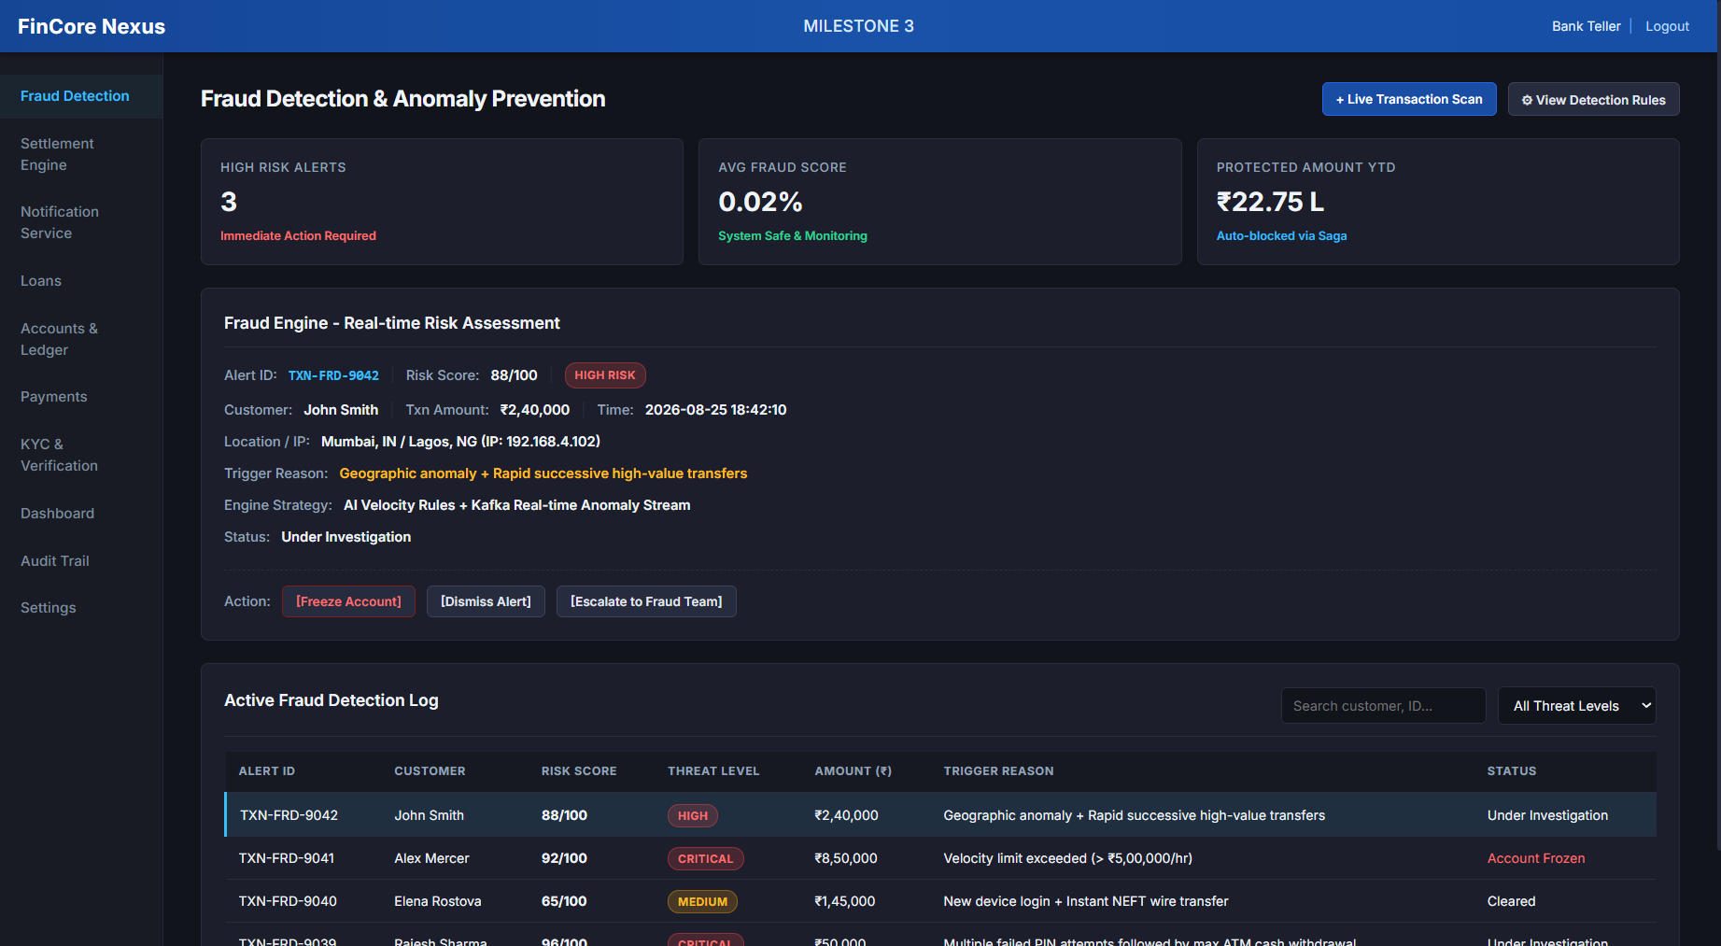
Figure 2: Fraud Detection and Anomaly Prevention Interface

9. Module 2 – Settlement Engine
The Settlement Engine processes a transaction only after applying the fraud-detection control layer. SettlementService is marked transactional and coordinates transaction retrieval, fraud screening, payment allocation, loan balance updates, transaction status changes, and settlement persistence.

9.1 Settlement Workflow
- Retrieve the transaction by transaction ID.
- Reject processing if the transaction has already been settled.
- Run the fraud-detection service and persist the resulting FraudEvent.
- Block the transaction if the fraud status is BLOCKED.
- Place the transaction under review if the fraud status is UNDER_REVIEW.
- Set the transaction to PROCESSING for an allowed settlement.
- Retrieve the associated loan and outstanding penalty, interest, and principal values.
- Allocate the payment amount across penalty, interest, and principal.
- Update the loan outstanding balances.
- Set the transaction status to SETTLED and persist the settlement record.

9.2 Payment Allocation
PaymentAllocationService implements a priority-based allocation rule. The payment is first applied to outstanding penalty, then to interest, and finally to principal. The service returns a PaymentAllocation record containing the amount allocated to each component.
Allocation Priority | Purpose
1. Penalty | Reduce outstanding penalty before other components.
2. Interest | Apply the remaining payment to outstanding interest.
3. Principal | Apply any remaining payment to outstanding principal.

9.3 Settlement Data Captured
Field | Purpose
Transaction ID | Identifies the transaction being settled.
Loan ID | Identifies the loan whose outstanding balance is updated.
Settled Amount | Stores the transaction amount processed by settlement.
Status | Tracks the settlement state.
Settled At | Stores the settlement timestamp.

9.4 Backend Implementation
- SettlementController exposes POST /api/settlements/{transactionId}.
- SettlementService coordinates fraud screening, settlement validation, allocation, and persistence.
- PaymentAllocationService calculates penalty, interest, and principal allocation.
- LoanRepo persists updated outstanding loan balances.
- TransactionRepo persists transaction status changes.
- SettlementRepo persists settlement records.
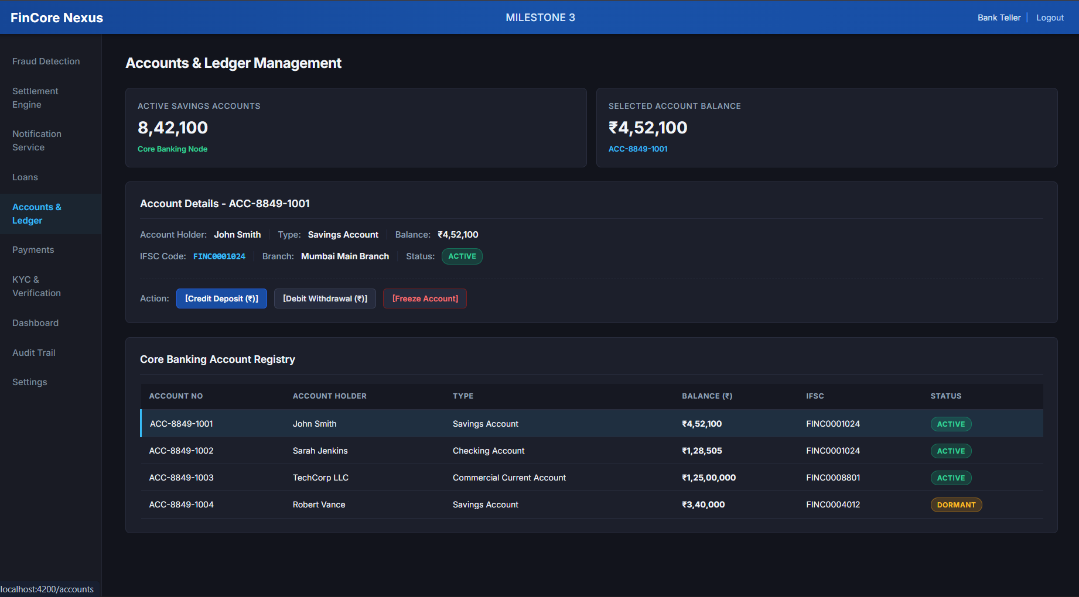
Figure 3: Interbank Settlement Engine Interface

10. Module 3 – Notification Service
The Notification Service provides an email-delivery workflow and maintains a persistent history of notification attempts. NotificationService creates a notification record, invokes EmailService to send the email through JavaMailSender, updates the status to SENT when successful, or FAILED when an exception occurs, and saves the resulting record.

10.1 Notification Workflow
- Receive recipient, subject, and message through the NotificationRequest DTO.
- Create a NotificationEntity with PENDING status.
- Invoke EmailService to create and send a SimpleMailMessage.
- Set the notification status to SENT when delivery submission succeeds.
- Set the status to FAILED when the email operation throws an exception.
- Persist the notification record.
- Allow notification history to be retrieved by recipient.

10.2 Data Captured
Field | Purpose
Recipient | Destination email address or recipient identifier.
Type | Notification channel/type, such as EMAIL.
Message | Notification content stored in the database.
Status | PENDING, SENT, or FAILED based on processing outcome.
Created At | Timestamp of notification creation.

10.3 Backend Implementation
- Controller exposes POST /api/notification/email for email dispatch.
- Controller exposes GET /api/notification/history?recipient=... for recipient history.
- NotificationService coordinates persistence and email delivery.
- EmailService uses JavaMailSender and SimpleMailMessage.
- NotificationRepo retrieves notification history in descending creation-time order.
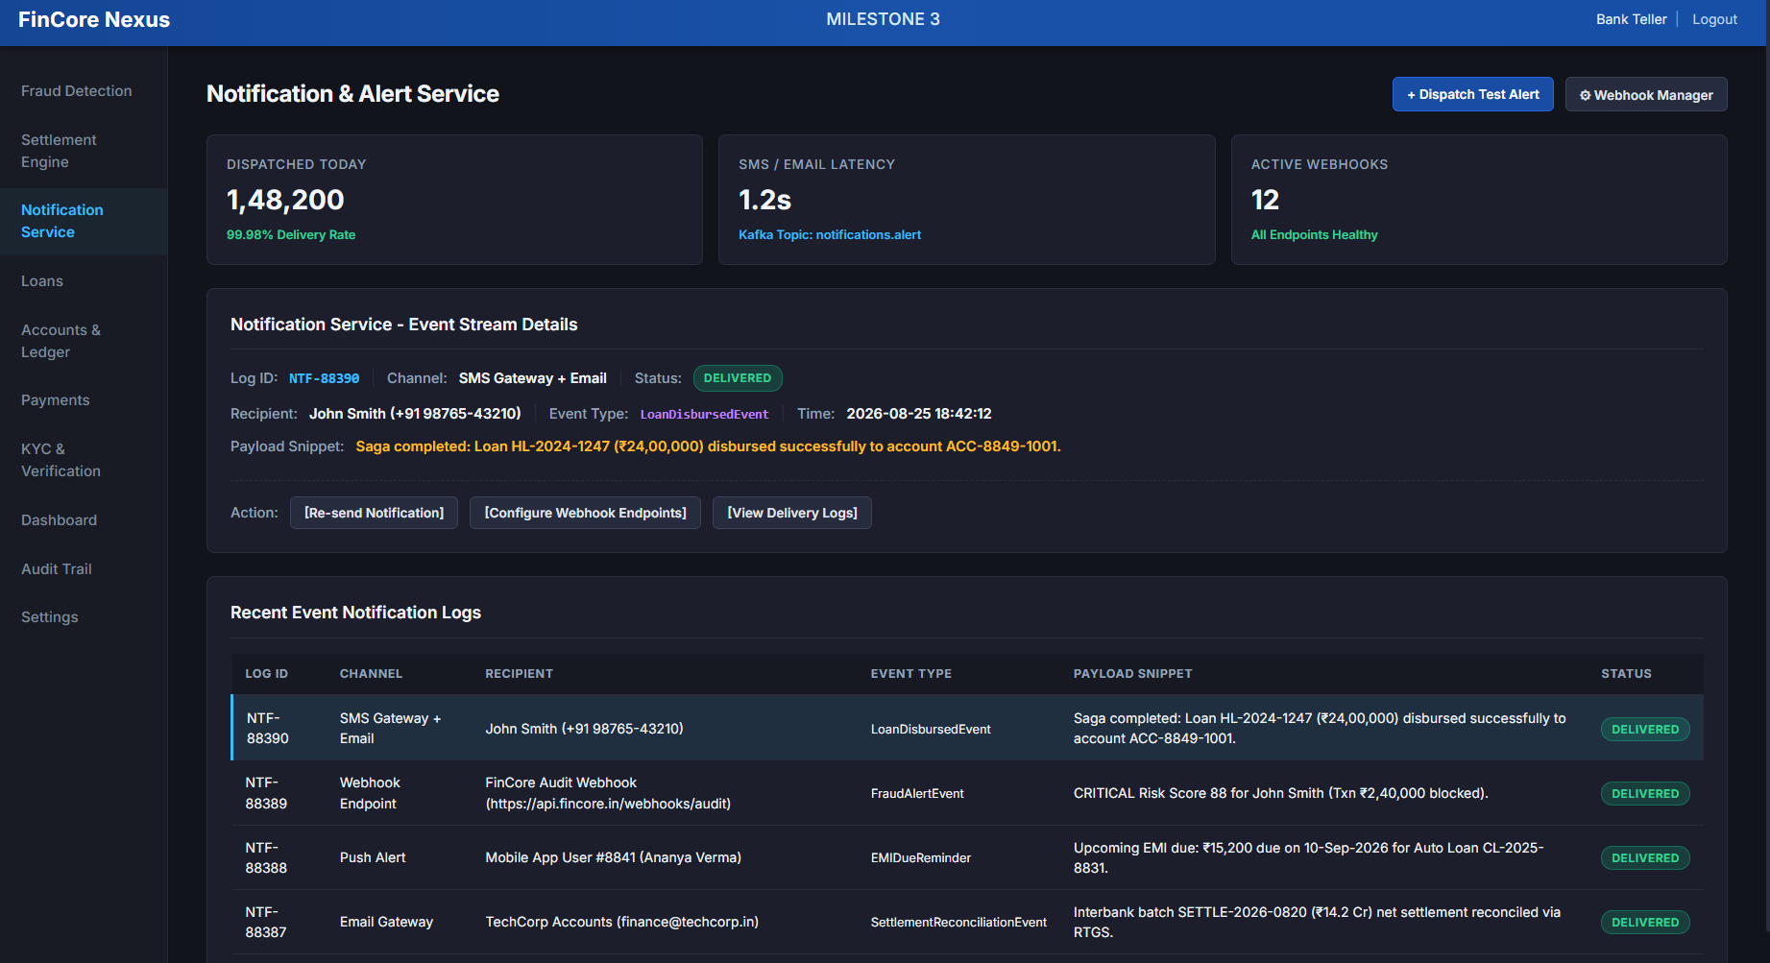
Figure 4: Notification and Alert Service Interface

11. Executive Banking Dashboard – Supporting Workspace
The Executive Banking & Saga Dashboard acts as a supporting workspace for Milestone 3. It consolidates portfolio indicators and displays a real-time-style event stream covering loan, fraud, settlement, and payment activities. The displayed dashboard includes total customers, total deposits, total loan portfolio, fraud prevented, loan portfolio distribution, and recent event messages.
The frontend dashboard provides operational context around the three core modules. For example, a fraud event can be shown alongside a loan event and a settlement event, helping a user understand the broader transaction lifecycle. The event-stream values shown in the supplied UI are demonstration-oriented frontend data.
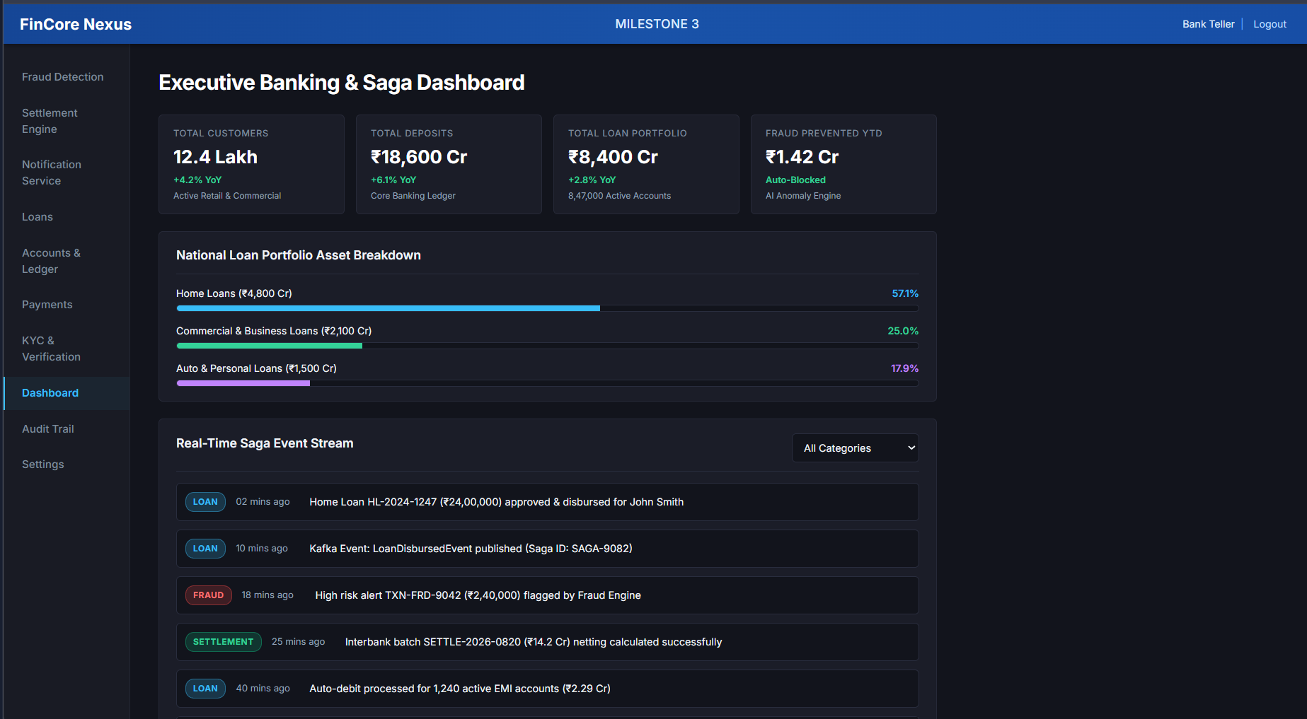
Figure 5: Executive Banking and Saga Dashboard

12. Database Design
The supplied Milestone 3 backend uses H2 as an in-memory relational database. The JPA entities define the principal persistence model for loans, transactions, fraud events, and settlements. NotificationEntity is stored in the notifications table.
Table / Entity | Purpose
Loan | Stores customer ID, principal outstanding, interest outstanding, penalty outstanding, total outstanding, and loan status.
Transaction | Stores transaction reference, loan ID, amount, type, status, and creation time.
FraudEvent | Stores user ID, transaction ID, fraud score, fraud status, reason, and creation time.
Settlement | Stores transaction ID, loan ID, settled amount, settlement status, and settlement timestamp.
NotificationEntity | Stores recipient, notification type, message, status, and creation timestamp.

12.1 Entity Relationships
- One Loan can be associated with multiple Transaction records through loanId.
- A Transaction can produce a FraudEvent during fraud screening.
- A Transaction can produce a Settlement record after successful settlement.
- A Settlement references both the Transaction and Loan identifiers.
- Notification records are independent communication records and are retrieved by recipient.
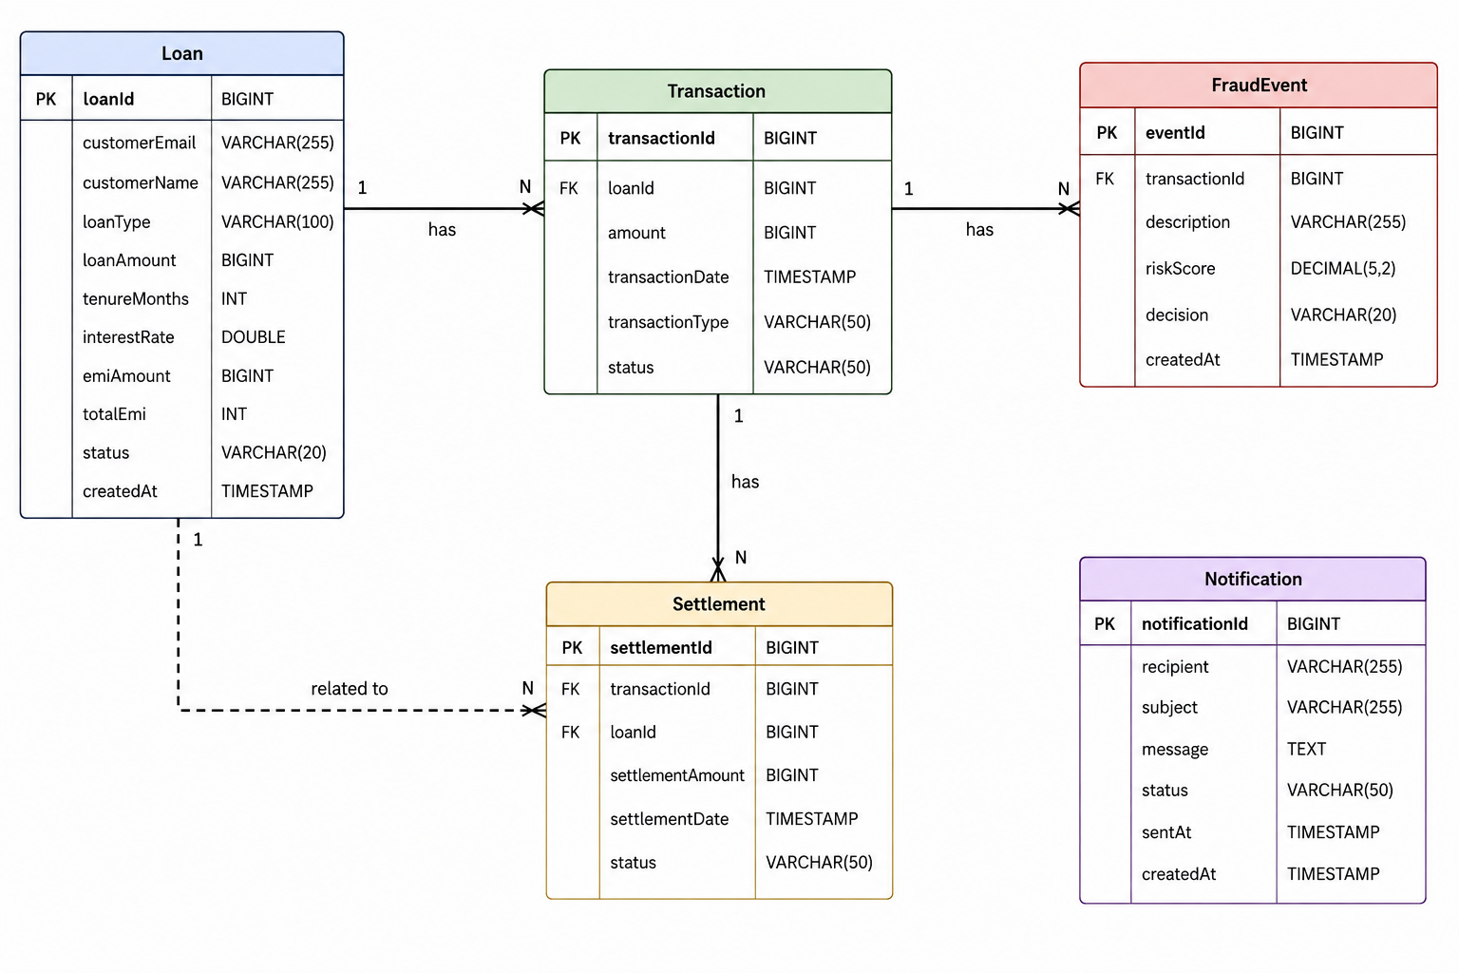
Figure 1: Milestone 3 Entity Relationship Diagram

12.2 Database Integrity and Processing
- Primary keys are generated using JPA identity generation.
- Transaction, loan, fraud event, and settlement records maintain explicit identifiers for traceability.
- The settlement operation is annotated with @Transactional so related updates are processed as one transaction boundary.
- The fraud velocity query counts transactions belonging to loans associated with a customer and created after a supplied time.
- The backend initializes sample loan and transaction records through data.sql for development and demonstration.

13. API Design
The Spring Boot backend exposes REST endpoints for the three core modules. Controllers receive requests, invoke service-layer operations, and return response data or status messages.
Module | Method | Endpoint | Purpose
Fraud Detection | POST | /api/fraud/check/{transactionId} | Evaluate a transaction, persist the fraud event, and return the fraud result.
Settlement | POST | /api/settlements/{transactionId} | Process settlement after fraud screening and return the settlement record.
Notification | POST | /api/notification/email | Send an email notification and persist its delivery status.
Notification | GET | /api/notification/history?recipient=... | Retrieve notification history for a recipient.

14. User Interface Implementation
The Angular interface is organized into reusable standalone components for fraud detection, settlement engine, notification service, dashboard, loans, accounts, payments, KYC, audit, and settings. The application uses route-based lazy loading for the module views.
- The Fraud Detection interface contains KPI cards, a selected alert panel, risk score, threat level, trigger reason, action buttons, search, threat filtering, and a fraud alert table.
- The Settlement Engine interface contains pending clearing metrics, netting efficiency, settlement SLA, selected batch details, batch actions, queue history, and a new-batch modal.
- The Notification Service interface contains dispatch metrics, latency/webhook indicators, event details, notification history, test-alert dispatch, webhook configuration, and delivery-log dialogs.
- The Dashboard interface provides portfolio metrics and a real-time-style event stream.
- Supporting Payments, Accounts, and KYC interfaces provide transaction, account, and verification context.
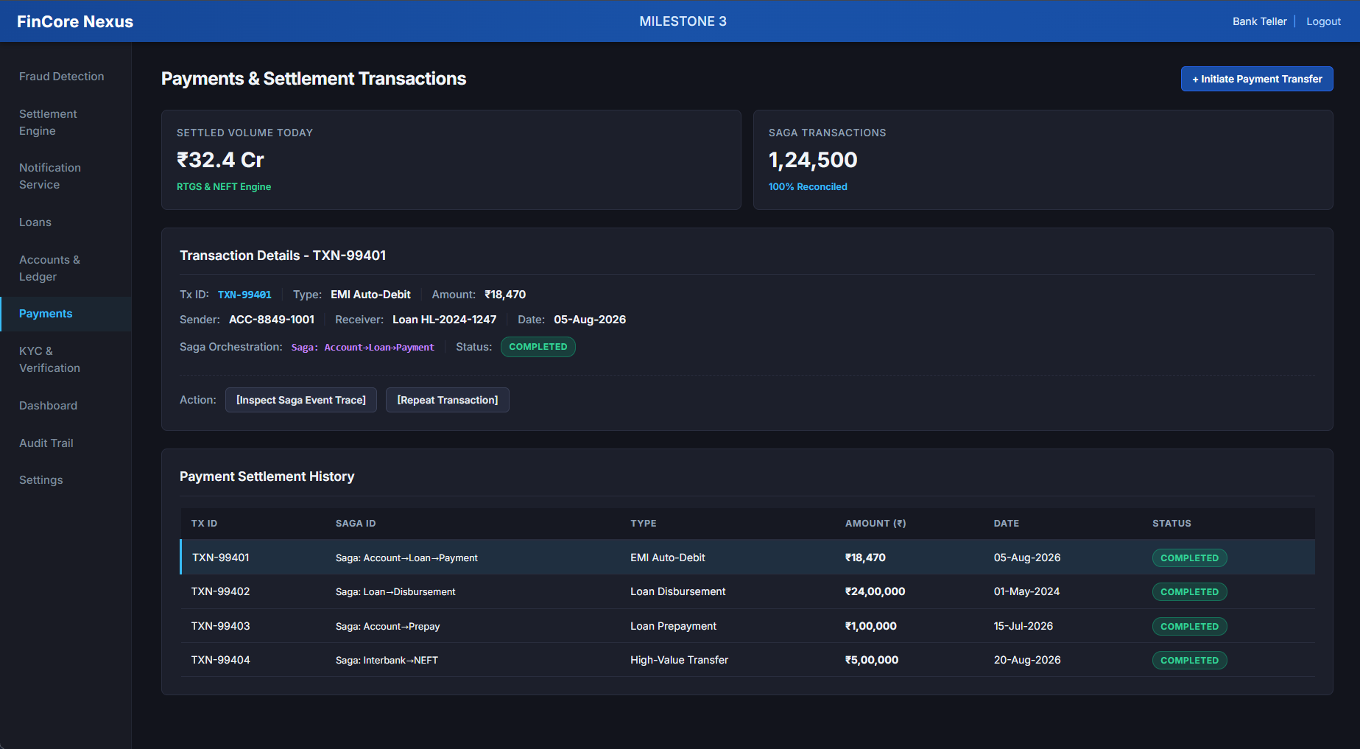
Figure 6: KYC and Identity Verification Supporting Interface
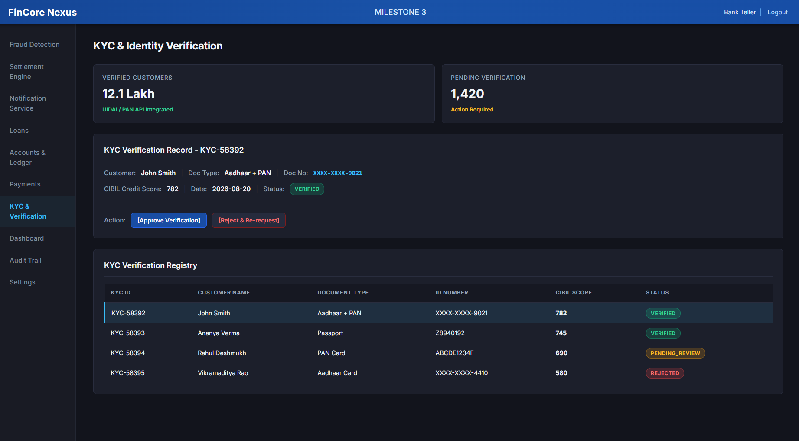
Figure 7: Payments and Settlement Transactions Supporting Interface
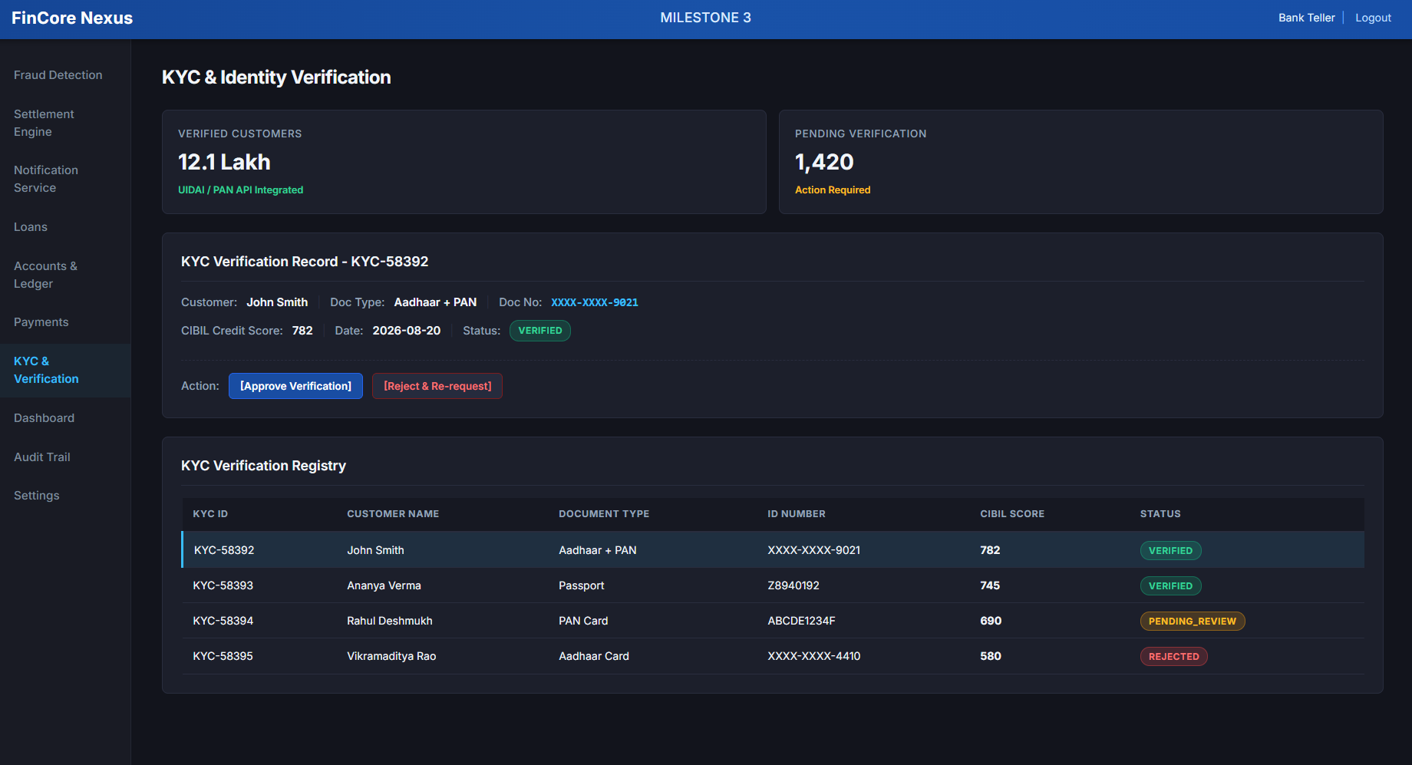
Figure 8: Accounts and Ledger Management Supporting Interface

15. Testing and Validation
Testing for Milestone 3 focuses on fraud scoring, fraud-status classification, settlement validation, payment allocation, loan balance updates, notification delivery status, notification history retrieval, and frontend interaction. The supplied backend contains a Spring Boot application-context test setup; runtime integration verification may require the configured development environment and external SMTP availability.

Test Area | Test Condition | Expected Result
Fraud Detection | Transaction amount ≥ ₹1,00,000 | Fraud score increases by 30 and large-amount reason is recorded.
Fraud Detection | 5 or more customer transactions within 5 minutes | Fraud score increases by 25 and velocity reason is recorded.
Fraud Detection | Score ≥ 80 | Transaction is classified as BLOCKED.
Fraud Detection | Score 50–79 | Transaction is classified as UNDER_REVIEW.
Fraud Detection | Score 25–49 | Transaction is classified as SUSPICIOUS.
Fraud Detection | Score < 25 | Transaction is classified as SAFE.
Settlement | Transaction already SETTLED | Settlement request is rejected.
Settlement | Fraud status BLOCKED | Transaction becomes BLOCKED and settlement is stopped.
Settlement | Fraud status UNDER_REVIEW | Transaction becomes UNDER_REVIEW and settlement is stopped.
Settlement | Allowed transaction | Payment is allocated and transaction becomes SETTLED.
Allocation | Payment exceeds penalty | Remaining amount is applied to interest, then principal.
Allocation | Payment remains after interest | Remaining amount is applied to principal.
Notification | Email dispatch succeeds | Notification status becomes SENT and record is persisted.
Notification | Email dispatch throws an exception | Notification status becomes FAILED and record is persisted.
Notification | History requested for recipient | Recipient notifications are returned newest first.
UI | Fraud/settlement/notification module navigation | Correct module view is displayed.

16. Results and Outcomes
Milestone 3 establishes a transaction-control layer for the FinCore platform. The implemented Fraud Detection module evaluates transaction risk and persists fraud events. The Settlement Engine uses the fraud result as a processing gate, allocates payments against outstanding loan components, updates loan balances, and records settlements. The Notification Service provides email delivery and notification-history persistence.
The supplied frontend demonstrates these workflows through dedicated banking screens. The Fraud Detection view presents a high-risk transaction with a risk score, threat level, trigger reason, and operational actions. The Settlement Engine presents settlement batches, gross and net volumes, netting efficiency, clearing status, and settlement history. The Notification Service presents event logs, delivery status, test-alert dispatch, webhook configuration, and delivery-log views.
The supporting dashboard and banking screens provide an integrated operational context across fraud, settlement, payments, accounts, loans, and KYC. The frontend contains demonstration-style metrics and event-stream values for the user interface, while the backend implements the core fraud, settlement, and email notification services described in this milestone.

17. Conclusion
FinCore Digital Banking Management Platform Milestone 3 successfully extends the platform from loan servicing into transaction risk control, settlement processing, and customer/event communication. The Fraud Detection module provides rule-based risk scoring and fraud-event persistence. The Settlement Engine connects fraud screening with payment allocation and loan balance updates. The Notification Service provides email delivery with persistent status and recipient history.
The combination of Angular 18, TypeScript, Java, Spring Boot, Spring Data JPA, Hibernate, H2, and Spring Mail provides a modular foundation for extending the banking platform. The separation of controllers, services, repositories, entities, and frontend components supports further evolution toward richer fraud rules, production settlement rails, event-driven notification delivery, and expanded audit capabilities.

18. Team Members
Name | Role
Bharati Bhat | Frontend Developer
Ramya Chava | Frontend Developer
Janhvi Pandey | Backend Developer
Indu Patil | Database
Shanmukha Sai | Frontend Developer
Raziya | Backend Developer

