FINCORE DIGITAL BANKING
MANAGEMENT
PLATFORM
MILESTONE 4
Security, Risk & Audit
Core Modules
Liveness Detection
Risk Assessment
Audit Logging
Team Members
Bharati Bhat
Ramya Chava
Janhvi Pandey
Indu Patil
Shanmukha Sai
Raziya

1. Abstract
FinCore Digital Banking Management Platform is a full-stack banking application designed to support secure and efficient digital banking operations. Milestone 4 extends the platform into security, risk assessment, biometric liveness verification, and audit traceability. The milestone focuses on three core functional modules: Liveness Detection, Risk Assessment, and Audit Logging.
The frontend is implemented using Angular 18 and TypeScript with standalone components, Angular Forms, routing, HTML, and CSS. The supplied database design is implemented in PostgreSQL and defines relational tables, constraints, indexes, sample records, views, and demonstration queries for liveness detection, risk assessment, and audit logging.
The milestone provides a security-oriented user workspace with camera-access handling and interactive liveness challenges, configurable transaction and customer risk parameters, risk score calculation and classification, audit-log filtering, pagination, and audit-record detail inspection. The frontend implementation also makes clear where behavior is simulated for demonstration purposes rather than claiming a production biometric or server-side risk engine.

2. Introduction
Security is a critical part of a digital banking platform because financial services must verify customer presence, evaluate transaction risk, and maintain traceable records of important actions. Weak identity verification or incomplete audit trails can make suspicious activity difficult to detect and investigate.
FinCore Milestone 4 addresses these requirements through a connected security and risk workspace. The Liveness Detection module provides camera access, a face-target interface, and sequential challenges such as blinking, turning the head, and facial movement. The Risk Assessment module evaluates transaction and customer parameters through a rule-based risk matrix. The Audit Logging module provides searchable, filterable, paginated security activity records and detailed inspection.
The PostgreSQL design complements the frontend by defining persistent structures for customers, liveness detection results, accounts, transactions, risk assessments, and audit logs. Together, these components establish a security-oriented layer for the banking platform.

3. Problem Statement
Digital banking systems handle sensitive customer identities and financial transactions. If the system cannot verify that a real customer is present, distinguish normal transactions from risky ones, or retain an auditable history of security-sensitive actions, fraud investigation and compliance activities become difficult.
FinCore Milestone 4 provides a security, risk, and audit layer that addresses these concerns. Liveness verification records the outcome and confidence of a verification session, risk assessment assigns a score and level based on transaction and customer factors, and audit logging records important actions with user, module, status, timestamp, and descriptive information.

4. Objectives
- Implement a liveness verification interface for customer identity checks.
- Support camera access through the browser MediaDevices API when available.
- Provide sequential liveness challenges including blink, turn head, and smile/facial movement.
- Generate a liveness score and verification outcome for the demonstration workflow.
- Implement a transaction and customer risk-assessment module using configurable rule-based factors.
- Consider customer verification, transaction amount, transaction type, and transaction history during risk evaluation.
- Classify assessments into LOW, MEDIUM, and HIGH levels in the frontend risk matrix.
- Maintain an assessment history that can be viewed from the Risk Assessment interface.
- Design PostgreSQL tables for persistent liveness, risk, and audit information.
- Implement audit logging records containing user, action, module/entity, status, description, device/IP, and timestamps.
- Provide search, user/module/action/status filters, date fields, pagination, and detail viewing for audit records.
- Provide a consistent Angular security workspace with navigation between the three milestone modules.

5. Scope of Milestone 4
The scope of Milestone 4 consists of three core functional modules supported by a common Security & Risk workspace.
Module | Main Functionality
Liveness Detection | Customer identification, camera access, face-target preview, sequential liveness challenges, verification progress, liveness score, success/failure status, failure reason, retry, and verification summary.
Risk Assessment | Customer and transaction inputs, transaction/account type selection, KYC/history indicators, rule-based scoring, risk-level classification, approval/review/flag status, risk factors, and assessment history.
Audit Logging | Audit-log search, user/module/action/status filters, date fields, pagination, audit status display, and detailed audit-record inspection.
Security & Risk Workspace | Common header, sidebar navigation, module switching, role display, and Security Core status indicator.

The milestone concentrates on the security and risk workflows listed above. The supplied frontend implements the primary interaction layer, while the supplied PostgreSQL script defines the intended persistent database structures and sample data.

6. Technology Stack
Category | Technology / Component
Frontend | Angular 18
Language | TypeScript
UI | HTML, CSS, Angular standalone components
Forms | Angular Forms / FormsModule
Routing | Angular Router
Reactive Support | RxJS
Database | PostgreSQL
Database Features | Relational tables, constraints, indexes, views, sample data, SQL queries
Build / Package | Angular CLI, npm
Browser Integration | MediaDevices getUserMedia API for camera access

The supplied frontend package declares Angular 18 dependencies, TypeScript 5.4, RxJS 7.8, Zone.js, and Angular CLI 18. The application is organized around standalone components and route-based module selection. The database script uses PostgreSQL-specific data types such as BIGSERIAL, JSONB, and INET.

7. System Architecture
FinCore Milestone 4 uses an Angular security workspace containing three standalone functional components. The application shell controls the active module and renders the selected component. The PostgreSQL script separately defines the persistence model for the milestone.
Angular Application Shell → Security & Risk Navigation → Module Component → UI State / Rules
Layer | Milestone 4 Responsibility
Application Shell | FinCore Nexus header, user-role display, logout link, sidebar navigation, and active-module selection.
Liveness Component | Camera access, verification state, challenge sequencing, simulated verification outcome, score, and retry.
Risk Component | Transaction/customer input handling, rule evaluation, risk classification, assessment history, and result display.
Audit Component | Audit data presentation, search, dropdown filters, pagination, reset, and detail modal.
Database Layer | PostgreSQL tables for liveness_detection, risk_assessment, and audit_logs, with supporting customer, account, and transaction structures.
Reporting Layer | Views for high-risk transactions and recent audit activity, plus demonstration queries.

8. Module 1 – Liveness Detection
The Liveness Detection module provides a browser-based verification experience for a customer. The interface accepts a customer ID, generates a verification ID, provides a camera preview area, and guides the user through three sequential challenges.

8.1 Liveness Inputs
- Customer ID.
- Automatically generated verification ID in the VER-###### format.
- Browser camera access.
- Liveness challenge sequence.

8.2 Camera Access
The frontend attempts to access the browser camera through navigator.mediaDevices.getUserMedia with a 640×480 video constraint. If camera access is unsupported or denied, the interface switches to a simulated camera-feed state and displays an explanatory message.

8.3 Liveness Challenges
Step | Challenge | Instruction
1 | Blink | Please blink your eyes naturally.
2 | Turn head | Slowly turn your head to the left.
3 | Smile / facial movement | Smile slightly into the camera.

During verification, the component progresses through the challenges at a fixed demonstration interval. Each challenge becomes active and is then marked complete before the next challenge starts.

8.4 Verification Result
After the challenge sequence, the supplied frontend demonstration generates an outcome using a randomized simulation. The pass branch produces a score between 90% and 99%, while the failure branch produces a score between 40% and 69% and records a spoof-detection failure reason. The implementation therefore demonstrates the verification workflow, but it does not claim to perform actual computer-vision or facial-micro-movement analysis.

8.5 Database Design for Liveness
The PostgreSQL liveness_detection table stores the persistent metadata required for a liveness session without storing raw biometric images. It includes customer ID, session ID, verification type, verification status, confidence score, attempt number, device ID, IP address, failure reason, and verification timestamp.
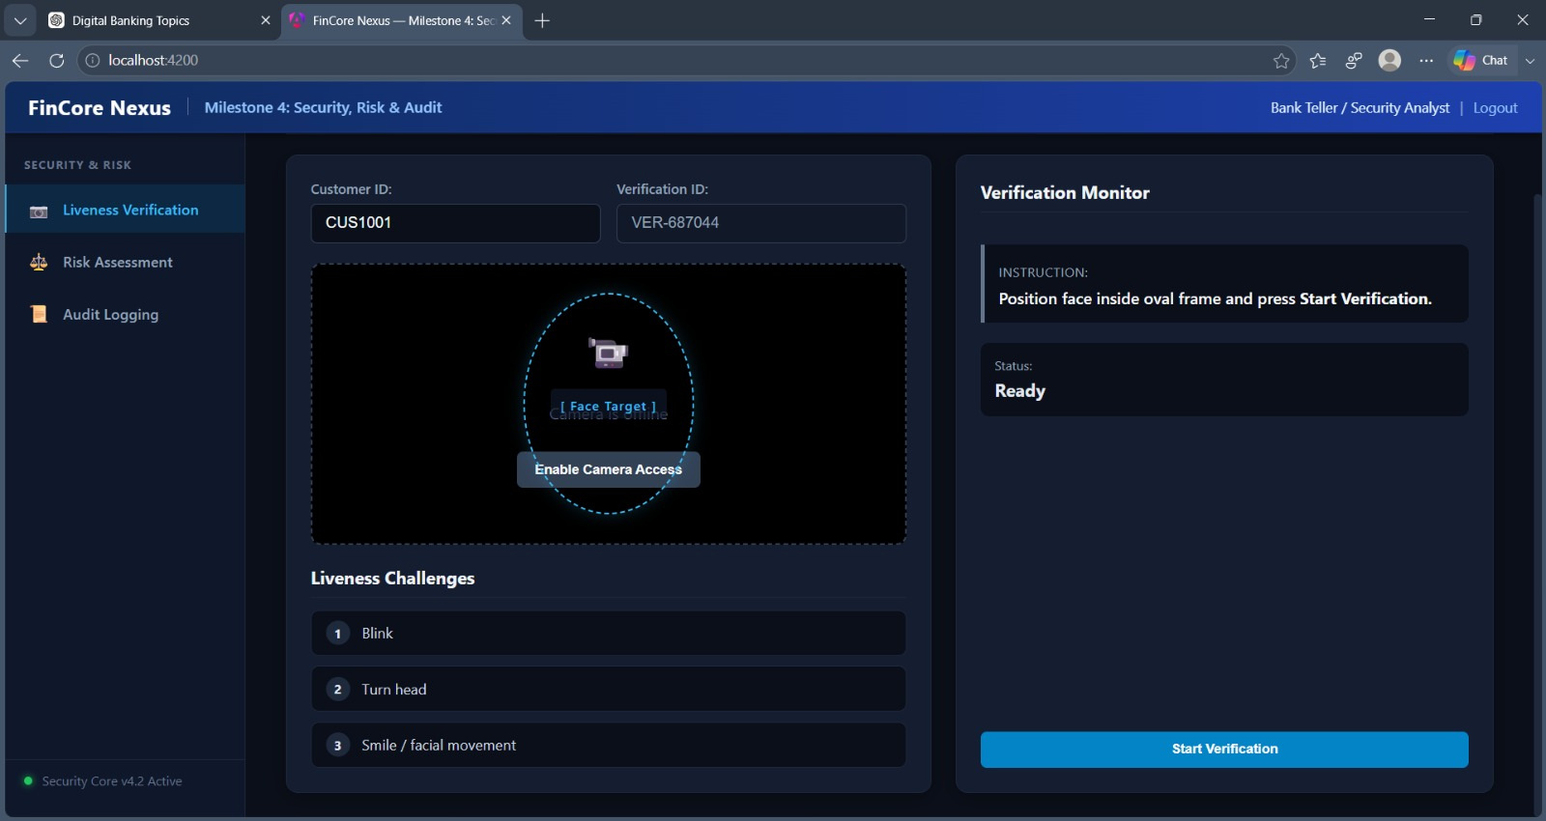
Figure 2: Liveness Verification Interface

9. Module 2 – Risk Assessment
The Risk Assessment module evaluates a transaction using customer and transaction parameters. The interface provides input fields for customer ID, transaction ID, amount, transaction type, account type, customer verification, and previous transaction history.

9.1 Risk Assessment Inputs
Input | Available / Demonstrated Values
Customer ID | Example: CUS1001
Transaction ID | Example: TXN5001; new IDs can be generated.
Amount | Numeric transaction amount in INR.
Transaction Type | Fund Transfer, International Wire, Bill Payment, ATM Withdrawal, Crypto Exchange.
Account Type | Savings, Current, Business, NRE / NRO.
Customer KYC | Verified / unverified indicator.
Previous Transaction History | Available / unavailable indicator.

9.2 Frontend Risk Rules
The supplied Risk Assessment component begins with a baseline score of 15 and then adds risk points according to the selected parameters.

Condition | Score Contribution | Risk Factor
Customer is unverified | +35 | Unverified or incomplete customer KYC.
Amount > ₹5,00,000 | +45 | High amount transaction exceeding threshold.
Amount > ₹1,00,000 and ≤ ₹5,00,000 | +20 | Moderate transaction size.
International Wire or Crypto Exchange | +30 | Cross-border or high-volatility transaction type.
No previous transaction history | +25 | New account with no prior transaction history.

Verified customers, normal transaction amounts, standard domestic transfer channels, and active transaction history add positive explanatory factors without increasing the score.

9.3 Risk Classification

Score Range | Risk Level | Frontend Status
0–39 | LOW | APPROVED
40–69 | MEDIUM | UNDER_REVIEW
70 and above | HIGH | FLAGGED

The PostgreSQL design uses a broader four-level interpretation for stored risk assessments: LOW (0–24), MEDIUM (25–49), HIGH (50–74), and CRITICAL (75–100). This distinction is retained in the report because the database specification and the current frontend component use different classification schemes rather than silently pretending they are identical.

9.4 Assessment History
Every new frontend assessment is added to an in-memory assessment history list. The interface provides a View History control that opens a table containing customer, transaction, amount, score, level, status, and assessment time.
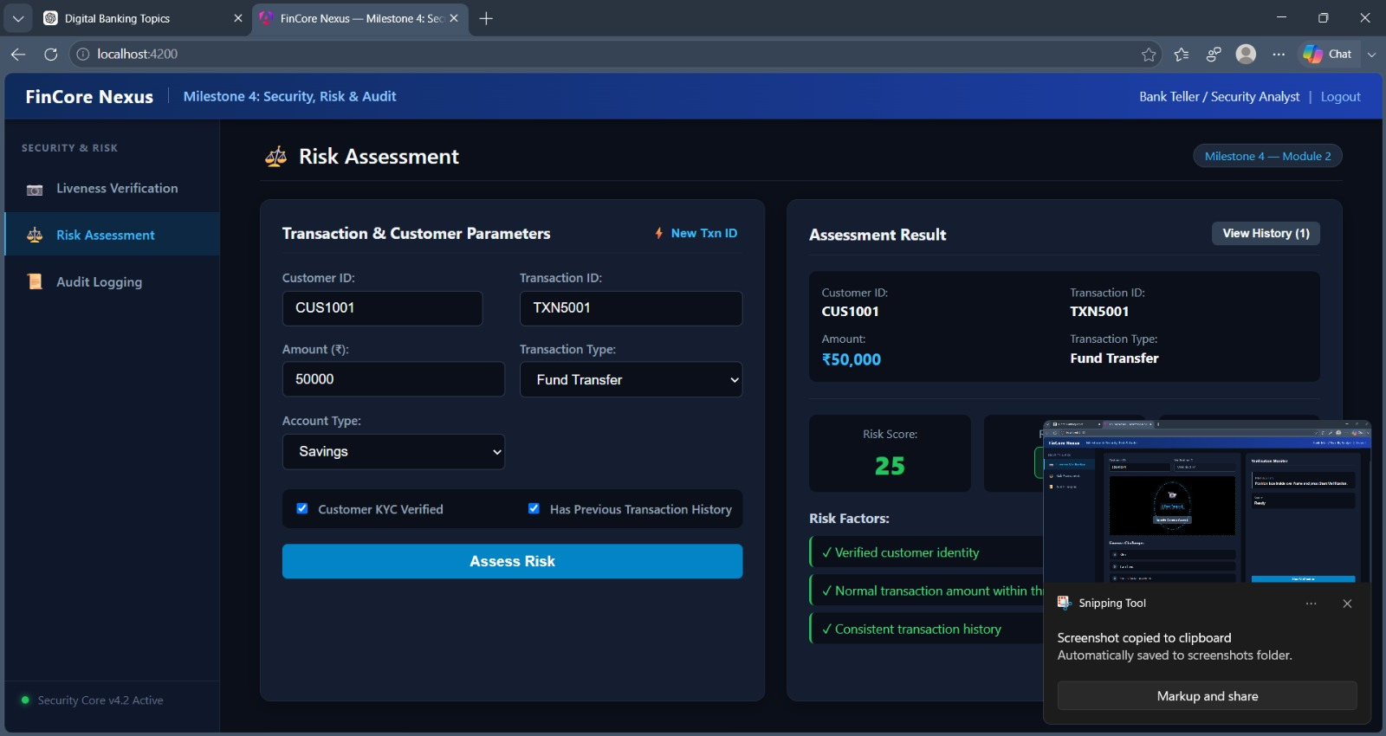
Figure 3: Risk Assessment Interface

10. Module 3 – Audit Logging
The Audit Logging module provides a searchable and filterable operational view of security and banking actions. Each record includes a user, user ID, action, module, status, timestamp, and description. The interface also provides a detail modal for inspecting an individual record.

10.1 Audit Log Data
Field | Purpose
Audit ID | Unique identifier displayed for an audit entry.
User / User ID | Identifies the actor associated with the action.
Action | Records the operation, such as LOGIN, RISK_ASSESS, LIVENESS_CHECK, PAYMENT, or ACCOUNT_FREEZE.
Module | Identifies the originating area such as AUTH, RISK, LIVENESS, COLLECTION, PAYMENT, or ACCOUNTS.
Status | SUCCESS or FAILED in the frontend model.
Description | Human-readable explanation of the audit event.
Timestamp | Date and time of the activity.

10.2 Search and Filtering
- Free-text search across user name, action, module, description, and audit ID.
- User filter.
- Module filter.
- Action filter.
- Status filter.
- From Date and To Date fields in the interface.
- Reset Filters operation.

10.3 Pagination and Detail View
The component displays five records per page and calculates the number of pages from the filtered result set. Previous/next controls and page-number controls are provided. Selecting View opens a modal containing the audit ID, user, action, target module, execution status, date/time, and event description.

10.4 Database Audit Structure
The PostgreSQL audit_logs table provides a richer persistent structure than the current frontend display model. It includes user ID, username, action, entity type, entity ID, description, old and new JSONB values, IP address, device ID, service name, and creation timestamp. Indexes are provided for user, action, entity, and creation time.
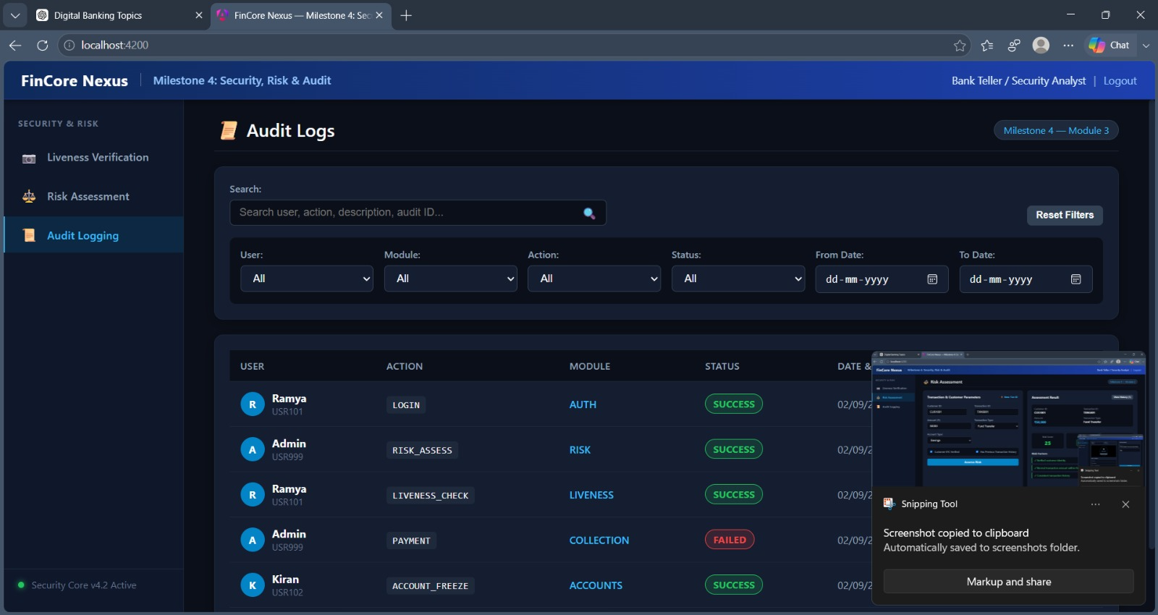
Figure 4: Audit Logging Interface

11. Database Design
PostgreSQL is used as the relational database for Milestone 4. The supplied schema defines the security-related tables together with customer, account, and transaction structures represented in the ER diagram.
Table | Purpose
customers | Stores customer master information such as name, email, phone, date of birth, KYC status, and creation time.
liveness_detection | Stores liveness/identity verification session metadata, result, confidence, attempt, device/IP, failure reason, and verification time.
accounts | Stores customer account information including account number, type, currency, balance, status, and creation time.
transactions | Stores financial transaction information including source/target accounts, customer, amount, currency, type, channel, status, and creation time.
risk_assessment | Stores transaction risk score, risk level, reason, assessment status, assessor, and assessment time.
audit_logs | Stores security and banking audit events, including actor, action, entity, old/new values, device/IP, service, and timestamp.

11.1 Entity Relationships
- One customer can have many liveness_detection records.
- One customer can have many account records.
- Accounts participate in transaction relationships as source or destination accounts.
- A transaction is associated with a customer.
- A transaction can have multiple risk assessment records.
- Audit logs record important actions associated with users, entities, services, liveness activity, and risk activity.
- The ER diagram shows the operational security flow as Customer → Liveness Detection → Transaction → Risk Assessment → Audit Log.
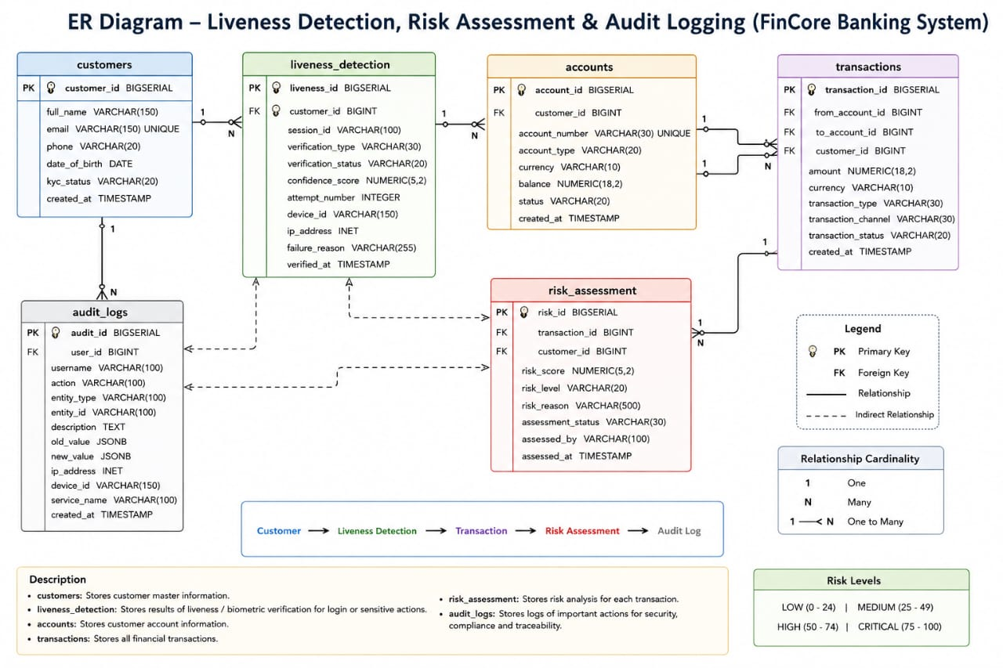
Figure 1: Entity Relationship Diagram – Liveness Detection, Risk Assessment and Audit Logging

11.2 Database Integrity and Performance
- Primary keys uniquely identify liveness, risk, and audit records using BIGSERIAL.
- Liveness verification type is restricted to FACE, VIDEO, or BIOMETRIC.
- Liveness status is restricted to PASSED, FAILED, or PENDING.
- Liveness confidence scores are restricted to the 0–100 range when present.
- Liveness attempt numbers must be greater than zero.
- Risk scores are restricted to 0–100.
- Risk levels are restricted to LOW, MEDIUM, HIGH, or CRITICAL.
- Risk assessment status is restricted to PENDING, COMPLETED, or REVIEW_REQUIRED.
- Indexes are created for frequently queried customer, status, transaction, risk level, user, action, entity, and timestamp fields.
- The schema intentionally does not store raw biometric images in liveness_detection.

12. Sample Data, Views and Queries
The PostgreSQL script includes representative sample records for all three core modules. Liveness examples include successful, failed, and pending sessions with confidence scores and failure reasons. Risk examples cover LOW, MEDIUM, HIGH, and CRITICAL assessments. Audit examples cover login, liveness, transfer, risk assessment, settlement, notification, fraud, account, and system service events.

12.1 Liveness Sample Scenarios
Scenario | Example
Successful face verification | Customer 101, confidence 98.50, PASSED.
Failed video verification | Customer 103, confidence 42.80, FAILED due to low liveness confidence.
Retry after failure | Customer 103 session SES-10003-R2, confidence 94.70, PASSED.
Pending verification | Customer 104, FACE verification, PENDING.
Repeated failure | Customer 106 has two failed FACE attempts with confidence 35.40 and 48.60.

12.2 Risk Sample Scenarios
The sample risk dataset contains 15 assessments. Examples include transaction 5001 at score 12.50 LOW, transaction 5004 at 82.00 CRITICAL, transaction 5006 at 67.40 HIGH, transaction 5009 at 76.50 CRITICAL, and transaction 5015 at 95.20 CRITICAL. Several high-risk records have REVIEW_REQUIRED status.

12.3 Database Views
View | Purpose
high_risk_transactions | Returns HIGH and CRITICAL risk assessments ordered by risk score descending.
recent_audit_activity | Returns audit activity ordered by creation time descending.

12.4 Demonstration Queries
- Retrieve all liveness records ordered by verification time.
- Retrieve only successful liveness checks ordered by confidence score.
- Find customers with failed liveness attempts and count their failures.
- Retrieve all risk assessments ordered by risk score.
- Retrieve high and critical risk transactions.
- Count transactions by risk level.
- Find transactions whose assessment status is REVIEW_REQUIRED.
- Retrieve audit history for a specific user.
- Retrieve all fraud-related audit events.
- Retrieve the latest 20 audit records.

13. API Design and Integration Scope
The Milestone 4 material supplied for this report contains the Angular frontend and PostgreSQL database specification. Unlike Milestone 3, no Milestone 4 Spring Boot backend source or endpoint specification was supplied in the current materials. Therefore, this report does not invent REST endpoints or claim completed backend integration that cannot be verified from the supplied source.
Component | Verified Implementation
Frontend Routing | Angular routes: /liveness, /risk, /audit.
Liveness | Client-side camera handling and simulated verification workflow.
Risk | Client-side rule-based assessment and in-memory assessment history.
Audit | Client-side mock audit records with search, filters, pagination, and detail modal.
Database | PostgreSQL schema, indexes, sample data, views, and queries supplied separately.

14. User Interface Implementation
The Angular interface is organized as a common FinCore Nexus shell with a top header, left Security & Risk navigation, and a main content workspace. The active module is controlled through the AppComponent and displayed using conditional rendering.
- Header displays FinCore Nexus, Milestone 4: Security, Risk & Audit, the Bank Teller / Security Analyst role, and Logout.
- Sidebar provides navigation for Liveness Verification, Risk Assessment, and Audit Logging.
- A Security Core v4.2 Active indicator is displayed in the sidebar footer.
- Liveness uses a two-column layout containing customer/verification fields, camera preview, challenge list, verification monitor, score, failure reason, and action controls.
- Risk Assessment uses transaction/customer input controls alongside an assessment-result panel and history modal.
- Audit Logging uses a filter card, audit table, pagination bar, and audit-detail modal.
- The application uses standalone Angular components and FormsModule for interactive controls.

15. Testing and Validation
Testing for Milestone 4 focuses on the behavior visible in the supplied frontend implementation and the integrity constraints defined by the PostgreSQL script.
Test Area | Test Condition | Expected Result
Liveness | Camera access available | Browser camera stream is attached to the video element and camera state becomes active.
Liveness | Camera unavailable/denied | Camera error is displayed and simulated camera state is used.
Liveness | Start verification | Status changes to VERIFYING and the first challenge becomes active.
Liveness | Challenge progression | Blink, turn head, and smile challenges complete sequentially.
Liveness | Successful simulated result | Status becomes SUCCESS and score is in the 90–99% range.
Liveness | Failed simulated result | Status becomes FAILED, score is in the 40–69% range, and a failure reason is displayed.
Risk | Verified customer, normal amount, known history | Low score and APPROVED result.
Risk | Amount above ₹1,00,000 | Moderate-amount risk points are added.
Risk | Amount above ₹5,00,000 | High-amount risk points are added.
Risk | International Wire or Crypto Exchange | High-risk transaction-type points are added.
Risk | No transaction history | New-account risk points are added.
Risk | Score ≥ 70 | Assessment becomes HIGH and FLAGGED.
Audit | Search text entered | Matching user, action, module, description, or audit ID records remain.
Audit | Dropdown filters changed | Records are filtered by selected user/module/action/status.
Audit | Reset Filters | All filter values return to defaults.
Audit | View selected record | Audit detail modal opens with record information.
Database | Invalid liveness/risk status or score | PostgreSQL check constraints reject invalid values.
Database | High-risk view query | Only HIGH and CRITICAL risk records are returned.
Database | Recent audit view | Audit records are returned in descending creation order.

16. Results and Outcomes
Milestone 4 establishes a dedicated security, risk, and audit workspace for the FinCore banking platform. The Liveness Detection interface provides a guided verification experience with camera access, sequential challenges, verification states, score display, failure handling, and retry support.
The Risk Assessment interface provides configurable transaction and customer parameters and calculates a rule-based score from verification, transaction amount, transaction type, and transaction history. The resulting risk level, status, risk factors, and assessment history are presented in a structured banking interface.
The Audit Logging interface provides searchable and filterable records with pagination and detailed inspection. The PostgreSQL design strengthens the milestone with constrained liveness and risk values, indexed audit activity, sample security events, high-risk and recent-audit views, and demonstration queries.
The supplied implementation also clearly separates demonstration behavior from persistent database design. The current Angular liveness and risk workflows operate in client-side state, while the PostgreSQL script provides the persistent schema and representative data required for a complete security and risk data layer.

17. Conclusion
FinCore Digital Banking Management Platform Milestone 4 extends the platform into Security, Risk & Audit through Liveness Detection, Risk Assessment, and Audit Logging. The Liveness Detection module provides a structured identity-verification workflow. The Risk Assessment module evaluates transaction and customer parameters using a transparent rule matrix. The Audit Logging module provides traceability through searchable, filterable, and inspectable activity records.
The Angular 18 and TypeScript frontend provides the interactive security workspace, while the PostgreSQL design supplies relational persistence structures, constraints, indexes, sample data, views, and queries. The milestone provides a foundation for future integration with production facial-liveness models, server-side risk engines, authenticated audit pipelines, and persistent REST services.

18. Team Members

Name | Role
Bharati Bhat | Frontend Developer
Ramya Chava | Frontend Developer
Janhvi Pandey | Backend Developer
Indu Patil | Database
Shanmukha Sai | Frontend Developer
Raziya | Backend Developer

