S

Failure cases:

Modify status code value with wrong value in test_main.py file and check into git

**Build is failed as expected:**

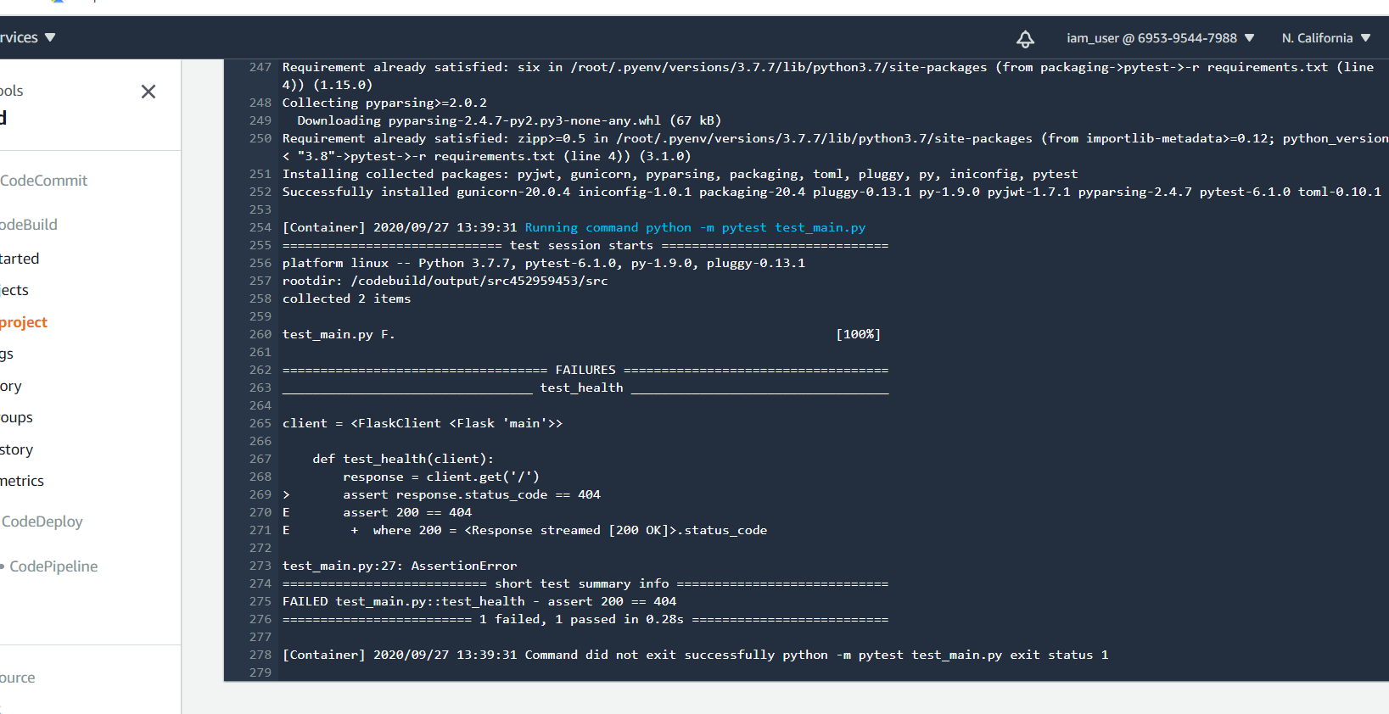

Respective build failed automatically

Build Number -8

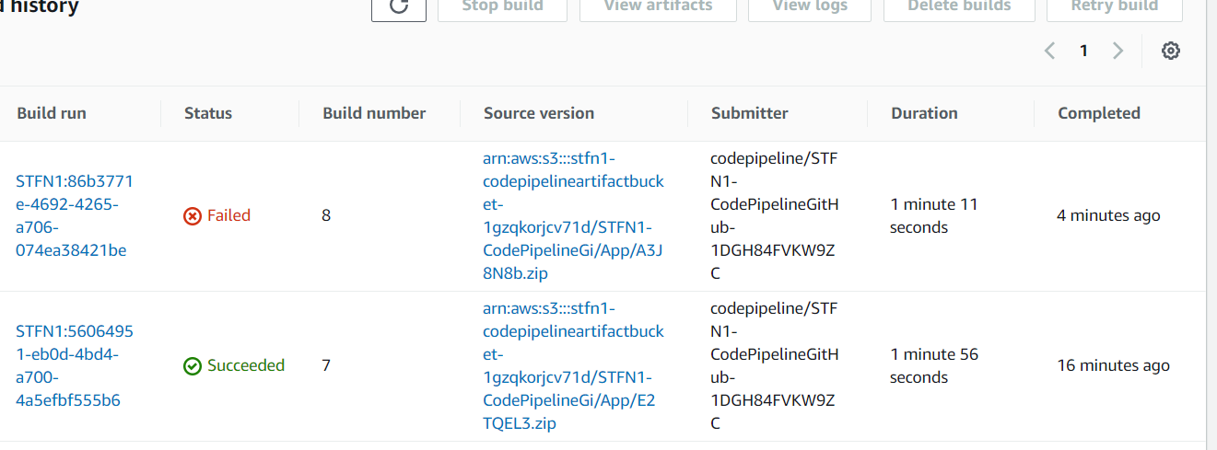

Update test_main.py file correct status code

Build is successful as expected –Build number 9

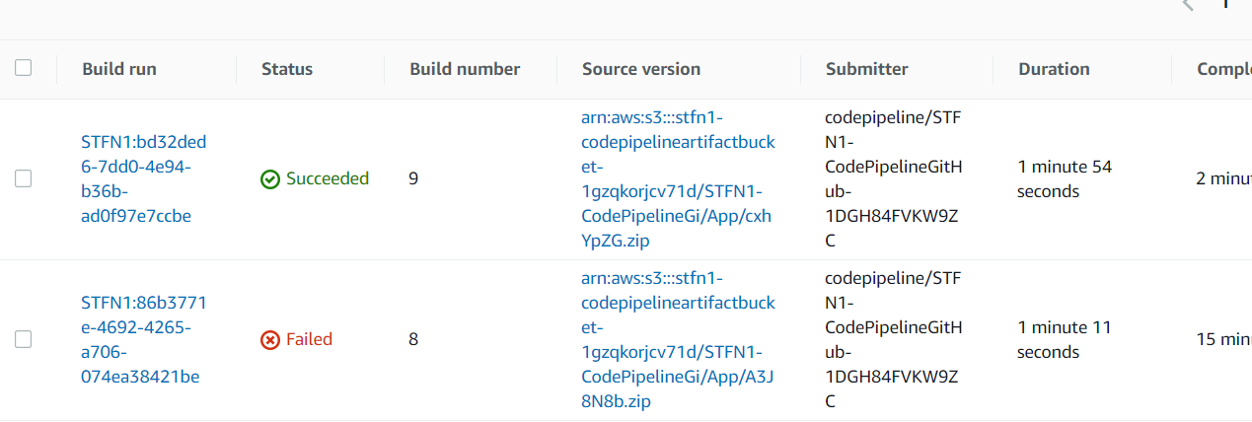

Testing URL:

External URL: a9192f325afc34bde81a6a2d2c5802c9-1101667049.us-west-1.elb.amazonaws.com/auth

[http://a9192f325afc34bde81a6a2d2c5802c9-1101667049.us-west-1.elb.amazonaws.com](http://a9192f325afc34bde81a6a2d2c5802c9-1101667049.us-west-1.elb.amazonaws.com/contents)

<http://a9192f325afc34bde81a6a2d2c5802c9-1101667049.us-west-1.elb.amazonaws.com/auth>

<http://a9192f325afc34bde81a6a2d2c5802c9-1101667049.us-west-1.elb.amazonaws.com/contents>

Screenshots of these URL via postman:

