Vending Machine Problem Solution

Part 1- Motor Control & Feedback

In this part I am implementing functional block diagram

**Research**

**1.0 Motor control**

Where I find out theoretical knowledge of how this h-bridge topology works so my finding was if we want to control the speed of motor according to requirement then we can this in two ways

1. Current control in coil of motor
2. Current direction change

And I find out that we also have BLDC(brushless DC motors ) in that we have a better control on our motor functionality like speed

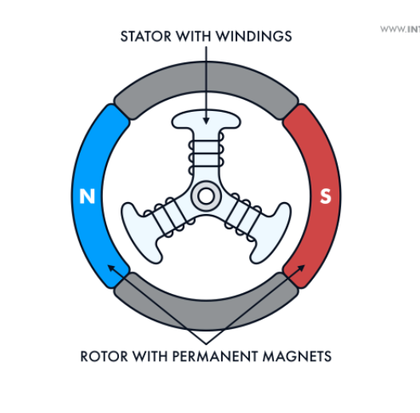

But in this I need to implement only control over a simple DC motor so I can control that using PWM signal controlling the mosfets

**1.0.1 H-bridge**

So here we have to know about H-bridge ……….how

So we know that if we generate a PWM signal through controller so it will be upto 3v but we want to control 24V DC motor so we need to add MOSFET or IGBT in our circuit to control mosfet

But we know we need minimum gate drive voltage for our MOSFET or IGBT where out controller voltage is not enough so to enhance that we need to add transitor at every gate

We have to keep in mind that we need two MOSFET one for high side and other is for low side

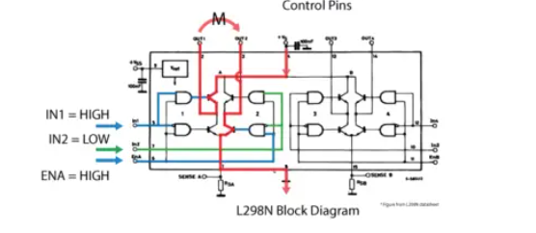

This is the working of H-bridge has one H-bridge has 4mosfet 4 Transistor

* 1. **Finding Best Method**

**1.1.1 transistor level Circuit**

So we need one h-bridge either we can go to adding simply mosfets & transistor in circuit and prepare a H-bridg but here two challenges

1. Cost
2. Complexity of circuit
3. Need more space on PCB

So implementing bare minimum transistor & MOSFET level circuit is not a solution

**1.1.2 H-bridge driver ICs**

So we need to find out H-bridge driver IC’s I was looking for that and to select them we need to keep these things in mind-

1)cost

2)current rating

3) voltage rating

4) additional if we have protection circuit

5)temp rating

So I have selected two ICs one is **L298N** and other is **DRV8872**

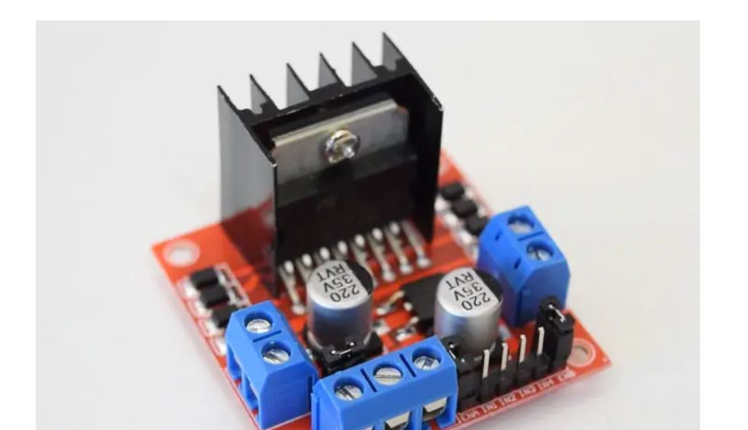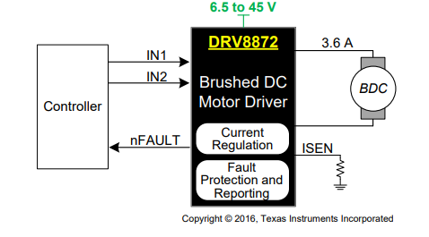

Here I made some assumption

1. Current Mes not mentioned in project detail
2. Not specified about power supply so I am assuming we have 24v DC voltage source

**1.2 Controller Selection**

Now we have to select controller to drive whole system so these parameter should be in mind

1. 2 PWM channel
2. Atleat 3-4 analog pin (one for switch to get feedback)
3. Cost
4. Size

So I found out that **ATMEGA328P** suits these parameters

* Here we can also go with some low cost controller like microchips ATTINY 402 but I am choosing this because of programming interface it has

**1.3 LDO Selection**

We know that we have a 24V DC supply in our system but we can’t operate controller on that so we need a LDO so we can get 5v supply

Now these are the parameter

1. Input voltage range
2. PWM channels
3. Analog pins
4. Cost

So after searching I find out a Texas LDO

UA78L Series Positive-Voltage Linear Regulators

It’s in stock and cost is also lesser **UA78L05ACD**

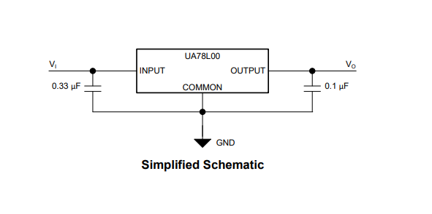

**1.4 Block Diagram**

Now we have selected all the components let’s figure out how to interface all these components for that I Have designed a Block diagram get a better idea

I have added schematic file for this in project

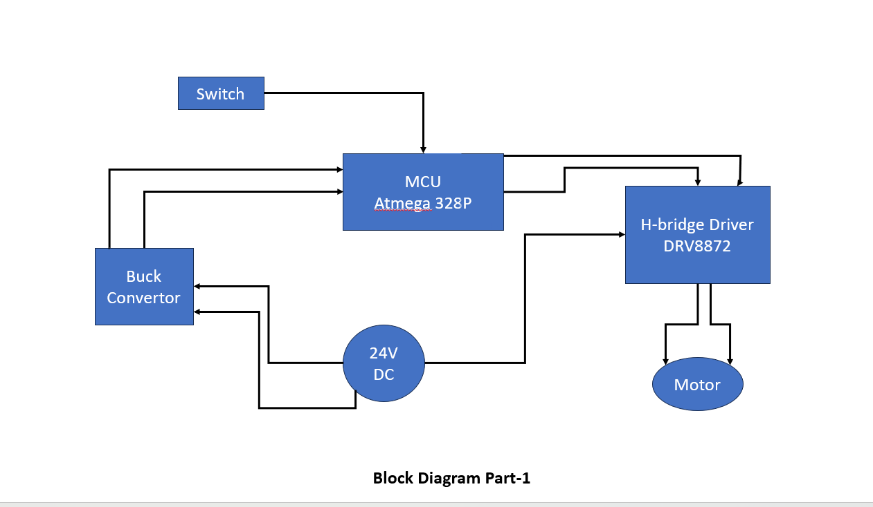

**1.5 Firmware**

**Motor Control**: The motor is controlled by two PWM signals on **Pin 9** and **Pin 10**.

* When one signal is high, the other is low, and vice versa. This setup is used to drive the motor.

**Start Button** (Pin 3): This button starts the motor when pressed.

**Task Button** (Pin 2): This button prints **"Task Successful"** to the serial monitor when pressed.

I have added code file in project

Part 2- Sensor Integration

So here we have to add a analog sensor to add analog sensor we need to see how we have to implement hardware for that

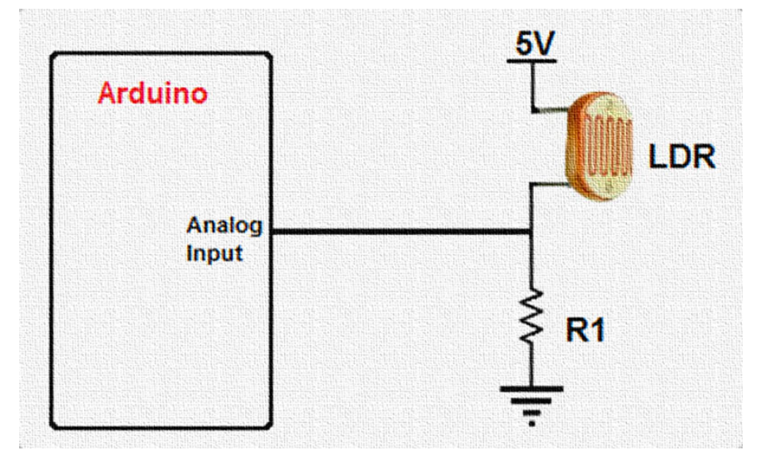

We can implement some IR sensor to detect the product status

According to that I have to made changes in code also

