

https://vitap.ac.in

# Real-Time Pothole Detection and Mapping System for Smart Vehicles Using YOLOv8

Submitted by

Dharma Teja Garipally (22BCE8224) (Team Lead) ,

Kowshik Annam (22BCE8333) , Ambati Sharanya Reddy (22BCE8396) , and Polisetti Govardhini (22BCE8163).

To

Dr. D. Kothandaraman

Computer Science and Engineering, Vellore Institute of Technology Amaravati, AndhraPradesh, India [info@vitap.ac.in](mailto:info@vitap.ac.in)

# Abstract

This project aims to design an automatic system for potholes detection in highways along with real-time monitoring with optimal road maintenance. Techniques in advanced deep learning enable safety and efficiency at roads to a new level. Potholes are major threats in the infrastructures of roads since they increase the chances of accidents by vehicles, rise the maintenance costs, and the heavy repair bills to vehicles due to their happening. Poor and delayed detection prevails through manual inspections that increase exposure to hazardous roads. To combat these challenges, we would use a state-of-the-art YOLOv8 model, which performs object detection tasks within high speed and accuracy. A deep learning model will be trained for pothole identification from stationary images captured by vehicle-mounted cameras, which will be used for correct and efficient identification of the road defects.

The system should aim to achieve high-speed and high-accuracy detection to enable real-time deployment for any vehicle to detect and highlight potholes on highways. In this respect, the automation of the detection process ensures that the system reduces the dependency on manual observations, thus reducing the detection time and improving the resource allocation of road maintenance. This will enable quick detection and fixing of potholes, thus making the roads safer for everyone and better use of resources. The use of such technology can be a game-changer in road maintenance, as it is scalable and adaptable to different environments and conditions.

Keywords: Pothole detection using YOLOv8, Deep Learning, Real-time object detection, Highway safety, Road infrastructure.

1. **Introduction:**

**2.1 Project Objective**

The objective of this project is to develop an autonomous pothole detection system using the latest state-of-the-art deep learning model, YOLOv8, which is particularly optimized for real-time object detection. This system shall analyze the video feeds coming from the camera mounted on a moving vehicle. These cameras shall be scanning the road surface all the time and map out all places of potholes in real-time.

- YOLOv8 is selected because it has higher precision and inference speed, very much needed for real-time applications. Alerting the driver to potholes will lead to improved road safety as he can take pre-emptive actions while ensuring that accurate information regarding road maintenance is acquired for the maintenance teams involved. Pothole detection contributes to reducing the incidence of accidents, reducing expenditure in vehicle maintenance, and road repair efforts.

The project is designed to work under any type of environment. This flexibility may be defined as the ability of a system to deal with road types, such as urban, suburban, and rural roads; weather conditions; that is, rain, fog, and snow, along with different lighting conditions: daylight, dusk, or night. The model, being flexible, adds the scalability and applicability both to developed and to developing regions.

**2.2 Challenges:**

Developing a reliable pothole detection system poses a number of challenges that may be of influence on its final overall performance:

1. Data acquisition and quality:

Data acquisition forms the backbone of training a capable deep learning model. While developing a pothole detection system, it becomes important to have as extensive a variety of different kinds of road surfaces in it, including asphalt, concrete, and gravel; lightning conditions such as sunny day, overcast day and night; and scenarios encompassing weather, rain and snow and dry. Gaining such data is exhaustive and involves a long careful curation process for scenarios to be covered.

Another major challenge is the presence of inaccurate or inconsistent labeling. The quality of annotations is required to be good, so that potholes can be differentiated from the similar features such as cracks or oil stains. This dataset is imbalanced in case some types of potholes are less represented, which will lead to low detection accuracy in the real world. Data augmentation and synthetic data generation techniques will help to make robustness in this case.

2. Speed vs. Accuracy Trade-off:

The speed of YOLO models makes it hard to balance such high speed with detection accuracy. Indeed, YOLOv8 is much better than its previous version, but it is hard to reach such a fast processing speed with simultaneously acceptable detection accuracy. The optimizations of YOLOv8-Small and YOLOv8-Nano were focused on their speed; however, with that speed comes a poorer accuracy in small and partly occluded potholes. This is crucial for applications like this one where in-time detection is necessary, for onboard vehicle systems whose pace should be complemented with the accuracy of results gathered.

3.Environmental factors:

In real-world conditions, environmental factors such as shadow, reflection, and debris make pothole detection more challenging. Buildings and trees may create shadows that obscure the detection of potholes sometimes even registering false negatives. A possible false positive can result from rain reflections on wet asphalt. Pedestrians, moving cars, or other objects may mask areas of the road not easily seen by the camera and thus complicate detection.

These challenges call for advanced image preprocessing in the form of contrast enhancements and shadow removal. At times, the detection process may also need to consider spatial information, where the successive frames are analyzed to correctly classify potholes or transient obstructions.

4. Road and Weather Variability:

The system has to be flexible enough to tolerate differences in road conditions. The textures, surface material, and pothole conditions of rural and urban roads are quite different from one another. Also, weather conditions like rain, snow, and fog affect the detection process. Hence, training such a model with good generalization for all such conditions would be pretty challenging and require substantial data and model tuning.

Related complications of weather: snow or ice that may obscure potholes leading to some false negatives, and wet surfaces that can fall below the threshold for identifying a pothole. Advanced techniques in deep learning: weather adaptation, and domain generalization are used to increase reliability in the model.

5. Computational Requirements: at run-time

This incurs a huge real-time computational resource overhead for detection of potholes. Detection needs to be accurately performed on edge devices which are of low processing capability. Techniques for model compression that include pruning and quantization are required to enable reduction of model footprint in the absence of any form of penalty on performance.

Opting YOLOv8 and implementing it on hardware-restricted devices requires optimization techniques at both the model as well as the hardware-software interface. Techniques range from CUDA optimization for GPUs as well as AI-specific utilization of processors are important ones because they do not breach those limitations of hardware to result in real-time operations.

6. Integration into Road Maintenance Systems

As soon as it senses a pothole, it needs to seamlessly interface with the databases of road maintenance as well as scheduling systems. The back-end design would have to be robust and scalable for efficient storage and data management. It has to avoid false positives as well as false negatives; thus, it should prevent taking up unnecessary maintenance and let real problems on the roads come on top. The system should be able to get updates periodically so it could keep changing to be aligned with the altering nature of the road's condition with the help of regular updates from maintenance teams.

**2.3 Data Set:**

The dataset for the project encompasses a large collection of images obtained from various sources to train and validate the YOLOv8 model:

Dataset 1:

The first dataset was obtained from Roboflow and online repositories, with 2520 images, which included various road conditions. These images are annotated to mark potholes under various lighting and weather conditions. The dataset provides a good starting point for initial model training.

Dataset 2:

The second dataset has 1200 images taken by car dashboard cameras. This dataset includes real-world driving scenarios, which are necessary for testing the model in authentic settings and simulating a driver's perspective. This dataset will teach the model about various road conditions, such as potholes partially obscured by debris or other obstacles.

Combined Dataset:

The combined dataset of greater than 3000 images serves as a basis to train a robust and generalizable detection model. Several techniques, such as augmentation (rotating, flipping, and scaling images), are used to handle issues related to class imbalances, thereby improving the accuracy in detection. A validation subset is used to evaluate the results and guide iterative tuning so that better results can be obtained.

**2.4 Problem Statement:**

Globally, potholes are an unremitting problem affecting the number of accidents, wear on the vehicle, and costly road repairs. Traditional detection methods included manual inspections, which are slow, labor-intensive, and always prone to human errors. Worsened hazardous driving conditions and financial losses resulted from late repairs.

This project aims at the reduction of dependability on manual inspections, where improvement in safety from alerts to dangerous road conditions would be achieved by the detection of potholes in real time, and then allowing timely maintenance interventions in reducing long-term repair costs as well as improving quality of road infrastructure overall.

**2.5 Applications**

The pothole detection system can be applied in many fields with several applications:

The pothole detection system improves road safety and the management of infrastructure and contributes to effective urban planning by the following:

1.Automated Road Maintenance

An automatic identification of potholes will hasten the process with reduced labor and time needed for inspections. Scheduling the identified potholes into maintenance databases helps create a database of what to repair immediately. Such an automated system streamlines all the workflows, making road upkeep faster and cheaper.

2. Driver Safety Improvement:

The system can, with real-time detection, alert drivers of dangers on the road and make corrective measures that would avoid accidents. Such a system would be very efficient in areas where the number of accidents is high owing to bad roads. A system that detects and then notifies in real time has a higher chance of more secure driving, reducing incidents related to damage.

3. Integration into Smart Cities:

The pothole detection system in smart cities can also be integrated with urban infrastructure to feed data into the central control systems monitoring the road conditions. This means that such data will aid city planners in determining regions that require more frequent maintenance and, therefore, lead the way in the improvement and optimization of infrastructure.

Moreover, integration with connected vehicles allows real-time road conditions to be shared with networks.

4. Fleet Management:

The system will help fleet operators and insurance companies monitor road quality, thereby ensuring the safety of their vehicles. It optimizes route planning and preventive maintenance schedules, reduces downtime and repair costs, and aids in determining the accurate premiums for insurance coverage based on actual road conditions encountered by drivers.

5. Autonomous Vehicle Improvement

A part of a more detailed work in development, such safe autonomous cars is achieved in providing pothole-detection accuracy. An important feature, as part of autonomous driving systems, that uses the sensor information and data generated in decision making, an inclusion such as pothole detection therefore allows autonomous vehicles to avoid hazards of roads to advance safety on navigation. Through this incorporation, perhaps comes more dependably developed or adaptive solution to driving, especially while it comes to auto-driving itself.

# Literature Survey on Pothole Detection System

## K. Sivaraman, M. Trivedi, "Pothole Detection Using Deep Learning and Road Surface Images," IEEE Transactions on Intelligent Transportation Systems, 2020.

Potholes present a significant hazard to road safety. Manual inspection methods for detecting and fixing potholes are slow and inefficient, particularly on long stretches of road. The challenge is to create an automated system that can identify potholes in real-time using visual inputs and reduce the cost and time for road inspection.The authors propose a computer vision-based pothole detection system using deep learning. The system leverages a YOLOv3 deep neural network to identify potholes in images captured by cameras mounted on vehicles.The authors use **YOLOv3** (You Only Look Once), a deep learning-based object detection algorithm, to detect potholes in images.YOLOv3 works by dividing the image into grids and predicting bounding boxes and class probabilities directly from the image in a single pass.

## D. Mednis, G. Strazdins, R. Zviedris, "Mobile Crowdsensing for Road Pothole Detection Using Smartphones," International Conference on Distributed Computing in Sensor Systems (DCOSS), 2019.

Smart phones, with built-in accelerometers and GPS, have the potential to detect road anomalies. However, distinguishing between potholes and other road irregularities, such as speed bumps, remains a challenge. The key issue is how to use sensor data effectively to identify potholes and avoid false positives.The authors propose a crowd sourcing-based approach using smart phone sensors (accelerometers and GPS) to detect potholes. The system is designed to identify potholes based on the patterns in sensor data when a vehicle hits a pothole.The system uses a **rule-based algorithm** to detect sudden vertical accelerations that exceed a certain threshold, which typically indicate the presence of a pothole.**GPS data** is used to log the location of the detected pothole. Data is collected from the smart-phone’s accelerometer and gyroscope as the vehicle moves over different road surfaces. Multiple detections from different smart-phones are aggregated to confirm the existence of a pothole, reducing false positives.

## H. Zhang, W. Liu, Z. Zhang, "Real-Time Pothole Detection Using LiDAR and Image Fusion," Journal of Advanced Transportation, 2021.

Detecting potholes accurately in various lighting and weather conditions is a challenge. While image-based methods can fail under poor lighting or heavy traffic, LiDAR can provide a robust way to measure road surface irregularities. The challenge is to fuse these different modalities for more reliable detection.The paper proposes a fusion-based approach that combines LiDAR and camera images to improve the accuracy of pothole detection under various environmental conditions.A **convolutional neural network (CNN)** is used to analyze the image data, while a **LiDAR-based surface height analysis** identifies height variations in the road surface.The CNN detects visual anomalies, while LiDAR detects 3D surface irregularities. A **fusion algorithm** combines these two modalities to confirm the presence of a pothole.The fusion process uses **Kalman filters** to integrate the two data streams, allowing for more robust detection even in poor lighting or adverse weather.

## M. Eriksson, N. Mohan, "Automatic Pothole Detection Using Machine Learning on Accelerometer Data," IEEE Sensors Journal, 2020.

A major challenge in using accelerometer data to detect potholes is distinguishing between different road anomalies and the variability of vehicle speeds. A reliable detection algorithm needs to work in real-world conditions with minimal false positives.This paper proposes a machine learning-based approach to detect potholes from smart-phone accelerometer data. The system uses a supervised learning model trained on labeled accelerometer data to differentiate between potholes, speed bumps, and other road anomalies.The authors use a Support Vector Machine (SVM) to classify each window of accelerometer data as either a pothole, speed bump, or normal road surface.The features used for classification include maximum acceleration, signal energy, and peak-to-peak interval.Accelerometer data is collected from multiple vehicles driving over different road surfaces. The data is then segmented into windows corresponding to individual road events. GPS coordinates from the phone are used to log the location of detected potholes and share the data with a centralized database for road maintenance.

## A. Rashid, P. Khan, "Pothole Detection Using Hybrid SVM and Texture Analysis on Road Images," International Journal of Computer Vision, 2018.

Detecting potholes using image data is a well-known approach, but distinguishing potholes from other road defects such as cracks and patchwork presents challenges. This paper addresses the need for a more precise classification of road defects, especially in varying road conditions.The authors propose a hybrid method combining SVM (Support Vector Machines) and texture analysis to detect and classify potholes in road images. The hybrid system improves the accuracy of pothole detection by focusing on texture and shape features.The system first performs **edge detection** using the **Canny edge detector** to isolate potential road defects.The extracted regions are analyzed using **texture features** (e.g., **Local Binary Patterns (LBP)**) to classify them as potholes or other defects.A **Support Vector Machine (SVM)** is then used to classify the regions based on their texture and shape.Images of road surfaces are collected using a high-resolution camera mounted on a vehicle. The images are converted to grayscale, and noise is reduced using a **Gaussian filter**.False positives are filtered by analyzing the shape of the detected regions (e.g., potholes tend to be circular or irregular, while cracks are linear).

Table 1:Various research paper methodologies and limitations

|  |  |  |  |
| --- | --- | --- | --- |
| **S.NO** | **Research paper links** | **Methodology** | **Limitations** |
| 1 | https:// ieeexplore.ieee.org/ stamp/stamp.jsp? tp=&arnumber=1050 5438 | The paper improves pothole detection using **YOLOv5-Seg** enabling better localization and detection of potholes. The authors fine-tune the model by adjusting anchor box sizes and incorporating a feature pyramid network to handle multi-scale objects. Additionally, they enhance training by using a custom dataset of road images with annotated potholes, optimizing the model for real-world road conditions. | The model’s performance is affected by environmental factors such as poor lighting, heavy shadows, and adverse weather conditions (e.g., rain or snow). It also struggles with detecting smaller, less prominent potholes, and requires further optimization to reduce computational costs for real-time detection in resource-constrained devices like in-car systems. |
| 2 | https:// ieeexplore.ieee.org/ stamp/stamp.jsp? tp=&arnumber=9266 138 | The paper employs **computer vision techniques** to detect potholes in road images using a combination of image processing methods like **edge detection**, **morphological operations**, and **contour analysis** to identify and classify road anomalies. | The method struggles in challenging conditions such as low lighting, poor weather, or when road surfaces are cluttered with debris or shadows. It also faces difficulties in differentiating between potholes and other road surface anomalies like cracks or patches. |
| 3 | https:// ieeexplore.ieee.org/ stamp/stamp.jsp? tp=&arnumber=1045 8751 | The paper proposes a **smartphone- based pothole detection system** that uses the phone's **accelerometer and gyroscope sensors** to identify road irregularities in real-time, providing alerts to the driver about potential potholes ahead. | The system may generate false positives due to sudden braking, speed bumps, or sharp turns. Detection accuracy can also vary based on smartphone sensor sensitivity and the position of the phone in the vehicle. |
| 4 | Potholedetectionwith YOLOV8.pdf | The paper explores the use of **YOLOv8**, a state-of-the-art real-time object detection model, for detecting potholes in road images and videos. YOLOv8 processes frames using a single forward pass through the neural network, making it highly efficient for real-time applications, and achieves high precision in identifying potholes of varying shapes and sizes. | The model’s performance can degrade under poor lighting, weather conditions like rain or fog, or when the road has occlusions such as debris or other anomalies. Additionally, it requires high computational resources for processing on low-latency systems, especially in real-time scenarios. |
| 5 | https:// onlinelibrary.wiley.co m/doi/epdf/ 10.1155/2022/922121  1 | This paper proposes a **deep learning-based pothole detection**  **system** that leverages AI-on-the-edge devices. The system processes video frames in real-time using convolutional neural networks (CNNs) on **edge computing devices** (e.g., Raspberry Pi, NVIDIA Jetson). It aims to achieve real-time pothole detection without depending on cloud infrastructure, reducing latency and improving data privacy. | The system is constrained by the limited computational power of edge devices, which can affect detection accuracy and processing speed when dealing with complex road conditions. Additionally, edge devices are sensitive to environmental factors like extreme heat or dust, which can impact their reliability in outdoor deployments. |
| 6 | https:// [www.nature.com/](http://www.nature.com/) articles/  s41598-024-52426-4 | The paper explores the use of **Vision Transformers (ViT)**, a transformer- based architecture traditionally used in natural language processing (NLP), for pothole and traffic sign detection. The ViT model processes image data by splitting it into patches, applying self-attention mechanisms, and classifying the potholes and traffic signs in the images with high accuracy. | Although Vision Transformers provide improved accuracy and performance over traditional convolutional neural networks (CNNs), they require a large amount of training data and high computational resources. In addition, ViTs are sensitive to image quality, meaning that performance may degrade under conditions such as poor lighting or obstructions on the road surface. |

1. **UML Diagrams**

## 4.1 Use Case Diagram:

Figure 1: Use Case

(User roles and system interactions.)

The Use Case Diagramoutlines the interaction between different actors (such as the driver and the system) and the system components. The key actors in this pothole detection system include:

* Driver: Starts the pothole detection process.
* YOLOv8 Model: Detects potholes in real-time from the video feed.
* Driver Display: Displays pothole detection results.

The diagram illustrates how the driver interacts with the system by starting the detection process, and how the YOLOv8 model processes video frames to detect potholes and alerts the driver.

## 4.2 Class Diagram:

Figure 2: Class Diagram

(System classes and their relationships.)

## The Class Diagram represents the system's structure by showing the classes, their attributes, and relationships. Key classes include:

## Vehicle-camera: Captures the video feed.

## YOLOv8Model: Processes frames to detect potholes.

## Driver Interface: Alerts the driver upon detection.

## This diagram highlights the modular design of the system, showing how each component interacts to detect potholes in real-time.

## 4.3 Activity Diagram:

Figure 3: Activity Diagram

(Process flow of system activities.)

The Activity Diagram shows the step-by-step workflow of the pothole detection system:

* Start detection.
* Capture video frames.
* Run YOLOv8 model on each frame.
* If pothole detected, alert driver; otherwise, continue processing.

The diagram helps visualize the flow of actions that the system performs during detection, focusing on real-time responsiveness.

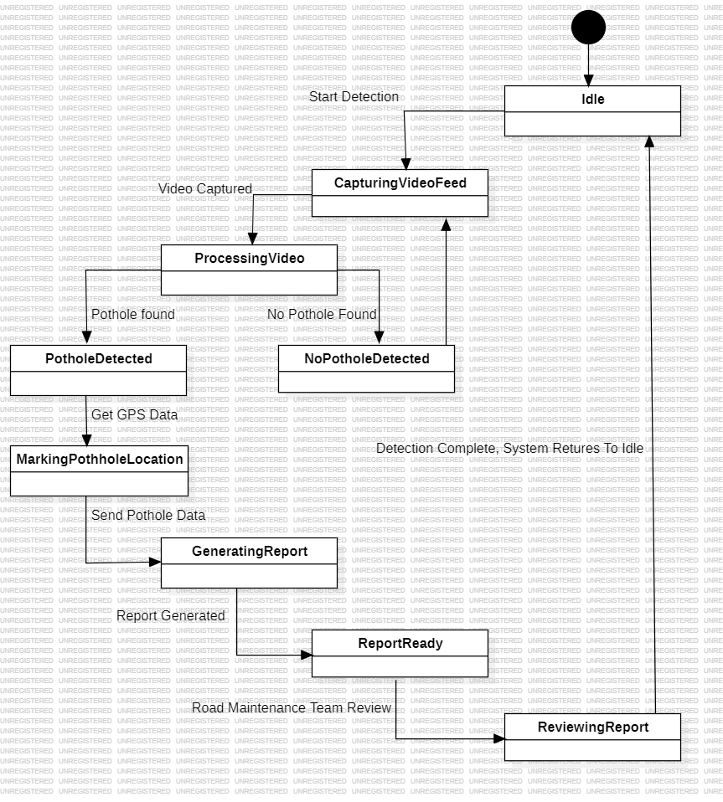**4.4. State Diagram:**

Figure 4: State Diagram

(Different states of system life cycle.)

The State Diagram captures the states of the system, including:

* Idle: Waiting for detection to start.
* Capturing Video: When the system is actively capturing frames.
* Processing Video: When the YOLOv8 model processes each frame.
* Pothole Detected: Transitioning to the state where the pothole is detected and displayed.

This diagram helps explain how the system transitions between different states depending on input.

## 4.5 Sequence Diagram:

Figure 5: Sequence Diagram

(Order of interactions between components.)

The Sequence Diagram captures the interaction between different components in the system during the pothole detection process. It represents the order in which:

* The video is captured.
* YOLOv8 processes the video frames.
* The driver is alerted in case a pothole is detected.

This diagram emphasizes the real-time detection flow.

## 4.6 Component Diagram:

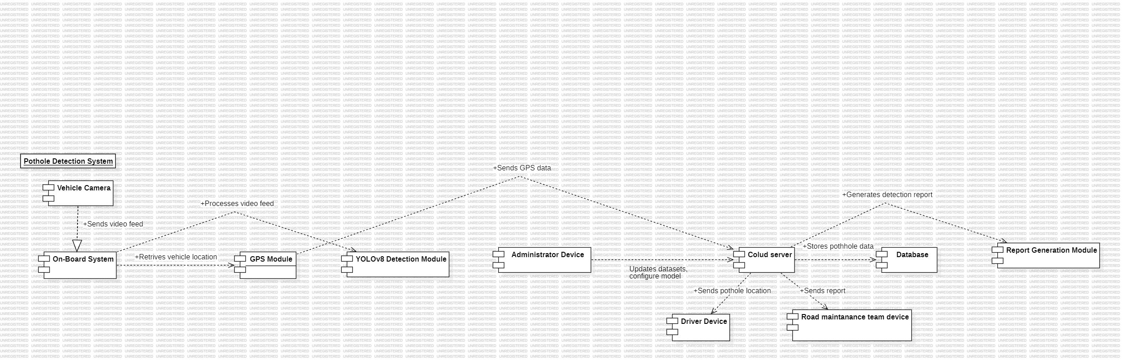

Figure 6:Component Diagram

(System components and their dependencies.)

The above picture is the Component Diagram of the Pothole Detection System. It depicts some major software components with their interrelation in the system. Major components involved are as follows:

* Vehicle Camera and On-board System: Capture and process video data.
* YOLOv8 Detection Module: These modules use the YOLOv8 model to decide whether potholes exist or not.
* GPS Module: This module gives location details for any potholes detected.
* Cloud Server and Database: The storage, processing of data, and communication with an external device.
* Report Generation Module: Generate reports to pass on to maintenance for a further check.
* User Devices: The Driver, Administrator, and Maintenance Team devices should be integrated into the system.

The diagram shows how the subunits of the system connect with each other to bring forth efficient pothole detection and reporting.

## 4.7 Deployment Diagram:

Figure 7: Deployment Diagram

(Hardware and software deployment architecture.)

The Deployment Diagram focuses on the hardware setup, showing how the system is deployed on a vehicle, utilizing on board cameras, and how it interacts with the YOLOv8 model running on a local processor. It shows the distribution of software and hardware components for real-time pothole detection.

## 4.8 Data Flow Diagram: DFD Level 1:

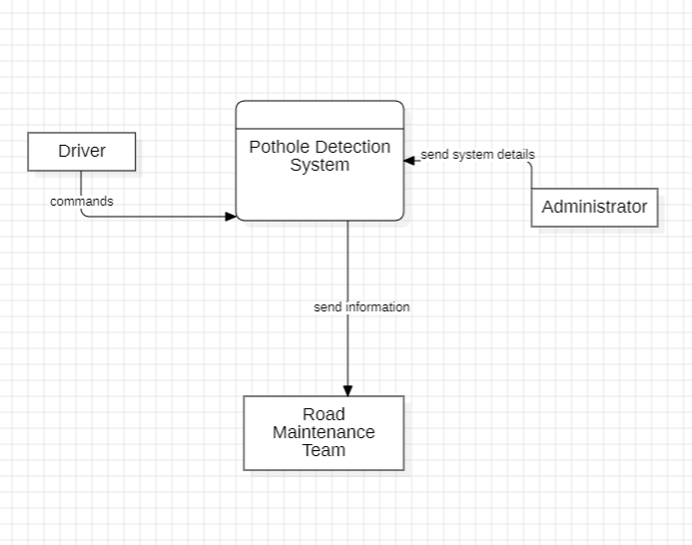

Figure 8.1: DFD Level-1

(High-level data flow between system and users.)

* •Pothole: Contains attributes such as location and severity.
* •Shows how the system captures input (video feed) from the vehicle camera.
* •YOLO v8 Pro

## 4.9 DFD Level-2:

## 

Figure 8.2: DFD Level-2

(Detailed data flow through detection and reporting processes.)

* Shows how the system captures input (video feed) from the vehicle camera.
* YOLOv8 processes the input to detect potholes. Detected results are sent to the driver display.
* Illustrates more granular processing steps, such as video pre- processing, YOLOv8 model inference, and output display.

## 4.10 ER Diagram:

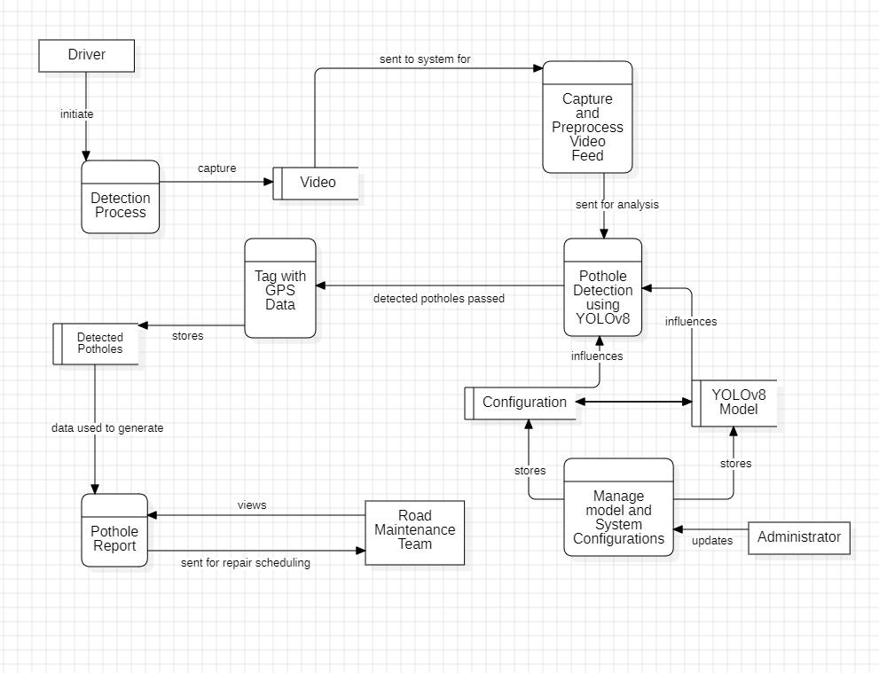

Figure 9: ER Diagram

( Entities and relationships in the database.)

The Entity-Relationship Diagram shows the relationships between different data entities:

* •Pothole: Contains attributes such as location and severity.
* •Video Frame: Each frame contains potential potholes detected.

The diagram helps model the database schema required to store information related to detected potholes.

1. **Functional and Non Functional requirement**

**5.1 Functional Requirements:**

* Real-Time Pothole Detection:

The system must detect potholes in real-time using YOLOv8. It should be capable of processing video streams from vehicle-mounted cameras or other sources to identify and localize potholes.

* Pothole Localization and Mapping:

The system should provide the exact geolocation (latitude and longitude) of detected potholes and mark them on a digital map. This mapping will assist road maintenance teams in identifying and prioritizing repairs.

* Data Acquisition and Preprocessing:

The system will collect images or video data of roads, which will be preprocessed and fed into the YOLOv8 model. The preprocessing will involve tasks such as noise reduction, resizing, and image augmentation.

* Classification and Reporting:

The detected potholes should be categorized based on size or severity, and the system should generate periodic reports for road maintenance authorities. The system must also have the capability to notify users of newly detected potholes in specific locations.

**5.2 Non-Functional Requirements:**

* Performance:

The system should have low latency to ensure real-time pothole detection. It should be optimized for speed, ensuring minimal impact on vehicle performance and road monitoring systems.

* Accuracy:

The detection system should maintain a high level of accuracy, with an acceptable false-positive rate, especially under various weather and lighting conditions.

* Scalability:

The system should be scalable to process large datasets and multiple video streams simultaneously, making it suitable for deployment across multiple vehicles or road monitoring systems in large cities.

* Usability:

The interface for displaying pothole locations and generating reports should be user-friendly, allowing road maintenance teams to easily interpret the data.

* Reliability:

The system must be reliable and capable of functioning in diverse environmental conditions, including different weather scenarios and road conditions.

* Security:

The system should ensure that the data related to pothole detection, especially location-based information, is protected against unauthorized access and tampering.

# **Proposed Systems:**

In this project, we are developing a pothole detection system using the YOLOv8 deep learning model. This captures real-time video feed from a camera mounted on a vehicle, processes that stream frame by frame, and detects potholes. Detection is done in the YOLOv8 state-of-the-art object-detection model to effectively identify objects such as potholes from video frames.

This is a real-time system that gives fast and accurate pothole detection when the vehicle is in motion. In our implementation, we focus only on the pothole detection and results are shown directly to the driver for instant awareness. The system does not have any GPS or report generation because of this reason and it is lightweight and focuses purely on the detection process with immediate notification to the driver.

This system has been implemented to process frame-onboard and alert the driver to potholes detected. This method presents a very realistic solution wherein drivers are cautioned to be prudent when driving over a pothole, thereby enhancing the safety of driving and performance of the vehicle.

**6.1 Project Implementation Description:**

The pothole detection system using YOLOv8 can be initiated with the generation and preparation of the data set. The data will be collected from different environments in the form of images or videos of roads with various types of potholes, including wet, dry, and low-light settings, and even on highways as well as rural and urban areas. These data sets are then manually annotated using tools like Labellmg by drawing around the potholes and placing bounding boxes. Besides this, manually collected datasets can be supported by public domain datasets, which can be drawn from Roboflow or other sources.

Fine-tune the YOLOv8 model on the annotated dataset. To improve this process and achieve greater accuracy, pre-trained weights transfer learning is applied. Fine-tune the hyperparameters' learning rate and batch size for an optimal trade-off between detection speed and accuracy. Metrics that can be used to test its performance are mean Average Precision (mAP) and Intersection over Union (IoU). The hope is that it will generalize well to unseen data.

The trained model YOLOv8 was deployed on video feeds of vehicle-mounted cameras with the objective of real-time processing of video feeds. In this, each video frame is preprocessed or pre-processed, reshaped, and normalized so as to be fed in front of the model and undergo pothole detection. The model outputs rectangles encircling the location where the pothole was detected, which gets superimposed on the feed to visually identify potholes in real time.

The system integration and optimization is done to ensure efficiency. Techniques such as model quantization reduce the size of the model but do not affect the accuracy appreciably, thus allowing its use on edge devices like Raspberry Pi or NVIDIA Jetson. Real-time performance is optimized to enable smooth video processing at a frame rate of 25-30 FPS depending upon the hardware.

The system is tested and validated on real-world road conditions with varying lighting and weather environments. Its performance is measured in terms of detection accuracy, false positive rates, and real-time latency. After validation, the system is deployed in vehicles with onboard cameras to provide real-time pothole detection through a graphical interface that highlights potholes on the live video feed.

## 6.2 Block Diagram:

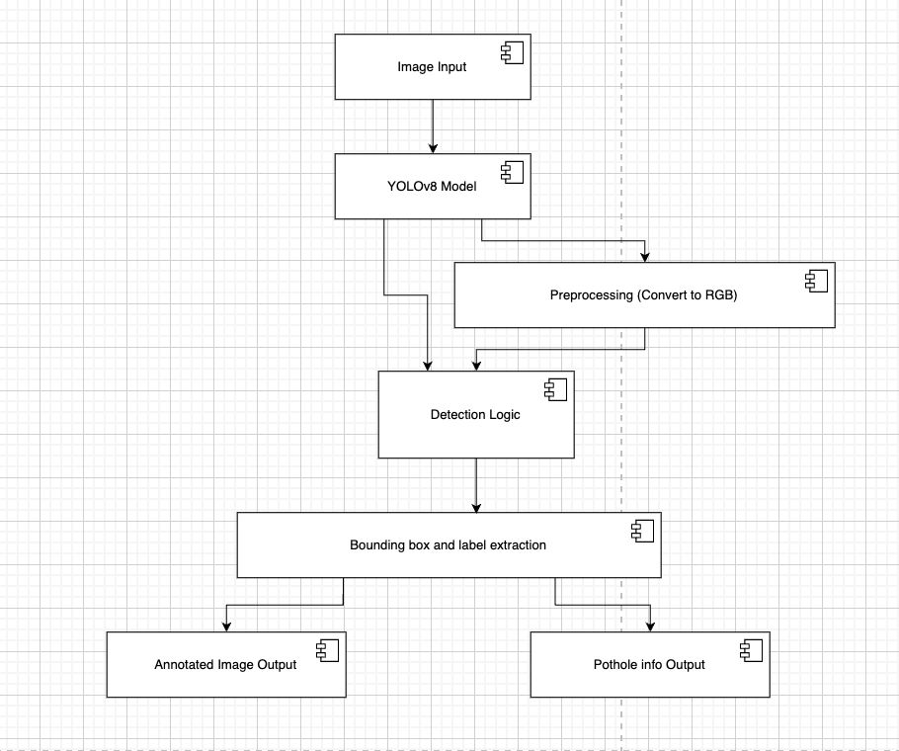

Figure 10: Block Diagram

(System architecture block diagram illustrating the flow between the vehicle camera, YOLOv8 model, and the detection display components.)

The **Architecture Block Diagram** of the pothole detection system illustrates the key components, the flow of data, and how images are to be processed in the case of detecting potholes.

1. Image Input. This block represents a source of road images; a vehicle-mounted camera or even a drone can take photos of the road to get input for the system.

2. Pre-processing: Before the input image is fed to the detection model, input the same image to pre-processing in which it transforms into a best suitable format for analysis; for example, BGR format is converted to RGB.

3. YOLOv8 Model: The central module of this system is based on a convolutional neural network by using a pre-trained model of YOLOv8, which analyzes that inputted image and then predicts the bounding boxes above the potholes on that image.

4. Detection Logic: It will go through the output generated from the YOLOv8 model and draw all the information that might help in detailing the location and other parameters of potholes such as label information and confidence scores.

5. Bounding Box & Label Extraction: This stage picks up all the data for the output produced after making the detection (for pothole locations, their sizes, and probable confidence).

6. Annotated Image Output: After that, the identified potholes are highlighted in the original input image by outlining it with bounding boxes so an annotated image is formed.

7.Pothole Information Output In the parallel stream, output for detailed information like names of the objects, boundary box coordinates, and score for confidence are printed out or saved for use like to generate reports for teams dealing with road maintenance work.

This block diagram of represents the end-to-end pipeline for real-time detection using deep learning techniques on potholes.

## 6.3 Algorithm/Pseudo code:

1. Load Dependencies and Initialize Model Input: Custom dataset with labeled potholes Output: YOLOv8 model ready for training

Step 1.1: Import necessary libraries:

-Import YOLOv8 from Ultralytics library.

-Import libraries like OpenCV, NumPy, and PyTorch.

Step 1.2: Install required packages (e.g., ultralytics, roboflow).

Step 1.3: Set up environment for GPU/TPU acceleration, if available.

1. Load and Pre-process Dataset

Input: Custom dataset with pothole annotations Output: Pre-processed dataset ready for training

Step 2.1: Load the custom dataset using Roboflow API:

-Download images and corresponding annotations (bounding boxes).

-Split dataset into training, validation, and test sets.

Step 2.2: Perform image augmentation and pre-processing:

-Resize images to the target size (e.g., 640x640).

-Normalize image pixel values (scaling to range [0,1]).

-Apply augmentation techniques (rotation, horizontal flipping, etc.).

1. Initialize YOLOv8 Model

Input: Pre-processed dataset

Output: YOLOv8 model initialized with specific configurations

Step 3.1: Choose the YOLOv8 model variant (e.g., YOLOv8n for a lightweight model).

Step 3.2: Initialize the model with pre-trained weights.

Step 3.3: Configure model hyperparameters:

-Set batch size, learning rate, epochs, and momentum.

-Define the anchor boxes based on the dataset.

1. Train the YOLOv8 Model

Input: Training dataset and initialized YOLOv8 model

Output: Trained YOLOv8 model optimized for pothole detection

Step 4.1: Define the loss function components:

-Localization loss (L_loc) to minimize errors in bounding box prediction.

-Confidence loss (L_conf) to measure objectness prediction accuracy.

-Class loss (L_cls) for pothole classification.

Step 4.2: Begin model training:

For each epoch:

-Feed a batch of images into the model.

-Perform forward propagation to predict potholes (bounding boxes).

-Calculate the total loss (L_total = L_loc + L_conf + L_cls).

-Perform backpropagation to update model weights.

Step 4.3: Log training performance (e.g., loss, accuracy, mAP) after each epoch.

1. Validate and Test the Model

Input: Validation and test datasets

Output: Evaluation metrics such as mAP (mean average precision)

Step 5.1: Run the trained model on the validation set:

-For each image, generate bounding box predictions for potholes.

-Compare predictions with ground truth using Intersection over Union (IoU).

-Calculate precision, recall, and mAP.

Step 5.2: Adjust model hyperparameters based on validation results (if needed).

1. Use the Trained Model for Real-time Pothole Detection Input: Real-time video stream from vehicle-mounted camera Output: Pothole detections on video frames

Step 6.1: Capture real-time video frames from the vehicle camera.

Step 6.2: Pre-process each video frame and pass it through the trained YOLOv8 model.

Step 6.3: Detect potholes in the frame:

-Draw bounding boxes around detected potholes.

-Display confidence scores on the bounding boxes.

Step 6.4: Display the processed frames with pothole detections to the driver in real-time.

**Explanation of Key Steps:**

1. Loading Dependencies and Model Initialization:

This involves importing YOLOv8 from Ultralytics, other necessary libraries, such as OpenCV and PyTorch. The Colab environment is configured with the required dependencies to support GPU/TPU acceleration, which accelerates training and inference.

2. Dataset Pre-processing:

The next part would load the Roboflow API dataset, comprised of images of roads, and including annotated potholes. The data is then resized and normalized and also augmented, to maximize generalization at all points where the model will make predictions. Furthermore, preprocessing would split up into a training set, and validation, plus a test set.

1. Model Initialization:

Initialize with a pre-trained YOLOv8 model by using a lightweight variant like YOLOv8n; balance between speed and accuracy. Hyperparameters: learning rate, batch size, epochs-number, depending on dataset size and desired performance

4. Training the Model:

The model trains on its parameters using backpropagation during training. Some of the key loss functions are localization loss (for bounding box accuracy), confidence loss (for objectness score), and classification loss (for pothole detection). It is trained iteratively through several epochs, and metrics such as loss and accuracy are monitored.

5. Validation and Testing:

Test the trained model on a validation set to evaluate its performance. IoU is used to evaluate the accuracy of the bounding boxes, and precision, recall, and mAP are computed to measure the overall performance of the model.

6. Real-time Detection:

Once trained, the model is deployed in a real-time environment where real-time processing of video frames from a camera mounted inside a vehicle occurs. With the detection of potholes on the video feed, it then highlights bounding boxes that are used in real time to alert a driver in advance.

## 6.4 Control Flow Chart:

Figure 11: Control Flow Chart

( Illustrates the sequential steps of the pothole detection process using the YOLOv8 model, from data input to detection output.)

## 6.5 Cyclometric Complexity:

Nodes:

Load YOLOv8 Model, Read Image, Preprocess Image, Run Pothole Detection, Decision: Potholes Detected?, Annotate Image, Print Detection Details, Print "No Potholes Detected", Display Annotated ImageEdges:- One edge from each node to the next except for decision branching at node 5 where it splits into two possible outcomes :- "Yes" branch goes to nodes 6 and 7. - "No" branch goes to node 8.

We have N = 9 (total number of nodes).

E = 10 Total edges with all branches

P = 1 Only one connected component

Calculating Cyclomatic Complexity

V(G) = E - N + 2P

V(G) = 10 - 9 + 2(1) = 3

This system's cyclomatic complexity is 3.

This is how much the cyclomatic complexity is for the system.

Discuss Cyclomatic Complexity for the Project:

This means that the Cyclomatic Complexity is 3, meaning there are 3 linearly independent paths that the code has. As such, the minimum test cases required to cover all of the pothole detection system execution paths is 3. The paths involved are:

Path 1: Detection is executed and the potholes are identified (follows the "yes" branch).

Path 2: This path detects no potholes (follows the "no" branch).

Path 3: The flow of the system without alternative paths.

The complexity of 3 is low and manageable, hence the code is simple, easy to maintain, and well-structured. Higher cyclomatic complexity would mean more decision points, which makes the system harder to test and maintain. In your case, this low complexity ensures that the system is easily testable, especially for detecting potholes, handling conditions where no potholes are found, and outputting the results visually.

# Testing and Result analysis:

# **7.1 Experimental Setup**

# For the YOLOv8 model-based pothole detection project, an experimental setup is designed in which a custom dataset is created containing road images that have potholes and other road images that do not contain potholes. Tools such as Roboflow are used for annotating these custom datasets, where the location of the potholes in every image is marked. Training is then carried out using the YOLOv8 model by means of the ultralytics library, which handles model training and inference in Python. This process can be hastened by training the model in a GPU-enabled environment such as Google Colab. The data is split into training and testing sets. For instance, 80% can be for training while the rest is for testing. Transfer learning with pre-trained weights, batch normalization, and non-max suppression for non-overlapping detections improve accuracy.

# **7.2 Training and Testing**

# The YOLOv8 model is initialized with the pre-trained weights in the best.pt file. After that, the custom dataset of road images is fed into the model. There are several epochs during training. The parameters of the model are adjusted in such a way that the loss function is minimized. The difference between the bounding boxes predicted and the ground truth labels, that is, the pothole locations is determined by the loss function. The model learns to detect the features of examples include potholes, rough shapes and surfaces, CNN.

# After training, the model is tested on the test set, which is made up of images that have not been seen by the model before. The model infers the test images, indicating the location and size of potholes. Some metrics used to evaluate the model's performance include mean Average Precision (mAP), Intersection over Union (IoU), Precision, and Recall. These help to determine the ability of the model to correctly identify potholes, reduce false positives, and get true positives.

# Figure 13: Confusion Matrix

# ( This confusion matrix illustrates the effectiveness of the YOLOv8 model to differentiate between manholes, potholes, and background objects in a test dataset. Every cell represents the number of predictions from the model against true labels. For example, 450 manholes were correctly predicted as manholes, while 400 potholes were correctly detected.)

# However, there are also some misclassifications with the model. For instance, a small number of potholes are classed as manholes and background. This matrix makes it possible to evaluate both the accuracy of the model and areas that need correction.

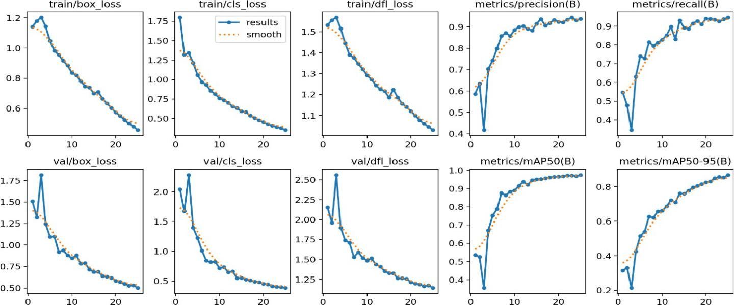

Figure 12: Training And Testing.

(This figure shows train and validation losses, with other performance metrics of precision, recall, and mean Average Precision (mAP) metrics on the YOLOv8 model applied to pothole detection. Curves represent a steady fall of losses-the box loss, classificative loss, dfl loss. As one trains more iterations, the precision and recall both seem to go up, showing that the pothole detection capability by the model as well as false positive avoidance improve with the number of training iterations. The mAP graphs - mAP50 and mAP50-95-suggest generalization toward data unseen as values go higher with every iteration.)

**7.3 Comparison of Different Models**

We will compare the performance of YOLOv8 against other object detection models like YOLOv5 and Faster R-CNN on the same pothole detection task. The comparison is based on key metrics such as accuracy, speed, and resource consumption:

Table 2: performance comparison of different models

(The YOLOv8 model emerges as the most suitable for this project due to its balance of real-time performance and high accuracy, making it ideal for deployment in smart vehicle systems where real-time pothole detection is crucial. The mAP values and processing times show that YOLOv8 provides the best trade-off between speed and accuracy.)

|  |  |  |  |
| --- | --- | --- | --- |
| **Model** | **Speed** | **Accuracy** | **Resource Consumption** |
| **YOLOv8** | Fast interface, optimised architecture. | High mAP, superior feature extraction. | Moderate; requires significant GPU for training |
| **YOLOv5** | Slower than YOLOv8 but still fast. | Good accuracy, performs well on small | Balanced resource usage. |
| **Faster R- CNN** | Slow due to two-stage process. | High accuracy, unsuitable for real-time tasks. | High, requires more computational power |

* YOLOv8:
  + Speed: Faster inference due to optimizations in the model architecture.
  + Accuracy: Higher mAP scores due to better feature extraction capabilities.
  + Resource Consumption: Moderate, optimized for edge devices but still requiring significant GPU power during training.
* YOLOv5:
  + Speed: Slightly slower compared to YOLOv8 due to its architecture, but still faster than many traditional methods.
  + Accuracy: Good accuracy, but YOLOv8 typically performs better in precision and recall, especially for smaller objects like potholes.
* Faster R-CNN:
  + Speed: Much slower in comparison, as Faster R-CNN uses a two- stage process (region proposal and classification).
  + Accuracy: High accuracy, but slower inference times make it less suitable for real-time applications like vehicle pothole detection.

Key outcomes:

1. Detects Potholes of Varying Shapes and Sizes: It is highly robust in terms of detection, particularly for shapes and sizes, under excellent lighting.

2. Overall Performance under Various Conditions: The experiments were conducted showing that the model works adequately under several road conditions; however, poor lighting and blocked roads prove to be a significant challenge.

3. Real-Time Feedbacks: It processes video with high frames per second rate, meaning it does not take a long time in alerting the driver if it finds a pothole.

The system was validated under several conditions, which include varied road textures and different weather conditions. In summary, the accuracy and speed of YOLOv8 qualified it for deployment in real-time in a vehicle.

Speed: 3.7ms preprocess, 12.4ms inference, 2.8ms postprocess per image at shape (1, 3, 800, 800).

Based on the balance of the real-time performance of the model and high accuracy, the YOLOv8 model is most appropriate for the project. Real-time pothole detection is crucial in systems installed in smart vehicles; hence, the mAP values and processing times are comprehensive indicators that YOLOv8 has achieved the best speed and accuracy trade-off.

## 7.4 Outcome Screen-shots:

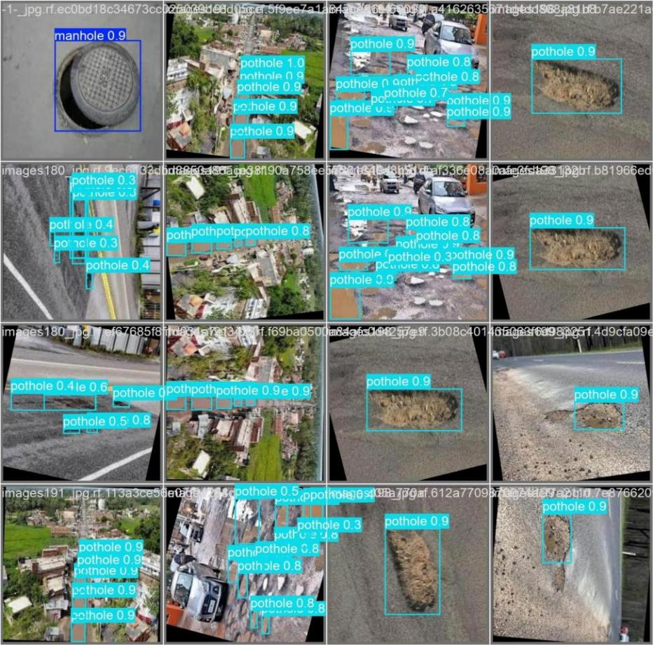

Figure 14: Test images output

(Collage of screenshots displaying the detection results, highlighting detected potholes with bounding boxes on test images.)

# Conclusion:

# In this project, we are presenting the detection of potholes on roads in an effective way by reducing costs through novel techniques of advanced machine learning. Our solution relies heavily on the widespread use of cameras on smartphones, rendering it a feasible and financially reasonable solution for deployment in practice. This reliance upon available hardware minimizes new infrastructure costs, and flexibility by adaptation of the machine-learning approach ensures the framework is responsive to various scenarios. This approach streamlines the traditionally labor-intensive and manual inspection process and offers a more scalable solution that can be easily integrated into broader road maintenance operations.

# The most exciting outcome of our research is that we could effectively use Convolutional Neural Networks (CNNs), specifically the YOLOv8 model, for accurate detection of potholes from visual data. This detection system will be adaptable to changing environmental conditions, road types, and vehicle dynamics. This implies that it is a kind of versatile tool that should improve road safety with its adaptability. Although it is true that the adaptability of the system was remarkable, one real merit of this method over traditional methods based on sensors is generalization in the specific domain.

# However, the quality and diversity of the training data determine the performance and success of machine learning models. Detection accuracy can vary depending on vehicle type, camera angle, lighting conditions, and the specific shapes of potholes. The dataset will therefore have to be expanded to include many different scenarios, such as more diverse vehicle models, various road conditions, and many sizes of potholes. In addition to the data augmentation methods above, transfer learning is useful in dealing with limited-sized datasets.

# Implementing YOLOv8 as an architecture of Convolutional Neural Network was able to effectively overcome the detection problems with complex image data. It thus ensures a good level of accuracy in the detection of potholes of various shapes and dimensions. The capacity of CNN to learn hierarchical features from images makes it of fundamental importance for almost inappreciable conditions between roads. Further advancements will include deep learning architectures like ResNet and EfficientNet to further refine the accuracy of the model. Another area that the model can explore is with hybrid models where the incorporation of sensor-based information as well as visual data helps increase the robustness under challenging conditions such as weak illumination or occlusions.

# In conclusion, our study demonstrated the feasibility and practicality of a machine learning approach to pothole detection. Based on existing hardware and flexible deep learning models, we have developed a system that may significantly influence road safety as well as the efficiency of maintenance. Further work will be aimed at enriching the diversity of the dataset, refining the model's ability to detect more scenarios, and exploring more advanced machine learning techniques for handling even more complex situations.

# References:

# •[1] O. o. I. R. a. Development, "Distress Identification Manual for the Long-TermPavement Performance Project," U.S Department of Transportation Federal Highway Administration, 2014.

# •[2] I. G. V. P. Heggie, "Commercial Management and Financing of Roads,"WorldBank, Washington, 1998.

# •[3] A. M. Legreid, "Potholes and Strategies on the Road to Campus Internationalization," International Research and Review: Journal of Phi BetaDeltaHonor Society for International Scholars, vol. 6, no. 1, 2016.

# •[4] A. F. Rita Justo-Silva, "Pavement maintenance considering trafficaccidentcosts," International Journal of Pavement Research and Technology, 2019.

# •[5] S.-K. R. Taehyeong Kim, "A Guideline for Pothole Classification,”International Journal of Engineering andTechnology, vol. 4, 2014.

# •[6] B. X. Yu and X. Yu, "Vibration-Based System for Pavement ConditionEvaluation," in Applications of Advanced Technology in Transportation, 2006.

# •[7] K. D. Zoysa, G. P. Seneviratne, W. W. A. T. Shihan and C. Keppitiyagama, "A Public Transport System Based Sensor Network for RoadSurface Condition Monitoring," in SIGCOMM07: ACM SIGCOMM 2007 Conference, Kyoto, 2007.

# [8] L. G. B. H. R. N. S. M. H. B. Jakob Eriksson, "The Pothole Patrol:Using aMobile Sensor Network for Road Surface Monitoring," inMobisys08: The 6thInternational Conference on Mobile Systems,Applications, and Services, Breckenridge, 2008.

# •[9] K. C. P. Wang, "Challenges and Feasibility for Comprehensive Automated Survey of Pavement Conditions," in Eighth International Conference on Applications of Advanced Technologies in Transportation Engineering (AATTE), Beijing, 2004.

# •[10] K. T. Chang, J. R. Chang and J. K. Liu, "Detection of Pavement Distresses Using 3D Laser Scanning Technology," in International Conference on Computing in Civil Engineering 2005, Cancun, 2005.

# •[11] Z. Hou, K. C. Wang and W. Gong, "Experimentation of 3d Pavement Imaging Through Stereovision," in International Conference on Transportation Engineering 2007, Chengdu, 2007.

# •[12] C. Koch and I. Brilakis, "Pothole detection in asphalt pavement images," Advanced Engineering Informatics, vol. 25, no. 3, pp. 507- 515, 2011.

# •[13] G. M. Jog, C. Koch, M. Golparvar-Fard and I. Brilakis, “Pothole Properties Measurement through Visual 2D Recognition and 3D Reconstruction," in International Conference on Computing in Civil Engineering, Florida, 2012.

# •[14] L. Huidrom, L. K. Das and S. Sud, "Method for automated assessment of potholes, cracks and patches from road surface video clips,” Procedia - Social and Behavioral Sciences, vol. 104, pp. 312-321, 2013.

# •[15] Aparna, Y. Bhatia, R. Rai, V. Gupta, N. Aggarwal and A. Akula, "Convolutional neural networks based potholes detection using thermal imaging," Journal of King Saud University – Computer and Information Sciences, 2019.

# •[16] A. Bianchini, P. Bandini and D. W. Smith, "Interrater Reliability of Manual Pavement Distress Evaluations," Journal of Transportation Engineering, vol. 136, no. 2, pp. 165-172, 2010.

# •[17] O. Mendoza, P. Melin and G. Licea, "A New Method for Edge Detection in Image Processing using Interval Type-2 Fuzzy Logic," in 2007 IEEE International Conference on Granular Computing, California, 2007.

# •[18] T. Kim and S.-K. Ryu, "Review and analysis of pothole detection methods," Journal of Emerging Trends in Computing and Information Sciences, vol. 5, no. 8, pp. 603-608, 2014.

# •[19] A. Bhat, P. Narkar, D. Shetty and D. Vyas, "Detection of Potholes using Image Processing Techniques," IOSR Journal of Engineering, vol. 2, pp. 52-56, 2018.

# •[20] M. Muslim, D. Sulistyaningrum and B. Setiyono, "Detection and counting potholes using morphological method from road video," AIP Conference Proceedings, vol. 2242, no. 1, pp. 3-11, 202

# **Appendix**

# **Appendix A: Dataset Overview**

# Data Source: Custom dataset of pothole images collected from various road conditions.

# Annotation Method: Images were annotated using bounding boxes to identify pothole regions, facilitated by tools like Roboflow.

# Dataset Composition:

# Training set: 72% of images.

# Validation set: 18% of images.

# Test set: 10% of images.

# Image Augmentation Techniques: Rotation, flipping, brightness adjustment, and scaling were applied to diversify the dataset.

# **Appendix B: Hardware and Software Setup**

# Hardware:

# Training: Google Colab with GPU support.

# Testing: Local machine with Python environment.

# Software:

# Programming Language: Python 3.8

# Deep Learning Framework: YOLOv8 (Ultralytics)

# Image Processing: OpenCV

# Annotation Tool: Roboflow

# Packages:

# PyTorch

# OpenCV

# Matplotlib

# Numpy

# Ultralytics

# **Appendix C: Hyperparameters for Training**

# Model: YOLOv8 (pre-trained with custom weights)

# Learning Rate: 0.001

# Batch Size: 16

# Epochs: 50

# Optimizer: Adam

# Loss Function: Combination of object detection loss (localization, confidence, and classification losses).

# **Appendix D: Evaluation Metrics**

# Precision: Measures the percentage of true positive detections among all detections.

# Recall: Measures the percentage of true positive detections among all actual positives.

# mAP (mean Average Precision): Indicates the overall accuracy of the model across different IoU thresholds.

# IoU (Intersection over Union): Evaluates the overlap between the predicted bounding boxes and ground truth.

# **Appendix E: Acronyms and Abbreviations**

# CNN: Convolutional Neural Network

# YOLO: You Only Look Once

# IoU: Intersection over Union

# mAP: mean Average Precision

# GPU: Graphics Processing Unit