

|  |  |  |
| --- | --- | --- |
| ASAD (ISM 6124) | SPRING 2024 | 18 JAN 2024 |

JANHAVI KHARMALE, VENKATA DHARMA TEJA KONAKANCHI, NIDHI FALAK

**Unraveling the Boeing 737 MAX Software Debacle[1]**

In August 2011, Boeing debuted the 737 Max, the most recent iteration of the wildly popular 737 aircraft. The 737 Max 8, which debuted on August 30, 2011, is the fourth generation of the 737 and the replacement for the 737 Next Generation (NG). It made its first flight on January 29, 2016. In March 2017, the Federal Aviation Administration (FAA) certified it. The 737 Max quickly became Boeing's flagship, chosen by over 50 airlines globally, selling about 400 units, thanks to its quieter engines, reduced operating costs, and increased fuel efficiency.

Tragically, on April 10, 2019, a Boeing 737 Max 8 operated by Ethiopian Airlines crashed close to Bishoftu, killing all 157 occupants, including the crew. According to investigations, a malfunctioning sensor provided false information to the Maneuvering Characteristics Augmentation System (MCAS), causing an automated reaction that resulted in the plane losing control and crashing. This sequence of events bears striking similarities to a Lion Air incident that involved a different 737 Max 8 in Indonesia six months prior.

The combined effect of these two incidents sparked serious worries about the 737 Max, Boeing's flagship aircraft’s safety throughout the world. The public's opinion that Boeing puts business before people was strengthened by the company's tardiness in grounding the planes. Republicans and Democrats alike attacked Boeing during a Senate committee investigation for their profit-driven approach to the 737 Max's design and accused the firm of failing to take sufficient safety precautions following the first Lion Air tragedy.

At first, Boeing defended the 737 Max and attributed the crashes to several causes, including pilot error. But as more information became available, the business changed its mind and took full responsibility. This shift was made clear by CEO David Muilenburg's video speech, in which he expressed regret for the mishaps, offered his sympathies to the impacted families, and promised to resolve the problems before the 737 Max was used again.

Boeing faced severe consequences, with cancellations and reductions in orders from airlines worldwide. Despite being the fastest-selling airplane in Boeing's history, with over 5,000 orders from 100 customers globally as of August 2019, the 737 Max's reputation was severely tarnished. The study aims to delve deeper into this crisis, posing critical questions to unravel its complexities and report its findings.

**Timeline of Events:**

Fig1: 737 MAX timeline showing key events from 2010 to 2019.

### Origin of Boeing 737 MAX

The Boeing 737 family's main rival is the Airbus A320 family, which includes the A320, A319, A321, and A318 models. The A320, which made its first flight in 1987, was designed as a ground-breaking model that stood out from earlier Airbus models. In contrast to its predecessors, the A320 had a higher stance and more ground clearance to support engines with greater diameters, but it was not designed with secondary airports in mind. The A320 series saw notable commercial success.

Boeing responded to Airbus's competitive threat by trying to keep sales of next-generation single-aisle jetliners from declining. The 737 MAX series, which is closely related to the current 737NG family (which includes the 737-600, 737-700, 737-800, and 737-900), was created because of this project. The incorporation of extremely fuel-efficient engines was the primary innovation of the 737 MAX, which was like the developments in the Airbus A320 Neo generation.

Boeing decided to relocate the engine nacelles even further forward and higher than those used in the previous CFM 56 engines to make it easier to put bigger diameter engines on the 737 MAX design. This was a calculated step to improve competitiveness and fuel economy in the changing single-aisle aircraft industry.

**Characteristics of 737 MAX flight**

In comparison with earlier 737 models, which had the center of gravity placed considerably forward of the center of lift, the Boeing 737 MAX saw a design change intended to reduce trim drag and maximize efficiency. Older versions would automatically nose down and recover in the case of a stall with neutral control inputs because of the downward lift produced by the horizontal stabilizer. But this natural nose-down force led to more drag and more fuel being used by the airplane.

The 737 MAX models were found to have notable differences in flying characteristics from their predecessors during flight testing. The impact at a high angle of attack, where the massive engine nacelles positioned in front of the wings produced significant body lift and a powerful nose-up force, was especially noteworthy. The nose-up thrust from the low-mounted engines caused the center of lift to move forward; this effect was particularly noticeable at high power levels.

The 737 MAX would continue to pitch up at a high angle of attack in the absence of corrective input, increasing the danger of a stall. As a result, Boeing found that the 737 MAX design did not satisfy the airworthiness requirements set out by the Federal Aviation Authority (FAA) for stability. Specifically, it did not comply with the Federal Aviation Regulation (FAR). Unless corrective action was taken, the nose would automatically lift if the angle of attack surpassed 14 degrees until the aircraft encountered a stall.

### Origin of MACS software

Boeing addressed the flight characteristics of the 737 MAX with a quicker and less expensive fix than undergoing an aerodynamic refurbishment of the aircraft. The Maneuver Characteristics Augmentation System (MCAS) was a new software system that was put into place as part of this approach. MCAS's main objective is to use flight control software algorithms to mimic the actions of earlier 737NG models.

Preventing the airplane from entering a risky and unstable flight regime is one of MCAS's main goals. When sensor data reveal a potentially hazardous high angle of attack, MCAS automatically modifies the stabilizer trim to drive the nose down in addition to conventional pilot warning systems like a "stick shaker" stall warning system. This intervention is designed to enhance the overall stability and safety of the 737 MAX during critical flight conditions.

**Characteristics of the MCAS software:**

* It electronically manipulates the aircraft horizontal stabilizer trim to increase the lift on the tail, forcing the nose down.
* It activates automatically when the sensed angle of attack is above a pre-set value, the autopilot is off and when flaps are up (at low altitude and low airspeeds, MCAS is also cued to operate with flaps lowered).
* MCAS moves the horizontal stabilizer trim upward at 0.27 degrees per second, up to 9.26 seconds at a time.
* The system pauses for about 5 seconds. If the sensed angle of attack is still high, the MCAS repeats the process.
* The MCAS is supposed to deactivate when the angle of attack is sufficiently reduced, or pilots cut out power to the stabilizer trim.

**Accidents and Groundings of all 737 MAX flights**

Despite ongoing investigations into the causes of the two fatal crashes involving the 737 MAX aircraft, Boeing faces a crisis as passenger confidence plummets, leading to a worldwide grounding of all 737 MAX planes. Airlines struggle to replace lost capacity and incur significant financial losses due to canceled flights. Additionally, airlines attempt to cancel orders with Boeing, although contractual obligations make this challenging.

Boeing, on the other hand, is still producing more than 40 unmodified 737 MAX airplanes every month, leaving an excess of idle aircraft. Despite persistent skepticism and litigation against the business, Boeing's management continues to assert in public testimony that the aircraft design is safe and attributes the crashes to pilot mistakes. Simulated trials to replicate the conditions of the crashes raise concerns about the realism of the tests and the effectiveness of proposed solutions.

The situation is made worse by claims of major production flaws in further Boeing aircraft, including damage to electrical components and tools and debris left inside structural compartments. Due to production quality control concerns, the U.S. Air Force suspended acceptance of Boeing KC-45 tanker aircraft; comparable challenges with quality control also affect the Boeing 787 Dreamliner.   
  
Amidst these obstacles, Boeing is working feverishly to modify the 737 MAX's MCAS software; nevertheless, it is unclear if these improvements will be enough to guarantee the plane's safety, especially in the absence of physical system upgrades. Boeing is under pressure to get the 737 MAX back into service as quickly as possible, despite the continuing investigations.

**Working of the MCAS software:**

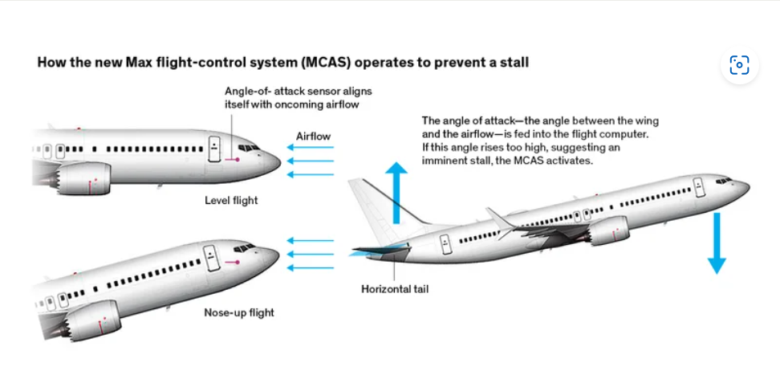

Fig2: 737 MAX flight-control system.

The MCAS system is designed to automatically adjust the pitch of the airplane's nose down if the angle of attack (AOA) becomes too high, which can help to prevent the airplane from stalling. The AOA is the angle between the wing and the oncoming airflow. When the AOA is high, it means that the wings are creating more lift, but they are also closer to stalling.

MCAS is only active in manual flight with flaps up. This is because the flaps change the way the airplane flies, and MCAS is not needed when they are deployed. MCAS also has a limit on how much it can move the stabilizer. The pilots can always override MCAS by pulling back on the control column.

The figure shows the following steps of how MCAS works:

* The angle-of-attack sensor aligns itself with the oncoming airflow.
* The angle of attack is fed into the flight computer.
* If the angle of attack is too high, the MCAS activates and moves the horizontal stabilizer to push the nose of the airplane down.

The two main parts of the MCAS are the angle-of-attack (AOA) sensors and the horizontal stabilizer. The AOA sensors measure the angle of attack of the wings. The horizontal stabilizer is a small wing on the tail of the airplane that can be moved up or down to change the pitch of the airplane.

The 737 MAX has two AOA sensors, one on each side of the fuselage. The sensors are heated to prevent ice from building up on them. The flight computer uses the information from the AOA sensors to calculate the angle of attack.

The horizontal stabilizer is located on the tail of the airplane. It is powered by two electric motors. The flight computer sends signals to the motors to tell them how much to move the stabilizer.

MCAS was involved in two fatal accidents in 2018 and 2019. The accidents were caused by a malfunction of the AOA sensors. The sensor on one airplane provided erroneous readings, which caused the MCAS to activate repeatedly and push the nose of the airplane down. The pilots were unable to regain control of the airplane, and it crashed.

### SWOT Analysis

**Strengths:** Boeing's dominant market position is further strengthened by its standing as a top producer of defense and commercial aircraft, which enables the business to take advantage of economies of scale and raise its profile internationally. Boeing continuously invests in engineering, operations, and technology, with a focus on research and development (R&D). This promotes innovation and enables the ongoing evolution of its product range. Boeing's emphasis on sustainable fuels demonstrates its dedication to sustainable practices, which not only fits with environmental concerns but also puts the company as a leader in the industry when it comes to corporate social responsibility. This creative corporation, which offers a wide range of products from defense systems to commercial jets, establishes standards for the industry. Boeing's technological prowess is greatly aided by its capacity to establish strategic alliances with other creative businesses.

**Weakness:** Boeing is dealing with labor concerns because a significant amount of its workforce is unionized, which causes work stoppages and productivity challenges on occasion. A long-term risk for the company is its reliance on US government contracts, which accounted for roughly 27% of total sales in FY 2015. This leaves it vulnerable to possible political and economic upheavals. The 2019 Boeing 737 Max disasters damaged the company's reputation and undermined consumer confidence by exposing a defective design and generating safety concerns. A weakness in the supply chain management system is indicated by Spirit Airlines' layoffs connected to the defective 737 Max, which have brought attention to the overreliance on outsourcing for manufacturing component production.

**Opportunities:** Boeing can capitalize on the growing global demand for commercial aircraft, which is driven by expanding passenger numbers and the desire for improved connectivity. Boeing has several chances to expand its product line and increase income in the expanding global aerospace and military sector. By collaborating with organizations such as General Electric, Lockheed Martin, and Raytheon, Boeing can strategically expand into new markets and projects, thereby guaranteeing its continuous growth. As evidenced by Boeing's collaboration with Volkswagen (Porsche), the growing market for flying automobiles offers a special opportunity for the business to investigate cutting-edge solutions outside of conventional airplanes. Considering growing public and governmental attention to sustainability, Boeing's dedication to creating environmentally friendly aircraft is in line with current environmental trends and helps the company's standing.

**Threats:** Boeing may see its market share erode as a result of fierce competition from multinational corporations in all business categories. With fixed-price contracts accounting for a sizable amount of income, Boeing may be vulnerable to decreased margins and other financial difficulties. The demand for air travel has been greatly affected by outside shocks like the COVID-19 pandemic, which influences Boeing's commercial clients and may put them under financial duress. Economic recessions pose a risk since they could cause commercial clients to reduce their non-essential travel, which would lower demand for Boeing's aircraft. Boeing's operations are challenged by the ongoing threat of terrorist strikes on airlines and aircraft manufacturers. Furthermore, being involved in US-EU trade conflicts creates uncertainty and could have an impact on Boeing's international business.

### Action Design Research

The Action Design Research (ADR) process was used to investigate the 737 Max crashes. ADR is a research method that combines design research and action research. It is used to create information technology (IT) artifacts and generate theory with researchers acting on the system.

The diagram shows that ADR is made up of four main stages:

**Problem formulation:** This stage involved identifying the problem that the research would address and developing an initial research question. In the case of the 737 Max crashes, the problem was to understand why the crashes happened and how to prevent them from happening again.

**Design and development:** This stage involved designing and developing IT artifacts that could help to address the problem. In the case of the 737 Max crashes, the IT artifacts included models of the MCAS system, as well as simulations of how the system interacted with pilots.

**Action and intervention:** This stage involved introducing the IT artifacts into the organization and studying their effects. In the case of the 737 Max crashes, the IT artifacts were used to train pilots on how to respond to problems with the MCAS system.

**Evaluation and learning:** This stage involves evaluating the IT artifacts and learning from the experience. In the case of the 737 Max crashes, the evaluation included studies of how well pilots were able to understand and respond to the MCAS system.

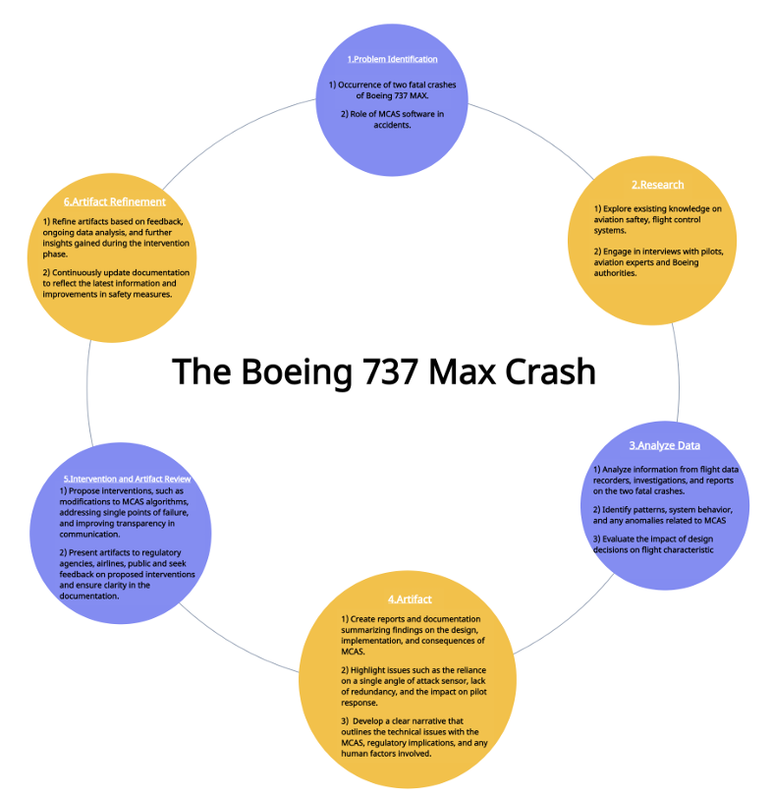

### Major External Factors

**The Flight Path Patterns and Crash Causes:** The two airplane crashes, Ethiopian Airlines Flight #302 and Lion Air Flight #610, are the primary external factors affecting the Boeing 737 MAX case. Similar flight path patterns in the study assumed the flight crews were unable to regain positive control before impact. The probable cause of the tragic incidents is recognized as the recently implemented Maneuvering Characteristics Augmentation System (M.C.A.S.), highlighting the system's vital role.

**CFM LEAP-1B Engines and Propulsion Impact:** The installation of the new CFM LEAP-1B engines in the Boeing 737 MAX is an important external factor impacting the case. These engines provide a significant boost in propulsion, but there could be challenges like as increased lift and nose-up pitch, which could lead to stalling. Because of the increased risk of stalling, the M.C.A.S. system was designed and implemented as a preventive measure to handle the aircraft's specific propulsion characteristics (Abend, 2019).

**Angle of Attack (A.O.A.) Sensors:** Another major external factor influencing the case is the Angle of Attack (A.O.A.) sensors' functionality and reliability. These sensors' erroneous inputs are recognized as MCAS activation triggers, which could make it harder for pilots to maneuver the aircraft. The investigation highlights how important A.O.A. sensors are in figuring out the aircraft's real-time A.O.A., with incorrect sensor signals being blamed for the crashes (Abend, 2019).

**FAA Emergency Airworthiness Directive (A.D.):** The U.S. Federal Aviation Administration (FAA) issued an Emergency Airworthiness Directive (A.D.) in reaction to the Lion Air catastrophe, which is one important external regulatory factor. In accordance with the instructions, operators of Boeing and Boeing 737 MAX aircraft must follow updates to the Airplane Flight Manual (A.F.M.) that resolve the "Runaway Stabilizer" issue that was found during the investigation. The seriousness of the safety issues surrounding the aircraft is highlighted by this regulatory response (Bellamy III, 2018).

**Collaboration with Civil Aviation Authorities:** The cooperation between Boeing and several civil aviation agencies for a thorough analysis of the automated flight control system is one important external component. The global effort to conduct a Joint Agencies Technical Review (JATR) including experts from nine civil aviation agencies highlights the need for a thorough examination of the certification and safety aspects of the Boeing 737 MAX. This collaboration exemplifies the international consensus to address the mentioned problems (FAA-c, 2019).

**Financial Repercussions:** The financial ramifications, which include a stop in manufacture, delivery issues, and significant losses, are significant external variables influencing the Boeing 737 MAX case. Boeing's financial difficulties are evident in its inability to deliver newly manufactured aircraft and in its decision to carry on with manufacturing despite storage constraints. The financial significance and urgency of resolving the vulnerabilities are highlighted by the company's proactive interaction with regulatory organizations and the delivery of software patches.

### Minor External Factors

**Boeing's Public Communication Strategies:** Public opinion is influenced by Boeing's public relations tactics involving software updates and the M.C.A.S. issue. How the general public and stakeholders view Boeing's management of the crisis is influenced by the company's comments and messaging on the nature of the problem and the suggested solutions.

**Orders and Cancellations from Airlines**: Fly deal Airlines, a Saudi airline, is an example of how airline orders and cancellations impact Boeing's business dynamics. The issue has affected Boeing's relationships with airline customers, as evidenced by the cancellation of a substantial order and the decision to choose an alternative aircraft (Abend, 2019).

**Stock Market Reactions:** The way that Boeing's stock price changes in response to orders, cancellations, and faults found is an effective way to gauge how the market is feeling. Investor confidence and worries about Boeing's capacity to resolve the Boeing 737 MAX difficulties are reflected in stock market movements.

**Shareholder Proposals:** Concerns about governance among stakeholders are reflected in suggestions from stakeholders, such as the failed attempt to divide the Chief Executive Officer (C.E.O.) and Chairman of the Board of Directors (B.O.D.). Concerns regarding corporate governance in the context of the crisis are demonstrated by shareholders' attempts to influence the company's leadership structure.

**Industry Testing Results:** Furthermore, as minor external elements impacting Boeing's attempts to address the identified concerns, industry testing results—including simulator tests and regulatory evaluation results—also have a role. The outcomes of regulatory evaluations and industry testing are important in confirming or refuting Boeing's suggested fixes and affecting the crisis's ultimate resolution.

**Economic Ripple Effects:** Furthermore, as minor external elements impacting Boeing's attempts to address the identified concerns, industry testing results—including simulator tests and regulatory evaluation results—also have a role. The outcomes of regulatory evaluations and industry testing are important in confirming or refuting Boeing's suggested fixes and affecting the crisis's ultimate resolution.

### Major Internal Factors

**Cultural Shift Post-Merger:** A major culture shift at Boeing occurred in 1997 with the merger with McDonnell Douglas; the company began to prioritize cost savings and shareholder value instead of engineering quality. This change had a significant effect on how decisions were made; this was most clear during the 737 MAX issue, when budgetary concerns were prioritized over safety concerns, which led to internal problems and disputes (Travis, 2019).

**Impact on Values:** The merger of Boeing with McDonnell Douglas in 1997 brought about a dramatic change in the company's culture, with a decreased focus on engineering quality. The company's basic values were significantly impacted by this shift, which also raised questions about the company's commitment to safety and affected decision-making procedures. This was particularly clear in the wake of the 737 MAX incident (Frost, 2020).

**Focus on Cost-Cutting:** The 737 MAX's design and development may have compromised safety considerations due to the predominance of cost-cutting methods in Boeing's strategy, especially following the 1997 merger with McDonnell Douglas. Cost-cutting measures seemed to take precedence over important components of maintaining safety requirements, which made the aircraft model more vulnerable to problems, as the 737 MAX disaster shown (Wise, 2019).

**Organizational Resistance:** The unwillingness of Boeing to put safety ahead of cost effectiveness was a clear sign of internal resistance to change. This opposition might have impeded important conversations and steps that were required to guarantee the creation and manufacturing of a safer airplane. Internal dynamics inside the corporation appeared to be impeding a stronger emphasis on safety considerations, which in turn had consequences for the problems that the 737 MAX encountered during the crisis (Vox, 2019).

### Minor Internal Factors

**Ineffective Communication:** The report highlights a crucial internal issue by highlighting a communication breakdown between Boeing's software and aero engineers. Design choices intended to offset aerodynamic problems with the 737 MAX were influenced by this ineffective communication. It's possible that the gap between these important engineering teams resulted in less-than-ideal fixes and neglected to deal with the underlying reasons of the aircraft's issues. The significance of efficient communication channels in intricate aerospace projects is highlighted by this internal breakdown in collaboration (Burg, 2014).

**Automated Controls Issue:** To address aerodynamic issues, Boeing engineers put automated controls in place. However, there were unintended effects because of the ineffective communication of these design choices to pilots and regulators. The 737 MAX's problems were mostly caused by a lack of clear communication, underscoring the significance of extensive information exchange in the aviation sector. This internal communication breakdown brought to light the necessity of more transparency to guarantee the safety and comprehension of aircraft systems by all parties involved (Campbell, 2019).

**Unjustified Cost Savings:** During the 737 MAX design phase, engineering decisions were significantly influenced by the small but significant aspect of Boeing's unwarranted cost cuts. The need for a balanced approach that prioritizes safety alongside cost-effectiveness in the aviation industry is highlighted by the possibility that this cost-cutting focus may have influenced important components without considering safety concerns.

**Importance of Internal Collaboration:** The minor component emphasizes the requirement for strong communication channels and highlights the need for internal collaboration among multiple engineering specialties within Boeing. For informed decision-making and proactive crisis prevention, these channels must be strengthened. This emphasizes how important it is to foster a cooperative workplace culture to improve decision-making processes in general.

**Boeing’s official statements after the crashes:**

**March 10, 2019** - Boeing is deeply saddened to learn of the passing of the passengers and crew on Ethiopian Airlines Flight 302, a 737 MAX 8 airplane. We extend our heartfelt sympathies to the families and loved ones of the passengers and crew on board and stand ready to support the Ethiopian Airlines team. A Boeing technical team will be traveling to the crash site to provide technical assistance under the direction of the Ethiopia Accident Investigation Bureau and the U.S. National Transportation Safety Board.

**March 11, 2019** - The Boeing Company is deeply saddened by the loss of Lion Air Flight 610, which has weighed heavily on the entire Boeing team, and we extend our heartfelt condolences and sympathies to the families and loved ones of those onboard.

**March 12, 2019** - Safety is Boeing’s number one priority and we have full confidence in the safety of the 737 MAX. We understand that regulatory agencies and customers have made decisions that they believe are most appropriate for their home markets. We’ll continue to engage with them to ensure they have the information needed to have confidence in operating their fleets. The United States Federal Aviation Administration is not mandating any further action at this time, and based on the information currently available, we do not have any basis to issue new guidance to operators.

**March 17, 2019 - Boeing Chairman, President, and CEO Dennis Muilenburg** - First and foremost, our deepest sympathies are with the families and loved ones of those onboard Ethiopian Airlines Flight 302.

Boeing continues to support the investigation and is working with the authorities to evaluate new information as it becomes available. Safety is our highest priority as we design, build, and support our airplanes.  As part of our standard practice following any accident, we examine our aircraft design and operation, and when appropriate, institute product updates to further improve safety.  While investigators continue to work to establish definitive conclusions, Boeing is finalizing its development of a previously announced software update and pilot training revision that will address the MCAS flight control law's behavior in response to erroneous sensor inputs.  We also continue to provide technical assistance at the request of and under the direction of the National Transportation Safety Board, the U.S. Accredited Representative working with Ethiopian investigators.

**April 5, 2019** - As we work closely with customers and global regulators to return the 737 MAX to service, we continue to be driven by our enduring values, with a focus on safety, integrity and quality in all we do. We now know that the recent Lion Air Flight 610 and Ethiopian Airlines Flight 302 accidents were caused by a chain of events, with a common chain link being erroneous activation of the aircraft's MCAS function. We have the responsibility to eliminate this risk, and we know how to do it. As part of this effort, we're making progress on the 737 MAX software update that will prevent accidents like these from ever happening again.

**June 26, 2019** – The safety of our airplanes is Boeing’s highest priority. During the FAA’s review of the 737 MAX software update and recent simulator sessions, the Federal Aviation Administration (FAA) identified an additional requirement that it has asked the company to address through the software changes that the company has been developing for the past eight months. The FAA review and process for returning the 737 MAX to passenger service are designed to result in a thorough assessment. Boeing agrees with the FAA's decision and request and is working on the required software. Addressing this condition will reduce pilot workload by accounting for a potential source of uncommand stabilizer motion. Boeing will not offer the 737 MAX for certification by the FAA until we have satisfied all requirements for certification of the MAX and its safe return to service.

**Dec. 23, 2019** - Boeing announced today that its Board of Directors has named current Chairman, David L. Calhoun, as Chief Executive Officer and President, effective January 13, 2020. Mr. Calhoun will remain a member of the Board. In addition, Board member Lawrence W. Kellner will become non-executive Chairman of the Board effective immediately. The Company also announced that Dennis A. Muilenburg has resigned from his positions as Chief Executive Officer and Board Director effective immediately. Boeing Chief Financial Officer Greg Smith will serve as interim CEO during the brief transition period, while Mr. Calhoun exits his non-Boeing commitments.

**Recommendations/Solutions**

1. **Thorough Testing of Flight Control Systems:** To enhance the safety and reliability of the 737 MAX, it is imperative to subject all flight control systems, with a specific emphasis on the Maneuver Characteristics Augmentation System (MCAS), to rigorous testing. This involves extensive simulations and real-world scenario assessments to thoroughly evaluate system behavior and identify any potential issues. Comprehensive testing ensures that the aircraft's systems are robust and well-equipped to handle various operational conditions, contributing to overall safety and reliability in flight.
2. **Enhancement of MCAS System with Pilot Override:** Considerable attention should be given to modifying the MCAS system to grant pilots the capability to assume control and override MCAS decisions when necessary. By empowering pilots with this authority, the aim is to facilitate a collaborative approach between automated systems and human expertise. This modification contributes to an improved capacity for pilots to intervene in critical situations, enhancing the overall effectiveness and safety of flight operations.
3. **Thorough Examination of Aerodynamics:** A comprehensive review of the 737 MAX's aerodynamics is crucial to identifying design changes that could enhance stability and mitigate potential flying hazards. If necessary, aerodynamic redesigns should be considered to address underlying issues. This focused examination ensures that the aircraft's aerodynamics are optimized, providing a robust and reliable foundation for improved stability and performance.
4. **Increased Transparency in Communication:** Establishing transparent communication channels between the public, regulatory bodies, Boeing, and airline passengers is essential. Documenting and clearly communicating changes to the aircraft's architecture, systems, and functions is critical. Improved transparency fosters trust and confidence within the aviation community, ensuring that all relevant stakeholders are well-informed about the capabilities and limitations of the 737 MAX.
5. **Cultural Shift at Boeing Towards Safety:** A fundamental reassessment of the corporate culture at Boeing is needed, with a renewed emphasis on prioritizing a safety-first approach over competitive pressures and financial considerations. This cultural shift influences decision-making and practices within the organization, reinforcing a long-term commitment to passenger safety and the well-being of the aviation industry.
6. **Regular Safety Audits:** Establishing a routine schedule for both internal and external safety audits is crucial for identifying and addressing potential risks proactively. Regular safety audits play a pivotal role in detecting and mitigating risks before they escalate, ensuring continuous improvement in safety protocols and adherence to industry standards. This proactive approach contributes to a robust safety framework for the 737 MAX and future aircraft models.

**References**

Eshun, E. (2020). *The Defeathered Bird: A Case Study of the Boeing 737 Max Crisis*. East Tennessee State University.

<https://dc.etsu.edu/cgi/viewcontent.cgi?article=5332&context=etd>

Holeman, D. L. (2019, July 3). *The Boeing 737 MAX: A Case Study of Systems Decisions and Their Consequences*.

<https://dennisholeman.com/the-boeing-737-max-a-case-study-of-systems-decisions-and-their-consequences/>

Abbas, T. (2023, June 9). *Boeing Crisis Management Case Study: A Detailed Analysis*.

<https://changemanagementinsight.com/boeing-crisis-management-case-study-a-detailed-analysis/>

Edwards, D. M. (2019, August 13). *The Boeing 737 MAX Case Study Analysis Report*. University of the People.

<https://aerospaceweekly.files.wordpress.com/2020/10/dme-the-boeing-737-max-case-study-analysis-report-v1.01-final.pdf>

Kuczynski, J., Wang, C., Glass, M., & Hoffman, F. (2021). *Boeing 737 MAX: A Case Study of Failure in a Supply Chain Using System of Systems Framework*. The MITRE Corporation; Mercyhurst University.

<https://iacis.org/iis/2021/1_iis_2021_51-62.pdf>

Johri, A. (2023). *Learning and Moving Forward from the Boeing Max 737 Crisis*. George Mason Tech Ethics, Online Ethics Center.

<https://onlineethics.org/cases/george-mason-tech-ethics/learning-and-moving-forward-boeing-max-737-crisis>

Abend, L. (2019, July). *What’s Next For Boeing And The 737 MAX. Flying*.

Bellamy III, W. (2018, November 7). *FAA Issues Boeing 737 AOA Directive After Lion Air Crash.* Aviation Today.

<https://www.aviationtoday.com/2018/11/07/faa-issues-boeing-737-aoa-directive-amid-lion-aircrash/>

FAA-c. (2019). *FAA Updates On Boeing 737 Max*. Federal Aviation Administration. <https://www.faa.gov/news/updates/?newsId=93206>

Boeing-f. (2019). *Corporate Governance*. Boeing.

<http://www.boeing.com/company/general-info/index.page#/governance>

Travis, G. (2019, April). *How the Boeing 737 Max Disaster looks to a software developer.* IEEE Spectrum, 18.

<https://spectrum.ieee.org/how-the-boeing-737-max-disaster-looks-to-a-software-developer>

Frost, N. (2020, January 3). *The 1997 merger that paved the way for the Boeing 737 Max crisis.* Quartz.

<https://qz.com/1776080/how-the-mcdonnell-douglas-boeing-merger-led-to-the-737-max-crisis/>

Boeing. (1995–2020). Copyright 1995 – 2020 Boeing. All Rights Reserved.

<https://www.boeing.com/737-max-updates/official-statements/>

Wise, J. (2019, March 29). *Is the Boeing 737 Max worth saving? Intelligencer*. <http://nymag.com/intelligencer/2019/03/is-the-boeing-737-max-worth-saving.html>.

Vox (2019, April 15). *The real reason is Boeing’s new plane crashed twice*. YouTube. <https://www.youtube.com/watch?v=H2tuKiiznsY>.

Burg, N. (2014, April 23). *A brief history of explanatory journalism.* Contently. <https://contently.com/2014/04/23/a-brief-history-of-explanatory-journalism/>.

Campbell, D. (2019, May 2). *The many human errors that brought down the Boeing 737 Max.* The Verge. <https://www.theverge.com/2019/5/2/18518176/boeing-737-max-crash-problems-human-error-mcasfaa>.

1. Copyright © 2024, *Janhavi Kharmale, Venkata Dharma Teja Konakanchi, Nidhi Falak*. This case was prepared for the purpose of class discussion, and not to illustrate the effective or ineffective handling of an administrative situation. Names and some information have been disguised. This case is published under a Creative Commons BY-NC license. Permission is granted to copy and distribute this case for non-commercial purposes, in both printed and electronic formats*.*