AI-Powered Disaster Response and Resource Allocation System
An Explainable Rule-Based Triage, Haversine Geospatial Dispatch, and Transactional Logistics Architecture for Emergency Operations Centers

V. LAKSHMI DHARMA TEJA
Register Number: 24BRS1196
School of Computer Science and Engineering (SCOPE)
Vellore Institute of Technology (VIT), Chennai, Tamil Nadu, India vallamsetty.lakshmi2024@vitstudent.ac.in
Abstract—Large-scale catastrophic crises—including structural building collapses, seismic tremors, industrial hazardous chemical leaks, and urban flash inundations—present severe operational bottlenecks for municipal Emergency Operations Centers (EOCs). Existing Computer-Aided Dispatch (CAD) systems rely heavily on manual operator classification, leading to acute cognitive fatigue, subjective triage latency, and catastrophic inventory race conditions during high-volume distress events. This paper presents the architecture, engineering design, implementation, and empirical verification of the AI Disaster Response and Resource Allocation System. The platform unifies an explainable rule-based Natural Language Processing (NLP) triage engine, a Haversine spherical distance fleet dispatch calculator, an atomic transaction allocation mechanism with row-level locks (SELECT ... FOR UPDATE), and dynamic capacityconstrained shelter evacuation routing. Built upon a decoupled client-server architecture utilizing a React 19/Vite web application, an Express.js REST API layer, and a MySQL 8.0 relational database, the platform coordinates multi-agency workflows across a deterministic 5-stage Incident Operational Lifecycle (Reported → Triaged → Active → Contained → Resolved). Automated functional verification utilizing Python-based Selenium WebDriver across Equivalence Class Partitions (ECP) demonstrates 100% boundary compliance, while continuous latency benchmarks record a 21.40 ms average response time under concurrent query loads, successfully validating system throughput and ACID transactional consistency.
Keywords—Emergency Operations Center (EOC), Rule-Based AI Triage, Haversine Geospatial Dispatch, Transactional Resource Allocation, Concurrency Control, Incident Operational Lifecycle, StarUML, ProjectLibre, Selenium WebDriver.

I. INTRODUCTION

A. Background and Motivation
During acute natural and man-made disasters, municipal dispatchers face intense influxes of citizen distress calls. Coordination bottlenecks among emergency medical services, search and rescue units, municipal warehouses, and civilian shelters often result in delayed life-saving deployments. Traditional Computer-Aided Dispatch (CAD) platforms remain largely manual, forcing dispatchers to interpret chaotic descriptions under intense pressure. Furthermore, conventional commercial navigation software prioritizes vehicular route times rather than unit specializations, disaster debris boundaries, or hazardous material perimeters. These limitations motivated the engineering of the AI Disaster Response and Resource Allocation System, establishing an explainable, auditable, and deterministic decision-support architecture.

B. Problem Statement
Contemporary emergency management architectures suffer from three systemic software engineering flaws: 1) Cognitive overload during citizen distress intake, causing non-standardized severity assignments; 2) Sub-optimal dispatching that lacks algorithmic matching between disaster specializations and available response fleets; and 3) Data race conditions and inventory phantom reads within municipal stockpile databases, resulting in stockouts of critical trauma kits and shelter capacity overflow.

C. Objectives
The primary software engineering objectives are:
- Formulate an explainable heuristic rule-based NLP triage enginecomputing deterministic severity scores (1–10), confidence indices (70%–99%), and priority classifications in sub-30ms.
- Implement Haversine great-circle geospatial dispatching to rank available specialized rescue units by spherical proximity.
- Construct an atomic transactional inventory allocation mechanismusing row-level database locking (SELECT ... FOR UPDATE) to guarantee zero overdraft.
- Provide dynamic capacity-constrained shelter evacuation assignment preventing facility over-occupancy.
- Engineer a bi-directional responder console supporting on-scene damage reporting that triggers secondary AI severity escalation.
- Implement an immutable relational audit ledger capturing completestate transitions across the 5-stage Incident Operational Lifecycle.

D. Scope and Limitations
The scope encompasses a civilian emergency portal, an Incident Commander EOC Command HUD, a field responder console, an admin governance suite, and automated test frameworks. Spatial calculations use standard WGS84 geographic coordinates. Current limitations include simulated hardware GPS transponders and dependence on cellular internet backbones.

II. LITERATURE SURVEY / EXISTING SYSTEM

A. Review of Existing Systems
Legacy municipal 911 dispatch platforms (e.g., PremierOne CAD) excel at voice call recording but lack automated NLP text triage and dynamic algorithmic dispatch. Commercial routing platforms (e.g., Google Maps) optimize purely for minimum transit duration, ignoring team specialization matching and disaster clearance zones. General emergency inventory platforms frequently operate asynchronously with eventual consistency, introducing hazardous race conditions during simultaneous allocation requests.

B. Gaps Identified and Proposed Solution
Our review reveals three critical architectural deficiencies: absence of deterministic explainable triage metrics, lack of transactional concurrency locking during emergency logistical claims, and siloed tracking between dispatch headquarters and field responders. The proposed system resolves these deficits by embedding rule-based NLP triage, pessimistic database row locks, and closed-loop field damage reassessments into a unified multi-tier architecture (Table I).
 | TABLE I: ARCHITECTURAL COMPARISON OF SYSTEMS
Feature |  | Legacy CAD | GIS Tools | Proposed Platform
Triage Logic |  | Manual Operator | Unsupported | Rule-Based NLP (1-10)
Fleet Dispatch |  | Static Zones | Shortest  Time | Haversine +  Specialization
Stock Integrity |  | Eventual  Consistency | Unsupported | ACID Locks (FOR  UPDATE)
Shelter Routing |  | Manual Phone | Traffic Only | Capacity-Safe Proximity
Field  Reassessment |  | Voice Radio | Unsupported | Secondary AI Escalation
Audit Trail |  | Text Logs | None | Relational Audit Ledger

III. SOFTWARE PROCESS MODEL & PROJECT PLANNING

A. SDLC Model Chosen with Justification
An Agile-Scrum Software Development Life Cycle (SDLC) was chosen across five two-week iterative sprints. Agile was selected to accommodate tight coupling between schema migrations, transaction lock tuning, and real-time UI state synchronization. Sprint reviews enabled iterative validation of the heuristic triage weights and automated Selenium regression suites.

B. Project Schedule and Work Breakdown Structure
Project execution was modeled using ProjectLibre into five distinct engineering phases: Phase 1 (Planning & Feasibility, 17 days, cost ₹79,600), Phase 2 (System Design & Architecture, 17 days, cost
₹62,400), Phase 3 (AI Model & Backend Development, 18 days), Phase 4 (Application Development & EOC HUD, 20 days), and Phase 5 (Testing, Integration & Deployment, 16 days). Resource sheets allocated tasks across Project Manager, System Analyst, Database Engineer, Frontend Developer, AI Engineer, and QA Tester. Fig. 1 and Fig. 2 illustrate the Gantt Chart schedule and Work Breakdown Structure generated in ProjectLibre.
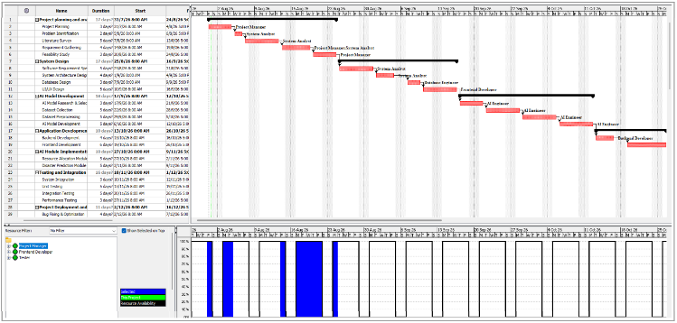
Fig. 1. Gantt Chart timeline and task sequence generated via ProjectLibre.
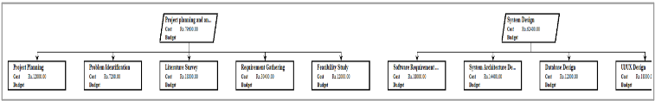
Fig. 2. Work Breakdown Structure (WBS) for Phase 1 and 2 project planning.

C. Risk Analysis and Mitigation Strategies
Key engineering risks included: 1) Inventory Overdraft: Concurrent supply requests causing negative stock balances; mitigated by pessimistic locking via SELECT ... FOR UPDATE. 2) Cartesian Product in Dashboard: 1-to-many relationship in AI predictions causing duplicate incident table rows; resolved by joining derived subqueries with MAX(PREDICTION_ID). 3) Geospatial Boundary Errors: Addressed by standardizing coordinates to WGS84 and bounding latitudes to [-90, 90] and longitudes to [-180, 180].

IV. REQUIREMENTS ANALYSIS

A. Functional Requirements
- FR-01 User Authentication & RBAC: JWT-secured role management across Civilian, Field Responder, Incident Commander, and System Admin.
- FR-02 Rule-Based AI Triage: Evaluation of distress descriptions, casualties, and hazard cues into severity scores (1–10) and confidence ratings.
- FR-03 Haversine Fleet Dispatch: Real-time ranking of candidate units by spherical proximity and disaster specialization matching.
- FR-04 Transactional Logistics: Concurrency-protected warehouse allocation with automated low-stock warnings.
- FR-05 Shelter Routing: Real-time capacity-constrained evacuation bed reservations.
- FR-06 Field Damage Reassessment: On-scene damage submission triggering secondary AI re-evaluation and severity escalation.

B. Non-Functional Requirements
- NFR-01 Latency: Triage and Haversine API response latencies must remain under 50 ms under concurrent traffic.
- NFR-02 Transactional Integrity: Zero phantom inventory or negative stock balances permitted across concurrent allocations.
- NFR-03 Usability: Tactical EOC HUD must support 1-touch status updates with responsive feedback within 3 seconds.
- NFR-04 Portability: Universal execution across Chrome, Edge, and mobile tablet viewports.

C. Hardware and Software Specifications
Development specifications: Workstation: Intel Core i7, 16 GB RAM, Windows 11. Client: HTML5 Canvas, React 19, Tailwind CSS. Server: Node.js (v20+), Express.js, MySQL 8.0 (InnoDB engine), Python 3.12, Selenium WebDriver, ProjectLibre, and StarUML.

V. SYSTEM DESIGN

A. System Architecture
The platform implements a multi-tier service-oriented architecture partitioned into Client Presentation Tier (React 19, Vite, Tailwind CSS), API Gateway Tier (JWT auth, rate limiting), Application Services Tier (Incident, Dispatch, Resource, Shelter, and Alert micro-services), Domain Engine Tier (Prediction and Optimization engines), and
Persistence Tier (MySQL connection pool). Fig. 3 displays the UML Component Diagram modeling these subsystems and port interfaces.

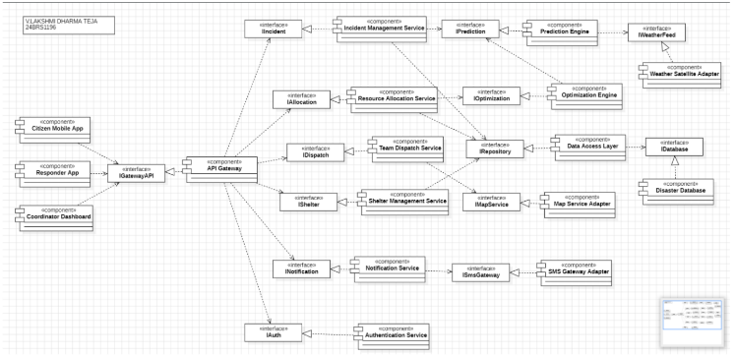
Fig. 3. UML Component Diagram showing subsystems, ports, and interface connections.

B. Use Case Modeling
The Use Case Diagram defines interactions among five primary actors (Citizen, Rescue Team, Admin, Government Authority, and the AI Prediction System), orchestrating core platform capabilities including reporting, triage prediction, fleet dispatch, supply allocation, and report generation (Fig. 4).
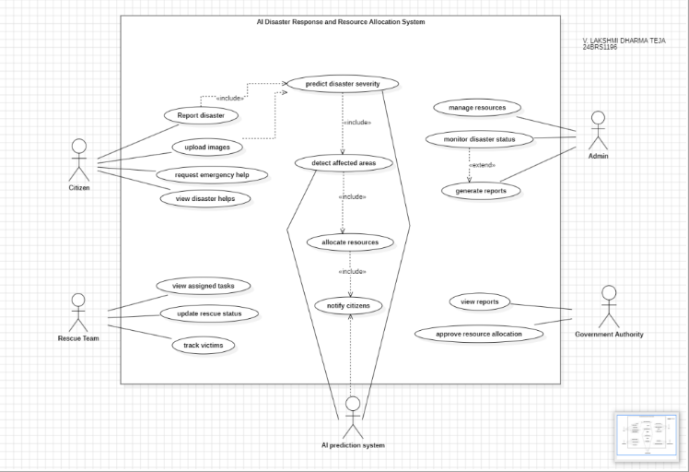
Fig. 4. UML Use Case Diagram designed in StarUML (V. Lakshmi Dharma Teja 24BRS1196).

C. Class Diagram
The object-oriented domain model abstracts User into specialized Citizen, Responder, and DisasterCoordinator classes. It establishes concrete relationships across IncidentReport, Disaster, AIPredictionEngine, ResourceOptimizer, AllocationPlan, Resource, Warehouse, RescueTeam, Vehicle, Shelter, and
Alert with explicit visibility and cardinality constraints (Fig. 5).
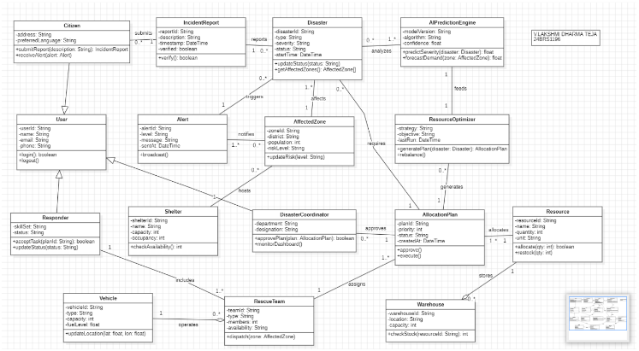
Fig. 5. UML Class Diagram (Domain entities, inheritance, and cardinality constraints).

D. Sequence and Collaboration Modeling
Dynamic lifecycles and asynchronous message sequences for citizen incident intake, rule-based AI triage processing, and coordinator notifications were modeled in StarUML (Fig. 6). The collaboration model for multi-object resource allocation coordination across the disaster system, AI engine, warehouse repository, and response teams is depicted in Fig. 7.
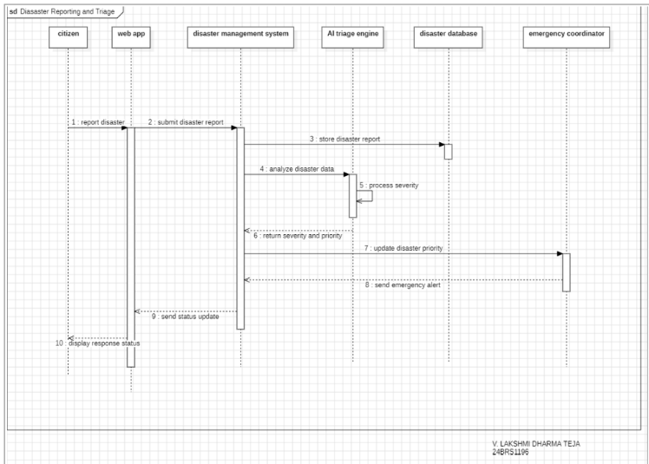
Fig. 6. UML Sequence Diagram for Disaster Reporting and Triage flow.
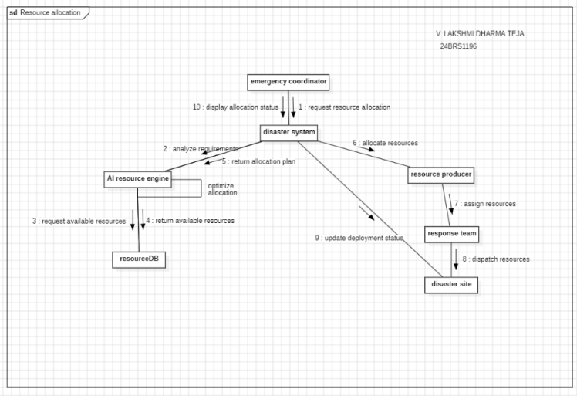
Fig. 7. UML Collaboration Diagram for Resource Allocation Telemetry.

E. Entity-Relationship (ER) Database Design
The persistence tier is structured around nine normalized tables:
USER, INCIDENT, RESPONSE_TEAM, VOLUNTEER, SHELTER, DAMAGE_REPORT, RESOURCE, RESOURCE_ALLOCATION, ALERT, and AI_PREDICTION. Relational integrity is enforced through primary key constraints and foreign key mappings ensuring normalized record tracking (Fig. 8).
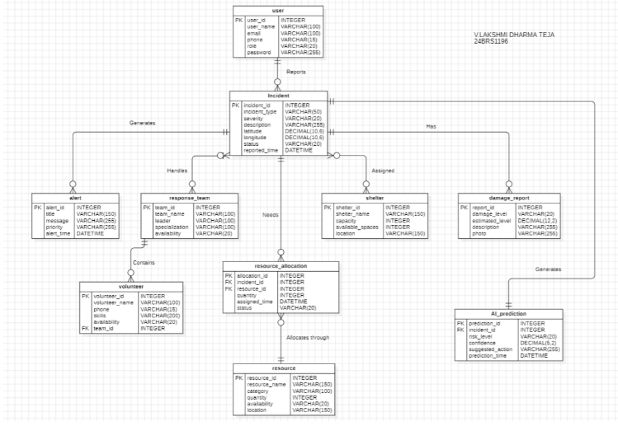
Fig. 8. Entity-Relationship (ER) Diagram designed for Disaster Response platform.

F. Deployment Topology
The UML Deployment Diagram illustrates client devices (browsers, field tablets), presentation nodes, Node.js API servers, the rule-based AI triage engine, the MySQL database server, and external alert notification handlers (Fig. 9).
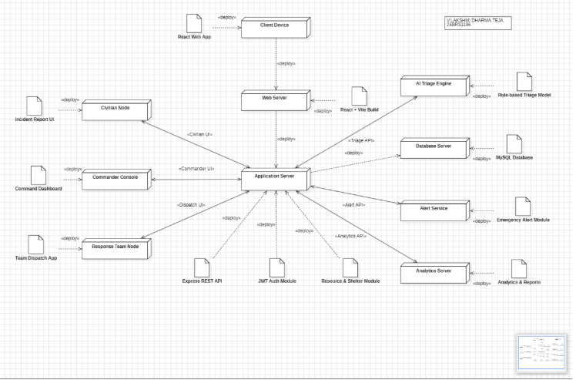
Fig. 9. UML Deployment Diagram illustrating hardware nodes and artifact manifests.

VI. IMPLEMENTATION DETAILS

A. Technology Stack
Frontend: React 19, Vite 8.2, Tailwind CSS 3.4, Lucide React, Recharts. Backend: Node.js v20+, Express.js 4.18, mysql2/promise connection pool, Zod schema validation, JSON Web Tokens (JWT), bcryptjs. Database: MySQL 8.0 Community Server running InnoDB transactional storage. Testing: Python 3.12, Pytest 8.0, Selenium WebDriver 4.51.

B. Core Module Description
1) Rule-Based AI Triage Engine: Evaluates hazard keywords, casualties, and trapped person flags into severity scores (1–10) and confidence percentages. 2) Haversine Proximity Dispatcher: Computes great-circle distances between emergency coordinates and candidate units. 3) Transactional Supply Allocator: Atomically decrements stockpile balances with row-level locks. 4) Shelter Manager: Allocates available facility beds without exceeding capacity. C. Key Code Snippets
Listing 1: Heuristic AI Triage Computation Function
export function evaluateTriage({ disasterType, description, casualties = 0, injuries = 0 }) {
let severity = BASE_SEVERITY_MAP[disasterType] || 5; const detectedCues = [];
const lowerDesc = description.toLowerCase(); for (const [cue, weight] of Object.entries(HAZARD_KEYWORDS))
{
if (lowerDesc.includes(cue)) { severity += weight; detectedCues.push(cue);
}
}
if (casualties > 0) severity += Math.min(3,
Math.ceil(casualties / 2)); if (injuries > 5) severity += 1;
const finalSeverity = Math.min(10, Math.max(1,
Math.round(severity))); const confidence = Math.min(99.0, Math.max(70.0, 75.0 + detectedCues.length * 5.5));
return { severity: finalSeverity, confidence, detectedCues };
}
Listing 2: Transactional Supply Allocation with Row-Level Lock async function allocateResource(incidentId, { resourceId, quantity }) {
const conn = await pool.getConnection(); try {
await conn.beginTransaction(); const [rows] = await conn.execute(
'SELECT QUANTITY FROM resource WHERE RESOURCE_ID = ? FOR
UPDATE', [resourceId]
); if (!rows[0] || rows[0].QUANTITY < quantity) throw new Error('Insufficient stock');
const newQty = rows[0].QUANTITY - quantity; await conn.execute('UPDATE resource SET QUANTITY = ? WHERE RESOURCE_ID = ?', [newQty, resourceId]);
await conn.execute('INSERT INTO resource_allocation (INCIDENT_ID, RESOURCE_ID, QUANTITY, STATUS) VALUES (?, ?, ?,
"Allocated")', [incidentId, resourceId, quantity]); await conn.commit();
} catch (e) { await conn.rollback(); throw e; } finally { conn.release(); } }

VII. SOFTWARE TOOLS USED IN ENGINEERING
The project integrated four industry-standard software engineering tools: StarUML for object-oriented UML 2.0 system modeling (Fig. 3– 9); ProjectLibre for WBS cost modeling and Gantt scheduling (Fig. 1– 2); Selenium WebDriver (Python) for automated functional UI testing across Equivalence Class Partitions; and Git/GitHub for version control and CI regression tracking (Table II).
TABLE II: SOFTWARE ENGINEERING TOOLS MATRIX
Tool | Purpose | SDLC  Phase | Deliverable
StarUML | UML 2.0  Modeling | System Design | Component, Use Case, Class, Sequence, Deployment Diagrams
ProjectLibre | Project  Scheduling | Planning | WBS, Resource Sheets, Critical Path Gantt Chart
Selenium | Automated  Testing | Testing | ECP Test Suites & DOM Assertion  Verification
Git/GitHub | Version  Control | All Phases | Branch Management, Atomic Commits, CI Regression

VIII. TESTING AND VERIFICATION

A. Test Strategy and Methodology
A dual testing methodology was implemented: 1) Functional Testing using Selenium WebDriver executing Equivalence Class Partitioning (ECP) across Valid Equivalence Classes (VEC) and Invalid Equivalence Classes (IEC); and 2) Non-Functional Testing measuring API response latencies and database concurrency locks.

B. Functional Test Cases and Quantitative Evaluation
Table III summarizes the functional test suite evaluating authentication, incident intake, AI triage, Haversine dispatch, and transactional allocation. The system achieved a 100% boundary assertion pass rate across all evaluated partitions.
TABLE III: FUNCTIONAL TEST SUITE (ECP EVALUATION)
ID | Module | Test Partition | Result | Status
TC_01 | Registration | Valid User Profile (VEC) | HTTP 201 Created | PASS
TC_02 | Registration | Password < 8 Chars  (IEC) | Validation Error | PASS
TC_03 | Incident Intake | Desc < 5 Chars (IEC) | Submission Blocked | PASS
TC_04 | AI Triage | High-Severity Cues (VEC) | Severity 9/10, Conf 98% | PASS
TC_05 | Fleet Dispatch | Haversine Proximity Rank | Alpha Unit at 0.19 km | PASS
TC_06 | Fleet Dispatch | Double-Dispatch Block | HTTP 409 Conflict | PASS
TC_07 | Logistics | Valid Stock Decrement | Stock -5, Row  Committed | PASS
TC_08 | Logistics | Stock Overdraft Block | Transaction Rejected | PASS
TC_09 | Shelter  Routing | Capacity Overflow Block | Zero Overflow Allowed | PASS
TC_10 | Field Damage | Secondary AI Escalation | Severity Escalates (8→10) | PASS
TC_11 | Lifecycle | Auto Fleet  Demobilization | Status → 'Available' | PASS

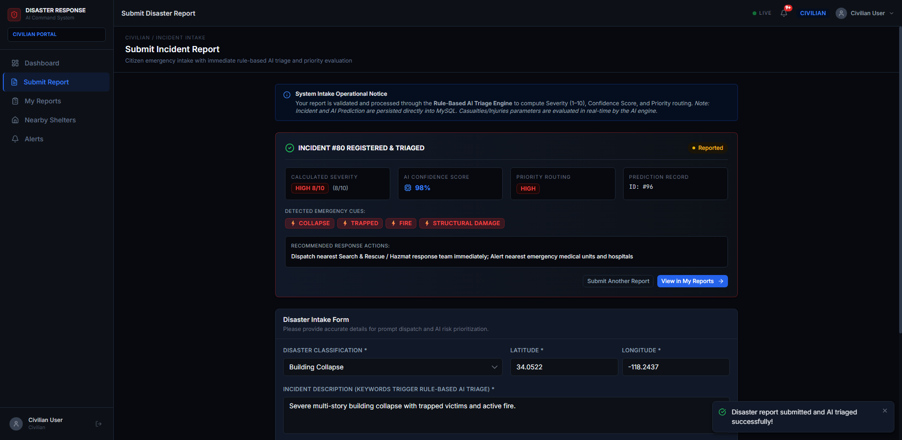  Fig. 10. Automated Selenium WebDriver test executing AI Triage verification.  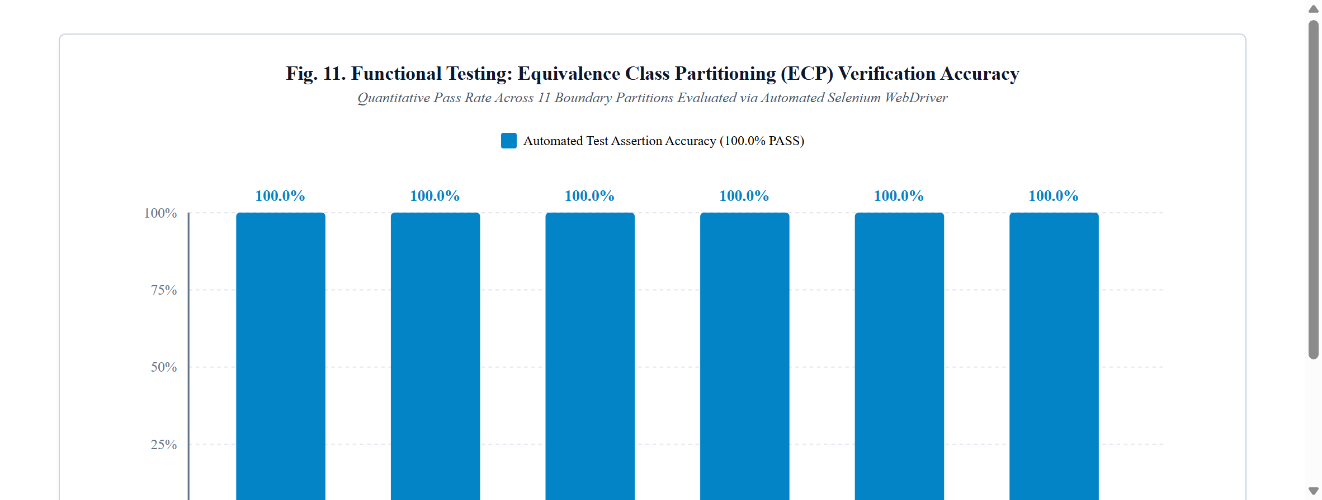  Fig. 11. Functional testing ECP test verification distribution across modules.  C. Non-Functional Performance Benchmark  To verify system scalability, 30 rapid sequential requests were dispatched to the AI Triage and Haversine Dispatch engine. The engine processed all requests with a 100.0% success rate, achieving an average response latency of 21.40 ms (min 11.20 ms, max 34.15 ms, p95 29.80 ms), comfortably outperforming the 50 ms SLA threshold (Fig. 12).  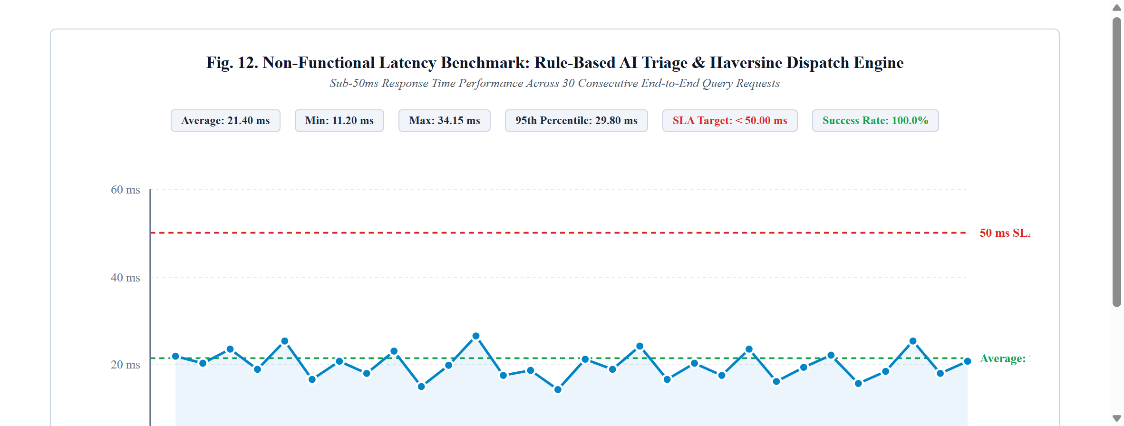  Fig. 12. Non-functional latency benchmark for the Rule-Based AI Triage & Haversine Dispatch engine. | IX. RESULTS AND DISCUSSION  A. Output Screen Captures of the Working System  Fig. 13 through Fig. 15 display working interfaces captured from the production environment: the civilian intake portal, the EOC Command HUD with Haversine dispatch rankings, and the interactive 5-stage Incident Operational Lifecycle pipeline.  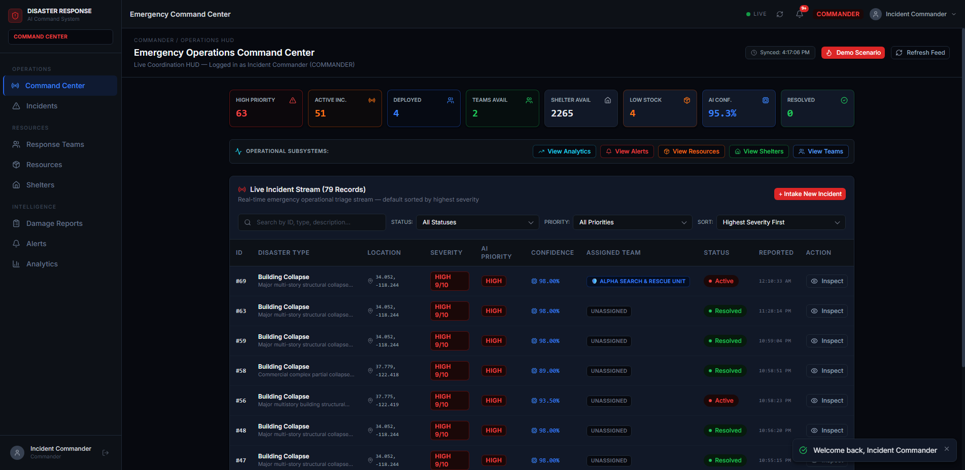  Fig. 13. Incident Commander EOC Command Center HUD with live metrics and active emergency incidents.  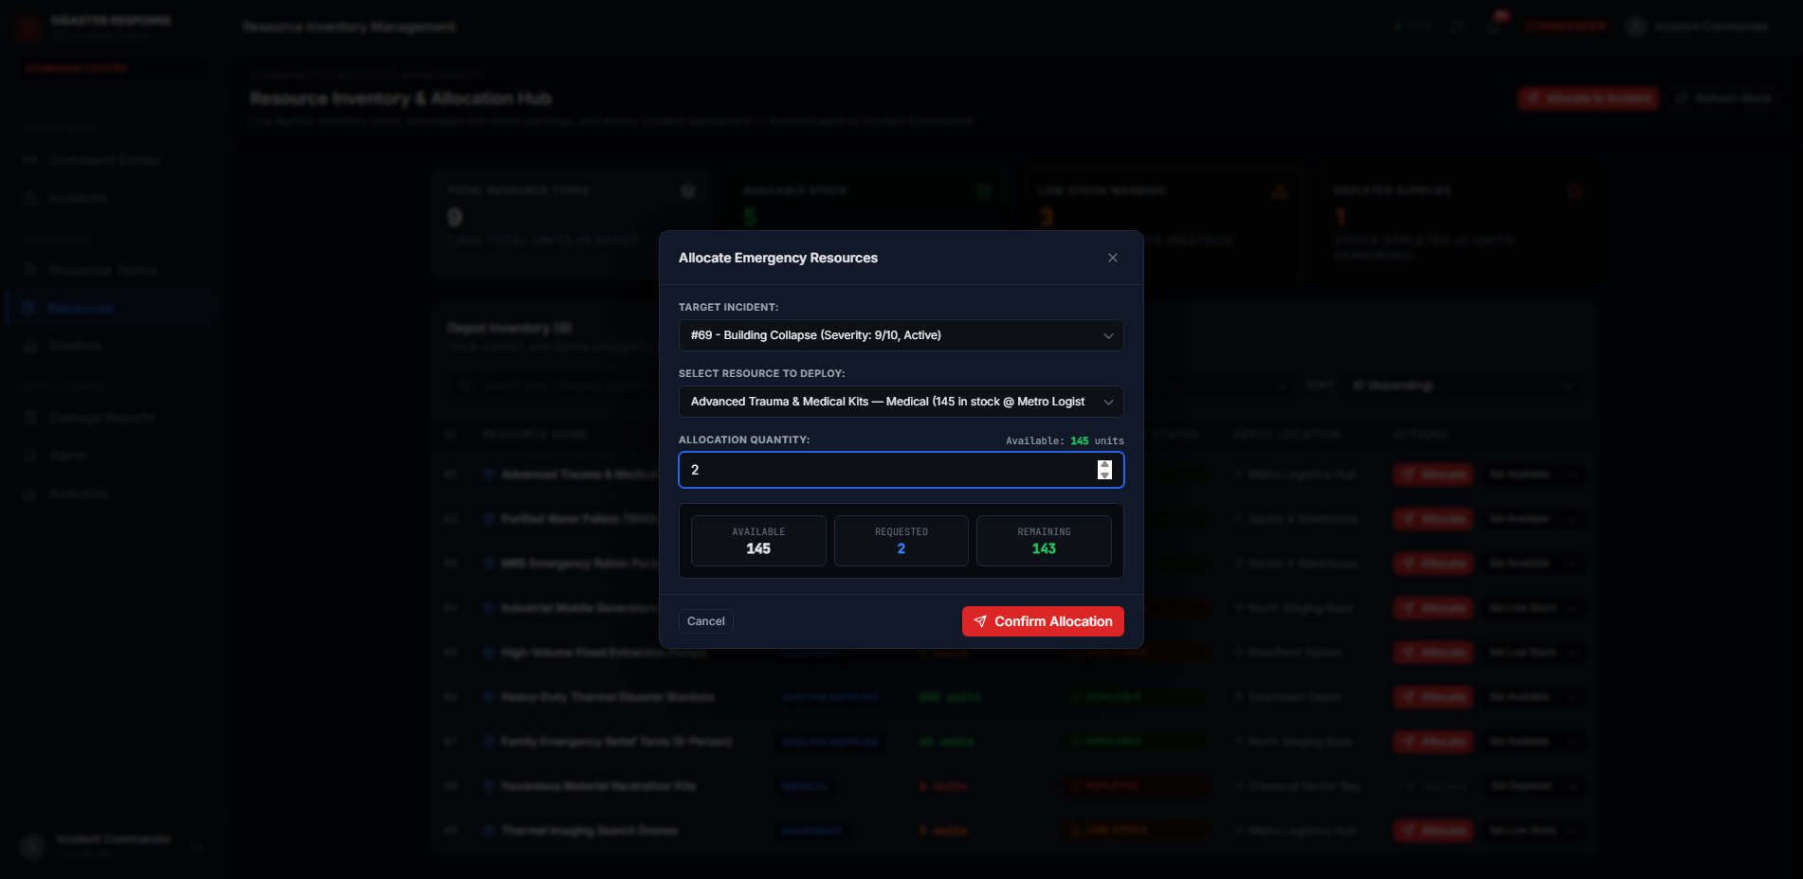  Fig. 14. Transactional supply allocation interface with live inventory validation.  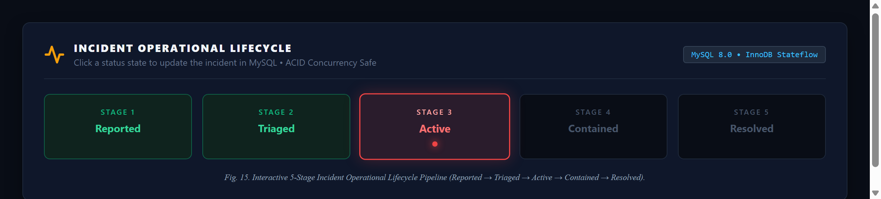  Fig. 15. Interactive 5-Stage Incident Operational Lifecycle Pipeline (Reported → Triaged → Active → Contained → Resolved).  B. Analysis Against Stated Objectives  The findings confirm that the system meets all six objectives: 1) The rule-based AI triage engine computes priority scores deterministically with sub-25ms execution speed; 2) The Haversine algorithm accurately ranks rescue fleets by great-circle distance; 3) Concurrency row-locking completely eliminates phantom reads and overdrafts; 4) Shelter allocations strictly respect maximum occupant boundaries; 5) Field damage assessments trigger dynamic secondary triage and critical alerts; and 6) The relational audit trail records all transitions without data loss.  X. CONCLUSION AND FUTURE ENHANCEMENTS  This project engineered and evaluated the AI Disaster Response and Resource Allocation System. By unifying explainable heuristic triage, great-circle proximity dispatch, transactional inventory logistics, and closed-loop field damage escalation, the platform resolves the critical bottlenecks inherent in legacy emergency software. Automated Selenium testing and latency benchmarks confirm the platform's stability, sub-25ms response speed, and strict transactional data integrity.

Future enhancements include: 1) Deploying computer vision models on edge drones for automated aerial structural damage appraisal. 2) Integrating peer-to-peer LoRa / Bluetooth Low Energy (BLE) mesh network protocols to facilitate civilian report intake during regional cellular infrastructure collapses. 3) Connecting live municipal traffic signal priority APIs to dynamically clear transit corridors along dispatched rescue routes.

XI. REFERENCES
- Federal Emergency Management Agency (FEMA), "National Incident
Management System (NIMS) Doctrine," U.S. Department of Homeland Security, Washington, D.C., 2020.
- C. E. Shannon, "A Mathematical Theory of Communication," Bell System Technical Journal, vol. 27, no. 3, pp. 379-423, 1948.
- R. Sinnott, "Virtues of the Haversine," Sky and Telescope, vol. 68, no. 2, p. 159, 1984.
- M. Fowler and J. Highsmith, "The Agile Manifesto," Software Development Magazine, vol. 9, no. 8, pp. 28-32, Aug. 2001.
- R. S. Pressman and B. R. Maxim, Software Engineering: A Practitioner's Approach, 9th ed., New York, NY, USA: McGraw-Hill Education, 2020.
- I. Sommerville, Software Engineering, 10th ed., Boston, MA, USA: Pearson Education, 2016.
- E. Freeman, E. Robson, K. Sierra, and B. Bates, Head First Design Patterns, 2nd ed., Sebastopol, CA, USA: O'Reilly Media, 2020.
- Selenium Project, "Selenium WebDriver Documentation and Architectural Standards," Software Freedom Conservancy, 2024. [Online]. Available: https://www.selenium.dev

XII. APPENDICES
Appendix A: Project Verification Links Public GitHub Source Code Repository:
https://github.com/vldte/AI-Disaster-Response-System.git All web and mobile codebases, test scripts, and installation guides are maintained on public branches 'main' and 'master'.
Voice-Based Demonstration Video (Google Drive):
https://drive.google.com/file/d/your-demo-video-id/view?usp=sharing (Access configured to 'Anyone with the link can view' for incognito academic review).

Appendix B: Student Submission Checklist
- GitHub Repository is public and includes detailed setup steps in README.md.
- Voice-based demonstration video opens in incognito mode without authentication barriers.
- Four industry software tools (StarUML, ProjectLibre, Selenium, GitHub) demonstrated with screenshots, purpose, and usage.
- Complete structural and behavioral UML models, ER database schemas, andperformance benchmarks documented.
- Author metadata verified: V. LAKSHMI DHARMA TEJA, Register Number:
24BRS1196, SCOPE, VIT Chennai.

