Roll No : AA.SC.U3BCA2207138

Name : Dharmabhushan Dattajirao Powar Date: 24-July-2024

**PySpark Installation :**

<https://colab.research.google.com/drive/1fa2G3YuXx3Isqyby5kFETqmWotFwtqlH?usp=sharing#scrollTo=hxv7w_2y2bb9>

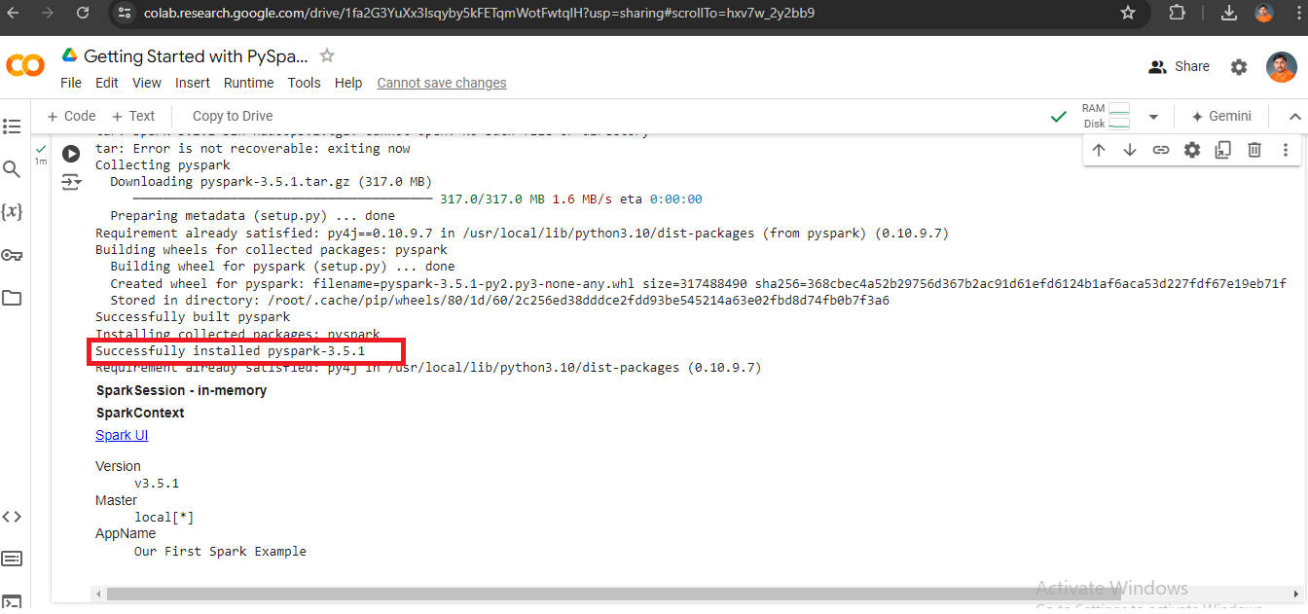

**cluster setup:**

[**https://colab.research.google.com/github/jigsawlabs-student/pyspark-cluster-lab/blob/main/1-pyspark-cluster-lab.ipynb#scrollTo=miniature-paragraph**](https://colab.research.google.com/github/jigsawlabs-student/pyspark-cluster-lab/blob/main/1-pyspark-cluster-lab.ipynb#scrollTo=miniature-paragraph)

