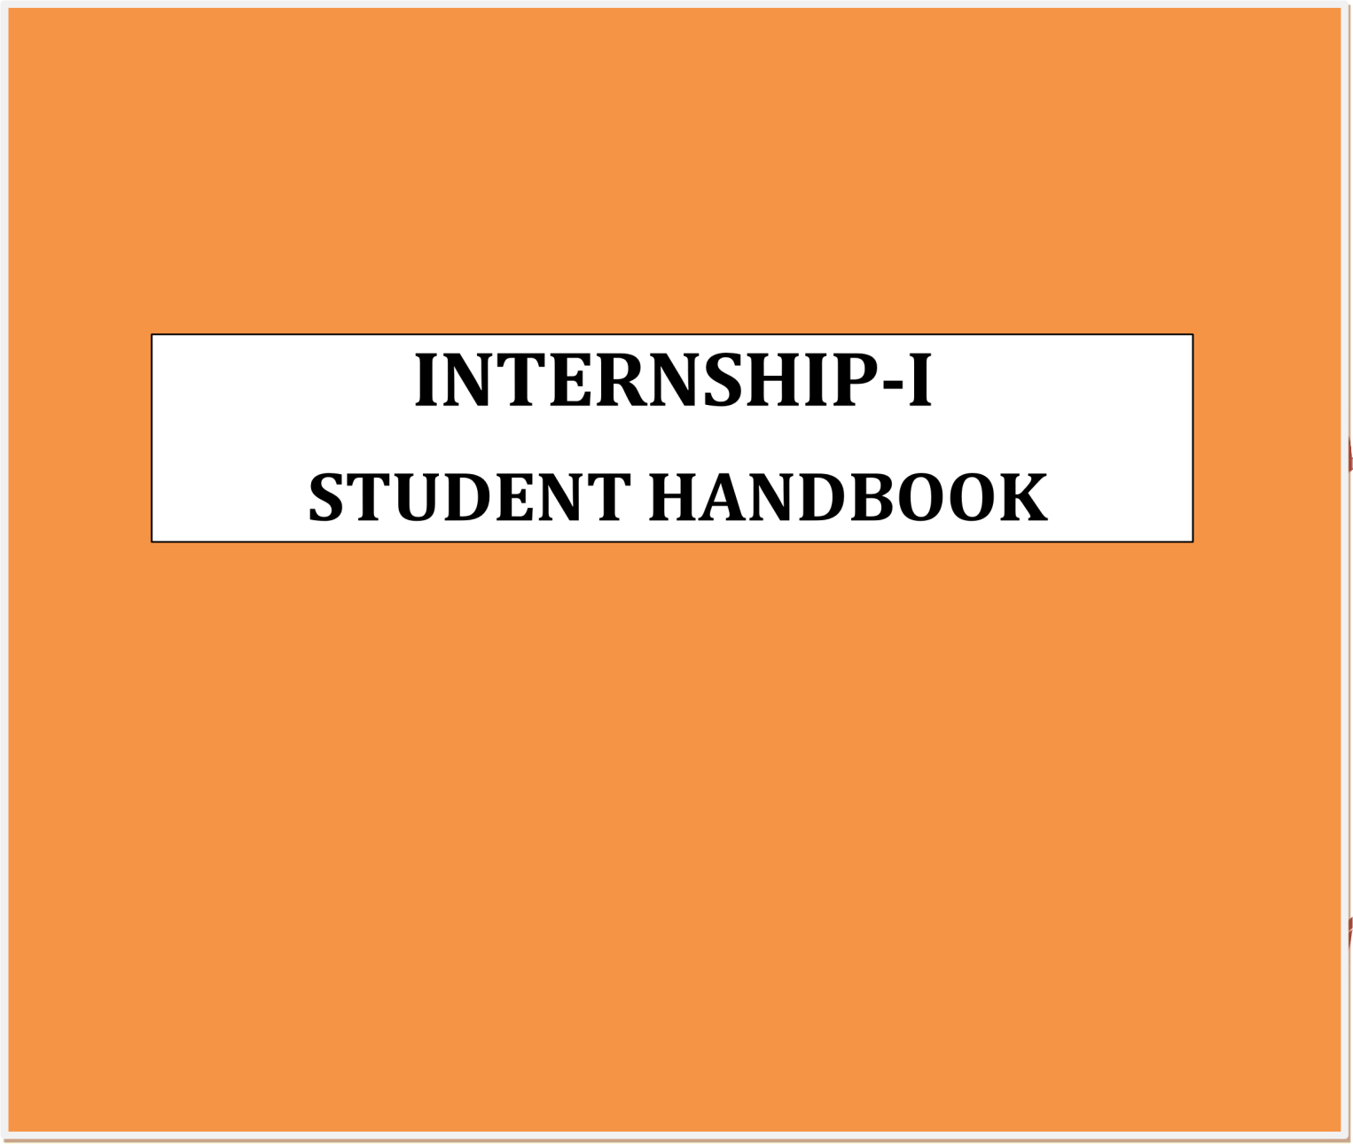 **Academic Year: 2024-25 Student Roll Number: 22881A0573**



# Department of Computer Science and Engineering

## Online Internship in Machine Learning



An

Internship Report

Submitted partial fulfillment of the requirements For the award of the Degree of

**BACHELOR OF TECHNOLOGY**

**In**

**COMPUTER SCIENCE AND ENGINEERING**

**By**

**D SHIVARAM GOUD 22881A0573**

**Under the Supervision of**

**Ms. J Srilatha**

**Associate Professor**

**CSE**

**VARDHAMAN COLLEGE OF ENGINEERING (Duration: 01-04-2025 to 01-05-2025)**



**Department of Computer Science and Engineering**

#### VARDHAMAN COLLEGE OF ENGINEERING

**(Autonomous)**

Affiliated to **JNTUH**, Approved by **AICTE**, Accredited by **NAAC** with **A++** Grade, **ISO 9001:2015** Certified Kacharam, Shamshabad, Hyderabad – 501218, Telangana, India

2024-2025

## VARDHAMAN COLLEGE OF ENGINEERING



**(Autonomous)**

Affiliated to **JNTUH**, Approved by **AICTE**, Accredited by **NAAC** with **A++** Grade, **ISO 9001:2015** Certified Kacharam, Shamshabad, Hyderabad – 501218, Telangana, India

#### Department of **C**omputer **S**cience and **E**ngineering



**CERTIFICATE**

Certified that this is a bonafide record of the Internship entitled **Online Internship in Green Skills using Ai**

**Technologies** done by **D SHIVARAM GOUD** bearing Admission No: **22881A0573** submitted to the faculty of

**Dr. Reddy Sai SindhuTeja** Computer Science and Engineering, in partial fulfillment of the requirements for

the Degree of **BACHELOR OF TECHNOLOGY** in **Computer Science and Engineering** from Vardhaman College of Engineering Hyderabad during the year 2024-2025.

|  |  |
| --- | --- |
| **Department Internship Incharge** | **Name & Signature of HOD** |
| **Mr. CH Bala Subramanyam** | **Dr. Ramesh Karnati** |
| **Associate Professor, CSE** | **HOD, CSE** |

##### ACKNOWLEDGEMENT



I take this opportunity to express my deepest gratitude and appreciation to all those who have helped me directly or indirectly towards the successful completion of this internship.

It gives us a great sense of pleasure to present the report of the internship “**Online Internship in Machine learning**” undertaken during B. Tech final year. We owe special debt of gratitude to **Dr. Ramesh Karnati** (Head of the department) of Computer Science and Engineering for his constant support and guidance throughout the course of our work.

I also take the opportunity to acknowledge the contribution of **Dr. Reddy Sai SindhuTeja**, Internship Coordinator Department of Computer Science and Engineering for his immense support and giving necessary guidance.

I show gratitude to our honorable Principal **Dr. J.V.R RAVINDRA**, for providing all facilities and support. express our gratitude to all the faculty of our department for their cooperation and keen interest throughout this Internship.

**D SHIVARAM GOUD - 22881A0573**

 **VARDHAMAN COLLEGE OF ENGINEERING**



(AUTONOMOUS)

Affiliated to **JNTUH**, Approved by **AICTE**, Accredited by **NAAC** with **A++** Grade, **ISO 9001:2015** Certified Kacharam, Shamshabad, Hyderabad-501218, Telangana, India **DEPARTMENT OF COMPUTER SCIENCE AND ENGINEERING**

INTERNSHIP-I

# STUDENT HANDBOOK

NAME OF THE STUDENT : **D SHIVARAM GOUD**

STUDENT REGISTRATION NO : **22881A0573**

BRANCH : **COMPUTER SCIENCE AND ENGINEERING**

SEMESTER : **VI**

YEAR OF ADMISSION :  **2022**

TRAINING DURATION : **APRIL 01 TO MAY 01**

MOBILE NO : **9381556375**

EMAIL ID : **dharmalashiva2004@gmail.com**

### Company Profile:



Name of Organization : **Edunet Foundation**

Managing Director : **NAGESH SINGH**

HR/Contact Person Name : **SANDIP GUPTA**

Phone No.: **7304056975**

Email Address: **[skills4future@edunetmail.com](mailto:skills4future@edunetmail.com%20)**

Industrial/ College supervisor’s name : **Ms. J Srilatha**

Designation:  **ASSOCIATE PROFESSOR**

Mobile No : **9494653332**

Email Address:  **srilatha1734@vardhaman.org**

##### Year of Establishment: 2015

**Address:** Netaji Subhas Road, Kolkata, West Bengal, India - 700001

##### Product Details :

##### Shell-Edunet Skills4Future AICTE Internship is designed to support individuals in developing essential foundational skillsneeded for productive careers in the rapidly evolving job market. Participants will have the opportunity to earn credentials and receive guidance from industry experts, all at no cost throughout the duration of the internship.

##### Any other special information:

Shell-Edunet Skills4Future AICTE Internship is a 4-week, no-cost program (April 1–30, 2025)

focused on Green Skills using AI.It includes mentorship, project-based learning, and certifications

from AICTE, Shell, and Edunet.Participants must maintain 70%+ attendance and submit

weekly milestones and a final project.No stipend is provided; final certification is based on

project completion and presentation.



**Weekly Work Report**

## Week – 1



|  |  |  |  |
| --- | --- | --- | --- |
| **S. No:** | **Date:** | **Description of Work** | **Sign of Industry Supervisor/College**  **Supervisor** |
| 1 | 01-04-25 | Selection of Projects through Google form .Commence Project Related Tasks |  |
| 2 | 03-04-25 | Installation of PowerBI |  |
| 3 | 04-04-25 | Power BI Desktop was used to visualize sector-wise carbon footprints across. |  |
| 4 | 05-04-25 | Use of basic charts on PowerBI  Desktop for a given Data set. |  |
| Name of Supervisor : Ms. J Srilatha  Supervisor’s Sign:  Date:  Remark by Supervisor: | | | |

### Weekly Summary



Duration: From 01-04-25 To 05-04-25

##### Work Assigned by the Supervisor:

##### Using Power BI Desktop, visualize carbon footprints across sectors for 14 countries over a 5-year period, and create a sector-wise carbon footprint chart showing emissions (in megatons) for Power Industry, Ground Transport, Residential, International Aviation, and Domestic Aviation.

##### Learning Outcome:

Gained proficiency in Power BI Desktop for multi-dimensional data visualization, including configuring data models, crafting interactive charts, and comparing sectoral emissions trends over time across multiple countries ​

Name of supervisor : Ms. J Srilatha

Sign of supervisor:

## Week – 2



|  |  |  |  |
| --- | --- | --- | --- |
| **S. No:** | **Date:** | **Description of Work** | **Sign of Industry**  **Supervisor/College Supervisor** |
| 1 | 07-04-25 | Project Planning, Importing, Pre  Processing & Data Modelling​ |  |
| 2 | 09-04-25 | Created line charts showing the sum of emissions by month and by sector to reveal seasonal trends |  |
| 3 | 10-04-25 | Built pie and donut visuals for sector-wise and year-wise distribution of total carbon footprints. |  |
| 4 | 11-04-25 | Learning preprocessing of Dataset. |  |
| Name of Supervisor : Ms. J Srilatha  Supervisor’s Sign:  Date:  Remark by Supervisor: | | | |

### Weekly Summary



Duration: From 07-04-25 To 11-04-25

##### Work Assigned by the Supervisor:

##### Using Power BI Desktop, analyze and visualize monthly and yearly carbon footprint data

##### (in megatons) across six sectors—Power, Industry, Ground Transport, Residential, International Aviation, and Domestic Aviation—for multiple countries, and create distribution and average-

##### trend charts by sector, month, year, and country .

##### ​ Learning Outcome:

Developed advanced Power BI skills in multi-dimensional data modeling and visualization,

including building interactive month-wise and year-wise charts, computing sectoral averages

and distributions, and interpreting cross-country emissions patterns to inform sustainability insights ​

Name of supervisor : Ms.J Srilatha

Sign of supervisor:

## Week – 3



|  |  |  |  |
| --- | --- | --- | --- |
| **S. No:** | **Date:** | **Description of Work** | **Sign of Industry**  **Supervisor/College Supervisor** |
| 1 | 14-04-25 | Exploring DAX, Dashboard design, Model selection, and Report building. |  |
| 2 | 15-04-25 | Sector-wise bar chart of carbon footprints for 14 countries over 5 years. |  |
| 3 | 16-04-25 | Month-wise emission trends, overall and by sector. |  |
| 4 | 17-04-25 | Year-wise sector share distributions, average emissions table, and country ranking. |  |
| Name of Supervisor: Ms.J Srilatha  Supervisor’s Sign:  Date:  Remark by Supervisor: | | | |

### Weekly Summary



Duration: From 14-04-25 To 17-04-25

##### Work Assigned by the Supervisor:

Using Power BI Desktop, build interactive month-wise and sector-wise carbon-footprint visualizations— including distribution charts by sector and year, average-trend tables, and country-wise ranking of total emissions—by configuring data models and writing DAX measures.

##### Learning Outcome:

Developed advanced skills in DAX formula creation, data-model selection, and dashboard design in Power BI to compute sectoral averages, visualize temporal trends, and rank countries by carbon emissions for actionable insights.

Name of supervisor : Ms. J Srilatha

Sign of supervisor:

## Week – 4



**(Project Submission)**

|  |  |  |  |
| --- | --- | --- | --- |
| **S. No:** | **Date:** | **Description of Work** | **Sign of Industry**  **Supervisor/College Supervisor** |
| 1 | 21-04-25 | Visualization and Dashboard preparation,Model Evaluation  and Optimization. |  |
| 2 | 22-04-25 | Working on ppt presentation |  |
| 3 | 25-04-25 | Completion of all Tasks Assigned by Instructor. |  |
| 4 | 27-04-25 | Ppt Presentation. |  |
| Name of Supervisor : Ms. J Srilatha  Supervisor’s Sign:  Date:  Remark by Supervisor: | | | |

### Weekly Summary



Duration: From 21-04-25 To 27-04-25

##### Work Assigned by the Supervisor:

Presentation of Project in front of Subject Matter Experts Incorporate changes in the project mentioned by Mentors.

##### Learning Outcome:

Execution of the tasks which helped to learn new tools and improved AI-techonologies in PowerBI .

Name of supervisor : Ms. J Srilatha

Sign of supervisor:

### To be filled by the industrial supervisor/ College Supervisor



**Kindly refer to the mark scale provided below in assessing the performance of the intern.**

|  |  |  |  |  |  |
| --- | --- | --- | --- | --- | --- |
| **Mark Scale** | **Very Poor** | **Poor** | **Fair** | **Good** | **Very Good** |
| **0** | **1** | **2** | **3** |  |

|  |  |
| --- | --- |
| **Evaluation Criteria** | **Score** |
| 1. **Behavior & Attitude**    1. Grooming/ Personal Appearance | /4 |
| 2) Overall attendance | /4 |
| 3) Punctuality | /4 |
| 4) Compliance to Company/ College Policies | /4 |
| 5) Interest in Work | /4 |
| 6) Reliability and Accountability | /4 |
| 7) Ability to cope | /4 |
| 8) Acceptance of constructive criticisms and feedback | /4 |
| **2. Knowledge**  9) Business knowledge / General knowledge | /4 |
| 10) Work Ethics / Professionalism | /4 |
| **3. Skills**  11) Problem solving | /4 |



|  |  |
| --- | --- |
| 12) Interaction within the Work Environment (e.g. supervisor, Colleagues) | /4 |
| 13) Appropriate Interaction with Clients/ External Parties | /4 |
| 14) Oral Communications Skills | /4 |
| 15) Written Communication Skills | /4 |
| 16) Leadership | /4 |
| 17) Team work | /4 |
| 18) Technical skills (e.g. computer software, etc) | /4 |
| 19) Creative thinking | /4 |
| **4. Performance**  20) Quality of work performed | /4 |
| 21) Ability to priorities and multi-task | /4 |
| 22) Initiative to learn | /4 |
| 23) Ability to work independently | /4 |
| 24) Commitment to work | /4 |
| 25) Value-added contribution | /4 |
| **Total:** | **/100** |
| **Comments (if any):** | |
|  | |



|  |  |  |
| --- | --- | --- |
| **Supervisor’s name** | **Ms. J Srilatha** | |
| **Designation** | Associate Professor | |
| **Tel / Mobile No.** | 9848384391 | |
| **Signature** |  | |
| **Date** | 23-04-2025 | |
| Comments/Feedback/Remarks from Visiting Lecturer: | | |
|  | | |
| Visiting Lecturer’s Name: | | **Ms.J Srilatha** |
| Visiting Lecturer’s Signature: | |  |
| Date filed: | |  |

**INTERNSHIP CERTIFICATE:**



