PROJECT REPORT
ON
“LIBRARY MANAGEMENT SYSTEM:
Data Structures Based Book, Member and Transaction Manager”
Subject: Data Structures - Lab
Submitted By:
Name | Branch | PRN
Dharman Khambhalia | CSE | 25070721014
Anshuman Yadav | CSE | 25070721007

INDEX
1. Acknowledgement
2. Abstract and Introduction
3. Objectives
4. Methodology
5. Data Structures Used
6. Features and Rules
7. Complexity Analysis
8. Applications and Future Scope
9. Output Screenshots

ACKNOWLEDGEMENT
We take this opportunity to express our heartfelt gratitude to everyone who has guided and supported us throughout the completion of our project titled “LIBRARY MANAGEMENT SYSTEM: Data Structures Based Book, Member and Transaction Manager.”
First and foremost, we extend our deepest thanks to Dr. Rakesh Salakapuri, our professor and project guide, for his constant encouragement, valuable guidance, and continuous support. The insightful feedback and in-depth knowledge helped us understand how to choose the right data structure for each task and bring our concept to life as a fully functional program. This mentorship has been a constant source of inspiration throughout this journey.
We would like to express our sincere gratitude to Dr. Rajinikanth Aluvalu, Director of Symbiosis Institute of Technology, Hyderabad, for providing us with the necessary infrastructure, resources, and an environment that encourages innovation, experimentation, and research. His vision for academic excellence has motivated us to pursue this project with dedication and creativity.
Finally, we would like to express our gratitude to our peers and classmates for their helpful suggestions, cooperation, and moral support throughout the project. We are also thankful to Symbiosis Institute of Technology, Hyderabad, for providing us with the platform and resources to transform our ideas into reality.

ABSTRACT AND INTRODUCTION
Library Management System is a menu-driven C program in which every feature is backed by the data structure best suited to it. A binary search tree holds the book catalogue, a hash table holds the members, linked lists hold the books issued to each member, queues hold the waitlist for each book, and a stack records transactions so that the last one can be undone. Merge sort and tree traversal add a title-sorted view and keyword search.
A library repeats a small set of tasks all day: find a book, find a member, issue, return, reserve, and correct a mistake. A single array or list can perform all of them, but slowly and awkwardly. Matching each task to a suitable data structure makes the code simpler and the operations faster.
This project applies the concepts taught in the Data Structures course to one practical application. It also shows that the choice of data structure, not just the algorithm, decides how well a program behaves.
The approach supports learning and demonstration of core data structures, and can be extended into a complete library automation tool with persistent storage and a graphical interface.

OBJECTIVES
- Store and search the book catalogue efficiently using a binary search tree.
- Look up members in near-constant time using a hash table with chaining.
- Track issued books with linked lists and fair waitlists with queues.
- Record every issue and return on a stack and support undo.
- Present the catalogue sorted by title using merge sort.
- Enforce real library rules such as a three-book limit and first-come, first-served reservations.

METHODOLOGY
1. Identify the Tasks:
- List what a library does: add or remove a book, register a member, issue, return, reserve, undo, search and list.
2. Choose a Structure for Each Task:
- Pick the structure whose strengths match the task, e.g. a queue for waitlists because the first person to reserve must be served first.
3. Define the Records:
- Book node: ID, title, author, copies, waitlist and two child links.
- Member node: ID, name, loan list and chain link. Transaction node: type, member ID and book ID.
4. Link Records by ID:
- Books and members never point at each other. Loans store book IDs and waitlists store member IDs, which keeps deletion and undo simple.
5. Write the Operations and Rules:
- Implement each operation with the checks around it, such as the loan limit and the waitlist order.
6. Build the Menu and Test:
- Wrap everything in a numbered menu, preload seed data (7 books and 3 members: Arjun, Ram, Ravi) and test a scenario that exercises every structure.
- This program has been developed using the C programming language and compiled with gcc. It uses dynamic memory and frees all of it on exit.

DATA STRUCTURES USED
Seven techniques are used, each for a different job.
1. Binary Search Tree: the book catalogue
Each book is a tree node keyed by its book ID. Smaller IDs go to the left child and larger IDs to the right. Search follows a single path from the root. Deleting a node with two children replaces it with the smallest ID in its right subtree, and an inorder traversal lists all books in ID order. Duplicate IDs are rejected.
2. Hash Table with Chaining: members
The bucket for a member is the member ID mod 11. Members whose IDs collide are chained in the same bucket, with the newest at the head. In the seed data, Arjun (ID 1) and Ravi (ID 12) both land in bucket 1, and Ram (ID 2) is in bucket 2.
3. Singly Linked List: books issued to a member
Each member owns a list of the book IDs they hold. A new loan is added at the head, and a return unlinks the book from wherever it sits in the chain. A member may hold at most three books.
4. Queue: waitlist for each book
Every book has its own first-in, first-out queue of member IDs, built from a linked list with front and rear pointers. Reserving adds a member at the rear. When a copy is returned, the member at the front is named as next, and nobody else can issue that copy.
5. Stack: history and undo
Every successful issue or return is pushed onto a stack. Undo pops the top entry and reverses it, which suits a last-in, first-out structure. Undoing a return is refused if no copy is free or the member is already at the loan limit. The history view reads the stack from newest to oldest.
6. Merge Sort: catalogue by title
The tree is copied into an array of book pointers in ID order, then sorted by title with a case-insensitive merge sort. Merge sort is stable and always takes O(n log n) time, even when the tree itself is unbalanced.
7. Tree Traversal: keyword search
A keyword search walks the tree in order and prints every book whose title or author contains the keyword, ignoring case.

FEATURES AND RULES
The program offers 14 menu options, each tied to one data structure.
Option | Feature | Data structure
1 | Add book | Binary search tree
2 | Remove book | Binary search tree
3 | Search by ID | Binary search tree
4 | Search by keyword | Tree traversal
5 | List all books by ID | Inorder traversal
6 | List books sorted by title | Merge sort
7 | View waitlist | Queue
8 | Register member | Hash table
9 | View member and issued books | Hash table, linked list
10 | Issue book | Linked list, queue, stack
11 | Return book | Linked list, stack
12 | Reserve book | Queue
13 | Undo last transaction | Stack
14 | Transaction history | Stack

Rules enforced by the system
- A member can hold at most 3 books.
- A member cannot issue the same book twice.
- A book with no free copy cannot be issued; the member must reserve it.
- When a book has a waitlist, the returned copy is held for the member at the front of the queue.
- A book cannot be removed while any copy is issued.
- Duplicate book IDs and member IDs are rejected; invalid input is reported instead of crashing.

COMPLEXITY ANALYSIS
Most operations are O(1) or O(log n) on average; the only slow case is an unbalanced tree. Here n is the number of books and m is the number of members.
Operation | Structure | Average | Worst case
Add, find or remove a book | Binary search tree | O(log n) | O(n)
Find or add a member | Hash table | O(1) | O(m)
Add or remove a loan | Linked list (k ≤ 3) | O(1) / O(k) | O(k)
Reserve, dequeue | Queue | O(1) | O(1)
Issue, return, undo (stack step) | Stack | O(1) | O(1)
List sorted by title | Merge sort | O(n log n) | O(n log n)
Keyword search | Tree traversal | O(n) | O(n)

The tree is not self-balancing. If book IDs are inserted in sorted order, it degrades to a list and its operations become O(n). Merge sort needs O(n) extra space for its temporary array.

APPLICATIONS AND FUTURE SCOPE
Applications
1. A college or school library that manages a small catalogue and a few hundred members.
2. A teaching tool that shows how seven data structures cooperate in one program.
3. The core of a tool for other lending systems, such as equipment, laptop or lab-kit booking.
4. A base for experimenting with fairness rules such as priority queues for waitlists.
Future Scope
- Saving and loading the catalogue, members and loans from a file so data survives between runs.
- Adding due dates and fines for late returns.
- Replacing the plain tree with a self-balancing AVL or red-black tree to guarantee O(log n) search.
- Adding a graphical or web front end.
- Supporting search by author or subject using additional indexes.

OUTPUT SCREENSHOTS
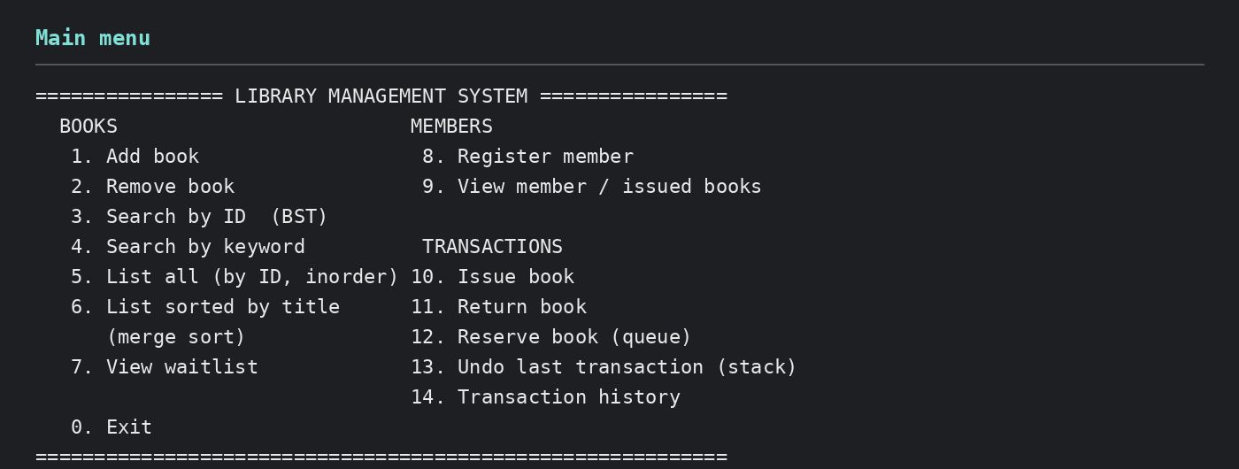
(this is the main menu of the program; each option is tied to one data structure)
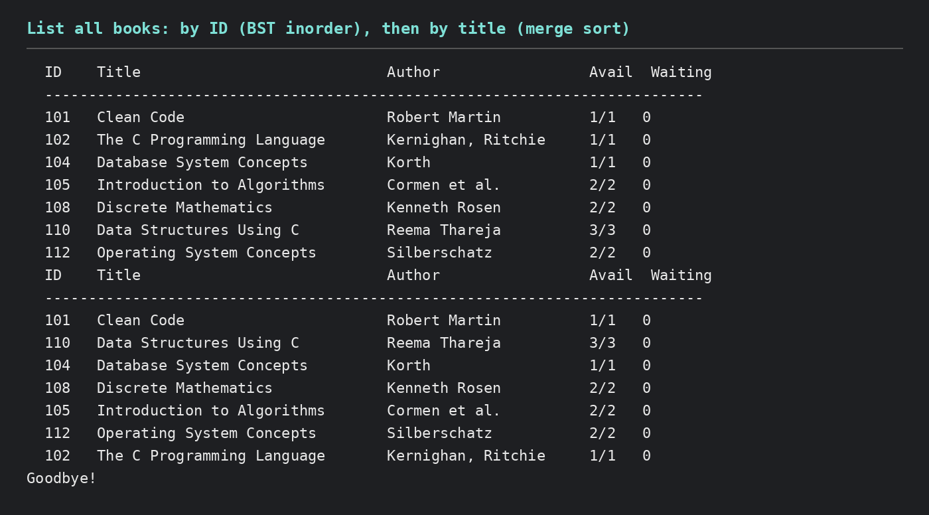
(books listed by ID using the tree’s inorder traversal, then by title using merge sort)
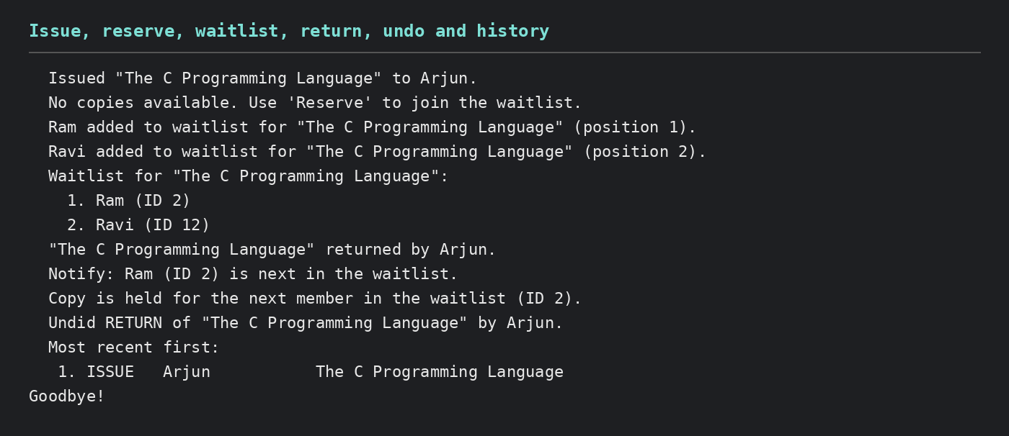
(Arjun issues the only copy; Ram and Ravi join the waitlist; the copy is held for Ram after the return; undo reverses the return)
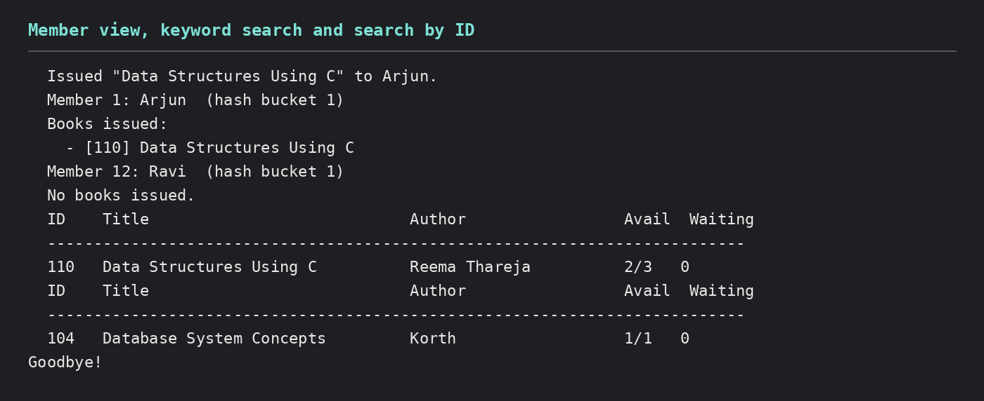
(member view with hash bucket, keyword search and search by ID)

