Devops_Final_project

Github link: https://github.com/Dharmaseelan2004/dharma_devops-tasks

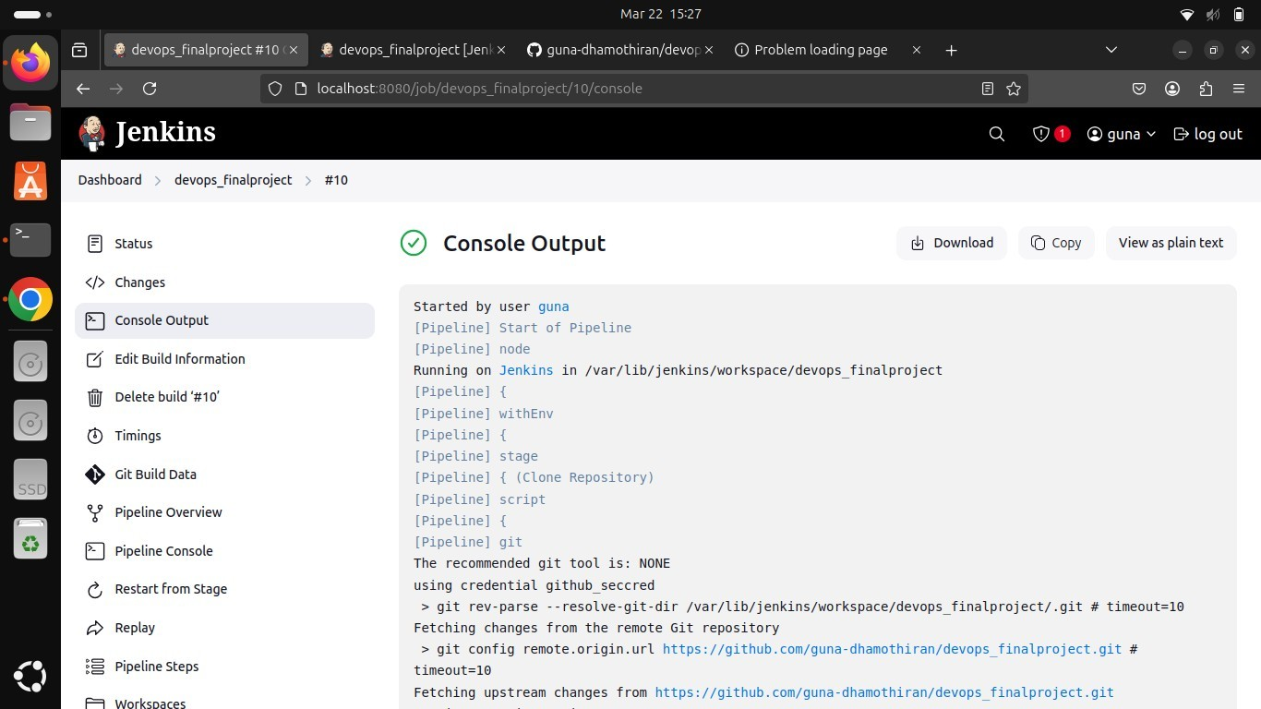

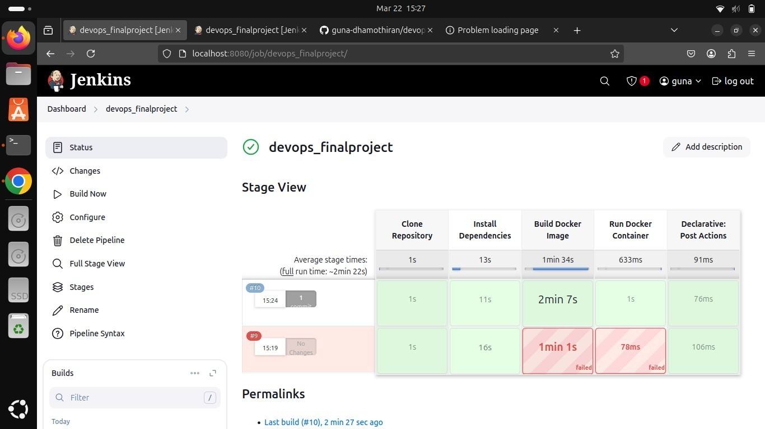

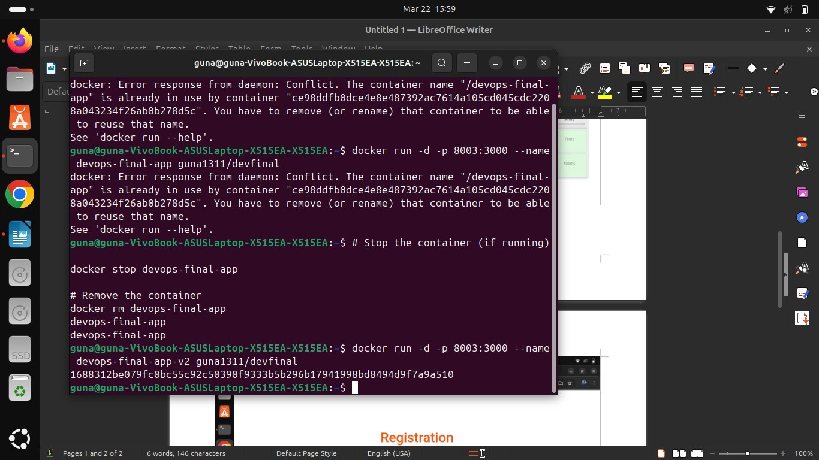

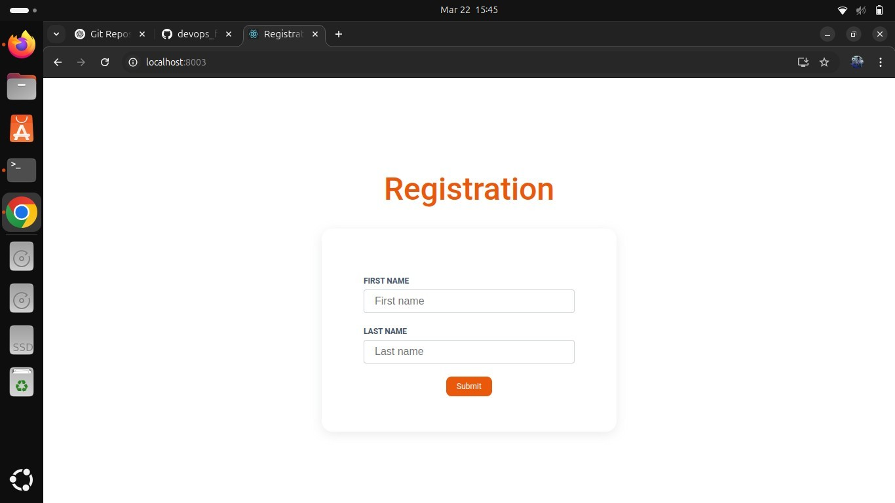

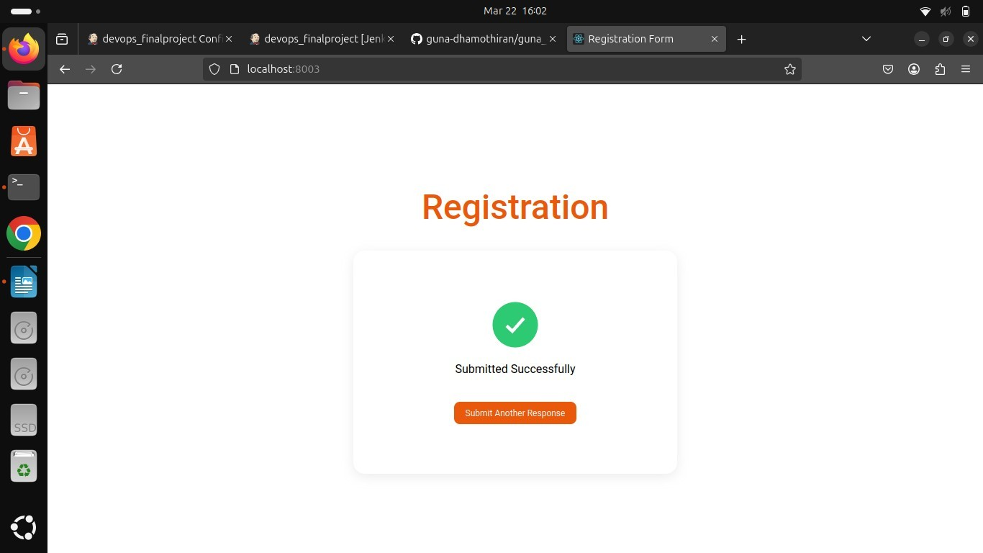

**Dockerfile:**

# Dockerfile

FROM node:18

# Set working directory

WORKDIR /app

# Copy package.json and package-lock.json

COPY package*.json ./

# Install dependencies RUN npm install

# Copy all project files COPY . .

# ✅ Use OpenSSL Legacy Provider to fix build issues

ENV NODE_OPTIONS=--openssl-legacy-provider

# Build the application RUN npm run build

# Expose port and run application

EXPOSE 8003

CMD ["npm", "start"]

**jenkins file:** pipeline { agent any

environment {

IMAGE_NAME = "Dharmaseelan2004/dharma_devops-tasks"

CONTAINER_NAME = "devops-react-app"

PORT = "5003" }

stages {

stage('Clone Repository') { steps {

https://github.com/Dharmaseelan2004/dharma_devops-tasks

}

}

stage('Install Dependencies') {

steps { script {

sh 'npm install'

}

}

}

stage('Build Docker Image') { steps { script {

sh 'docker build -t $IMAGE_NAME .'

}

}

}

stage('Run Docker Container') {

steps { script {

sh 'docker stop $CONTAINER_NAME || true' sh 'docker rm $CONTAINER_NAME || true'

sh 'docker run -d --name $CONTAINER_NAME -p $PORT:80 $IMAGE_NAME'

}

}

} }

post { success {

echo '🎉 Deployment successful! Visit http://localhost:5003'

} failure {

echo '❌ Deployment failed. Check logs.'

}

}

}