Spring Boot with Maven & Tomcat in Docker

https://github.com/Dharmaseelan2004/dharma_devops-tasks

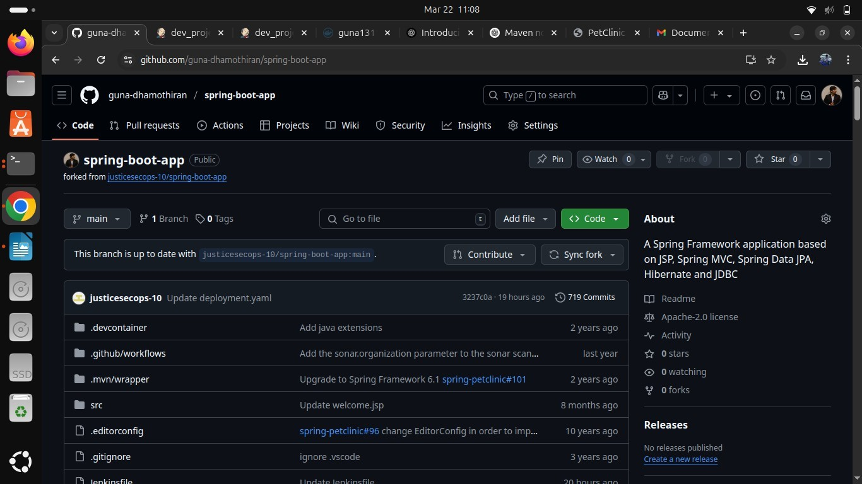

Plugins:

Maven Integration plugin Pipeline Maven plugin

Tools:

Use maven 3.9.8

and Maven Home as /opt/home Configure - pipeline:

pipeline { agent any

environment {

DOCKER_IMAGE = "Dharmaseelan2004/Devops_2" DOCKER_TAG = "latest" DOCKER_CREDENTIALS_ID = "docker"

GITHUB_CREDENTIALS_ID = "github-seccred" KUBECONFIG = "/var/lib/jenkins/.kube/config"

**}**

stages {

stage('Checkout Code') { steps {

git credentialsId: GITHUB_CREDENTIALS_ID, url: 'https://github.com/Dharmaseelan2004/dharma_devops-tasks, branch: 'main’

**}**

**}**

stage('Build Application') { steps {

script {

sh '${MAVEN_HOME}/bin/mvn clean package -DskipTests'

**}**

**}**

**}**

stage('Run Maven Tests') { steps {

script {

try {

sh 'mvn test'

} catch (Exception e) {

echo "Tests failed, but proceeding..."

**}**

**}**

**}**

**}**

stage('Build Docker Image') { steps {

script {

sh "docker build -t ${DOCKER_IMAGE}:${DOCKER_TAG} ."

**}**

**}**

**}**

stage('Push Docker Image') { steps {

withDockerRegistry([credentialsId: DOCKER_CREDENTIALS_ID, url: ''])

**{**

sh "docker push ${DOCKER_IMAGE}:${DOCKER_TAG}"

**}**

**}**

**}**

// stage('Deploy to Kubernetes') {

// steps {

// script {

// sh '''

// chmod +x scripts/deploy.sh

// ./scripts/deploy.sh

**// '''**

**// }**

**// }**

**// }**

**}**

post {

success {

echo "Deployment Successful!"

**}**

failure {

echo "Deployment Failed!"

**}**

**}**

**}**

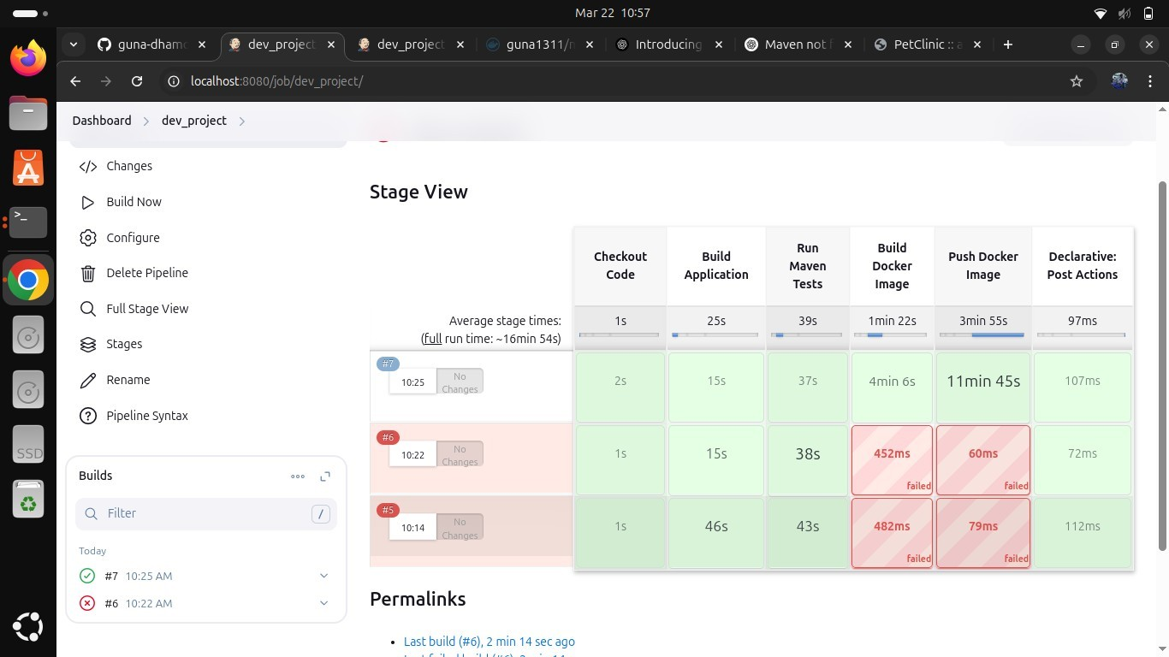

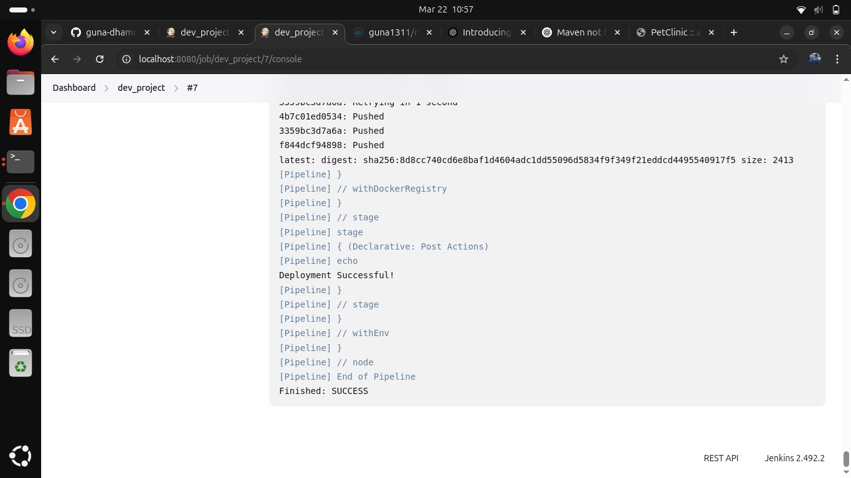

After build:

docker ps -a

docker run -it guna1311/mvn:latest /bin/bash

root@f5c4f8921dbf:/usr/local/tomcat# ps aux | grep tomcat root@f5c4f8921dbf:/usr/local/tomcat# /usr/local/tomcat/bin/catalina.sh run

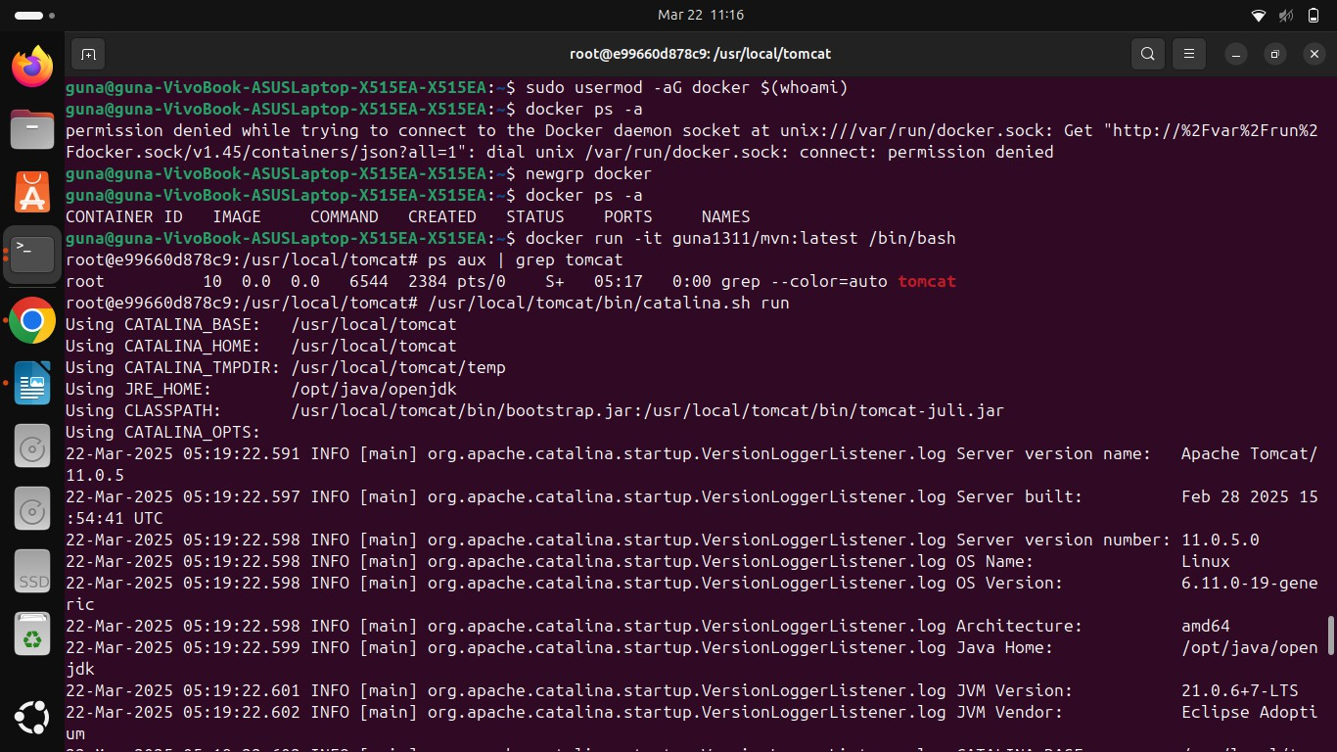

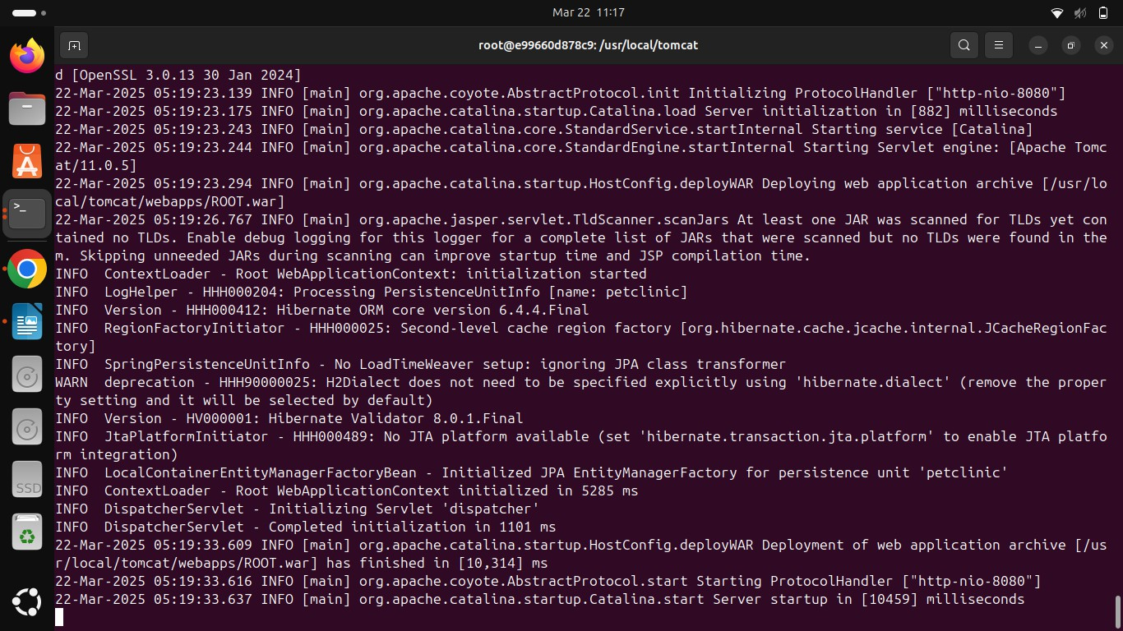

In new terminal: docker run -d -p 9123:8080 guna1311/mvn:latest

