**Week - 1. Design principles & Patterns**

**Exercise 1: Implementing the Singleton Pattern**

**What is Singleton Pattern *?***

**Ans *:***

**The singleton pattern ensures that a *class* has "only 1 instance" throughout the application and providing a global access point to the instance**

**Disadvantage:**

**Not Thread safe but we can counter that to using the different approaches**

**Singleton Class**

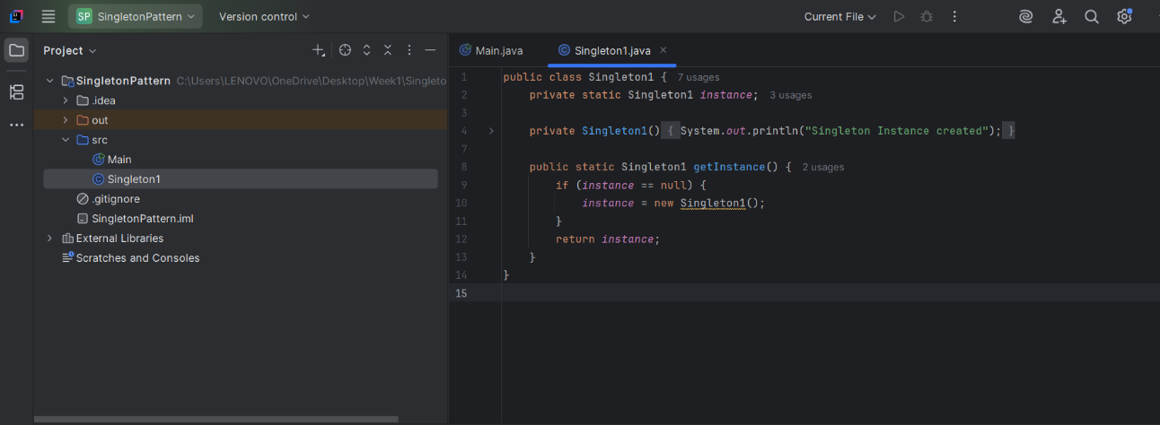

**Main Class**

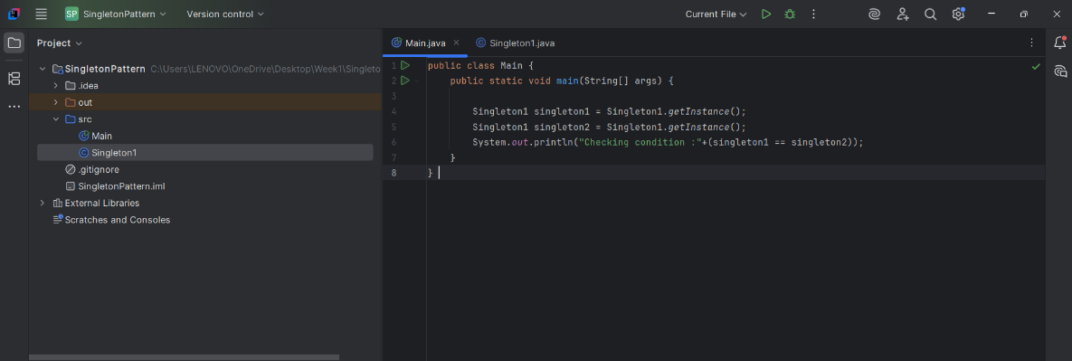

**Output:**

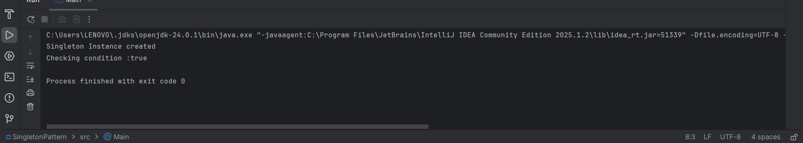

**Exercise 2: Implementing the Factory Method Pattern**

**What is Factory Method*?***

**It helps us create objects without exposing the object creation logic to the client. *The* client just asks the Factory, and the factory returns the correct object.**

**Example for Factory Method is Vehicle**

**Vehicle Interface:**

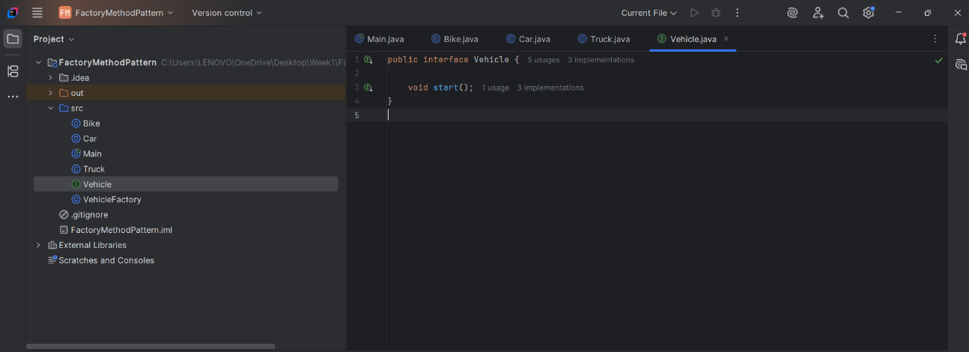

**Bike Class:**

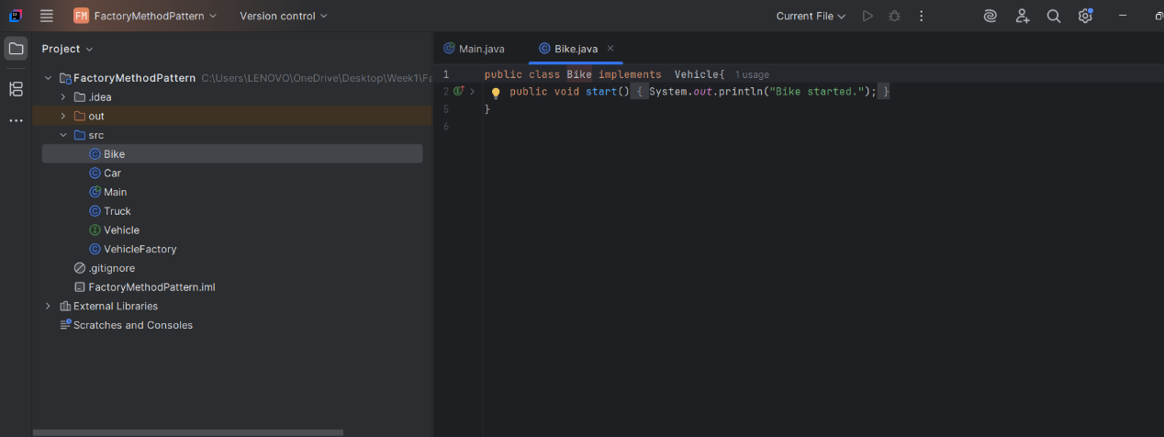

**Car Class:**

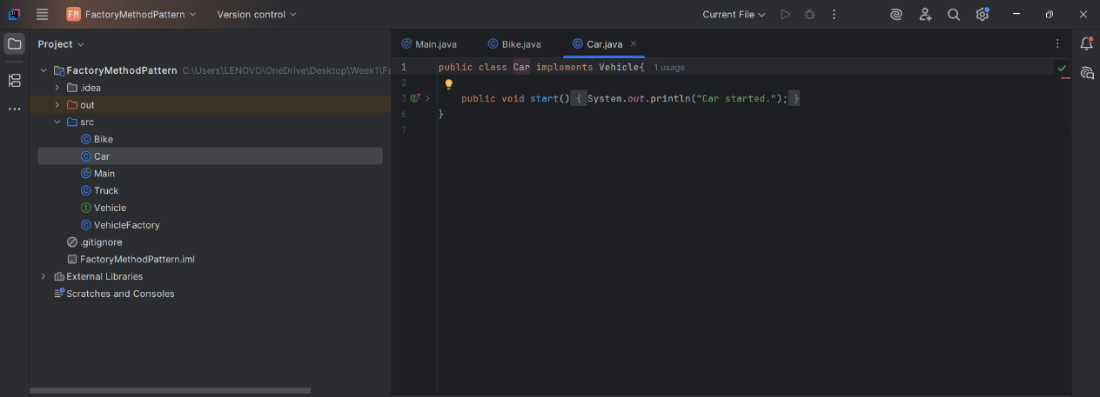

**Truck Class:**

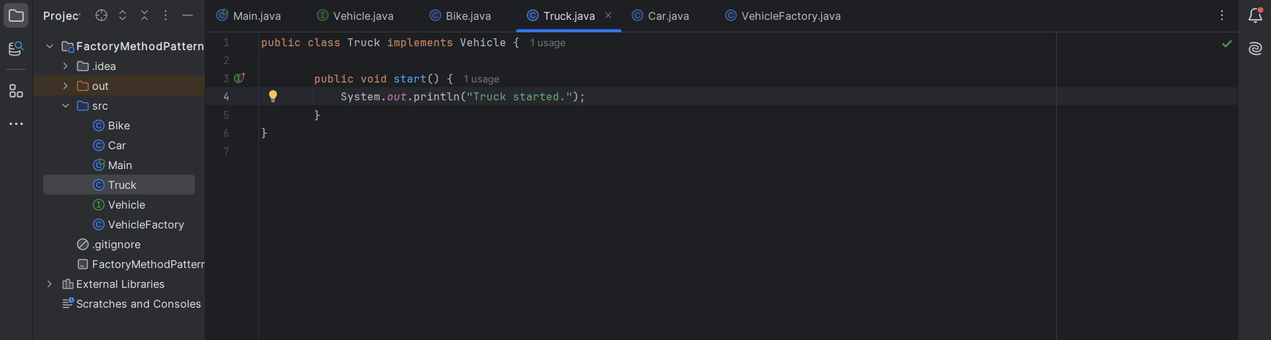

**VehicleFactory Class:**

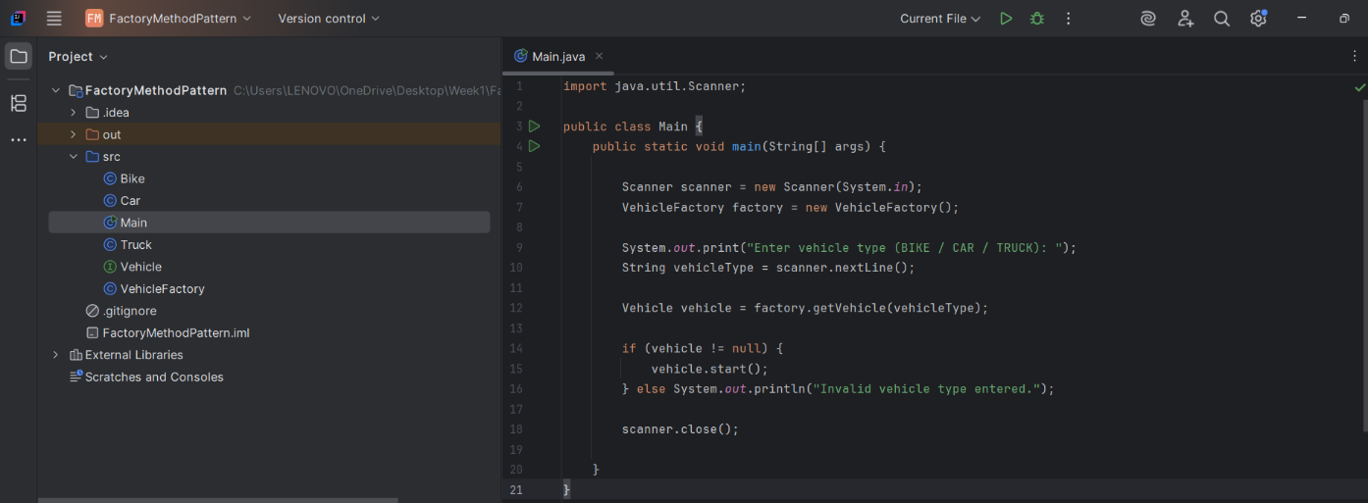

**Main Class:**

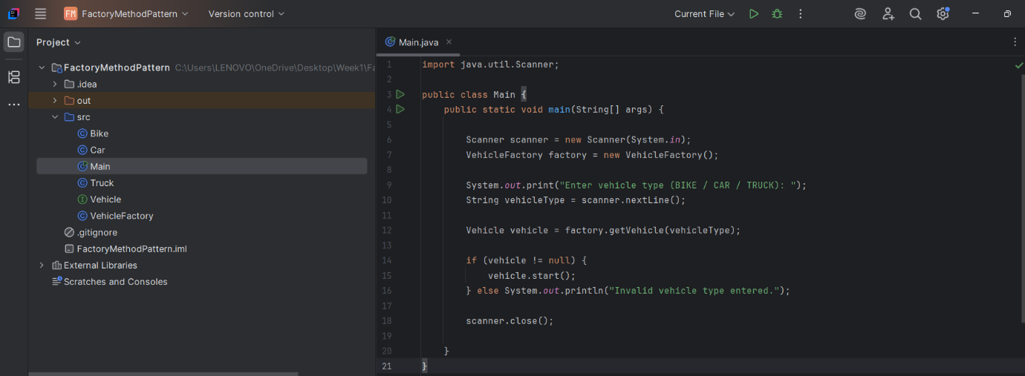

**Output:**

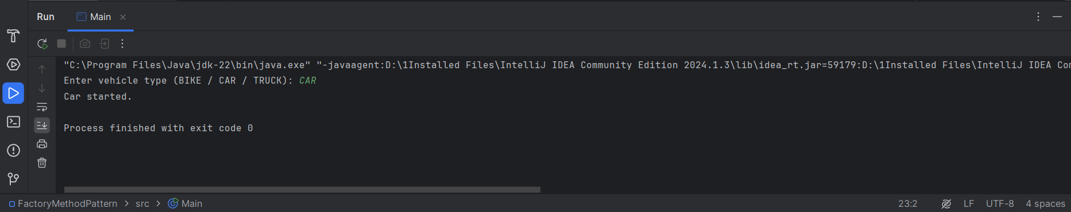

**2.Algorithms_Data Structures**

**Exercise 2:**  **E-commerce Platform Search Function**

**Product Class:**

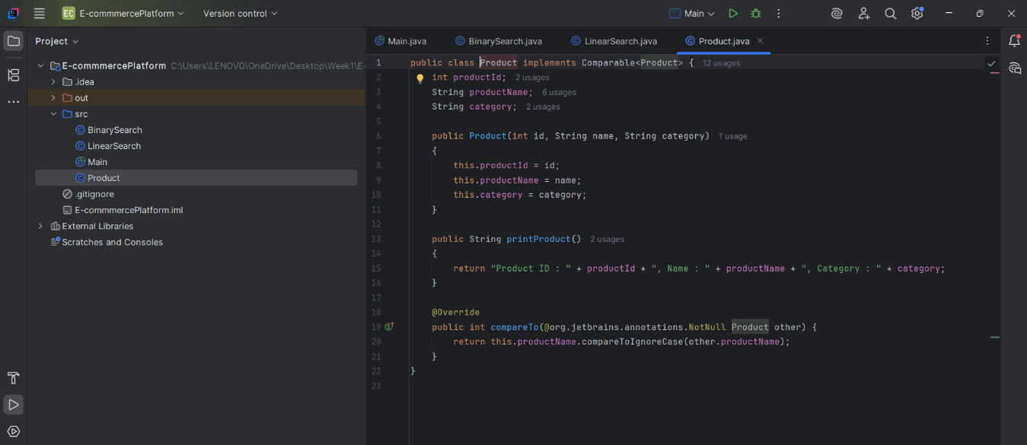

**LinearSearch Class:**

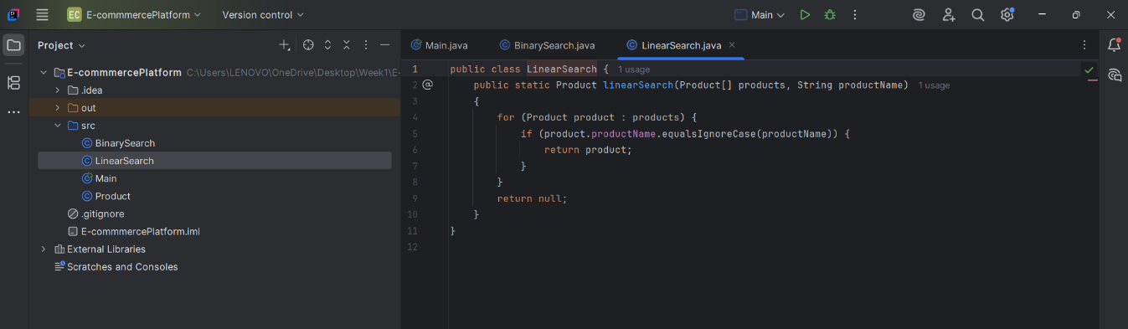

**BinarySearch Class:**

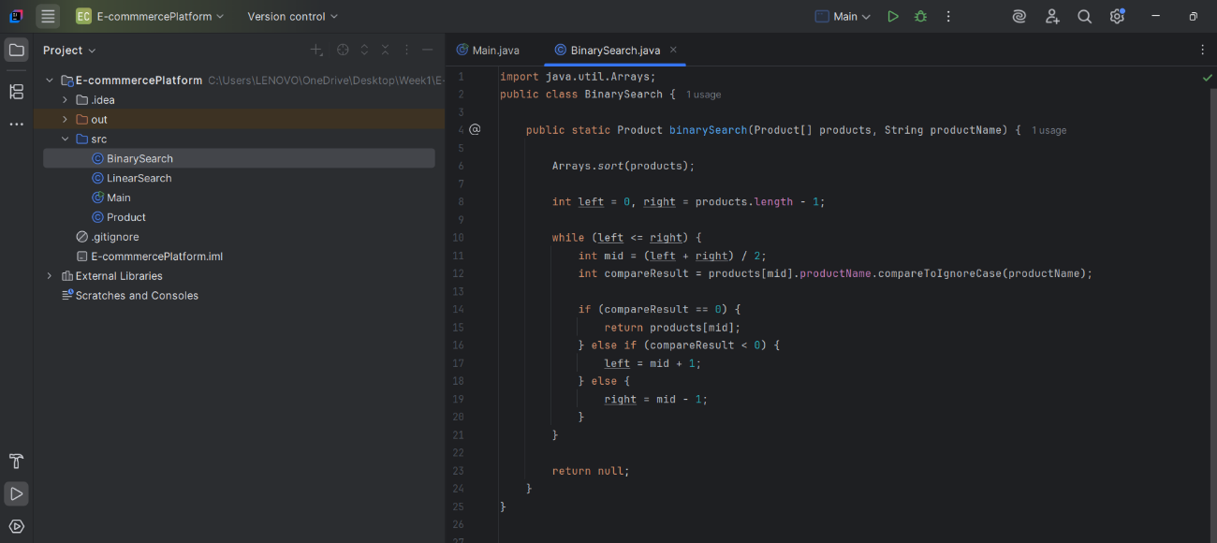

**Main Class:**

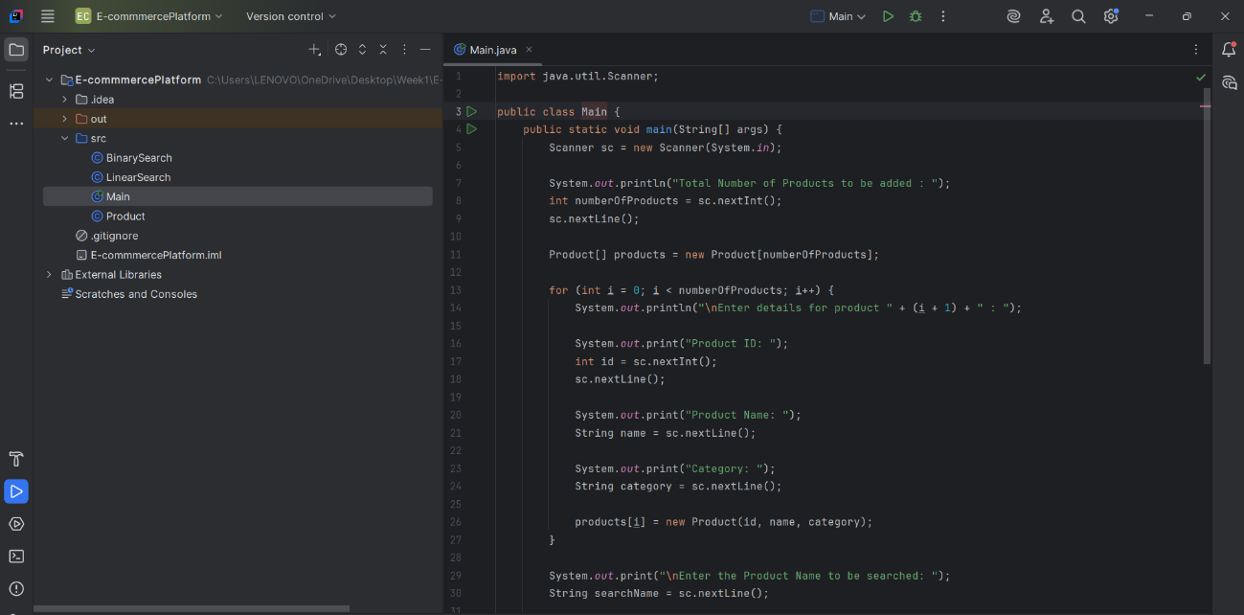

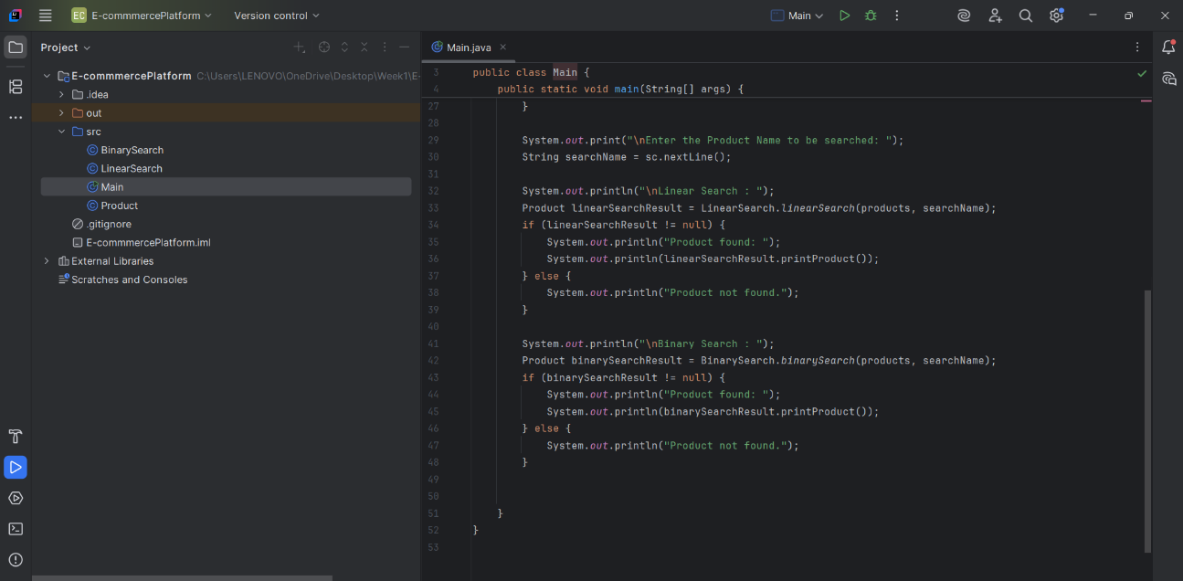

**Output:**

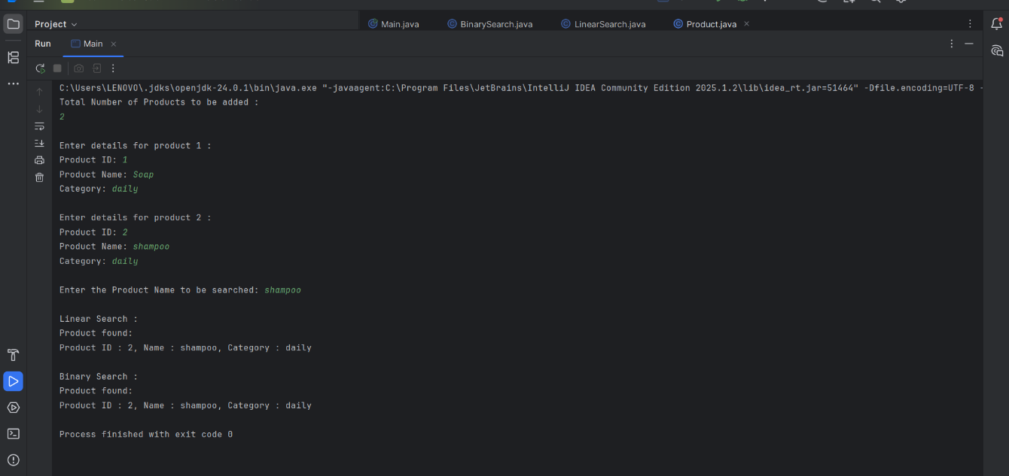

**Exercise 7:** **Financial Forecasting**

**FinancialRecord Class:**

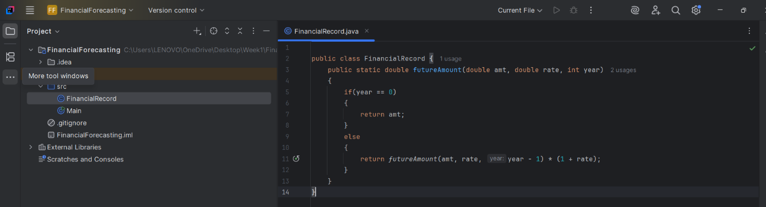

**Main Class:**

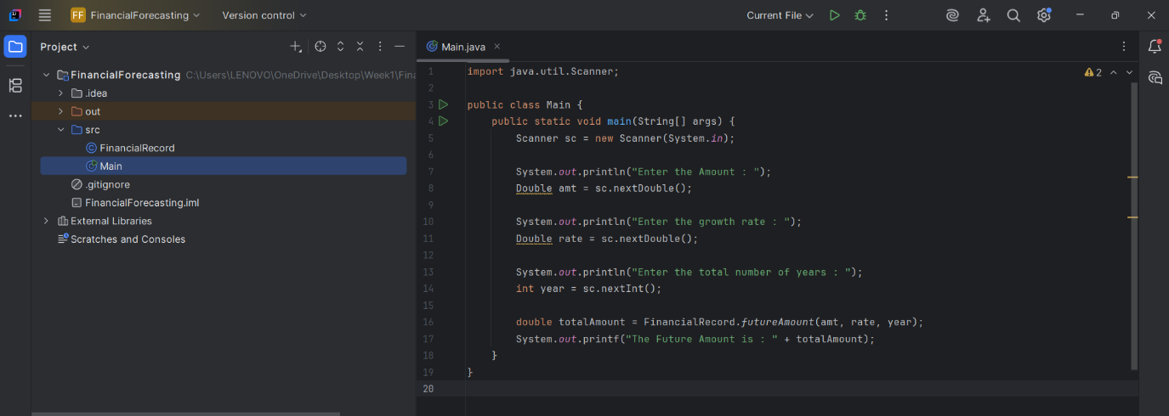

**Output:**

**[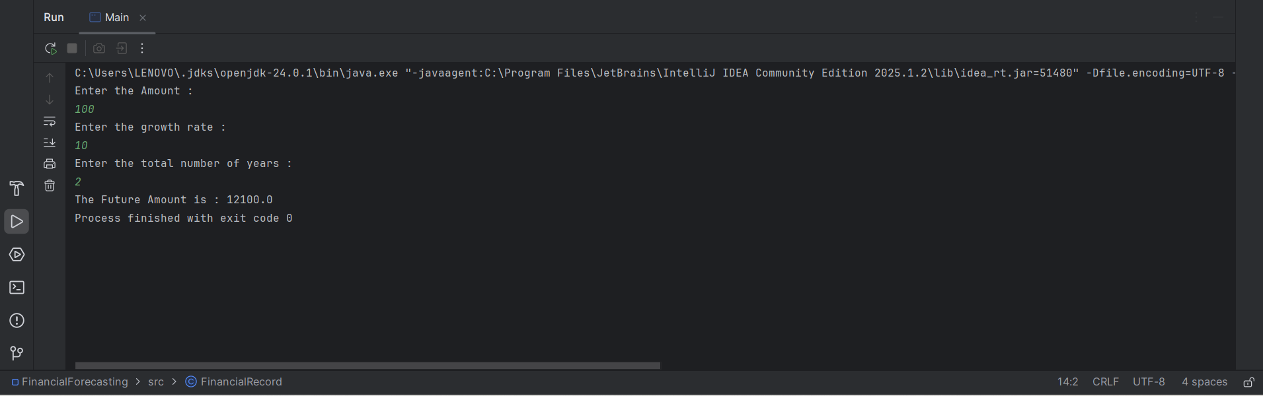](../OneDrive/Desktop/Week1)**

**Folder:** <https://drive.google.com/drive/folders/10Z_y-9v-elKOn0DHK1-sLEMkivaRzgDU?usp=drive_link>