**Week 8**

1. **Git-HOL**

**Gitbash:**

* + cd ~/GitDemo
  + git init
  + git config --global init.defaultBranch master
  + echo "Hello, I am Learning Git!" > welcome.txt
  + git status
  + cat welcome.txt
  + git add welcome.txt
  + git commit -m "Added welcome.txt file"
  + git log
  + git push origin master
  + git branch --set-upstream-to=origin/master
  + git status
  + git push
  + git add <file-name>
  + git commit -a
  + git status

**Gitlab:**

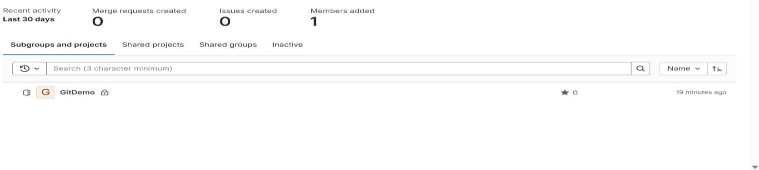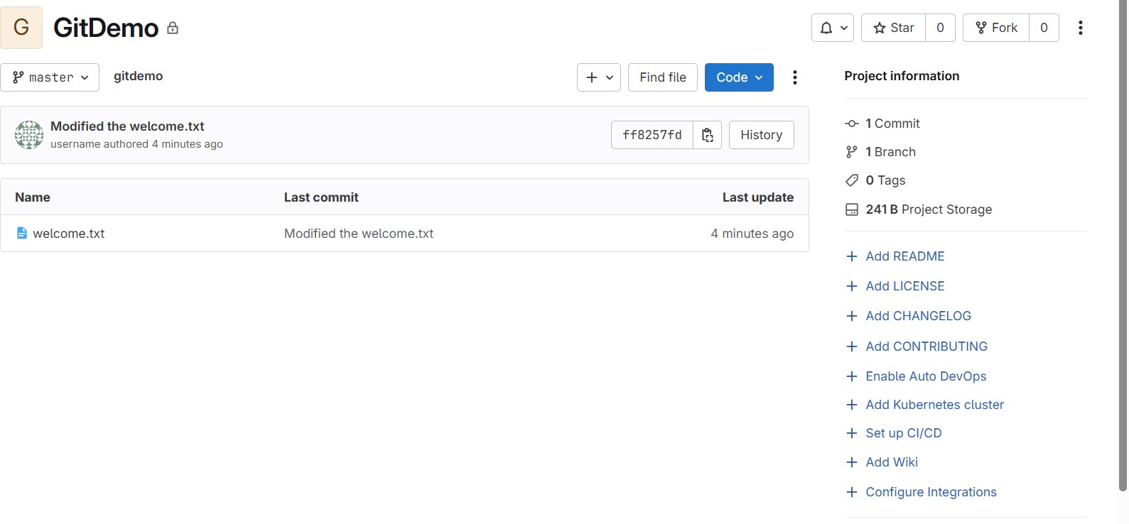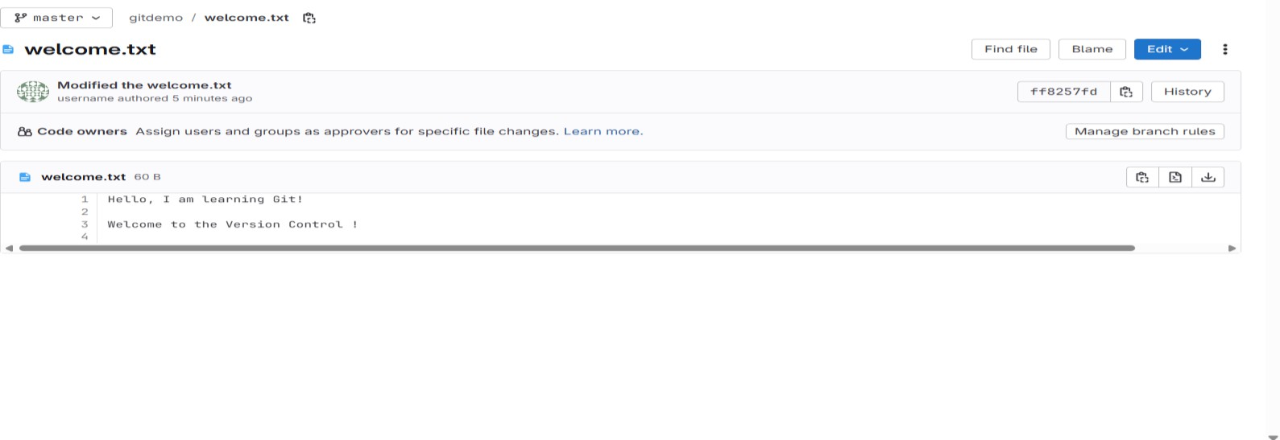

**Notepad++**

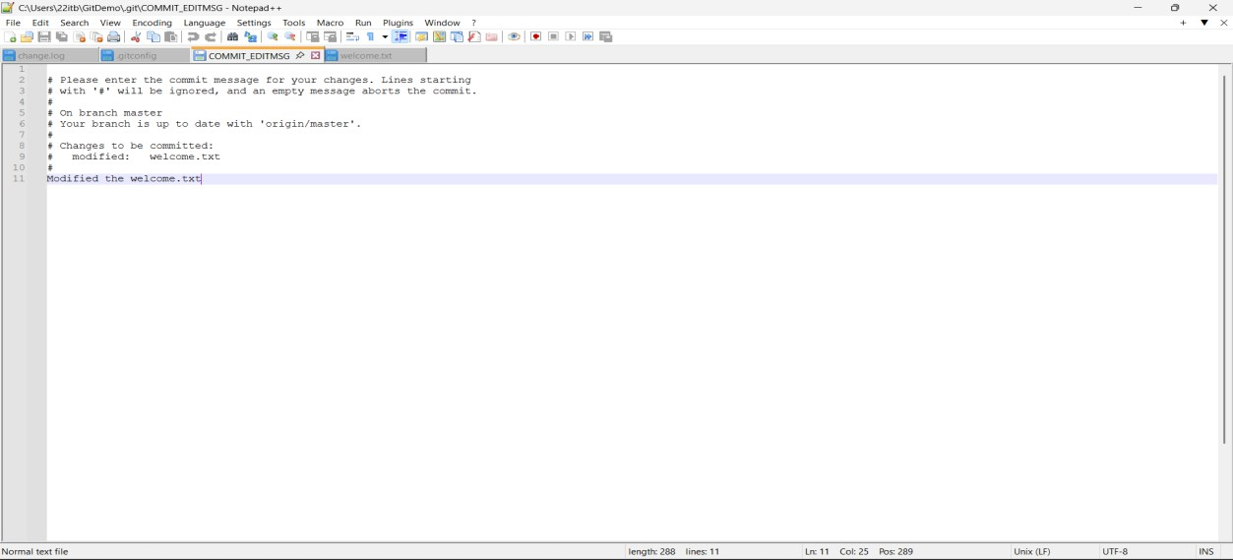

1. **Git-HOL**

**Gitbash:**

* + git rm --cached
  + rm .gitignore
  + rm welcome.txt
  + mkdir log
  + echo "Fix: ignore log files and folders" >> .gitignore
  + git add .
  + git commit -m "Fix: ignore log files and folders"
  + git push origin master
  + git status

**Gitlab:**

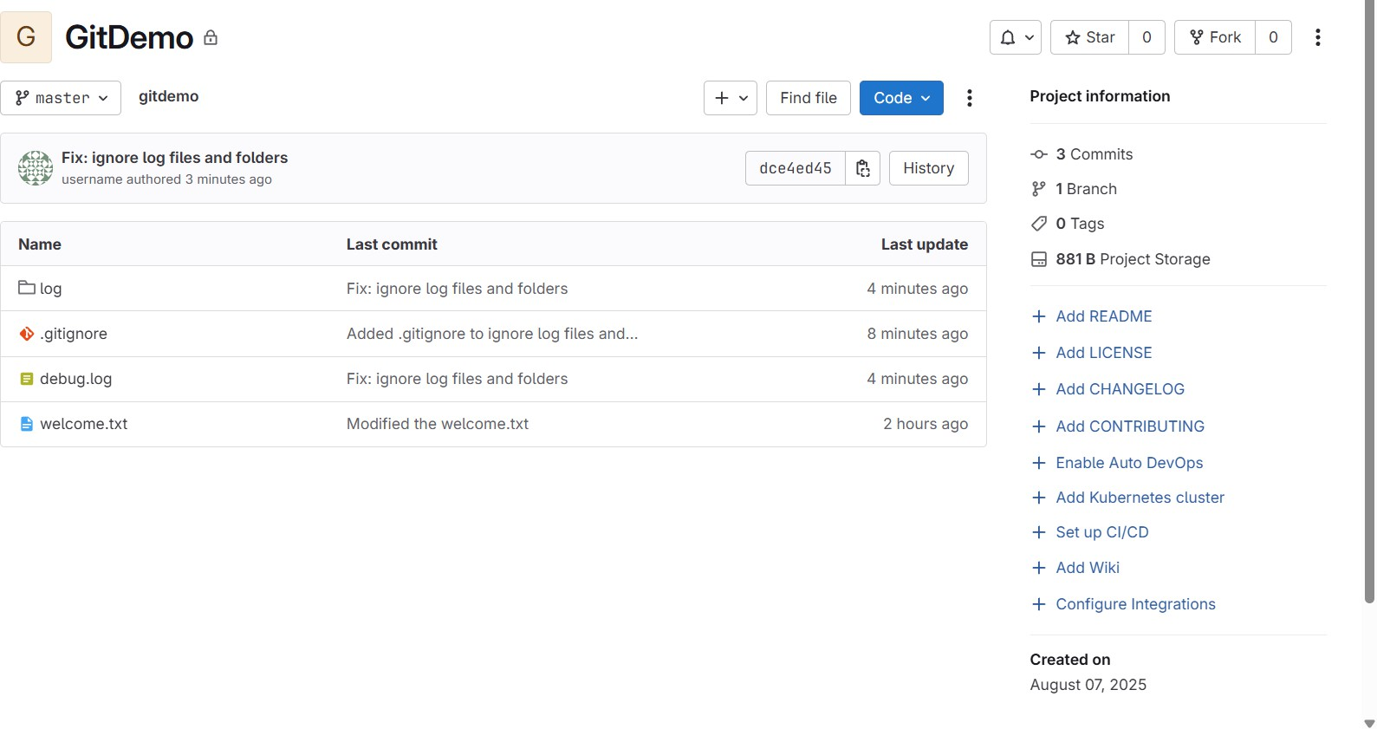

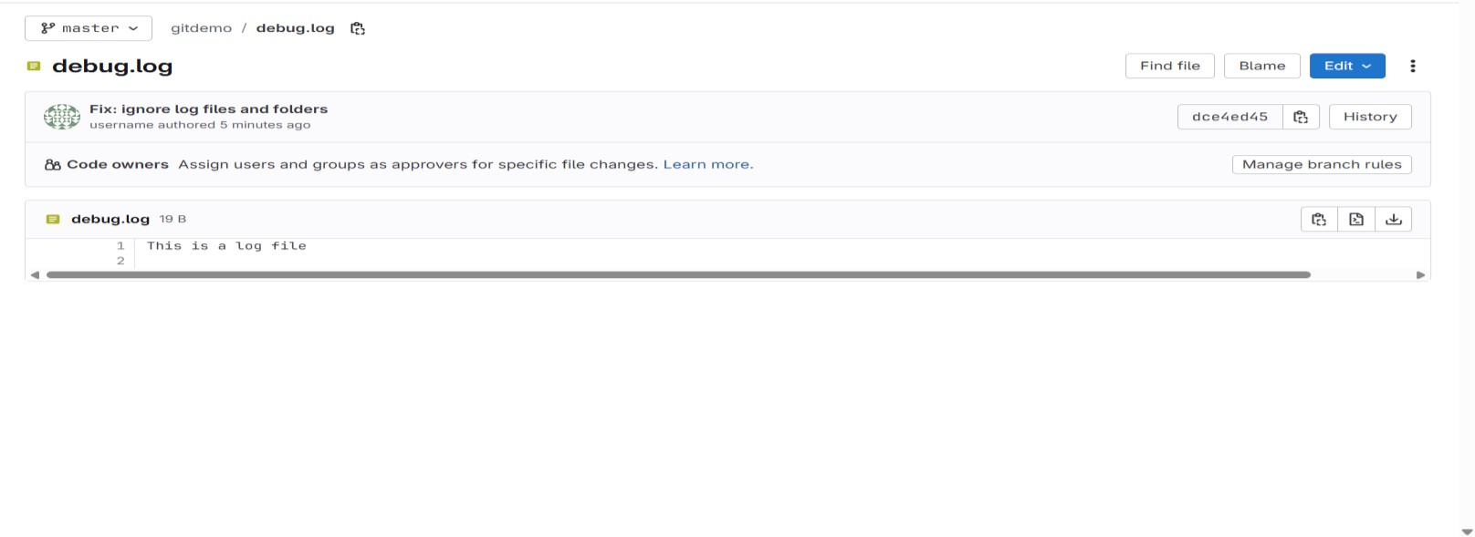

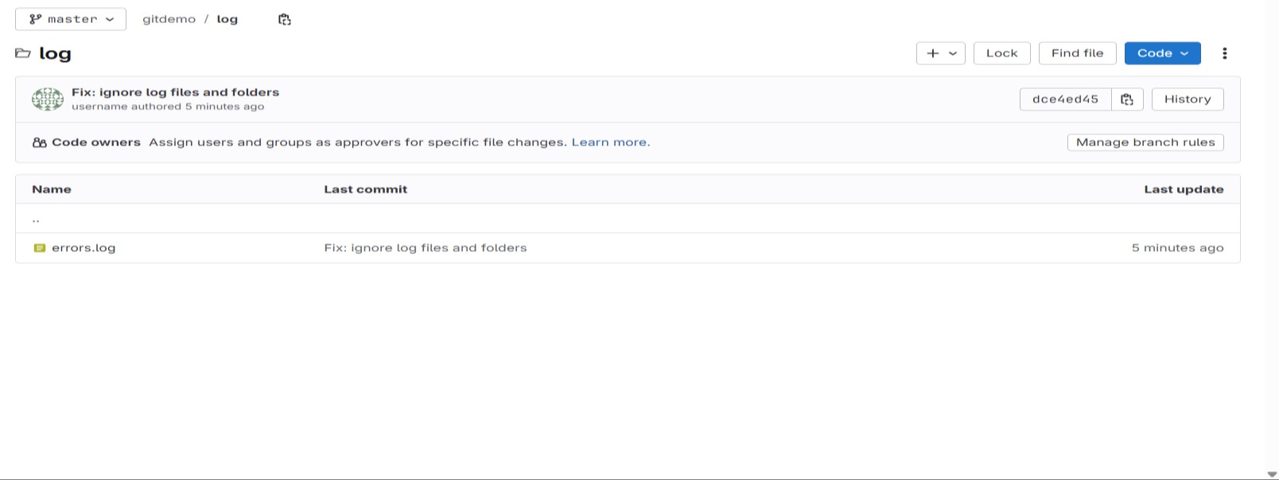

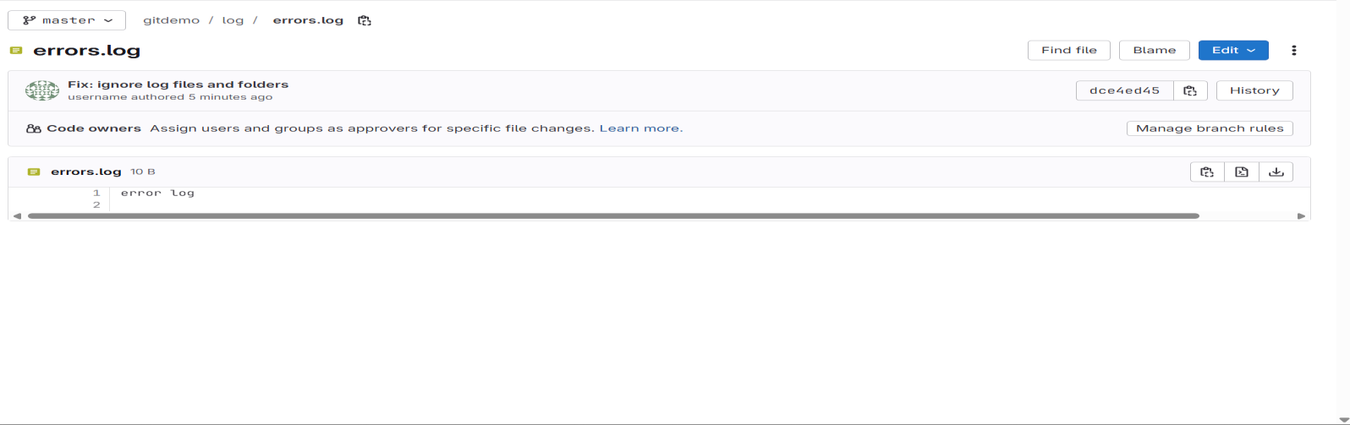

1. **Git-HOL**

**Gitbash:**

* + git branch
  + echo "Hello, this is my new branch!" > newfile.txt
  + git add newfile.txt
  + git commit -m "Added newfile.txt in gitnewbranch"
  + git status
  + git checkout master
  + git diff
  + echo "This is new content in GitNewBranch" > newfile.txt
  + git add newfile.txt
  + git commit -m "Added new content in GitNewBranch"
  + git checkout master

**View the changes by p4merge:**

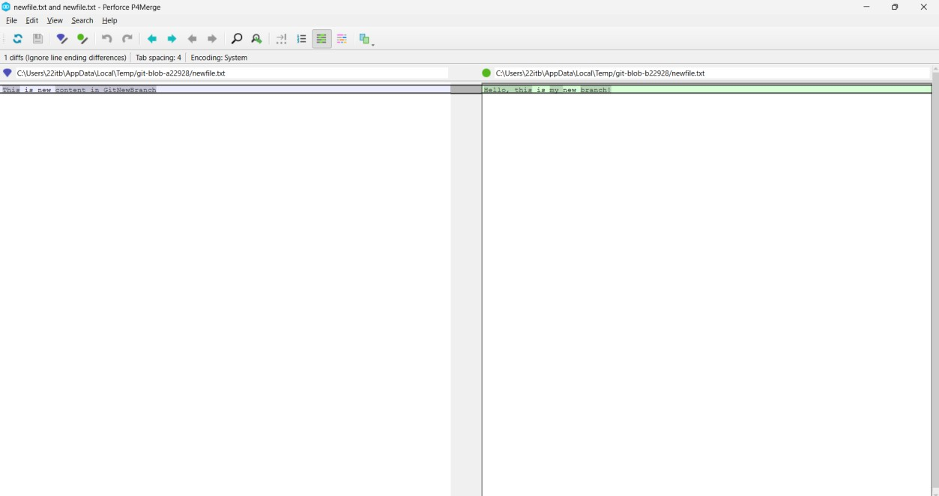

**After resolving the conflict the new branch is deleted: Deleted the new branch that is “GitNewBranch”:**

**Gitbash:**

* + git status
  + git checkout GitNewBranch
  + git diff master..GitNewBranch
  + git log --oneline --graph --decorate
  + git diff master..GitNewBranch
  + git branch -D GitNewBranch
  + git status

1. **Git-HOL**

**Gitbash:**

* + git status
  + echo "updated/edited in GitWork branch" > hello.xml
  + git add hello.xml
  + git commit -m "Added and updated hello.xml"
  + git checkout master
  + git commit -m "Master: Added conflicting hello.xml"
  + git log --oneline --graph --decorate
  + git diff master..GitWork
  + git diff master..GitWork --stat
  + git config --global diff.tool vimdiff
  + git difftool master..GitWork

**P4merge:**

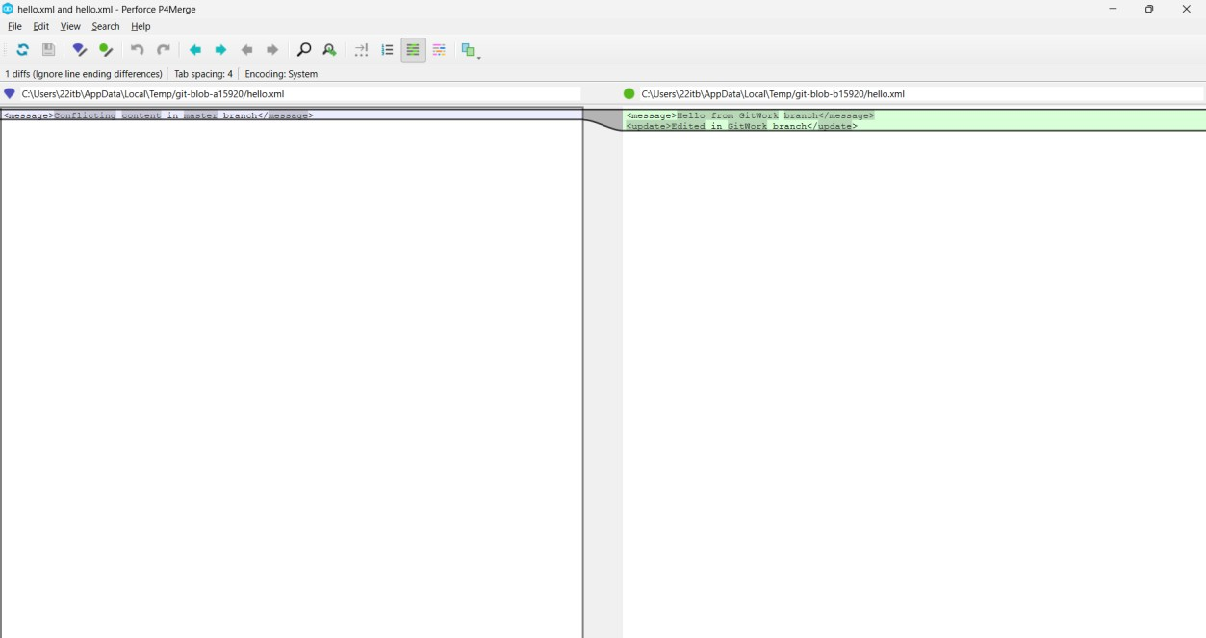

**Merging Conflict Gitbash:**

* + ls
  + git mergetool

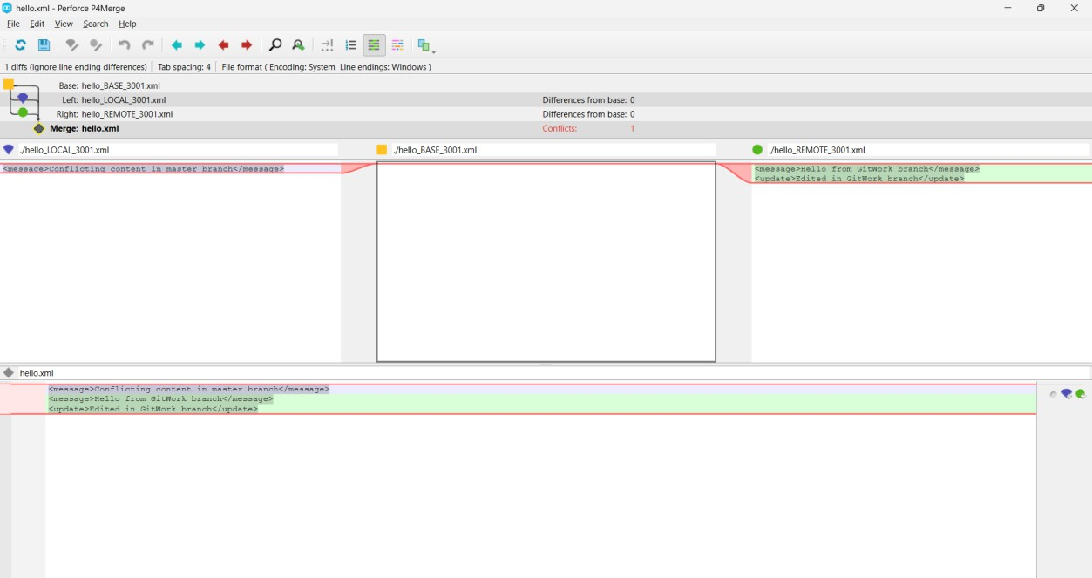

**Pushed to master branch Gitbash:**

* + git add hello.xml
  + git commit -m "Resolved merge conflict in hello.xml"

**After merging to master branch, the GitWork branch is deleted:**

**Gitbash:**

* + git log --oneline --graph --decorate

1. **Git-HOL**

**Gitbash:**

* + git branch
  + git pull origin master
  + git remote -v
  + git remote add origin https://github.com/Babuparsanth27/GitDemo.git
  + git remote -v
  + git fetch https://github.com/Babuparsanth27/GitDemo.git
  + git push --set-upstream origin master

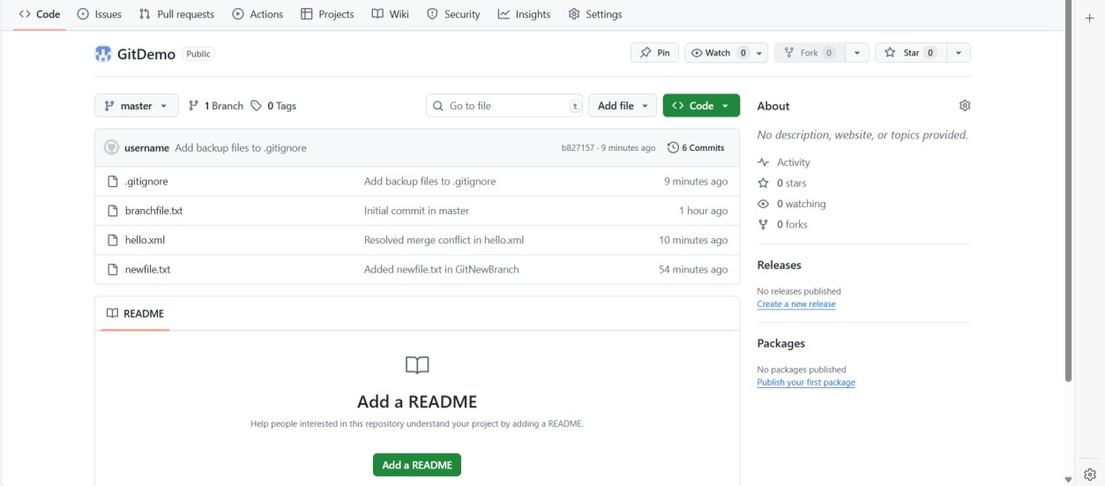**Pushed the code from local to github:**

**Changes are displayed**

