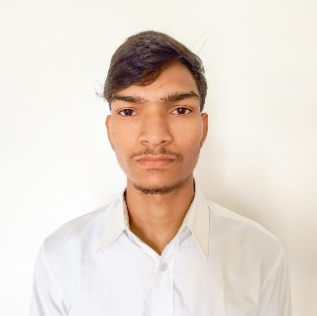
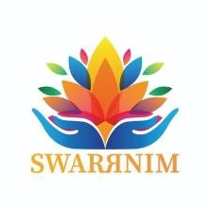
Dharmendra Dhital
+91 9316890719
dhitaldharmendra7@gmail.com
linked-in: /dharmendra-dhital-128592290/
portfolio: portfolio-psi-eight-tbk1i4r7wr.vercel.app

Objective

Aspiring Full Stack Developer pursuing B-Tech in Computer Engineering with a 9.35 CGPA. Proficient in MERN stack development with hands-on experience building production-ready web applications. Seeking a Software/Web Development internship to contribute technical skills while gaining real-world industry experience.

Education

Course / Degree | School / University | CGPA | Year
B.Tech in Computer Engineering | Swarrnim Startup & Innovation University | 9.35/10 | Currently Pursuing
Higher Secondary School | Khwopa Higher Secondary School | 3.04/4 | 2022
Secondary School | Bagiswori Secondary School | 3.65/4 | 2020

Projects

Stock Trading Platform (Zerodha Clone)
Technologies: React JS, Rest APIS, MongoDB, Bootstrap, Node JS, Express JS.
Description: Developed a full-stack stock trading web applications inspired by Zerodha, providing a real-world trading platform experience. Built a responsive and interactive frontend using ReactJS and Bootstrap for seamless user experience. Implemented features like user dashboard, stock listings, buy/sell orders, holdings history. Used MongoDB for efficient data storage and management of users, traders, and market data.

Portfolio | May’25

Technologies: React JS and Tailwind CSS
Project Definition: Designed and developed a fully responsive personal portfolio website to showcase projects, skills, and professional profile. Built the frontend using React JS, with a component-based architecture for maintainability and scalability. Used Tailwind CSS to create a clean, modern UI with mobile-first responsive design. Integrated Framer Motion to implement smooth animations, page transitions, and scroll-based reveal effects, enhancing user experience.

Link : portfolio-psi-eight-tbk1i4r7wr.vercel.app

Technical Skills Non – Technical Skills

- React JS • Communication Skills
- Node JS • Time Management
- JavaScript • Integrity
- Express JS
- MongoDB
- My SQL
- Bootstrap
- Tailwind
- C, C++

Certifications

- Full Stack Web Developer (MERN Stack) by Apna College | 2025
- SAP Certification in Python for Machine Learning & Deep Learning | July’24 - March’25
Industrial Exposer

Indian Space Research Organisation (ISRO), Ahmedabad | May’23
- Observed satellite assembly, testing facilities, and space technology R&D at SAC (Space Applications Centre)
- Gained insights into remote sensing, launch vehicle systems, and mission control operations
- Interacted with scientists about software systems for spacecraft navigation and data processing

Co-curricular Activities

1st Prize, Intercollege Football Tournament | January’25

Personal Details

- Nationality: Nepali
- Date Of Birth: February 23, 2006
- Languages Known: English, Hindi and Nepali
- Interests: Sports and Travelling
- Address: Swarrnim Hostel, Bhoyan Rathod, Gandhinagar, 382721

