Analyzing readability issues in an infographic webpage

Dharmendra Vaghela

Masters in Computer Science,

North Carolina State University,

Raleigh, NC, USA, 27606

[djvaghel@ncsu.edu](mailto:djvaghel@ncsu.edu)

Rohit Mandge

Masters in Computer Science,

North Carolina State University,

Raleigh, NC, USA, 27606

[djvaghel@ncsu.edu](mailto:djvaghel@ncsu.edu)

Aditya Mandhare

Masters in Computer Science,

North Carolina State University,

Raleigh, NC, USA, 27606

[amandha3@ncsu.edu](mailto:amandha3@ncsu.edu)

Rupaj Soni

Masters in Computer Science,

North Carolina State University,

Raleigh, NC, USA, 27606

rosoni@ncsu.edu

**ABSTRACT**

In this paper, we provide analysis and solutions of the problems faced by users while reading an infographic web page which contains image illustrations for textual information. An infographic webpage is susceptible to many design flaws. We collected data from different user groups by means of observations and survey. We established a cause-and-effect relationship between any particular design flaw and the magnitude of repercussions it has on the overall reading experience. After analyzing user feedbacks and common issues that they encountered on a daily basis, we identified potential areas of improvement. We developed 3 different Chrome extensions to solve these issues and worked closely with the user groups to further improve these solutions. In this paper, we present quantitative and qualitative evaluation of these solutions. Alongside, we gauge users’ proclivity for a certain solution and the reasons why they prefer one solution over the other.

**Keywords**

Readability, Comprehension, Context, Images, Web Page, Information, Concentration, Agile, Chrome extension

# INTRODUCTION

# In this age of internet, world wide web has become a major source of information. Majority of people use internet as a knowledge repository, thanks to the zetabytes of data uploaded on webpages. This knowledge comes from variety of sources such as blogs, science magazine, social media, community forums, websites etc. One common problem with information provided on the internet is that it does not come in the form of pure text. Articles over the internet are replete with image references and tabular data. It is observed by surveys and interviews conducted by our team, that not all peoples are really comfortable with way the information is provided over the internet.

Browser acts as a window to the world wide web and conclusively, browser extension provides the best outreach. An extension, is quite simply, a third party library that “plugs in” to the browser and process the pages that the browser loads, thus adding on to the browser UI. According to the usage statistics provided by w3schools, Google Chrome is the most used web browser worldwide[10]. Thus, developing the solutions as Chrome extensions was almost intuitive.

Since, user feedback was an integral part of this project, we have used Agile development methodology. We followed an incremental approach for development and incorporated feedback with every iteration. All the three solutions were tested throughout the project lifecycle. Ultimately, we achieved a high quality solution with this collaborative and cooperative approach.

# PROBLEM STATEMENT

# Many a times it is observed that a web page contains images and references to these images are made at multiple places across the page. In this case the reader has to scroll back and forth through the web page every time he has to refer to an image. This is highly inconvenient. Due to this, the user faces many problems like loss of comprehension, continuity and context. It also puts stress on user’s vision, due to which the user cannot concentrate fully. It also consumes considerable amount of user time. This results in spoiling the user’s reading experience. Our goal was to extract the source web pages and enhance them to increase visual comprehension through various means.

# TARGET USERS

All the people who use internet and read online content are affected by this problem. Image dense web pages are visited by users across all age groups. We have surveyed people from age groups ranging from 15 to 45 years to analyze the effect of this issue on their overall reading experience. We have surveyed around 100 people and observed and interviewed 50 people. The observations and findings are presented in this paper in sections below.

# LITERATURE SURVEY

## The readability of online web pages has been shown to be influenced by a number of variables including text size, type, positioning of image references etc. The users were more satisfied with the enhanced layout and reported it to be less fatiguing to read.[1]

## Data collection

To collect the data, we created a small survey using google forms (<http://goo.gl/forms/D5raoyVo2h>) and posted on various social media platforms like Facebook, WhatsApp and LinkedIn.

The questionnaire used for the survey included the type of articles users read, the device on which they prefer to read and issues while moving to and fro in search of images.

From the collected data, we found that 92.6% of the people who have taken the survey prefer web pages with text and images.

After developing the 3 solutions, we interviewed users about their feedback on their experience. We also gathered data through Google forms(<https://goo.gl/DUXFjD>).

We further incorporated the changes suggested by the user and took a final feedback from user through interviews and Google forms(<https://goo.gl/I61FdO>).

We tracked the user telemetry through the console logs which were a part of the script for the extensions. These logs provided a baseline for extracting the usage patterns and improving the functionalities to achieve better user satisfaction.

# OVERVIEW

The three solutions are as follows: (i) Solution 1- A sidebar with image thumbnails. (ii) Solution 2- Image pop-up on hover. (iii) Solution 3- Open image in new tab.

## Solution 1: A sidebar with image thumbnails

This solution is based on the idea that all the images are always available for reference. This means that the user doesn’t ever have to browse to a specific image when coming across it’s reference. All the images in the webpage are available in the sidebar. When a user wants to see any figure which has been referred in the text, the user can hover over that image in the sidebar and the webpage scrolls to the position of the image. Upon moving the mouse again/releasing hover, the webpage scrolls back again to its original position. So the user can continue reading effortlessly.

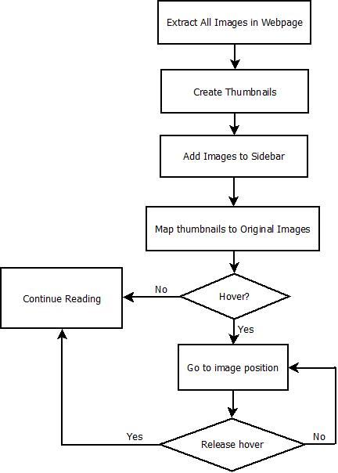

Fig 1. Flow chart for Solution 1(sidebar with image thumbnails)

## Solution 2: Image pop-up on hover

## The extension intelligently identifies all the occurrences of plaintext references to figures in the webpage. It then converts these plaintext references to hyperlinks to the actual figures. When a user hovers over its reference, the image pops-up instantly near the mouse. The best part about this solution is that the webpage remains at its position and the referenced image is popped-up over the current webpage. Thus the user doesn’t lose context even for a second.

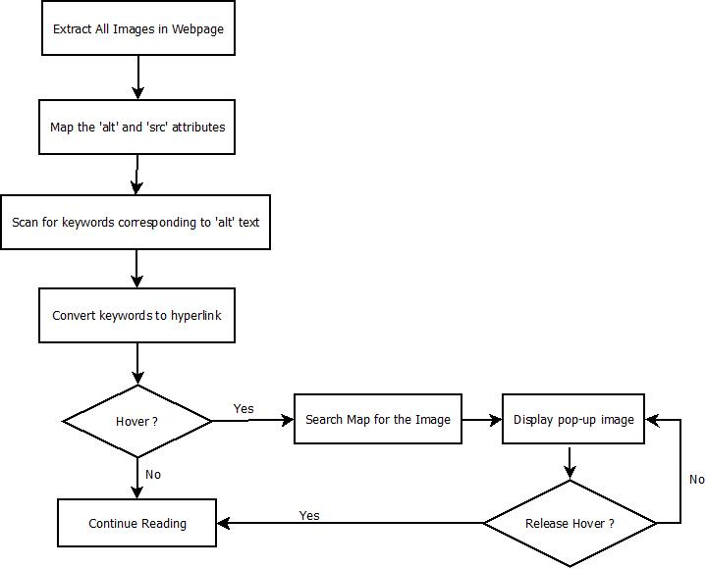

Fig 2. Flow chart for Solution 2(Image pop-up on hover)

## Solution 3: Open image in new tab

The extension intelligently identifies all the occurrences of plaintext references to figures in the webpage. It then converts these plaintext references to hyperlinks to the actual figures. The user can click on these links and the image opens in a new tab.

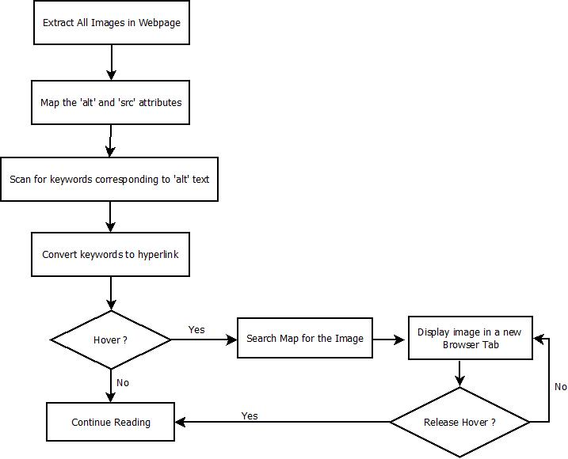

Fig 3. Flow chart for Solution 3(Open image in new tab)

# INITIAL FEEDBACK

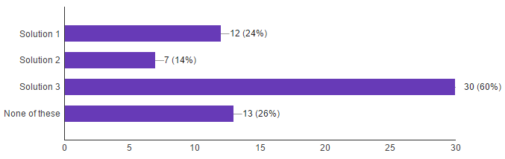

Fig 4. Analysis of loss of context while reading

When asked, if they lost context while reading an infographic web page after installing our browser extensions, we got the following responses. As seen from fig 4, 60% of respondents said they had problems using the Solution 3. They said they faced issues using this extension as they had to switch between the tabs. This spoiled their reading experience due to increase in reading time. 26% of people said that they had no problem with any of the three solutions and they felt that each of these solutions eased their reading experience. 12% of people said they lost context while using solution 1. This was because, after clicking on the thumbnail in the sidebar, the page navigated to the image position. The user then had to scroll back to the paragraph to continue reading. Again, 7% of people felt solution 2 did not solve their problem as it disturbed text alignment in the web page while displaying images on hover.

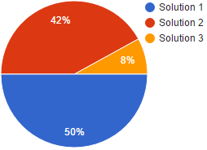

Fig 5. Analysis of time spent in reading web page

One of the main purpose of our extension is to reduce the time spent by the user on a web page. When asked which of the solutions served this purpose, 50% people voted in favor of solution 1 whereas 42 % people felt that solution 2 was better in this context (fig 5). It can be seen from the responses that, these two solutions have been appreciated by our users. However, solution 3 could please only 8% of the respondents (fig 5). Clearly, it is the least acceptable of the three solutions.

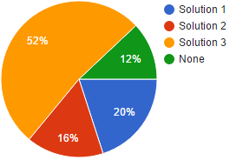

Fig 6. Analysis of amount of scrolling required

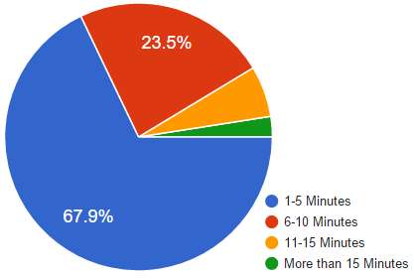

Fig 7. Analysis of time spent in scrolling

In our initial survey (refer fig. 7), we had observed that users on an average spend around 3 – 4 minutes in scrolling the web page for searching the referenced images. Hence, the focus of our extension was to reduce this time spent in scrolling. We tried to identify which of our solutions required maximum scrolling thereby gauging their efficiency. Consider fig 6. After providing the users with our three solutions and making them read infographic web pages of comparable complexity, it was found that 52% of users said that solution 3 required maximum scrolling in viewing images in the web page. 20% of users said that, solution 1 required maximum scrolling whereas 16% respondents found solution 2 to be the one with maximum scrolling requirement. 12% people were satisfied with all three solutions and decided to stay neutral on this.s

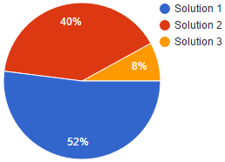

Fig 8. Comparison of the quality of solution

Finally when we asked the users which solution they liked the most, solution 1 emerged to be more acceptable solution. As seen in fig 8, 52% respondents voted in favor of solution 1 whereas 40% people said solution 2 was better. 8% people preferred solution 3. It can therefore be inferred that, solution 1 enjoyed the majority and was more effective in solving the readability issues.

# IMPROVISATION

Given below is the documentation of the steps followed, problems encountered, solutions developed and evaluated while following the Agile development cycle. The solution became matured and robust along the development. This list provides a summary of key improvements made in the functionality and performance.

## Solution 1: A sidebar with image thumbnails

**Issue 1: Sidebar positioning and Preview Images Size**

Initially, the sidebar was placed at the right bottom of the screen. This was not a design error or UI flaw but upon user interaction, we realized that the user were not so comfortable with this location. Also, the thumbnail image size was smaller. Margins were not proper and images were saturated.

**Fix:** We changed the location of the sidebar and moved to right center of the page. This was a more intuitive way for the user and it facilitated better retention of the context. We verified this by the difference in the console logs. We obtained a slight improvement in the time taken after changing the layout. We increased the thumbnail size after user review to 80px and increased the spacing between them in order to view them better.

**Issue 2: Navigation method**

The prototype of this solution had a different method of referring to the image when clicked on its thumbnail in the sidebar. When the user clicked on an image in the thumbnail, the screen would scroll to the original position of the image to get a detailed outlook. However, we noticed a flaw in this design through user responses that it sometimes was time intensive to return back to the original position and continue reading.

**Fix:** After careful review of the user feedbacks and brainstorming sessions, we devised a few possible solutions to tackle this problem. One of the solutions was to zoom the thumbnail image upon hovering over the image, but this would sometimes overlay over the reading material. Another solution included providing a “Go back” button on the sidebar through which the user could go back to the original reading material. We finally zeroed in on a solution wherein the page would scroll to the image location upon hovering over the thumbnail and scroll back to its original position after hovering away from the sidebar.

**Issue 3: Valid image extraction**

A webpage contains images many of which are logos, small thumbnails or other irrelevant images which do not form part of the reading material. We were faced with a task to disregard such images and only consider images which were relevant from readers point of view.

**Fix:** We developed a filter which would extract only relevant images and discount the others. We achieved this on the basis of original size of images. We only considered those images whose size was greater than a certain threshold.

**Issue 4: Dismiss sidebar**

Sometimes, the user felt that they would like to have control whether the sidebar should be visible at all. So they wanted a functionality to hide the sidebar when not needed.

**Fix:** We provided a “dismiss” button which enabled the user to dismiss the sidebar when they felt they did not need it. This could again be reverted by simply refreshing the page.

**Minor fixes:** Positioning the image such that it occupies the centerpage, spacing between thumbnails, adjusting sidebar width.

## Solution 2: Image pop-up on hover

**Issue 1: Image flickering**

In the early stages, the hover functionality was implemented such that the reference of the image was replaced in line with the original image. The problem here was that the image flickered whenever the user moved the mouse pointer. This would obstruct the extension from providing its core functionality.

**Fix:** We changed the CSS to fix this issue.

**Issue 2: Image pop-up**

In the early stages, the hover functionality was implemented such that the reference of the image was replaced in line with the original image. Although this would not require the user to scroll up to the reference of the image, it took away some concentration due to dynamic restructuring of the webpage. Also, the image would exceed the page’s length if the reference was made towards the bottom of the page.

**Fix:** We later devised a solution to keep the webpage intact and pop up the image when the user hovers over its reference. The popped up image overlaid the remaining web page and hence there was no dynamic restructuring of the web page. Thus the user had a seamless experience of reading through the material without having to worry about the changes in the structure. We modified the CSS in order to achieve the same.

**Issue 3: Text disorientation**

When the user hovered over the reference of an image, the sentence would break if the image reference was made in between the line. Thus, the sentence would get dispersed before and after the image which caused reading issues.

Fix: After providing the pop-up functionality, sentence remained intact to its original position thus solving the issue.

**Issue 4: Pattern matching**

One of the main issues was identifying the references made to an image to convert those references to hyperlinks. This was not always possible as few of the references would not exactly match the “alt text” within the <img> tag. For eg., alt text=Figure 1, while its reference may have fig 1. Such references should also be mapped to the original image.

Fix: We identified the nuances of the alt text which had occurred in the image and mapped all these nuances to the same image. Thus, Figure 1, fig 1, fig 1. Etc would all map to the same image.

## Solution 3: Open image in new tab

**Issue 1: Mapping issue**

**Fix:**

# FINAL FEEDBACK

After gathering the user feedback from the initial survey, the improvements suggested by the users were incorporated into the solutions. After fixing the problems, we presented the improvised solutions to the users. The responses of the users to this survey is as followed.

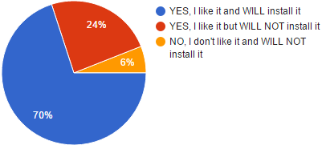

Fig 9. Feedback on whether users will use the extension

Any software is considered successful when it has a strong user base. Hence we asked the users whether they liked our idea of having a browser extension to solve the readability issue and whether they would want to have such an extension permanently installed in their browser. 70% of the respondents found this ‘extension’ an innovative and a useful one (refer fig 9). They appreciated this browser extension and said that they would like to have this installed in their browser.

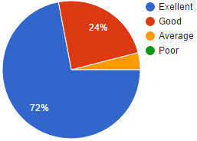

Fig 10. Rating for Solution 1

After incorporating the improvements suggested by the users, our primary goal was to improve the solutions to the level that the users are satisfied. When asked to rate the solution 1 we got the following responses (refer fig 10). 72% people provided ‘excellent’ rating to this solution. 24% said it was a good solution. It shows that, this solution is the most liked solution by the users and is also the most effective one.

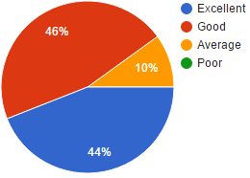

Fig 11. Rating for Solution 2

When asked to rate the solution 2 we got the following responses (refer fig 11). 44% people provided ‘excellent’ rating to this solution. 46% said it was a good solution. It’s evident from this feedback that even solution 2 is accepted by the users and is the second best solution.

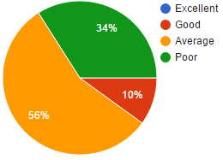

Fig 12. Rating for Solution 3

When asked to rate the solution 3 we got the following responses (refer fig 12). 56% people provided ‘average’ rating to this solution. 34% said it was a poor solution. It’s evident from this feedback that even solution 3 was turned down by the users and it clearly failed the user acceptance test.

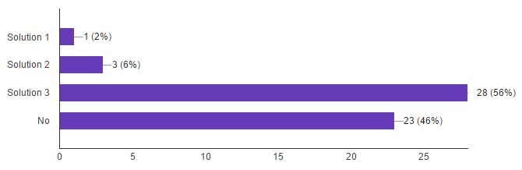

Fig 13. Analysis of whether users lost context with improved solutions

When asked, if they still lost context while using any of the solution, we got the following responses (refer fig 13). 56% people said, that they had problems with solution 3 as it did not seem to solve their readability issue. 23% of the people said they found all the solutions satisfactory. Only 6% people felt that solution 2 could be improved whereas only 2% said that solution 1 could have been better. Thus it can be inferred that, solution 1 and solution 2 are have passed the user acceptance testing and can be deployed.

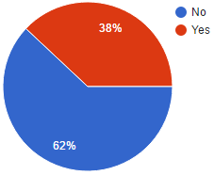

Fig 14. Tracking unsolved issues

When asked whether, they still faced any problems with any of the solutions which they previously encountered, 62% people responded that all the issues had been fixed (refer fig 14). However, 38% people felt that some loopholes still existed (refer fig 14). When asked, most of the problems faced were in solution 3 which the users found unsatisfactory.