AuditSmart
Audit Sampling, Journal-Entry Testing, VAT & Working-Paper Platform
Build Guide, Prompts & Project Plan – Firm Production Edition (UAE / IFRS / ISA)
Item | Details
Prepared for | Savio Jose – CLA Emirates
Primary purpose | Official internal audit tool for the firm, used daily on engagements
Secondary purpose | AICA Level 2 capstone – submitted at the MVP milestone
Build tools | Lovable (front end) • Google Antigravity (Python engine) • Google AI Studio (prompts) • GitHub
Production hosting | Azure UAE North (or firm servers) • Entra ID SSO • approved AI provider
Standards covered | ISA 200, 220, 230, 240, 265, 300, 315, 320, 330, 450, 500, 530 • ISQM 1 • IFRS • UAE VAT & Corporate Tax incl. FTA Decisions No. 13 and 17 of 2026
Version / date | v2.0 – 26 October 2026 (incorporates external review)

How to use this guide: Section 1 summarises what changed after the review. Sections 2–5 explain the design, the engine rules and the accuracy controls. Section 6 is your step-by-step task list with the exact prompts to paste. Section 7 is the plan, owners and risks. Appendices give the database schema, test data specification, go-live checklist and rule verification checklist. Text in {braces} must be replaced with your values.

Contents

1. What Changed in v2.0 (Review Response)
The external review confirmed the architecture and recommended changes to make AuditSmart a fully functional, user-friendly, official firm tool. All recommendations were accepted. Five further changes were added because the tool is now production-first.
Recommendation | Decision | Where in this guide
Implement every module end-to-end (VAT, evaluation, 9-sheet WP) | Accepted | 2.3, 3.2, Prompts 3.5–3.6, Definition of Done (6.0)
Row-level error messages with guidance; block on critical errors | Accepted | 3.7, Prompt 3.2, Lovable 4.1
Large files: chunked import, pagination, background jobs | Accepted | 3.6, Prompt 3.11, Lovable 4.6
Stale-result warnings; re-run required before sign-off | Accepted (strengthened: sign-off blocked) | 3.4, 3.5, Prompts 3.8, 3.10, Lovable 4.4–4.5
Consistent UX, mandatory contextual help, empty states | Accepted | 3.7, Lovable 4.1, 4.3
Intuitive Calendar and Rules screens | Accepted | Lovable 4.4, 4.5
Manager dashboard with alerts | Accepted | Lovable 4.1, page 2
UAE data residency, SSO/MFA, anonymiser tests | Accepted | 2.4, Stage 7
Tax-partner verification of seeded rules | Accepted | Appendix D
Add FTA Decisions No. 13 and 17 of 2026 | Accepted – verified on FTA site; new module M15 | 2.3, 3.8, Prompt 3.12
Schema appendix | Accepted | Appendix A
Stronger test data and golden workbook | Accepted | Appendix B, Prompt AI Studio 1.1
Sampling returns CF and formula; 'Not provided' rule; few-shot extraction | Accepted | Prompts 3.3, 2.1, 2.2
Training, pilot, annual review | Accepted | Stages 9–10
ADDED: Separate development and production environments | New | 2.4
ADDED: Formal tool validation file under ISQM 1 | New | 5.2, Stage 8
ADDED: Realistic timeline – MVP in 10 days, production over ~12 weeks | New | 7.1, Figure 4
ADDED: Definition of Done per module | New | 6.0
ADDED: Owners (RACI) for rules, calendars, tool changes | New | 7.3

2. Solution Design
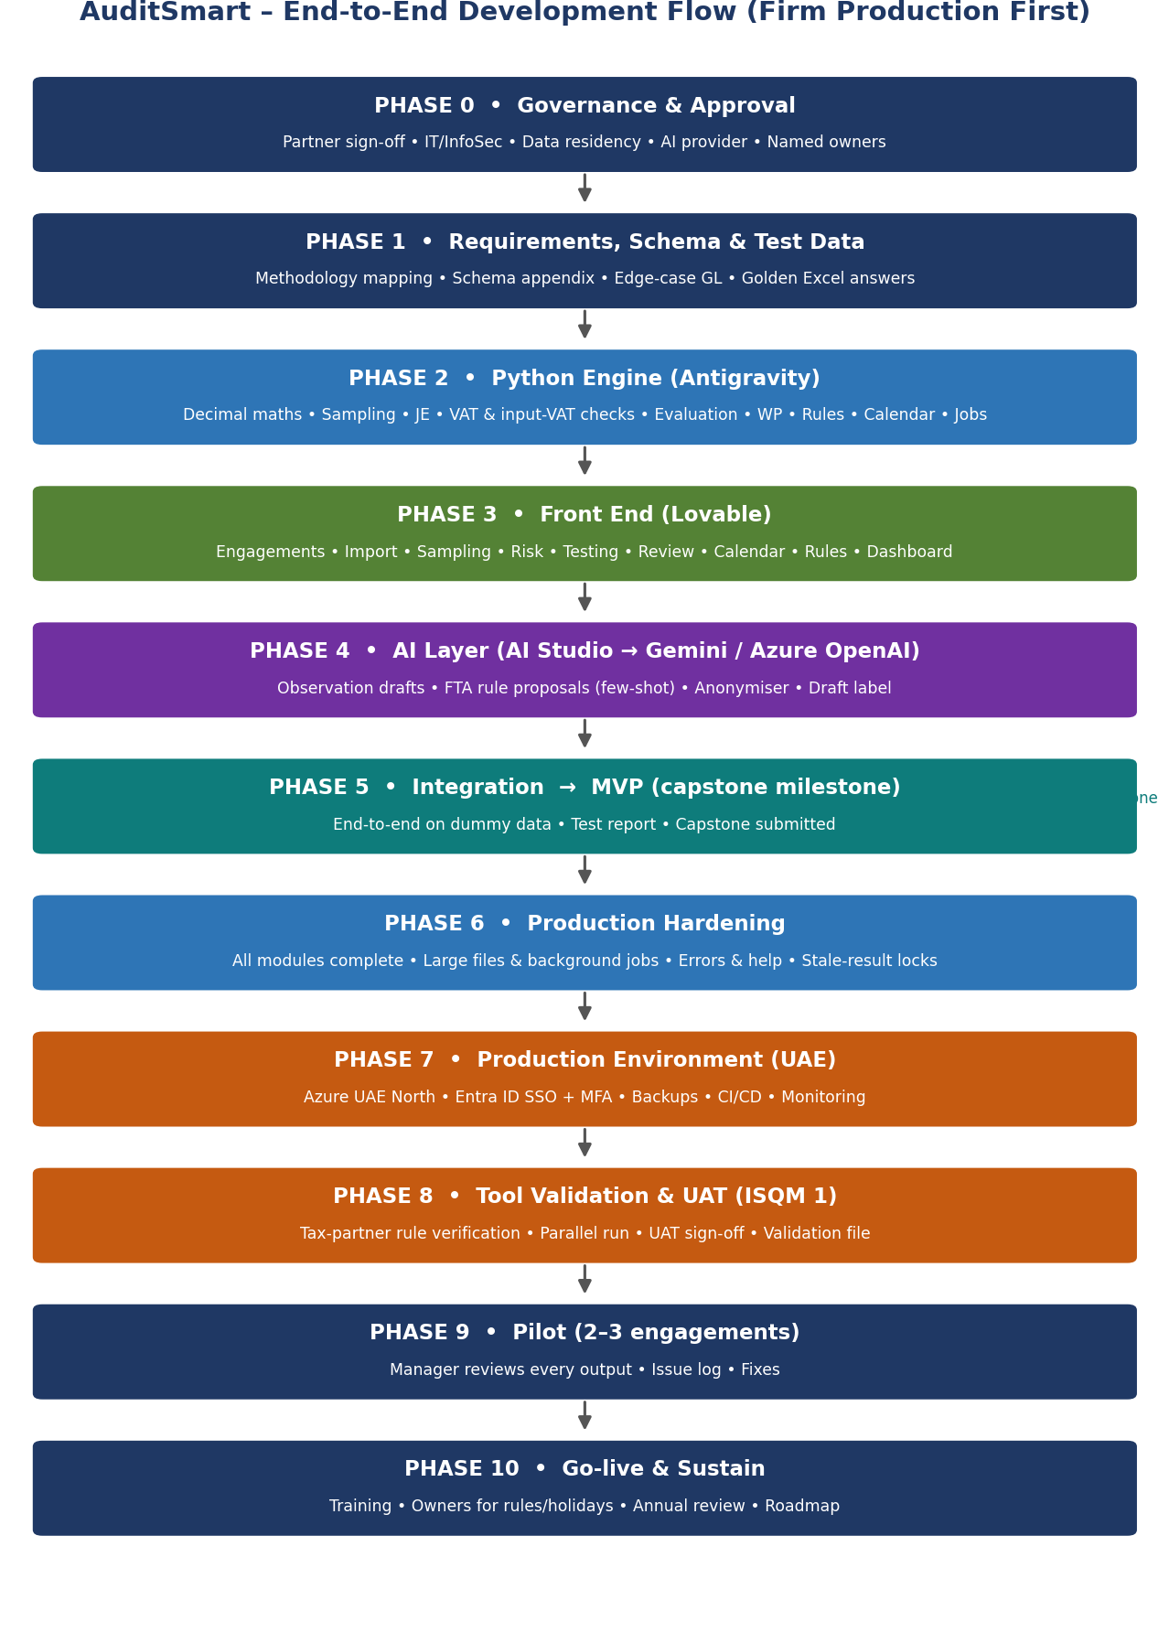
Figure 1 – End-to-end flow; capstone is a milestone, not the finish line

2.1 Hybrid build
- Front end (React, built in Lovable): every screen, workflow, sign-off and dashboard. Never calculates audit figures.
- Python engine (FastAPI, built with Antigravity): every number, rule look-up, calendar decision, working paper and background job. Fully unit-tested.
- AI model (Gemini in development; firm-approved provider in production): writes draft wording and proposes rule changes. Never calculates, selects samples or approves anything.
- Database and file storage: users, engagements, rules, calendars, results, evidence and an insert-only audit log.
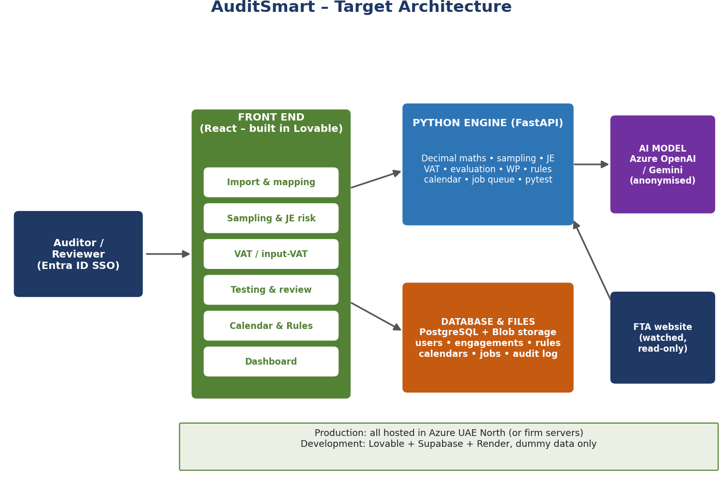
Figure 2 – Target architecture
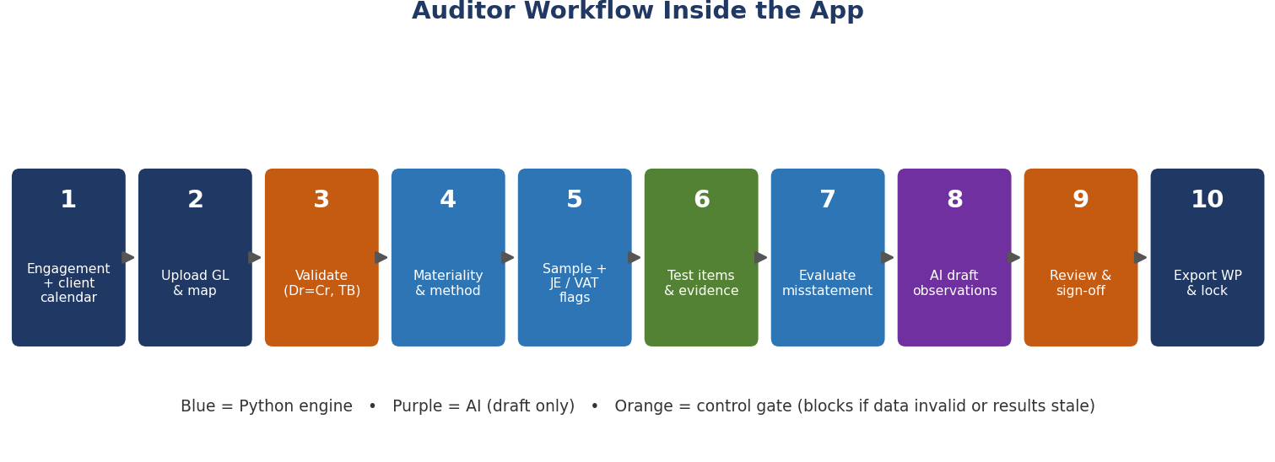
Figure 3 – Auditor workflow inside the app

2.2 Tool roles
Tool | Used for | Output
Lovable | Build screens by describing them; sync code to GitHub | React front end source
Google Antigravity | Agent IDE that writes, runs and tests the Python engine | FastAPI service + tests
Google AI Studio | Design and test AI prompts; model choice; dev API key | Approved system prompts
GitHub | Version control, pull requests, automated tests | Single source of truth
Azure (production) | Hosting in UAE North: app, engine, PostgreSQL, Blob storage, Key Vault, OpenAI | Firm environment
Excel | Independent golden calculations | Validation evidence
Power Automate / Teams | Reviewer and rule-alert notifications | Workflow messages

2.3 Modules
# | Module | What it does | Standard / law
M1 | Engagement set-up | Client code, emirate, period, framework, team, materiality | ISA 300, 320
M2 | Import & validation | CSV/XLSX GL + TB, mapping, row-level checks, file hash, large files | ISA 500
M3 | Population completeness | GL vs TB, Dr = Cr, voucher gaps, duplicates | ISA 500, 330
M4 | Sampling | MUS, random, systematic, stratified, key items; CF and formula shown | ISA 530
M5 | JE risk testing | Non-working days, round sums, period-end, users, narrations, Benford, duplicates | ISA 240
M6 | Testing grid | Attributes, evidence upload, exceptions | ISA 500, 330
M7 | Evaluation | MUS tainting + upper misstatement limit; non-MUS ratio | ISA 450, 530
M8 | Output VAT & TRN checks | Rate by code and date, tolerance, TRN format | UAE VAT law
M9 | AI drafting | Observation + ML point, draft label, review tick | ISA 265, 260
M10 | Working paper | 9-sheet Excel WP with sign-offs and rule/calendar versions | ISA 230
M11 | Review & audit trail | Sign-off, review notes, locking, insert-only log | ISA 220, 230
M12 | Dashboard | Engagement progress, exceptions, WPs awaiting review, overdue alerts | ISQM 1
M13 | Rules Library | Versioned rules, FTA monitor, approval workflow | UAE VAT & CT
M14 | Working Calendar | Federal, emirate, company work week, exceptions | ISA 240
M15 | Input-VAT recovery checks | Supplier verification (Decision 13/2026) and employee expenses (Decision 17/2026) | VAT Law Art. 54 bis; Exec. Reg. Art. 53
M16 | Administration | Users, roles, firm methodology settings, tool version, job monitor | ISQM 1

2.4 Development vs production environments
Lovable's built-in cloud services are convenient for building, but for client data the firm should control where data is stored. Before using Supabase or any vendor region for real data, confirm with IT where it is hosted. The recommended approach is to build in a development environment with dummy data, then deploy the same code from GitHub into the firm's UAE environment.
Layer | Development (build & capstone) | Production (firm use)
Front end | Lovable preview / Lovable hosting | Code exported via GitHub → Azure Static Web Apps or App Service (UAE North)
Engine | Local / Render free tier | Azure Container Apps or App Service (UAE North)
Database | Supabase (dummy data only) | Azure Database for PostgreSQL (UAE North)
Files / evidence | Supabase storage | Azure Blob Storage, encrypted, private
Login | Supabase email login | Microsoft Entra ID SSO with MFA, roles from security groups
Secrets | Environment variables | Azure Key Vault
AI | Gemini (AI Studio key) | Firm-approved provider and region, e.g., Azure OpenAI
Data | Synthetic only | Client data under firm policy
Design rule for Lovable: ask it to keep all database and auth calls behind one data-access layer (src/lib/data.ts) and one engine client (src/lib/engine.ts). That makes it easy to switch from Supabase to Azure PostgreSQL and Entra ID later without rewriting screens.

3. Python Engine Specifications
Save Sections 3, 4 and Appendices A–B as engine/SPEC.md. Antigravity reads it before every prompt.

3.1 Technology stack
Component | Specification
Language | Python 3.11+
API | FastAPI + Pydantic v2 (strict validation)
Money | decimal.Decimal everywhere (never float); ROUND_HALF_UP to 2 dp at presentation only
Data loading | pandas / pyarrow; chunked reading for large CSV; Parquet cache per dataset
Randomness | numpy.random.default_rng(seed); seed always stored and returned
Excel | openpyxl
Statistics | scipy (chi-square); MAD for Benford
Database | PostgreSQL via SQLAlchemy 2 + Alembic migrations
Background jobs | Job table + worker (RQ/Celery with Redis, or Azure-native queue); progress %, cancel, retry
Testing | pytest + hypothesis; ≥ 90% coverage on services/; golden and edge-case suites
Quality | ruff, mypy (strict on services/), pre-commit; GitHub Actions blocks merge on failure
Security | JWT from Entra ID / Supabase validated on every call; role checks; CORS whitelist; no ledger rows or party names in logs
Deployment | Docker image; same image in dev and production

3.2 Calculation rules
Calculation | Exact rule
Population | Absolute or signed amounts per user choice; zero lines excluded; count and value recorded; blocked if Dr ≠ Cr beyond tolerance from Rules Library
Confidence factors | From Rules Library (SAMPLING domain). Typical 0-error values: 80% 1.61, 90% 2.31, 95% 3.00, 99% 4.61 – to be confirmed against firm methodology
MUS sample size | n = ceil(Population × CF ÷ Tolerable misstatement); interval J = Population ÷ n. Response returns CF used, rule version and the formula with values substituted
MUS selection | Random start in [0, J) from seed; item selected when cumulative value first ≥ start + k·J; items ≥ J are top stratum, tested 100%
Credit / negative lines | Excluded from MUS on debit-side populations, listed separately for consideration; never silently dropped
Random / systematic | Without replacement; systematic = random start + fixed count interval
Stratified | User or quantile strata; value-proportional allocation; minimum 1 per stratum
Key items | Items ≥ threshold removed and tested 100% before sampling the remainder
Projection (MUS) | Tainting = misstatement ÷ book value; projected = tainting × J for items < J; actual for top stratum
Upper misstatement limit | Basic precision (CF × J) + projected misstatement + incremental allowance using ranked taintings and incremental factors from Rules Library
Projection (non-MUS) | Ratio estimation: (misstatement in sample ÷ sample value) × population value
Benford | First digit, amounts ≥ 10; chi-square and MAD; thresholds in Rules Library
Non-working day | Resolved from the engagement's Working Calendar (3.5) for the posting date; never hard-coded
Round sums / period-end / users / narrations | Parameters in firm methodology settings; defaults: multiple of 1,000 and ≥ 10,000; ±5 days; users < 1% of entries; keyword list
Output VAT | Rate per VAT code and tolerance from rule version valid on invoice date; TRN format pattern from Rules Library
Input VAT (M15) | See 3.8; thresholds, effective dates and categories from Rules Library
Duplicates | Same party + amount + date; same invoice number + party

3.3 API endpoints
Endpoint | Purpose
POST /v1/datasets (async) | Upload GL/TB → job id; mapping suggestion, profile, SHA-256
POST /v1/datasets/{id}/validate | Row-level checks; returns errors with row numbers and guidance
GET /v1/datasets/{id}/rows | Paginated, filterable rows
POST /v1/sample | Sampling; returns sample, CF, formula, seed, rule versions
POST /v1/je-tests (async) | Risk tests with calendar; per-line flags, summary, calendar hash
POST /v1/benford | Distribution, chi-square, MAD, conclusion
POST /v1/vat-check | Output VAT and TRN checks
POST /v1/input-vat-check | Decision 13 supplier verification and Decision 17 employee-expense checks
POST /v1/evaluate | Projection and upper limit vs tolerable misstatement
POST /v1/workpaper | 9-sheet Excel; refused if any result is stale or unreviewed
POST /v1/ai/observation | Anonymise → AI → validated JSON draft
/v1/rules, /v1/rules/monitor | Rule look-up, proposals, approvals, FTA monitor
/v1/calendar/* | Resolve engagement calendar; import/export
GET /v1/jobs/{id} | Job status, progress %, result link, errors
GET /v1/health | Version, database and queue status

3.4 Regulatory Rules Library
The FTA publishes laws, decisions and clarifications on its website but does not, as far as I am aware, provide a data feed for rules. The tool therefore watches the website, AI proposes changes, and the Tax Partner approves them. Rules carry effective dates so earlier periods are tested under the rules that applied then.
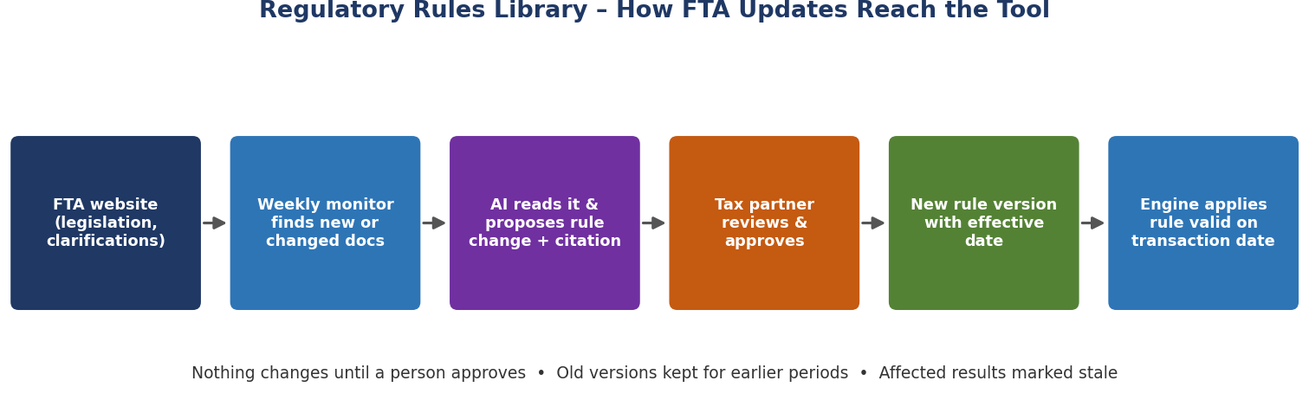
Figure 5 – How FTA changes reach the tool
Element | Specification
Domains | VAT, INPUT_VAT, CT, TRN, SAMPLING, BENFORD, LEGAL_REF
Versioning | effective_from / effective_to; no overlapping approved versions; approved versions immutable
Watched sources | Seeded with FTA legislation page, public clarifications, guides, and specifically: FTA Decision No. 13 of 2026, FTA Decision No. 17 of 2026, VAT Public Clarification VATP046, amended VAT Executive Regulation
Monitor | Weekly + 'Check now'; respectful fetching; manual PDF upload mode
AI proposal | Few-shot extraction prompt (2.2) → JSON proposal with citation → status 'proposed'
Approval | Tax Partner or Admin; mandatory comment; side-by-side old vs new
Stale results | When a rule version used by a result is superseded for the same period, the result is marked STALE; WP sign-off and export are blocked until re-run or the reviewer records a justified override

3.5 Working Calendar
Non-working days differ by emirate and employer (one, two or three days off; half days; historical weekend changes such as Fri/Sat to Sat/Sun from 1 January 2022). Users maintain this through screens; the engine never assumes a weekend.
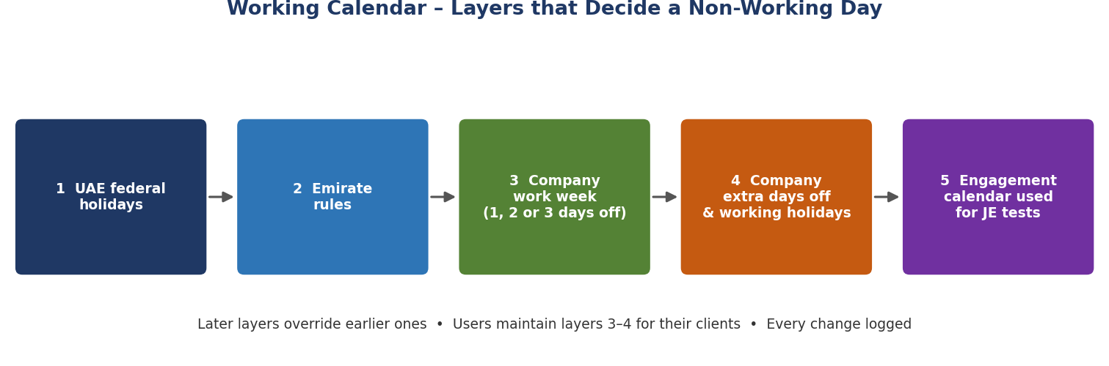
Figure 6 – Calendar layers
Layer | Detail
1 Federal holidays | Admin; yearly list; Islamic holidays 'Provisional' until announced
2 Emirate profile | Admin; emirate-specific weekend or holidays
3 Company work week | Manager/Senior; off-days Mon–Sun, half-day cut-off times, dated periods (non-overlapping)
4 Company exceptions | Extra closures or working holidays
5 Engagement calendar | Resolved automatically; month preview; hash stored with JE results and printed in WP
Stale results | Any change to layers 1–4 affecting the audit period marks JE results STALE (same blocking rule as 3.4)

3.6 Large data and background jobs
- Upload: chunked/resumable upload; default limit 500 MB (configurable); stored in private storage, not in the browser.
- Processing: chunked parsing into Parquet; validation, JE tests and Benford run as background jobs with progress %, cancel and retry.
- Screens: server-side pagination, filtering and sorting; exports generated as jobs for large tables.
- Performance target: 1 million GL lines imported and JE-tested in under 10 minutes on production sizing (to be confirmed in UAT).

3.7 User experience and error standards
Standard | Requirement
Formatting | AED 1,234,567.89, right-aligned; dates dd-MMM-yyyy; navy/white theme; sortable, filterable tables with CSV/Excel export
Error messages | Say what, where and what to do, e.g. 'Debits exceed credits by AED 0.05 – check voucher JV-0142 (rows 142, 387).' Critical errors block the next step; warnings allow continue with a reason
Help | Every tab has a Help panel: purpose, ISA reference, two-line plain-language guide
Empty states | Explain the next step ('Upload a ledger to start') with a button
Stale banner | Amber banner with 'Re-run' button and list of what changed
Confirmation | Destructive actions (delete, unlock) require confirmation and reason
Accessibility | Keyboard navigation, readable contrast, no information by colour alone

3.8 Input-VAT recovery checks (M15)
FTA Decision No. 13 of 2026 (issued 22 July 2026, effective 1 October 2026) requires taxable persons to verify suppliers and supplies before deducting input tax, under Article 54 (bis) of the VAT Law. FTA Decision No. 17 of 2026 (issued 9 September 2026, effective 1 October 2026) sets six cases and conditions for recovering input tax on employee expenses: transport, food and beverages, accommodation, temporary accommodation for new employees, mobile/internet and parking. For audit clients, these create new exposure areas worth testing.
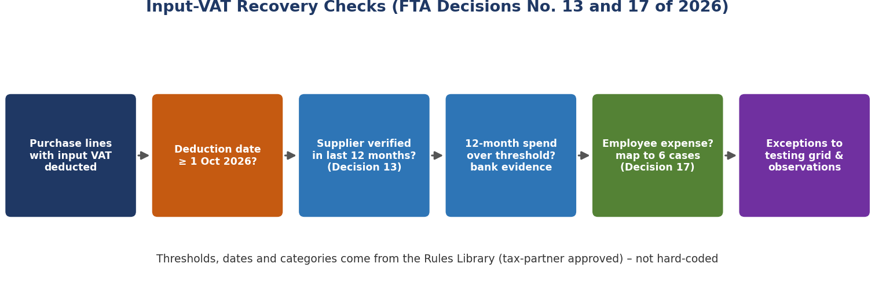
Figure 7 – Input-VAT checks
Check | How the engine supports it
Scope | Purchase lines where input VAT is deducted on or after the effective date in the Rules Library
Supplier verification register | Lists suppliers with deductions; client's verification date and evidence reference imported or entered; flags first-time suppliers and suppliers not verified within the period set in the Rules Library
Spend threshold | Rolling 12-month spend per supplier; flags suppliers above the threshold in the Rules Library needing bank-account evidence and public-information review
Risk indicators | Fields for address/key-staff changes and disproportionate transactions; requires a written explanation where indicated
Employee expenses | Auditor maps expense accounts to the six Decision 17 categories; lines in mapped accounts listed for condition testing (all conditions per category must be met); unmapped staff-cost accounts flagged
Output | Exceptions flow to the testing grid, observations and WP sheet 'Input VAT'
Limits | The tool supports testing; whether conditions are met remains an auditor/tax judgement. All thresholds and conditions to be verified by the Tax Partner before go-live

4. Security and Data Protection
Control | Requirement
Data residency | Production data, backups and logs in the UAE (Azure UAE North or firm servers)
Identity | Entra ID SSO, MFA, role mapping from security groups; no shared accounts
Authorisation | Engagement membership checked on every API call and in database row-level security
AI payload | Only anonymised fields; unit test fails if TRN, party, client name, email, phone or IBAN reaches the payload
Encryption | TLS in transit; encryption at rest; private storage for evidence
Logging | No ledger rows or party names; insert-only audit log for user actions
Backups & retention | Daily backups, tested restore quarterly, retention aligned with firm and legal requirements
Change control | Pull requests, automated tests, reviewer approval, release notes, version printed on every WP
Vendor review | IT to review Lovable, AI provider and hosting terms before production

5. Reliability and Tool Validation
No software can guarantee correct audit conclusions. AuditSmart aims for calculations that are exact and reproducible against independent checks, AI kept out of all numbers and approvals, and every output reviewed by a qualified auditor.

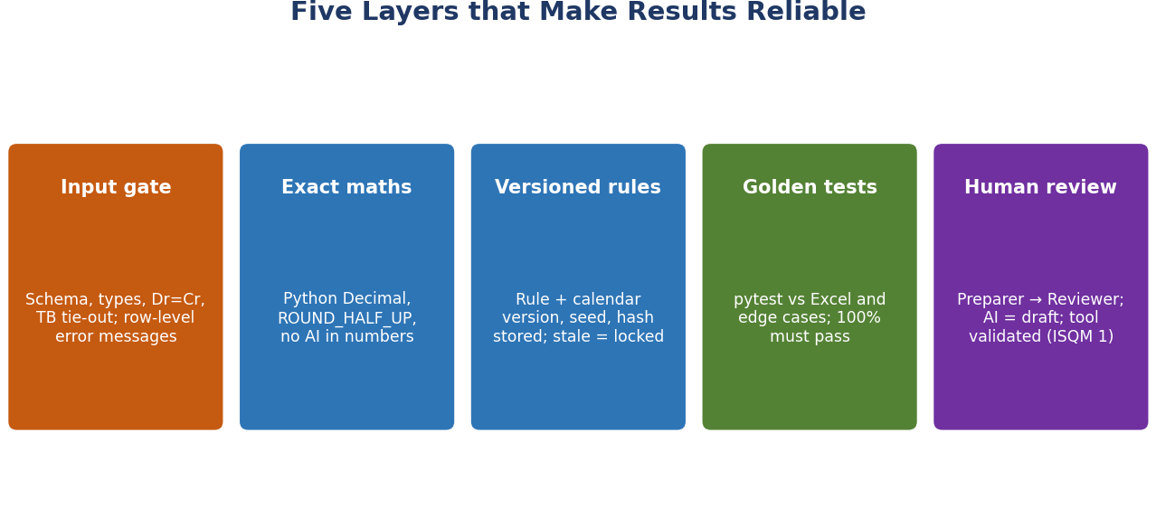
Figure 8 – Five layers of control

5.1 Controls
Control | How
Golden tests | Engine output vs Excel workbook to the fils; mismatch blocks release
Edge-case suite | Appendix B file: top stratum, credit notes, unbalanced vouchers, bad dates, weekend change, half days, invalid TRNs
Property tests | Same seed = same sample; sample ⊆ population; strata sum to population
Reproducibility record | File hash, seed, rule versions, calendar hash, engine version, user, time
Stale-result lock | Sign-off and export blocked when rules or calendars change after a run
Parallel run | Re-perform a closed engagement area; partner accepts differences

5.2 Tool validation file (ISQM 1)
Because the firm will rely on AuditSmart in performing engagements, keep a validation file that the quality management function can review:
- Scope and intended use statement (what the tool does and does not do).
- Methodology mapping to ISA requirements and firm manual.
- Test report (unit, golden, edge-case, security) for the release.
- Parallel-run comparison and partner acceptance.
- Rules Library verification checklist signed by the Tax Partner (Appendix D).
- UAT sign-off by preparers and reviewers.
- Known limitations and user guidance.
- Change log; re-validation required for any change to calculation services.

6. Step-by-Step Tasks and Prompts
Follow the stages in order. Each stage shows what to do, the prompt to paste and the check before moving on. Stages 0–6 deliver the MVP (capstone milestone); Stages 7–10 make it an official firm tool.

6.0 Definition of Done (applies to every module)
- Works end-to-end from the screen to the engine and back, with real (dummy) data.
- Calculations pass golden and edge-case tests; coverage ≥ 90% on the service.
- Errors are row-level, actionable, and block progress where critical.
- Help panel, empty state and export are present.
- Results store seed/hash/rule versions/calendar hash as relevant and appear in the WP.
- Audit log entries are written; role permissions tested.
- Reviewed in a pull request and documented in the user guide.
Stage | Focus | Main tool | Track
0 | Governance & set-up | Email, browser | Both
1 | Requirements, schema, test data | AI Studio, Excel | Both
2 | AI prompts | AI Studio | Both
3 | Python engine | Antigravity | Both
4 | Front end | Lovable | Both
5 | Integration | Antigravity, Lovable | Both
6 | Testing & capstone | Antigravity, GitHub | MVP
7 | Production environment | Azure, IT | Firm
8 | Validation & UAT | Team, Tax Partner | Firm
9 | Pilot | Engagement teams | Firm
10 | Go-live & sustain | Teams, SharePoint | Firm

Stage 0 – Governance and set-up
- Email the assurance partner and IT (prompt 0.1) to approve: purpose, UAE hosting, AI provider, data policy, owners.
- Create accounts: GitHub (organisation repo, private), Lovable, Google AI Studio; install Antigravity, Python 3.11, Git.
- Create folders auditsmart/engine, /data, /docs, /prompts.
- Check: approval request sent; accounts ready.
PROMPT – AI STUDIO | 0.1 Approval email
Draft a concise email from an audit manager at a UAE audit firm to the assurance
partner and IT head requesting approval to build "AuditSmart", an internal tool for
audit sampling, journal-entry testing, VAT checks and working papers, intended for
official firm use. Cover: development with synthetic data only; production hosting in
a UAE region with Entra ID SSO; AI used only for draft wording and rule-change
proposals from anonymised data; human approval of all rules and outputs; tool
validation under ISQM 1; parallel run and pilot before go-live; owners needed for
the rules library and calendars. Ask for approval and a 30-minute meeting. Under 220 words.

Stage 1 – Requirements, schema and test data
- Collect the firm's audit manual sections on sampling, JE testing and documentation; note confidence levels, materiality and WP referencing.
- Copy Appendix A into engine/SPEC.md (schema) and Appendix B (test data spec).
- Run Prompt 1.1 in AI Studio; save the script as data/make_gl.py and run it to produce dummy_gl.csv, edge_cases.csv, answer_key.csv.
- Build golden_results.xlsx per Appendix B (two confidence levels, one worked projection, expected calendar flags).
- Check: Dr = Cr on the main file; edge-case file fails validation in the expected ways.
PROMPT – AI STUDIO | 1.1 Synthetic ledgers and answer key
Write a Python script (seed 2025) producing three CSV files for a UAE trading company,
FY 1 Jan 2025 - 31 Dec 2025, and a second FY 2021-2022 extract for weekend-change tests.
1) dummy_gl.csv - 3,000 lines, multi-line balanced vouchers. Columns: line_id,
entry_date, posting_date, posting_time, voucher_no, account_code, account_name,
account_type, debit, credit, currency, narration, user_id, party_id, party_name, trn,
invoice_no, net_amount, vat_amount, vat_code (SR/ZR/EX/RC), expense_category.
Realistic UAE accounts (Emirates NBD, DEWA, rent Dubai, salaries WPS, staff transport,
staff accommodation, mobile, parking, VAT payable/receivable).
Include: 8 items larger than a typical MUS interval (top stratum); 40 credit-note lines;
company work week Sat/Sun off with Friday half day to 12:00.
Plant and record in answer_key.csv (line_id, error_type): 25 Sat/Sun postings,
10 Friday postings after 15:00, 15 public-holiday postings (from a provided list),
20 round sums (multiples of 10,000), 15 entries within 3 days of year-end by "FINMGR",
10 vague/blank narrations, 10 duplicate invoices, 12 output-VAT errors, 5 invalid TRNs,
15 purchases after 1 Oct 2025 from suppliers with no verification date,
3 suppliers whose rolling 12-month spend exceeds AED 375,000,
20 employee-expense lines in categories transport/food/accommodation/mobile/parking.
2) edge_cases.csv - 60 lines: 2 unbalanced vouchers, 5 unreadable dates, amounts with
commas and brackets, blank accounts, duplicate line_ids, 15-digit and 14-digit TRNs.
3) fy2021_2022.csv - 400 lines spanning 1 Dec 2021 - 31 Jan 2022 with postings on
Fridays and Sundays to test a Fri/Sat -> Sat/Sun weekend change on 1 Jan 2022.

Stage 2 – AI prompts in Google AI Studio
- Create Prompt → choose a current Gemini model, temperature 0.2, JSON output.
- Paste 2.1; test with three exceptions including one with missing fields. Save as prompts/observation_system_prompt.txt.
- Paste 2.2; test with text from FTA Decision No. 17 of 2026 and from an unrelated FTA page (should return no changes). Save as prompts/rule_extraction_prompt.txt.
- Get a development API key; store it in a password manager only.
- Check: no invented facts; schema always valid; draft label present.
PROMPT – AI STUDIO | 2.1 Observation writer (system instruction)
ROLE: Audit senior in a UAE audit firm applying ISA and IFRS.
TASK: Draft an audit observation from the JSON provided.
RULES:
1. Use only facts present in the JSON. Never invent amounts, dates, names or causes.
2. If a field is missing write "Not provided". If cause is missing write
"Cause: To be confirmed with management."
3. Cite only references listed in "applicable_references" (from the approved
Rules Library). Do not add other laws or standards.
4. Headings: Condition, Criteria, Cause, Effect, Recommendation,
Management Letter Point, Working Paper Conclusion.
5. Neutral professional British English, under 220 words.
6. End with "Draft - generated with AI, subject to auditor review."
OUTPUT: JSON {condition, criteria, cause, effect, recommendation, ml_point,
wp_conclusion}.

PROMPT – AI STUDIO | 2.2 FTA rule extraction (system instruction, few-shot)
ROLE: You help a UAE tax partner keep an audit tool's rule library current.
INPUT: current_rules (JSON) and document_text with document_url.
TASK: Propose changes ONLY for these rule keys: vat.rate.*, vat.codes, trn.pattern,
input_vat.verification.*, input_vat.employee_expense.*, ct.rate.*, ct.threshold.*,
legal_ref.*. Ignore everything else.
RULES:
1. Every change must cite document name and article/clause/page.
2. Do not guess effective dates; use null if not stated.
3. If nothing relevant changes, return {"summary":"No relevant change","changes":[]}.
4. Output JSON only, exactly this schema:
{"summary":str,"changes":[{"rule_key":str,"current_value":any,"proposed_value":any,
"effective_date":"YYYY-MM-DD"|null,"citation":str,"confidence":"high|medium|low"}]}
5. You only propose. A human approves.
EXAMPLE INPUT (abridged): current_rules {"input_vat.verification.revalidate_months":null}
document_text "...supplier verification must be performed ... where the supplier has
not been verified during the previous 12 months ... This Decision shall come into
effect from 1 October 2026..." document_url "https://tax.gov.ae/..."
EXAMPLE OUTPUT:
{"summary":"Sets supplier re-verification period","changes":[{"rule_key":
"input_vat.verification.revalidate_months","current_value":null,"proposed_value":12,
"effective_date":"2026-10-01","citation":"FTA Decision No. 13 of 2026, supplier
verification clause","confidence":"high"}]}

Stage 3 – Python engine in Antigravity
- Open engine/ in Antigravity; ensure SPEC.md is complete.
- Run prompts 3.1 → 3.12 in order; review each plan before approving.
- After each prompt: run tests, read the summary, commit with a clear message.
- Check: all tests pass; /docs shows every endpoint; detection table 100%.
PROMPT – ANTIGRAVITY | 3.1 Scaffold
Read SPEC.md fully. Create a production-grade FastAPI project "auditsmart-engine":
app/main.py, app/api/v1/, app/core/(config, security, logging, db), app/services/
(importer, validation, sampling, je_tests, benford, vat, input_vat, evaluation,
workpaper, anonymiser, rules, rules_monitor, calendar, jobs), app/models/(SQLAlchemy),
app/schemas/(Pydantic), alembic/, tests/(unit, golden, edge, security), seed_data/.
Decimal for all money; mypy strict on services; ruff; pre-commit; pinned requirements;
Dockerfile; .env.example (DATABASE_URL, REDIS_URL, AUTH_ISSUER, AUTH_AUDIENCE,
ALLOWED_ORIGINS, AI_PROVIDER, AI_MODEL, STORAGE_URL). JWT validation supporting both
Supabase and Microsoft Entra ID via config. Role and engagement-membership checks as
reusable dependencies. Structured logging that never includes ledger rows or party
names. GET /v1/health with version, db and queue status. GitHub Actions running ruff,
mypy, pytest. Create, install, run tests, show results.

PROMPT – ANTIGRAVITY | 3.2 Import and validation
Implement importer and validation services with async endpoints per SPEC 3.3:
chunked upload to storage; SHA-256; parse to Parquet in chunks; header-synonym
mapping with override; dd/mm/yyyy, ISO and Excel serial dates; amounts with commas,
brackets, trailing minus. Checks: Dr = Cr per voucher and in total (tolerance from
rules), missing mandatory fields, bad dates, duplicate line_ids, voucher gaps,
optional GL vs TB per account. Each error: severity (critical/warning), row numbers
(first 50 + count), field, message in plain English with guidance, e.g. "Voucher
JV-0142 is out of balance by AED 0.05 (rows 142, 387). Correct the source file or
exclude the voucher with a reason." Block downstream endpoints while critical errors
exist. Tests using edge_cases.csv must produce each expected error.

PROMPT – ANTIGRAVITY | 3.3 Sampling (ISA 530)
Implement sampling per SPEC 3.2: MUS, simple random, systematic, stratified,
key items + MUS. Get confidence factors from rules.get_rule("sampling.mus.cf.<level>",
period_end). Response must include: method, parameters, cf_value, cf_rule_version,
formula_text with values substituted (e.g. "n = ceil(12,500,000.00 x 3.00 /
450,000.00) = 84; J = 148,809.52"), seed, top-stratum items, credit lines excluded
(listed), rationale paragraph for the WP, engine_version, dataset hash.
Tests: identical sample for same seed; subset; golden values at 90% and 95% to 0.01;
top stratum from test data selected 100%; hypothesis tests for strata totals.

PROMPT – ANTIGRAVITY | 3.4 JE tests (ISA 240) and Benford
Implement je_tests (background job) and benford. Non-working day via
calendar.resolve(engagement) - never hard-code weekends or holidays; also flag
postings after half-day cut-off. Other tests per SPEC 3.2 with parameters from firm
methodology settings. Return per-line flags, risk score, summary, calendar_hash.
Benford: first digit, amounts >= 10, chi-square, MAD, thresholds from rules,
conclusion, chart data. Detection test against answer_key.csv and fy2021_2022.csv
(weekend change) - print planted vs detected per test; must be 100%.

PROMPT – ANTIGRAVITY | 3.5 Output VAT and evaluation (ISA 450)
vat service: for each line get rule version valid on invoice date (rate by code,
tolerance, TRN pattern); expected VAT = net x rate, HALF_UP 2dp; flag variances >
tolerance; TRN format; summary by code; return rule_versions_used.
evaluation service: MUS - tainting per item, projection for items < J, actual for top
stratum, basic precision, incremental allowance (ranked taintings x incremental
factors from rules), upper misstatement limit vs tolerable misstatement, conclusion.
Non-MUS - ratio projection. Include one fully hand-worked example in tests matching
golden_results.xlsx sheet "Projection" exactly.

PROMPT – ANTIGRAVITY | 3.6 Working paper (ISA 230)
workpaper service, openpyxl, sheets: Lead; Population; Sampling (incl. CF, formula,
seed); Sample & Testing (Yes/No/N/A validation lists, audited value, misstatement,
evidence ref); JE Risk (with calendar version/hash); Benford (native chart);
Evaluation; Input VAT; AI Drafts (marked draft, with reviewer tick status);
Rules & Calendar (all rule versions with source URLs, calendar layers used);
Sign-offs (preparer, reviewer, dates, tool version). Professional format, frozen
panes, print setup, footer with WP ref and page numbers. Refuse generation if any
included result is STALE or any AI draft is unreviewed. Test opens file and checks
every sheet and key cell.

PROMPT – ANTIGRAVITY | 3.7 Anonymiser and AI gateway
anonymiser: build AI payload only from whitelisted fields (area, test, item_ref,
amounts, failed attribute, applicable_references, auditor remark scrubbed of names,
TRNs, emails, phones, IBANs, Emirates ID numbers). Provider adapter (Gemini, Azure
OpenAI) selected by AI_PROVIDER; temperature 0.2; JSON output validated by Pydantic;
one retry; draft label appended; store prompt version and model in the result.
Security test fails if any party name, client name or TRN from test data appears in
any payload.

PROMPT – ANTIGRAVITY | 3.8 Rules Library
rules service per SPEC 3.4 and Appendix A tables rule_versions and watched_sources.
get_rule(key, on_date) returns exactly one approved version or raises a clear error.
approve() closes the prior version, makes the new one immutable, writes audit_log,
and marks STALE every stored result whose rule_versions_used includes a superseded
version for an overlapping period. Seed seed_data/rules_seed.json with status
"pending_verification" for: VAT rates/codes, TRN pattern, input_vat verification
period, spend threshold and effective date, employee-expense categories, CT rate and
threshold, MUS factors, Benford thresholds, legal references with source URLs.
Tests: version by date; overlap rejected; immutability; stale marking.

PROMPT – ANTIGRAVITY | 3.9 FTA monitor
rules_monitor per SPEC 3.4: watched_sources seeded with FTA legislation and
clarification pages plus FTA Decision No. 13 of 2026, FTA Decision No. 17 of 2026,
VATP046 and the VAT Executive Regulation pages (admin editable). Polite fetching
(identified User-Agent, robots.txt, rate limit, timeout; no logins). Extract text
(BeautifulSoup / pdfplumber), hash, snapshot, detect new document links. For changes,
call AI with prompts/rule_extraction_prompt.txt; validate; save as "proposed".
Manual PDF upload endpoint. Weekly schedule + check-now. Notify admins (email /
Teams webhook). Monitor failures create an alert too. Tests use saved fixtures only.

PROMPT – ANTIGRAVITY | 3.10 Working Calendar
calendar service per SPEC 3.5 and Appendix A. resolve(client, emirate, start, end)
returns each date with is_working, reason, half_day_cutoff; precedence company
exception > company work week > emirate > federal. Validation of non-overlapping
periods. Excel template import/export with error preview. Asia/Dubai time
conversion. Any change affecting a period marks related JE results STALE.
Tests: 1, 2 and 3 off-days; Friday half-day 12:00; Fri/Sat to Sat/Sun on
1 Jan 2022 using fy2021_2022.csv; working-holiday exception; provisional holiday.

PROMPT – ANTIGRAVITY | 3.11 Background jobs and large files
jobs service: job table (id, type, engagement_id, status queued/running/succeeded/
failed/cancelled, progress, started_at, finished_at, error, result_ref). Worker
using RQ (Redis) behind an interface so Azure queues can replace it. Make import,
validate, je_tests, input_vat_check and large exports run as jobs with progress
updates. Paginated row endpoints with filters. Performance test generating 1,000,000
lines; report import and JE timings in docs/PERFORMANCE.md.

PROMPT – ANTIGRAVITY | 3.12 Input-VAT checks (FTA Decisions 13 and 17 of 2026)
input_vat service per SPEC 3.8 (background job). Inputs: purchase lines, supplier
verification register (supplier_id, verified_on, evidence_ref, risk_indicators,
explanation, bank_evidence_ref), employee-expense account mapping to the six
categories. All dates, periods and thresholds from rules (input_vat.*) valid on the
deduction date. Flags: deduction on/after effective date with no verification or
verification older than the rule period; rolling 12-month spend above threshold
without bank evidence; risk indicator without explanation; employee-expense lines by
category for condition testing; staff-cost accounts not mapped. Output exceptions for
testing grid and WP sheet "Input VAT". Tests against answer_key.csv.

Stage 4 – Front end in Lovable
- New project → paste 4.1 (master prompt).
- Then 4.2 (data), 4.3 (UX standards), 4.4 (calendar), 4.5 (rules), 4.6 (jobs & dashboard), 4.7 (input VAT).
- Connect GitHub so every change is versioned.
- Check each page against Definition of Done (6.0).
PROMPT – LOVABLE | 4.1 MASTER BUILD PROMPT
Build "AuditSmart", an official internal web application for a UAE audit firm,
covering sampling (ISA 530), journal-entry testing (ISA 240), VAT and input-VAT
checks, evaluation (ISA 450), working papers (ISA 230) and review (ISA 220).
ARCHITECTURE (must follow):
- No audit calculations in the front end. All calls go through src/lib/engine.ts to
a Python API (VITE_ENGINE_URL). Long operations return a job id: poll /v1/jobs.
- All database/auth access goes through src/lib/data.ts and src/lib/auth.ts so the
backend can later move from Supabase to Azure PostgreSQL and Microsoft Entra ID.
- Use mock responses until the engine URL is set.
DESIGN: navy #1F3864, white, accent #2E75B6; Inter; left sidebar; breadcrumbs;
AED 1,234,567.89 right-aligned; dates dd-MMM-yyyy; server-side paginated tables with
sort, filter, CSV/Excel export; status badges; Help panel on every tab (purpose, ISA
reference, 2-line guide); helpful empty states.
ROLES: Admin, Tax Partner, Partner, Manager (Reviewer), Senior/Staff (Preparer).
PAGES:
1 Login. 2 Dashboard: my engagements with progress, open exceptions, WPs awaiting
review, STALE results, rule alerts and calendar items overdue (red after 7 days).
3 Engagements + New engagement (client code, client name - never sent to AI,
emirate, mainland/free zone, FYE, framework IFRS/IFRS for SMEs, materiality,
performance materiality, trivial threshold, team).
4 Engagement workspace tabs: Data Import (upload with progress, mapping, profile,
row-level errors, block on critical) | Sampling (method, confidence, TM, expected
misstatement, key items, seed; shows CF, formula, rationale, top stratum) |
JE Risk (tests, flags table, risk score, Benford chart, calendar used) | VAT |
Input VAT | Testing Grid (Yes/No/N/A, audited value, remarks, evidence upload) |
Evaluation (green/amber/red conclusion) | Observations (Draft with AI, edit,
mandatory "I have reviewed and edited") | Working Paper (preview, sign-offs,
download - disabled with explanation if anything is STALE or unreviewed).
5 Review Queue: notes, return, approve; approved WPs locked.
6 Working Calendar. 7 Rules Library. 8 Jobs monitor. 9 Audit Trail.
10 Admin: users/roles, firm methodology settings, tool version.
STALE: amber banner on any result whose rule or calendar changed, listing what
changed, with Re-run button.
Footer: "Calculations by AuditSmart engine v{version}; AI text is draft and subject
to auditor judgement." Build in steps: layout, auth, engagements first.

PROMPT – LOVABLE | 4.2 Data model and security
Create the tables in Appendix A of our spec (paste Appendix A below this prompt)
with row-level security: users see only engagements they belong to; Manager/Partner
approve; Admin/Tax Partner approve rule versions; Admin edits federal holidays,
emirate profiles, watched sources; Managers/Seniors edit work weeks and exceptions
for their clients; locked WPs and approved rule versions are read-only; audit_log is
insert-only. Write audit_log on every create/update/delete with old and new values.
Keep all queries inside src/lib/data.ts.

PROMPT – LOVABLE | 4.3 UX standards pass
Review every page and apply: actionable error messages from the engine shown with
row numbers and a "How to fix" line; critical errors disable next-step buttons with a
tooltip; Help panel on every tab; empty states with a primary action; confirmation
with reason for delete/unlock; keyboard navigation; consistent AED and date formats;
export buttons on every results table. List what you changed.

PROMPT – LOVABLE | 4.4 Working Calendar screens
Build Working Calendar: Federal holidays by year (provisional/confirmed, copy to next
year, Excel template download/upload with error preview); Emirate profiles;
Client Work Week editor (Mon-Sun off-day toggles, half-day cut-off times, dated
periods with overlap validation); Client exceptions (extra holiday / working day);
colour-coded month preview. Show "Calendar used: {client} v{n}" on JE results and
mark results STALE after changes. Log all changes.

PROMPT – LOVABLE | 4.5 Rules Library screens
Build Rules Library for Admin and Tax Partner: Current Rules (filter by domain,
effective dates, source link, status incl. pending_verification); Update Alerts with
AI summary and confidence; Alert detail with side-by-side current vs proposed,
citation, editable value and effective date, Approve/Reject with mandatory comment;
Version history; Watched sources; "Check FTA now"; "Upload FTA PDF"; Verification
checklist view (Appendix D) showing which seeded rules are still unverified.
Approved versions read-only. Dashboard warning while any rule is unverified.

PROMPT – LOVABLE | 4.6 Jobs, large tables and dashboard
Add job progress UI: upload and long tasks show a progress bar, cancel button and
notification when done; Jobs monitor page for Admin. Convert all large tables to
server-side pagination with filters. Complete the Dashboard cards and a Manager view
across all engagements they review.

PROMPT – LOVABLE | 4.7 Input VAT tab
Build the Input VAT tab: Supplier Verification Register (import from Excel or edit:
verified on, evidence ref, risk indicators, explanation, bank evidence ref);
Employee-expense mapping (map staff-cost accounts to the six categories); Run check
button (job); results grouped by exception type with counts; send selected
exceptions to the Testing Grid. Help panel cites FTA Decisions No. 13 and 17 of 2026
and states that conditions require auditor/tax judgement.

Stage 5 – Integration (development)
- Deploy engine to a development host (prompt 5.1).
- Connect Lovable through a secure proxy (prompt 5.2).
- Run the full flow on dummy_gl.csv, edge_cases.csv and fy2021_2022.csv.
- Check: screen figures equal golden workbook; stale lock works; AI payload clean.
PROMPT – ANTIGRAVITY | 5.1 Deploy to development
Create render.yaml (or equivalent) for the engine, worker and Redis; health check;
environment variables from .env.example; weekly FTA monitor cron. Write step-by-step
deployment instructions in docs/DEPLOY_DEV.md.

PROMPT – LOVABLE | 5.2 Secure engine proxy
Create a server-side function "engine-proxy" that forwards authenticated requests
to ENGINE_URL with the user's token, so no keys reach the browser. Remove mock data,
add loading and error states, and log each call to audit_log.

Stage 6 – Testing, MVP and capstone
Test | How | Pass
Unit + golden | pytest | 100%; coverage ≥ 90%
Edge cases | edge_cases.csv | Each expected error raised
Detection | answer_key.csv, fy2021_2022.csv | 100% detected
Stale lock | Change a rule and a calendar after a run | Export blocked until re-run
Security | Cross-engagement access; AI payload scan | Denied; payload clean
Performance | 1 million-line file | Within target
End-to-end | Full UI flow | No errors; numbers match
PROMPT – ANTIGRAVITY | 6.1 Test report and README
Run all suites and produce docs/TEST_REPORT.md (counts, coverage, golden table,
detection table, edge-case results, performance timings, failures with root cause).
Then write README.md: problem, solution, architecture (mermaid), modules, standards,
Rules Library and Calendar design, input-VAT checks, accuracy controls, security,
setup, test summary, disclaimer, roadmap.

- Capstone: publish a public copy of the repo with synthetic data only and no secrets.
- Record a 6–8 minute video (on camera intro → problem → build → demo incl. calendar, rules approval, input VAT, stale lock → test report → firm rollout plan).
- Share links as unlisted / anyone with link; test in incognito; submit; queries to ai@icai.in.

Stage 7 – Production environment (firm)
- With IT, create Azure resources in UAE North: App Service/Static Web App, Container Apps (engine + worker), PostgreSQL, Redis, Blob Storage, Key Vault, monitoring.
- Move auth to Entra ID (prompt 7.1); map security groups to roles; enforce MFA.
- Switch AI_PROVIDER to the firm-approved provider and region.
- Configure CI/CD from GitHub: tests → staging → production with approval.
- Enable daily backups and test a restore.
PROMPT – ANTIGRAVITY | 7.1 Production migration
Prepare production deployment for Azure UAE North: Bicep or Terraform for all
resources; Key Vault for secrets; managed identity; Entra ID JWT validation and
group-to-role mapping; migration scripts from Supabase schema to Azure PostgreSQL;
storage adapter for Azure Blob; queue adapter option for Azure; staging and
production slots; GitHub Actions with manual approval for production.
Update the front end data/auth layers for Entra ID (MSAL) and Azure endpoints.
Document everything in docs/DEPLOY_PROD.md.

Stage 8 – Validation and UAT
- Tax Partner completes the Rules Library verification checklist (Appendix D); every seeded rule moves from pending_verification to approved.
- Admin enters federal holidays; managers enter work weeks for pilot clients.
- Parallel run on at least one closed engagement area; document and resolve every difference; engagement partner accepts.
- UAT with two seniors and one manager using scripted scenarios; record sign-off.
- Assemble the tool validation file (5.2) and obtain quality-management approval.

Stage 9 – Pilot
- Use on 2–3 live engagements; a manager reviews every output.
- Keep an issue log; fix, test, release with version notes.
- Decide go-live with the assurance partner based on pilot results.

Stage 10 – Go-live and sustain
- Publish a 2-page user guide and record a 20-minute training (set-up, calendar, tests, AI review, sign-off, re-runs after changes).
- Owners act on alerts: Tax Partner reviews rule alerts within 7 days; Admin updates holidays when announced; managers confirm client work week at planning.
- Annual review: methodology settings, watched sources, AI model and prompt versions, validation file.
- Roadmap: Tally/ERP connectors, revenue cut-off, CT adjustment schedule, Arabic reports.

7. Project Plan, Owners and Risks
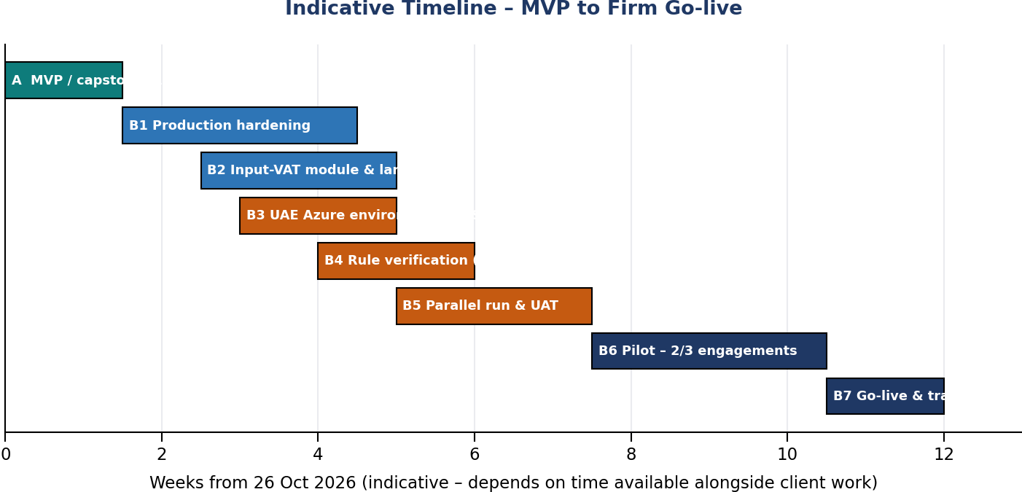
Figure 9 – Indicative timeline

7.1 Track A – MVP / capstone (10 days)
Day | Date | Work | Done when
1 | Mon 26 Oct | Stage 0; Stage 1 data and schema | Files and golden workbook ready
2 | Tue 27 Oct | Stage 2 prompts; Antigravity 3.1–3.2 | Import tests pass
3 | Wed 28 Oct | 3.3–3.5 | Sampling, JE, VAT, evaluation tests pass
4 | Thu 29 Oct | 3.6–3.8; Lovable 4.1 | WP opens; rules versioning works
5 | Fri 30 Oct | 3.10, 3.12; Lovable 4.2, 4.4 | Calendar + input VAT working
6 | Sat 31 Oct | 3.9, 3.11 (basic); Lovable 4.5–4.7 | Alerts and jobs visible
7 | Sun 1 Nov | Stage 5 integration | Full flow on dummy data
8 | Mon 2 Nov | Lovable 4.3; Stage 6 tests | Test report clean
9 | Tue 3 Nov | README; public repo copy | Repo ready
10 | Wed 4 Nov | Video; submit | Submitted
This is an ambitious 10 days. If time runs short, keep for the MVP: import, sampling, JE tests with calendar, VAT, testing grid, evaluation, WP, rules approval (manual PDF mode). Move the automatic FTA monitor, 1-million-line performance work and input-VAT module to Track B.

7.2 Track B – Production (indicative ~12 weeks)
Weeks | Work | Gate
2–4 | Complete all modules to Definition of Done; large files; UX pass | All DoD items met
3–5 | Azure UAE environment; Entra ID; CI/CD | IT security sign-off
4–6 | Tax Partner rule verification; holidays and work weeks | Appendix D signed
5–8 | Parallel run; UAT; validation file | Partner + QM approval
8–11 | Pilot on 2–3 engagements | Pilot review
11–12 | Go-live, training, owners active | Release v1.0

7.3 Owners (RACI)
Activity | Responsible | Accountable | Consulted | Informed
Tool build & changes | Savio (developer) | Assurance Partner | IT | Users
Rules Library approvals | Tax Partner | Tax Partner | Savio | Managers
Federal holidays | Admin | Savio | — | All users
Client work week | Engagement Manager | Engagement Partner | Client | Team
Tool validation file | Savio | QM Partner | Tax Partner, IT | Partners
Security & hosting | IT | IT Head | Savio | Partners
Training | Savio | Assurance Partner | Managers | All users

7.4 Risks
Risk | Level | Mitigation
Calculation error from AI-written code | High | Golden + edge tests; validation file; parallel run
Client data outside UAE or sent to AI | High | Dev/prod separation; UAE hosting; anonymiser tests
Rules out of date or misread by AI | High | Monitor + manual check; human approval; citations; stale lock
Wrong client calendar | Medium | Set at planning; preview; printed in WP; stale lock
Single developer dependency | High | Documentation, README, tests, second trained admin
Time alongside client work | High | Two tracks; MVP scope cut list
Over-reliance on AI text | Medium | Mandatory review tick; draft label; training
Vendor terms / pricing change | Medium | Code in GitHub; replaceable adapters for auth, storage, AI

Appendix A – Database Schema (core tables)
Table | Key columns and rules
clients | id, client_code (unique), name, emirate, entity_type
engagements | id, client_id, fye, framework, materiality, perf_materiality, trivial, status
engagement_members | engagement_id, user_id, role
datasets | id, engagement_id, file_name, sha256, rows, total_dr, total_cr, storage_ref, status
validation_errors | dataset_id, severity, field, rows (int[]), message, guidance
samples | id, engagement_id, dataset_id, method, parameters jsonb, cf_value, formula_text, seed, file_hash, rule_versions_used jsonb, engine_version, status (current/STALE), created_by/at
sample_items | id, sample_id, line_ref, book_value, top_stratum bool, attributes jsonb, audited_value, misstatement, remarks, evidence_ref
je_runs | id, engagement_id, dataset_id, parameters jsonb, calendar_hash, rule_versions_used jsonb, engine_version, status
je_flags | je_run_id, line_ref, flags text[], risk_score
input_vat_runs / supplier_register / expense_mapping | per SPEC 3.8
observations | id, sample_item_id, text jsonb, ai_generated, prompt_version, model, reviewed_by, reviewed_at
workpapers | id, engagement_id, wp_ref, status (draft/prepared/reviewed/locked), preparer, reviewer, dates, tool_version
rule_versions | id, rule_key, value jsonb, effective_from, effective_to, source_url, source_doc_hash, status (pending_verification/proposed/approved/rejected/superseded), proposed_by, approved_by, approved_at, comment. Constraint: no overlapping approved periods per rule_key
watched_sources / update_alerts | url, type, active, last_hash, last_checked / source_id, detected_at, summary, proposal_ids, status
holidays | date, name, scope (FEDERAL/EMIRATE), emirate, status (provisional/confirmed)
emirate_profiles | emirate, off_days int[], effective_from, effective_to
company_workweeks | client_id, off_days int[], half_days jsonb {weekday: cutoff}, effective_from, effective_to. Constraint: non-overlapping per client
company_exceptions | client_id, date, type (EXTRA_HOLIDAY/WORKING_DAY), note
jobs | id, type, engagement_id, status, progress, error, result_ref, timestamps
audit_log | id, user_id, action, entity, entity_id, old jsonb, new jsonb, at – insert-only

Appendix B – Test Data Specification
File / sheet | Must contain
dummy_gl.csv | 3,000 balanced multi-line vouchers; top-stratum items; credit notes; all planted errors in answer_key.csv
edge_cases.csv | Unbalanced vouchers, bad dates, formatted amounts, blank accounts, duplicate IDs, 14/15-digit TRNs
fy2021_2022.csv | Postings across a Fri/Sat → Sat/Sun weekend change on 1 Jan 2022
answer_key.csv | line_id and error_type for every planted error
golden_results.xlsx – Population | Totals, counts, Dr/Cr check
– MUS 90% / MUS 95% | CF, n, J, random start, selected line_ids for seed 2025
– Projection | Fully worked MUS evaluation with 3 misstatements incl. one top-stratum item
– Calendar | Expected non-working flags for 3 client profiles (1, 2, 3 off-days) and half day
– VAT / Input VAT | Expected variances, TRN failures, supplier and threshold flags

Appendix C – Go-live Checklist
- Partner and IT approvals on file.
- All modules meet Definition of Done.
- Production in UAE region; SSO + MFA; Key Vault; backups tested.
- All seeded rules verified and approved (Appendix D).
- Holidays and pilot clients' work weeks entered.
- Test report clean; performance within target.
- Parallel run accepted by engagement partner.
- UAT signed; validation file approved by QM.
- User guide and training published.
- Owners confirmed; alert notifications working.
- Release tagged v1.0; version prints on WPs.

Appendix D – Rules Library Verification Checklist (Tax Partner)
Rule key / area | Source to verify against | Verified value | Sign / date
VAT standard and zero rates; codes | VAT Law and Executive Regulation (current amended version)
Tax invoice and TRN format | FTA guidance; TRN verification service
Input VAT – supplier verification period, thresholds, effective date | FTA Decision No. 13 of 2026; VATP046
Input VAT – employee-expense cases and conditions | FTA Decision No. 17 of 2026; Exec. Reg. Art. 53
Corporate Tax rate and threshold | Federal Decree-Law No. 47 of 2022 and decisions
MUS confidence and incremental factors | Firm audit manual
Benford MAD thresholds | Firm methodology
Legal references used in observations | Current FTA legislation list
Federal holidays (current year) | Official UAE government announcements
Specific rates, thresholds and references in this guide are starting points. In the tool they remain 'pending verification' until approved here. AuditSmart supports, and does not replace, the auditor's professional judgement.

