**EXERCISE 2:**

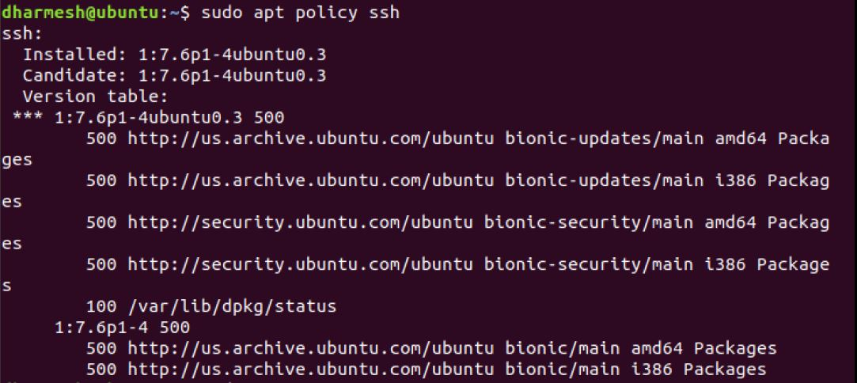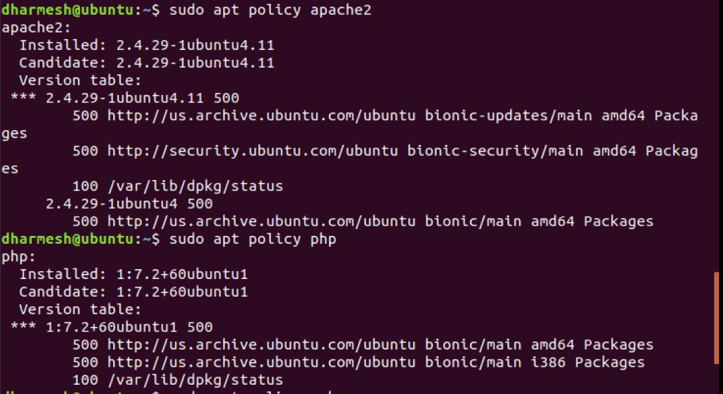

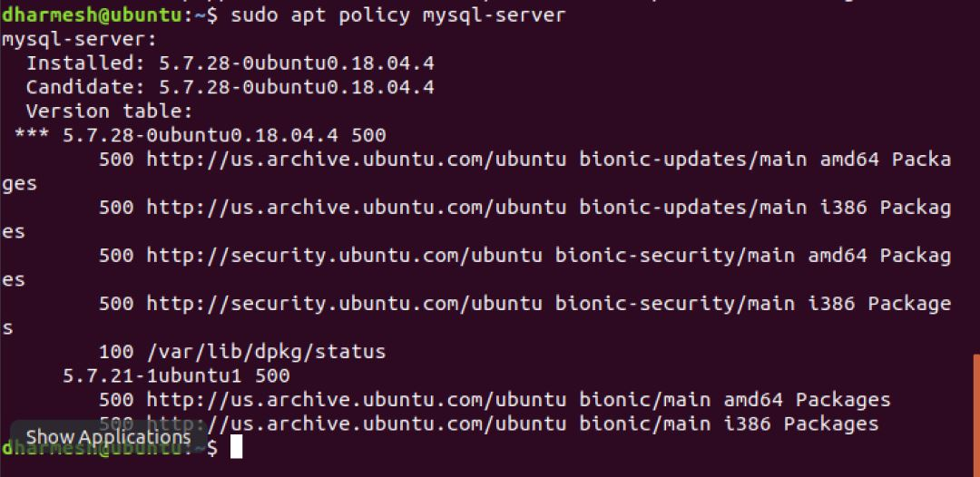

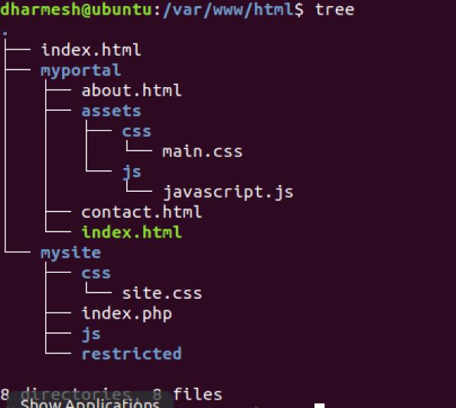

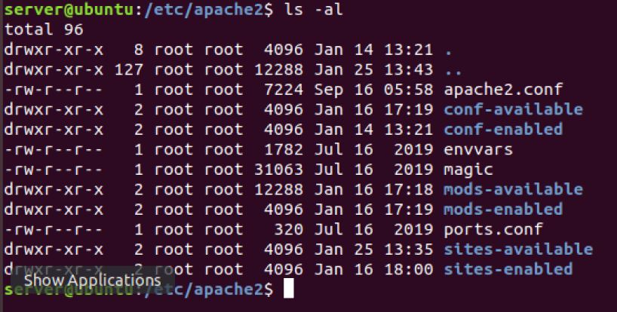

<VirtualHost *:80>

# The ServerName directive sets the request scheme, hostname and port that

# the server uses to identify itself. This is used when creating

# redirection URLs. In the context of virtual hosts, the ServerName

# specifies what hostname must appear in the request's Host: header to

# match this virtual host. For the default virtual host (this file) this

# value is not decisive as it is used as a last resort host regardless.

# However, you must set it for any further virtual host explicitly.

#ServerName www.example.com

ServerAdmin webmaster@localhost

DocumentRoot /var/www/html/myportal

Alias "/js" "/var/www/html/myportal/assets/js"

<Directory "/var/www/html/myportal/assets/css">

Require all denied

</Directory>

# Available loglevels: trace8, ..., trace1, debug, info, notice, warn,

# error, crit, alert, emerg.

# It is also possible to configure the loglevel for particular

# modules, e.g.

#LogLevel info ssl:warn

Redirect permanent "/yahoo" "http://mail.yahoo.com"

ErrorLog ${APACHE_LOG_DIR}/error.log

CustomLog ${APACHE_LOG_DIR}/access.log combined

# For most configuration files from conf-available/, which are

# enabled or disabled at a global level, it is possible to

# include a line for only one particular virtual host. For example the

# following line enables the CGI configuration for this host only

# after it has been globally disabled with "a2disconf".

#Include conf-available/serve-cgi-bin.conf

</VirtualHost>

# vim: syntax=apache ts=4 sw=4 sts=4 sr noet