WEB SECURITY TOOLING
Burp Suite
Training Notes — 1 August 2026

1. What Was Done
Installed Burp Suite and configured the browser to route all traffic through it as an intercepting proxy, so requests are captured before they reach the target server.

2. Steps
- Installed Burp Suite (Community Edition) and launched its built-in browser / proxy listener.
- Configured the browser's proxy settings to point to Burp's local listener (default 127.0.0.1:8080).
- Verified traffic flow: outgoing HTTP/HTTPS requests now pass through Burp before reaching the server, and responses pass back through Burp before reaching the browser.

3. Why It Matters
Routing traffic through Burp turns the browser into a controllable entry point for testing — every request and response can be intercepted, inspected, and modified in transit. This is the foundation for manual web application testing: tampering with parameters, replaying requests, and analyzing hidden fields..

4. Burp Suite — Repeater
Used Burp's Repeater tool to manually resend and modify captured requests, and observe how the server responds to each change.
- Sent a captured request from Proxy → Repeater (right-click → "Send to Repeater", or Ctrl+R).
- Edited request values directly in Repeater (parameters, headers, cookies, body data) without needing to reload the page in the browser.
- Clicked "Send" to resend the modified request and reviewed the raw response returned by the server — status code, headers, and body.
- Repeated this cycle, tweaking one value at a time, to test how the server handles unexpected or malicious input.

5. Burp Suite — Intruder
Intruder automates sending many variations of a captured request — instead of changing and resending one value at a time like in Repeater, it takes a base request, marks positions to inject values into, and fires the request repeatedly using a payload set (wordlist), e.g. for brute-forcing logins, fuzzing parameters, or testing many inputs quickly.
- Sent a captured request from Proxy → Intruder (right-click → "Send to Intruder", or Ctrl+I).
- On the Positions tab, marked the parameter(s) to attack with §payload markers§ (e.g. a password field, an account number, or a hidden parameter).
- Chose an attack type based on how many positions/payload sets were involved (see below).
- On the Payloads tab, loaded a payload list (e.g. a wordlist of common passwords or ID values) for each position.
- Started the attack and reviewed the results grid — sorting by response status code, length, or content to spot the request that behaved differently (e.g. a successful login, a valid account ID, or a bypassed check).

5.1 Attack Types
Attack Type | How It Works
Sniper | One payload set, cycled through each marked position one at a time — every other position stays at its original value while one is tested per request. Best for testing several parameters individually for the same flaw (e.g. checking each parameter in turn for SQL injection).
Battering Ram | One payload set, but the same payload is inserted into all marked positions at once in every request. Useful when the same value must be repeated in multiple places simultaneously (e.g. a username that appears in both a URL parameter and a cookie).
Pitchfork | Multiple payload sets (one per position), stepped through in parallel — request 1 uses item 1 from every list, request 2 uses item 2 from every list, and so on. Useful for testing paired/related values together (e.g. a list of usernames matched line-by-line with a list of known passwords).
Cluster Bomb | Multiple payload sets, but every possible combination of values across all positions is tried. Useful when the correct combination is unknown, such as brute-forcing a username and password together without knowing which pairs are valid — at the cost of far more requests (sets multiply).

6. Burp Suite — Sequencer, Decoder & Comparer

6.1 Sequencer
Sequencer analyzes the randomness/quality of tokens generated by an application — such as session cookies, CSRF tokens, or password-reset tokens — to check whether they are predictable enough to be guessed or brute-forced.
- Sent a request that returns a token (e.g. a login response setting a session cookie) to Sequencer.
- Selected the token to analyze from the response, then let Sequencer capture a large number of samples by resending the request repeatedly.
- Ran the analysis, which scores the token's randomness (entropy) and flags whether it's statistically predictable.
Why it matters: if session tokens are predictable, an attacker could guess a valid token and hijack another user's session without needing their password.

6.2 Decoder
Decoder encodes and decodes data between common formats — useful for reading obfuscated values found in requests/responses, or for crafting payloads that need to be encoded before sending.
- Pasted or sent a value into Decoder (e.g. a parameter that looked Base64-encoded or URL-encoded).
- Applied a decode operation (URL, Base64, HTML, Hex, ASCII Hex, etc.) to reveal the underlying plain-text value.
- Could also work in reverse — encoding a crafted payload into the correct format before pasting it back into Repeater or Intruder.
Why it matters: application data is often encoded, not encrypted — Decoder quickly reveals what a value actually contains and lets it be modified and re-encoded for testing.

6.3 Comparer
Comparer highlights the differences between two pieces of data — typically two requests or two responses — either word-by-word or byte-by-byte.
- Sent two responses (e.g. a valid login response vs. an invalid one) to Comparer.
- Ran a word or byte-level comparison, which highlights exactly what changed between the two.
- Used the differences to spot subtle indicators — e.g. a slightly different response length or an extra header — that reveal how the application behaves differently under different conditions.
Why it matters: manually eyeballing two large responses for a small difference is unreliable — Comparer makes subtle behavioral differences (often the sign of a vulnerability) immediately visible.

7. HTTP & HTTPS

7.1 What is HTTP & How It Works
HTTP (HyperText Transfer Protocol) is the protocol web browsers and servers use to communicate. It defines how a client asks for a resource (a web page, image, API response, etc.) and how the server replies.
HTTP works on a request–response model over TCP (traditionally port 80, or port 443 when encrypted as HTTPS):
- The client (browser, curl, Burp Suite, etc.) opens a connection to the server and sends an HTTP request.
- The server processes the request and sends back an HTTP response containing the requested data (or an error).
- HTTP is stateless — each request is independent; the server doesn't inherently remember previous requests. Sessions/logins are maintained separately using cookies or tokens.
HTTPS is simply HTTP sent over an encrypted TLS/SSL connection, so the request and response contents can't be read or tampered with in transit — this is exactly what Burp Suite intercepts and unwraps for testing.

7.2 HTTP Request
Example request:

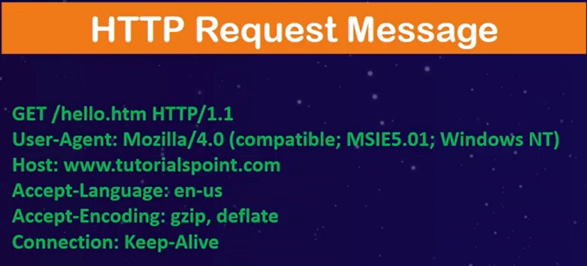
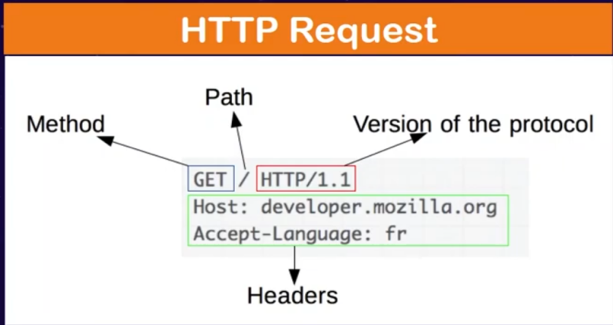

An HTTP request is made up of four parts:
- Request line — the method, the target path, and the HTTP version (e.g. GET /index.html HTTP/1.1)
- Headers — key-value metadata about the request (e.g. Host, User-Agent, Cookie, Content-Type).
- Blank line — separates headers from the body.
- Body (optional) — data sent to the server, used by methods like POST and PUT (e.g. form data, JSON).

7.3 HTTP Request Methods
Methods (verbs) tell the server what action to perform on the given resource:
Method | Purpose
GET | Retrieve a resource without modifying it. Parameters are usually sent in the URL. Most common method; used to load pages, images, API data.
HEAD | Same as GET but returns only the headers, no body. Used to check if a resource exists or get metadata (e.g. size) without downloading it.
POST | Submit data to the server to create or process something (e.g. login forms, file uploads). Data is sent in the request body.
PUT | Create or fully replace a resource at a specific URL with the supplied data.
DELETE | Remove the specified resource.
CONNECT | Opens a tunnel to the server, typically used to establish an HTTPS connection through a proxy.
OPTIONS | Asks the server which methods/actions are supported for a resource — used in CORS pre-flight checks.
TRACE | Echoes back the received request for diagnostic/debugging purposes. Rarely enabled in production as it can expose sensitive data (Cross-Site Tracing).

7.4 HTTP Response & Status Codes
An HTTP response mirrors the request structure: a status line, headers, and an optional body.
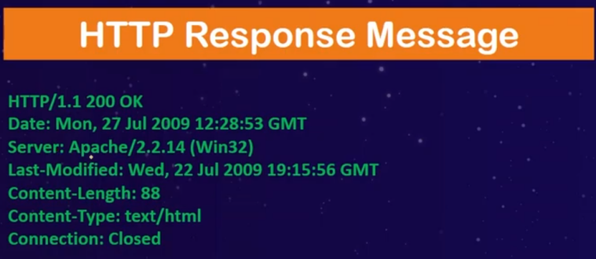
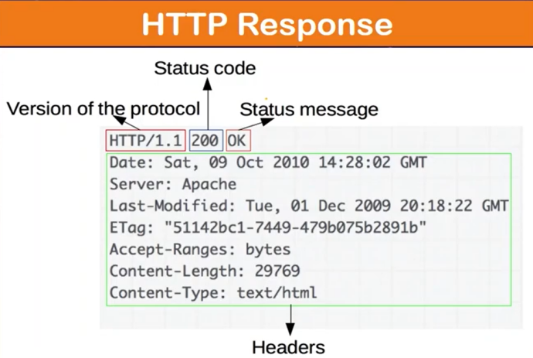
The status code in the response tells the client how the request was handled. Codes are grouped into five classes:
Range | Class | Meaning
1xx | Informational responses | Request received, continuing process (e.g. 100 Continue).
2xx | Success responses | The request was successfully received and processed (e.g. 200 OK, 201 Created, 204 No Content).
3xx | Redirection message | Further action is needed to complete the request (e.g. 301 Moved Permanently, 302 Found).
4xx | Client Error responses | The request had a problem on the client's side (e.g. 400 Bad Request, 401 Unauthorized, 403 Forbidden, 404 Not Found).
5xx | Server Error responses | The server failed to fulfil a valid request (e.g. 500 Internal Server Error, 502 Bad Gateway, 503 Service Unavailable).

