TRYHACKME
Cyber Security Training Report
Offensive Security & Defensive Security — Introductory Modules

1. Executive Summary
This report documents the completion of two introductory TryHackMe rooms from the Cyber Security 101 learning path: Offensive Security Intro and Defensive Security Intro. Both rooms were completed to 100%, covering the foundational mindset, tools, and workflows used on each side of cyber security.
The offensive module focused on thinking like an attacker — using reconnaissance techniques and enumeration tools to discover hidden, unlinked pages on a simulated banking application ("FakeBank"), and exploiting an unauthenticated admin panel to demonstrate a real business-logic vulnerability (unauthorized funds transfer).
The defensive module shifted perspective to the SOC analyst side, walking through the phases of investigating an ongoing attack against the same FakeBank environment: detecting the initial compromise, containing/stopping it, investigating the attacker, and compiling a written incident report.
Together, the two rooms illustrate the same incident from both the attacker's and the defender's point of view, reinforcing how offensive findings map directly onto defensive response workflows.

2. Skills Demonstrated
- Differentiating offensive vs. defensive security roles and mindsets
- Web reconnaissance using directory brute-forcing tools (dirb)
- Identifying and accessing unlinked/hidden web application endpoints
- Recognizing and exploiting a broken access control vulnerability (unauthenticated admin panel)
- Understanding remediation options for insecure endpoints (authentication enforcement vs. security-through-obscurity)
- Following the SOC incident-response lifecycle: detection → containment → investigation → reporting
- Translating technical findings into a written report deliverable

3. Offensive Security Intro
Room objective: test the security of FakeBank's systems by thinking and acting like an attacker.
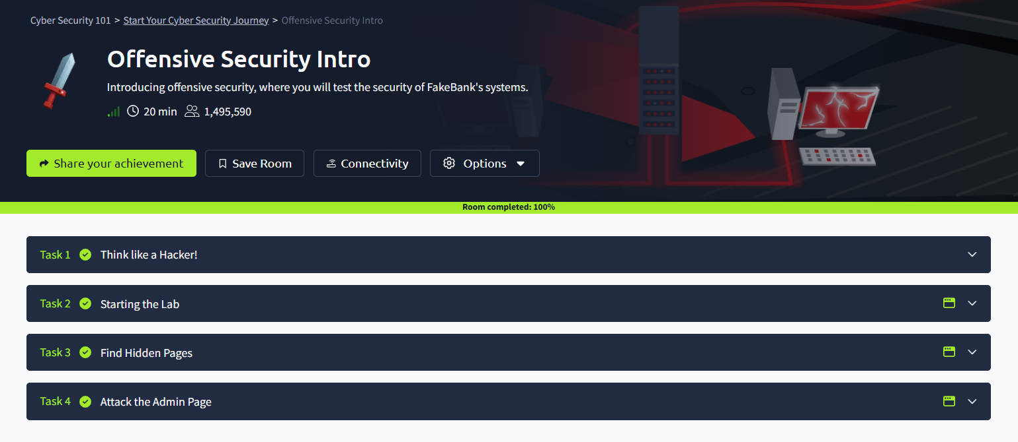
Figure 1 — Offensive Security Intro room overview, showing all four tasks completed (Room completed: 100%).

Task 1 — Think Like a Hacker!
This task introduced the core distinction between offensive and defensive security through a short scenario involving two bank employees:
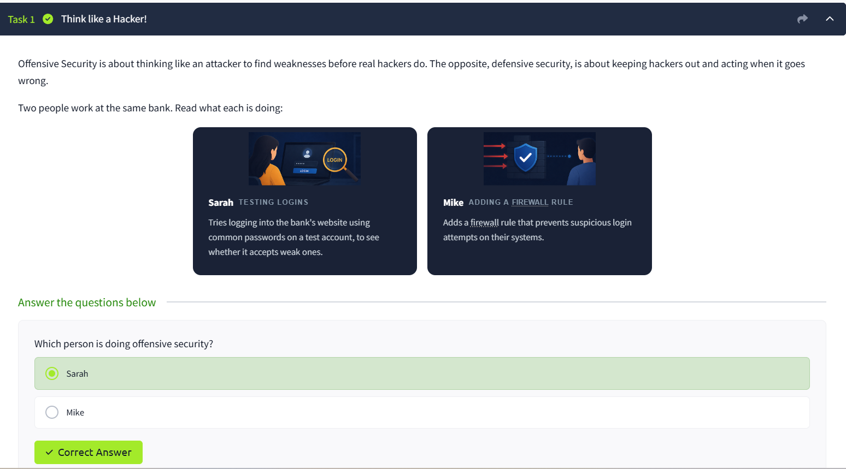

Task 2 — Starting the Lab
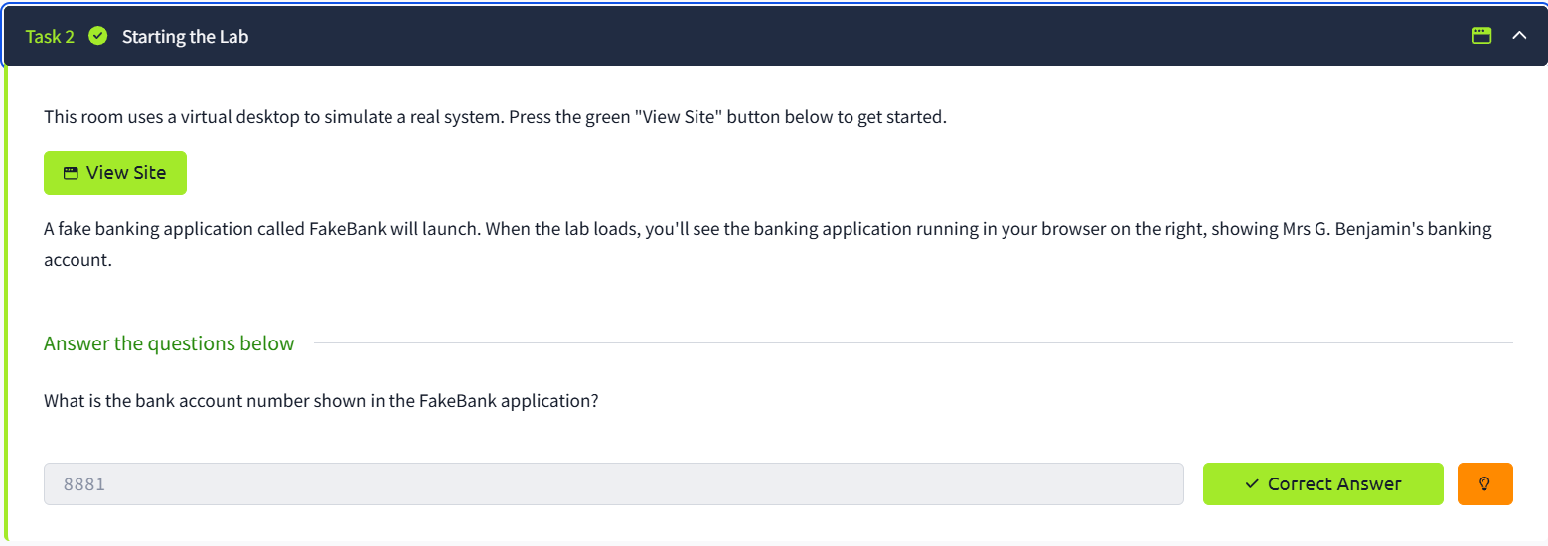

Task 3 — Find Hidden Pages
This task covered a common reconnaissance technique: discovering pages that exist on a web server but are not linked anywhere in the site's navigation. Attackers look for these hidden pages because they can expose sensitive functionality never intended to be publicly reachable.:
dirb http://fakebank.thm
dirb is a directory brute-forcing tool: it tests a wordlist of common page names against a target URL and flags which ones actually exist on the server, revealing pages that aren't linked anywhere on the site.
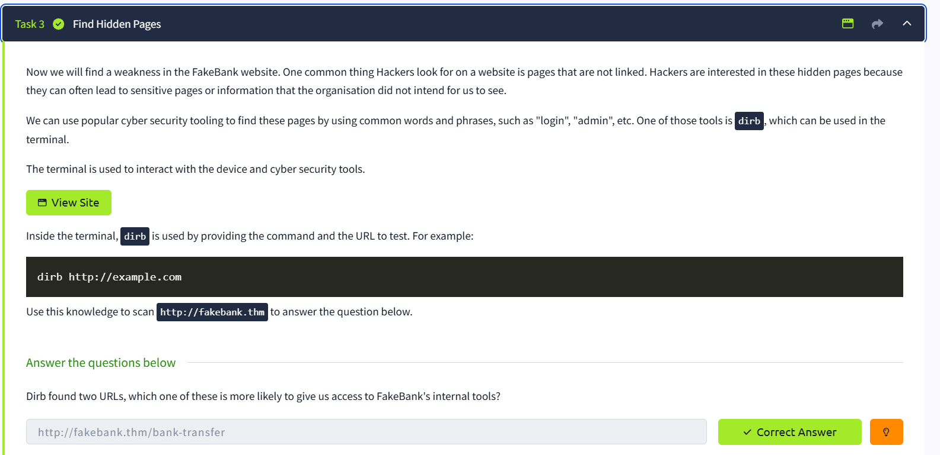

Task 4 — Attack the Admin Page
Navigating directly to the discovered /bank-transfer path revealed an unauthenticated admin panel for FakeBank, confirming that the hidden page was not secured behind a login. This is a real-world vulnerability class known as broken access control / security through obscurity.
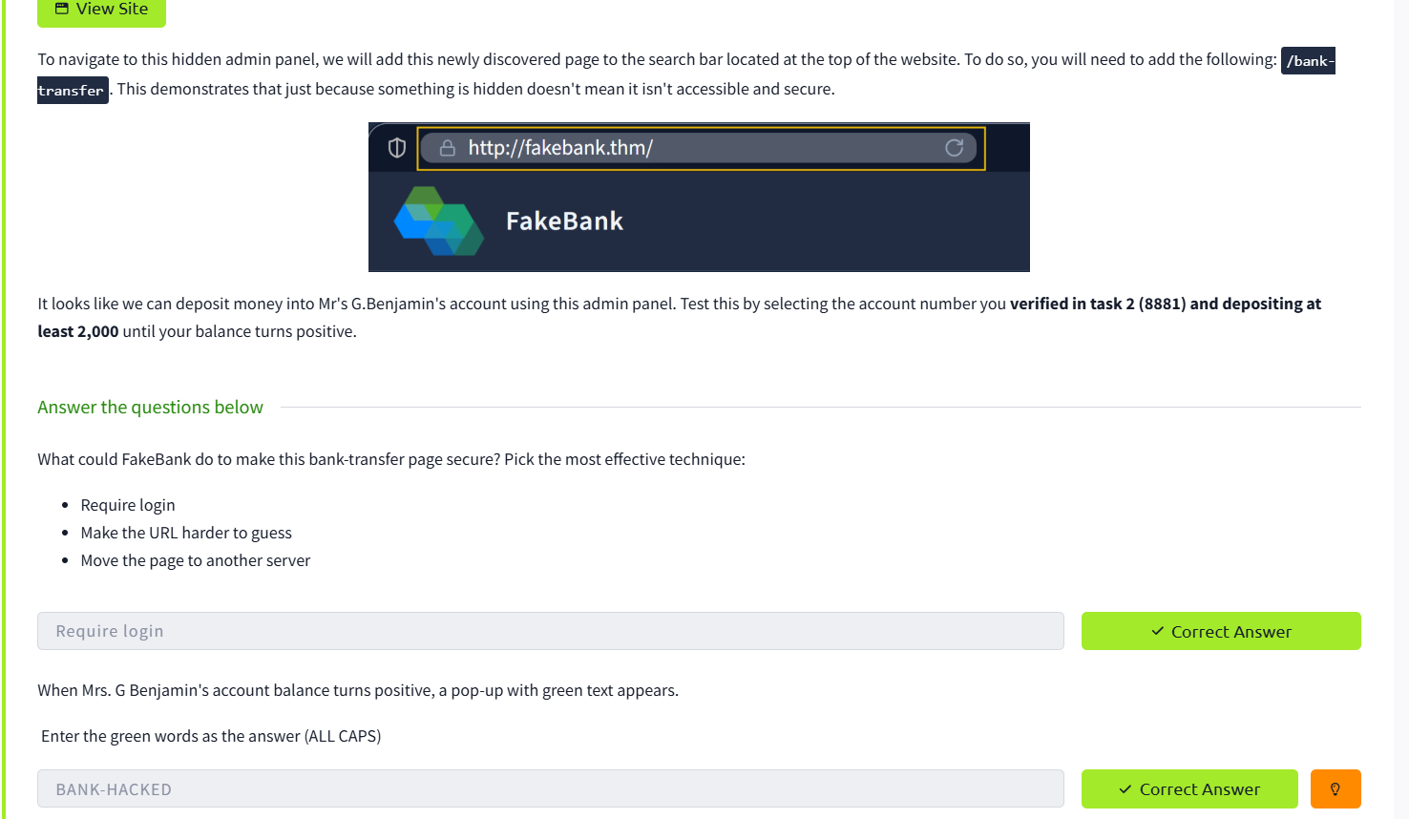

4. Defensive Security Intro
Room objective: investigate an ongoing attack at FakeBank from the perspective of a SOC (Security Operations Center) analyst — the direct counterpart to the attack carried out in the Offensive Security Intro room.
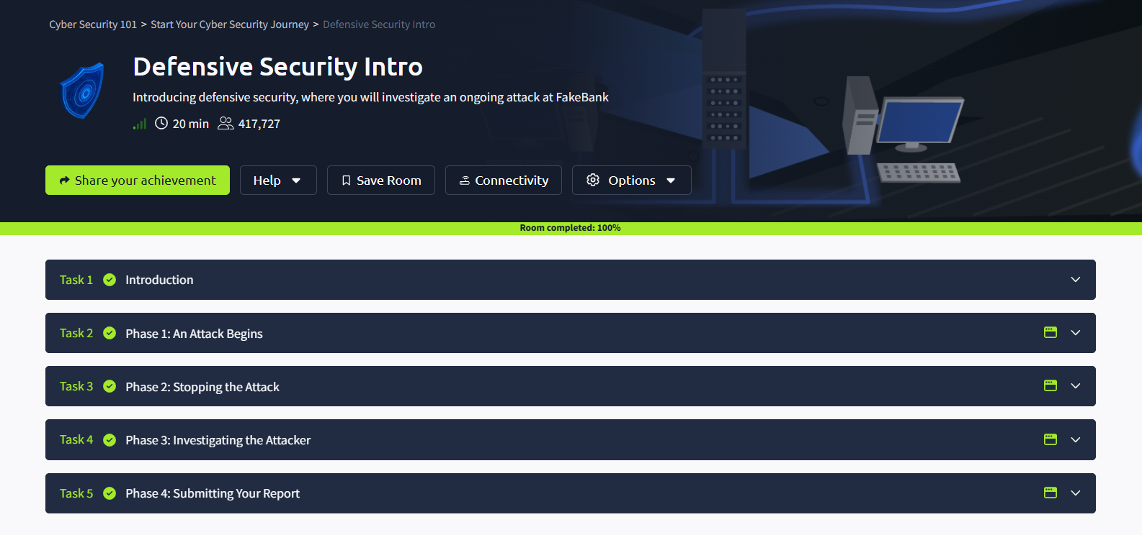

Task 1 — Introduction
Set up the scenario: the same FakeBank environment is now shown from the defender's seat, framing the room as a walkthrough of a live security incident from first detection through to final reporting.

Task 2 — Phase 1: An Attack Begins
Covered how a SOC analyst first becomes aware that something is wrong — recognizing the early indicators of an in-progress attack (e.g. suspicious account activity or alerts) rather than only reacting after the fact.

Task 3 — Phase 2: Stopping the Attack
Focused on containment: taking action to stop the attack from continuing or escalating once it has been identified — mirroring the industry-standard priority of containing a threat before attempting full eradication.

Task 4 — Phase 3: Investigating the Attacker
Covered the investigative phase of incident response — gathering evidence, tracing what the attacker did (such as the unauthenticated /bank-transfer access from the offensive room), and building a picture of scope and impact.

Task 5 — Phase 4: Submitting Your Report
Concluded the incident response lifecycle by compiling findings into a written report — reinforcing that documentation and lessons-learned are a core deliverable of the SOC process, not an afterthought.

