**MySQL Assignment - 3**

**1.** write a SQL query to find Employees who have the biggest salary in their Department

**select emp_id, e.dept_id, mngr_id, emp_name, salary from Employee e, (select max(salary) maxsalary, dept_id from Employee group by dept_id) d where e.salary = d.maxsalary and e.dept_id = d.dept_id;**

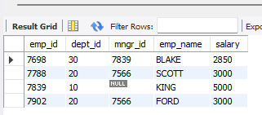

**2.** write a SQL query to find Departments that have less than 3 people in it

**select dept_name, e.dept_id, count_emp from (select dept_id, count(emp_id) count_emp from Employee group by dept_id having count(emp_id)<=3) e inner join department d on e.dept_id = d.dept_id;**

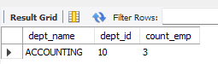

**3.** write a SQL query to find All Department along with the number of people there

**select dept_name, e.dept_id, count_emp from (select dept_id, count(emp_id) count_emp from Employee group by dept_id) e inner join department d on e.dept_id = d.dept_id;**

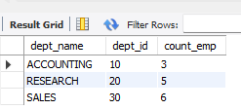

**4.** write a SQL query to find All Department along with the total salary there

**select d.dept_name, e.dept_id, e.sum_salary from (select dept_id, sum(salary) sum_salary from employee group by dept_id) e inner join department d on d.dept_id=e.dept_id;**

