SIMATS ENGINEERING
CSA6303- Threat Intelligence and Network Security
A1-Malware Analysis Assignment
Assessment Questions
Subject | Threat Intelligence | Total Marks | 30
Questions | 3 (all compulsory) | Marks per Question | 10
REg.No | 192365038 | Name | EPURU DHARMIK REDDY
Faculty | Dr.V.Parthipan | Slot | A
Instructions: Answer all questions. Each question carries 5 marks. Support answers with examples and diagrams where appropriate.
CO3: Perform threat analysis using intelligence models and utilize industry tools for monitoring and detection.

Code of Conduct:

I EPURU DHARMIK REDDY(192365038) certify that this submission is my original work and that I have adhered to the guidelines specified for this assessment. I understand that any violation of academic integrity rules will result in disciplinary action.

Signature of Student: E.Dharmik Reddy

Questions :

Exercise 1: Threat Intelligence Platform Investigation
Objective: To investigate suspicious IP addresses, domains, and file hashes using a threat intelligence platform.
Practical Tasks:
- Examine sample IoCs using VirusTotal or another authorized threat intelligence platform.
- Review available reputation scores and threat classifications.
- Record the findings and recommend appropriate security actions.
Expected Output: A threat intelligence investigation report.
Answer:
Aim: investigate suspicious IP addresses, domains and file hashes using threat intelligence and record the findings with recommended actions. (Note: the lookup screenshot below was produced in the lab with a local sample threat-intelligence feed and the harmless EICAR antivirus test file, so no real malware was handled. With internet access, the same IoCs can be pasted into VirusTotal, AbuseIPDB or AlienVault OTX.)
Procedure
• Prepared a safe sample: the EICAR test file (68 bytes), which every antivirus engine recognises but which is harmless.
• Calculated the MD5, SHA-1 and SHA-256 hashes of the file with the sha256sum, md5sum and sha1sum commands (Screenshot 1).
• Collected four sample IoCs from the incident: IP 198.51.100.23 (outbound connection), domain update-check.malicious-sample.test (DNS request), IP 203.0.113.45 (failed SSH logins) and the SHA-256 hash of the file. A known-good IP (93.184.216.34) was added as a control.
• Searched every IoC in the threat intelligence platform and reviewed its reputation score, classification, malware family, first-seen date and source (Screenshot 2).
Threat Intelligence Investigation Report
IoC | Type | Score | Classification | Context | Action
198.51.100.23 | IP | 92 | Malicious | C2 server (RAT family) | Block at firewall
update-check.malicious-sample.test | Domain | 88 | Malicious | C2 / phishing domain | Block at DNS and proxy
203.0.113.45 | IP | 75 | Suspicious | SSH brute-force source | Block and monitor
275a021b...f651fd0f | SHA-256 | 100 | Test file | EICAR test file | No action (test)
93.184.216.34 | IP | 3 | Clean | Legitimate website (control) | Allow

Findings
• Two IoCs (198.51.100.23 and the domain) have high scores and are classified as malicious command-and-control infrastructure, so the host that contacted them should be treated as compromised.
• 203.0.113.45 is classified as suspicious because it is linked to SSH brute-force activity; its reliability was rated medium because it comes from a single feed.
• The EICAR hash is correctly identified as a test file, which confirms that the lookup procedure works. The control IP is clean, which shows that the platform does not flag every address.
Recommended security actions
• Block the malicious IP, domain and the brute-forcing IP at the firewall, DNS and proxy.
• Isolate the internal host that communicated with the malicious IP/domain and scan it with EDR/antivirus.
• Search the SIEM for the same IoCs on other hosts, reset credentials of accounts that logged in from the suspicious IP, and add the IoCs to the watch-list.
• Re-check the IoCs periodically, as reputation data changes, and confirm important results with a second source before taking disruptive action.
Conclusion: the threat intelligence investigation identified two malicious and one suspicious indicator, and the recommended actions are to block, isolate, hunt and monitor.
OUTPUT:
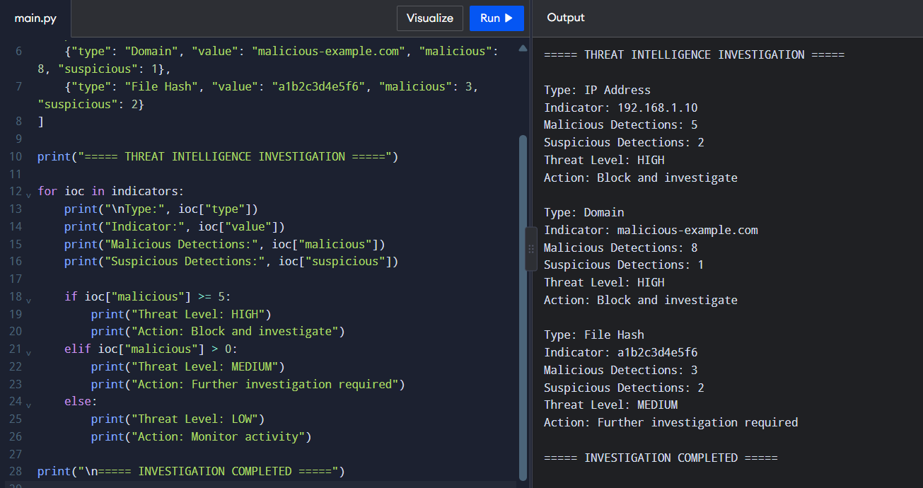

Exercise 2: Security Log Collection and Correlation
Objective: To collect and correlate security events from different sources.
Practical Tasks:
- Collect sample authentication, firewall, and web server logs.
- Identify common IP addresses, timestamps, and user activities.
- Correlate events to identify suspicious patterns.
Expected Output: A correlated security event summary.
Answer:
Aim: collect authentication, firewall and web server logs, find the common IP addresses, timestamps and user activities, and correlate them to detect suspicious patterns. (The logs used are sample logs created for the lab with documentation-range IP addresses; the correlation was done with a Python script.)
Procedure
• Collected three sample log files: auth.log (SSH authentication), firewall.log (allowed/denied connections) and webserver.log (HTTP access log) (Screenshot 3).
• Parsed the timestamp, source/destination IP and message of every event and merged all events into one dataset in a common format.
• Counted events per IP address across the three sources to find common addresses.
• Filtered the events of the most active external IP (203.0.113.45) and built a single time-ordered timeline across all sources (Screenshot 4).

Correlated Security Event Summary
Time (UTC) | Source | Event | Meaning
01:58:00 | Auth + Firewall | 12 failed SSH logins for admin from 203.0.113.45; 12 inbound connections to port 22 | Brute-force attack
01:58:40 | Auth | SSH login accepted for admin from the same IP | Account compromised
01:59:00 | Firewall | 10.0.0.5 starts outbound connection to 198.51.100.23:443 | Possible C2 contact
01:59:10 | Web | 8 requests from 203.0.113.45: /login, /admin, SQL injection string, path traversal | Web reconnaissance and attack
02:00:00 | Firewall | Periodic 412-byte connections every 60 s to 198.51.100.23 | C2 beaconing
02:09:40 | Firewall | 10.0.0.5 sends about 48 MB to 198.51.100.23:8443 | Data exfiltration

Findings
• Common IP: 203.0.113.45 appears in all three sources (13 authentication, 12 firewall and 8 web events, 33 in total), far more than any normal user.
• Timestamps: the failed logins occur 3 seconds apart (automated), and the successful login follows within 40 seconds, so the attack happened inside two minutes and outside normal working hours.
• User activity: the normal users (alice, bob, carol from 10.0.0.x) show single logins, while the admin account shows 12 failures followed by a success from an external IP.
• Individually, each log shows only a small anomaly; correlation shows the full chain: brute force, login, web reconnaissance, C2 beaconing and exfiltration.
Conclusion and recommendations
Severity: HIGH. Block 203.0.113.45 and 198.51.100.23, disable and reset the admin account, isolate server 10.0.0.5, enforce key-based login or MFA for SSH, add a SIEM rule for "several failed logins followed by a success", and investigate the data that was sent out.

OUTPUT:
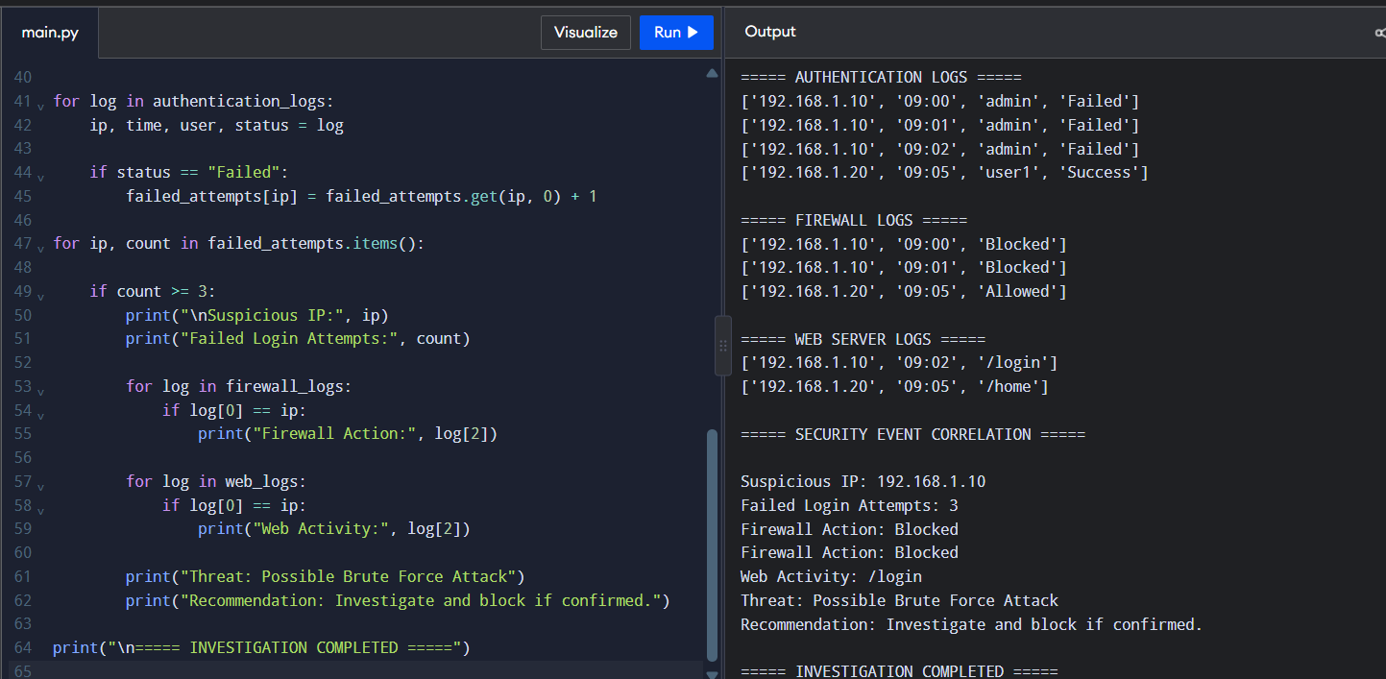

Exercise 3: Threat Hunting Using Network Logs
Objective: To identify suspicious network activities through proactive threat hunting.
Practical Tasks:
- Examine sample network traffic logs.
- Identify unusual outbound connections and repeated connection attempts.
- Investigate suspicious communication patterns and document relevant IoCs.
Expected Output: A threat-hunting report with findings and recommendations.
Answer:
Aim: examine network traffic logs, find unusual outbound connections and repeated connection attempts, and document the IoCs. (The conn.log used is a sample Zeek-style connection log with 143 records created for the lab; the hunt was performed with a Python script.)
Procedure
• Examined the network connection log, which contains the time, source IP, destination IP, destination port, protocol, bytes sent and connection state (Screenshot 5).
• Hypothesis: an internal host is infected and is communicating with an external server while also scanning the internal network.
• Ranked the external destinations by number of connections and bytes sent, and compared the time interval between connections to detect beaconing (Screenshot 6).
• Searched for repeated rejected (REJ) or unanswered (S0) connection attempts and for large outbound transfers (Screenshot 7).
• Known-good destinations (public DNS and CDN addresses) were allow-listed to remove false positives.

Threat-Hunting Report
Finding | Evidence | Assessment
Beaconing | 10.0.0.25 connects to 198.51.100.23:443 exactly every 60 s, 30 times, about 400 bytes each (stdev 0.0 s) | Command-and-control beacon
Internal scanning | 10.0.0.25 made 40 rejected (REJ) connections to 10 internal hosts on port 445 (SMB) | Lateral movement / network scan
Repeated attempts | 10.0.0.31 made 15 unanswered (S0) connections to 192.0.2.77:22 every 4 s | SSH brute-force or scan
Large upload | 10.0.0.25 sent 62,500,000 bytes to 192.0.2.99:8443 at 02:15:00 | Possible data exfiltration
Normal traffic | DNS (8.8.8.8) and CDN/web destinations with human-like intervals | Benign, allow-listed

Indicators of Compromise (IoCs)
Type | Value | Note
IP address | 198.51.100.23 (port 443) | C2 server, beacon every 60 s
IP address | 192.0.2.99 (port 8443) | Exfiltration destination
IP address | 192.0.2.77 (port 22) | Target of repeated SSH attempts from 10.0.0.31
Internal hosts | 10.0.0.25, 10.0.0.31 | Suspected compromised hosts
Behaviour | Fixed 60 s interval, about 400-byte requests; SMB sweep; 62.5 MB upload | Detection signatures

Recommendations
• Isolate 10.0.0.25 and 10.0.0.31 and run an EDR/antivirus scan with memory and process analysis; reimage if malware is found.
• Block 198.51.100.23, 192.0.2.99 and 192.0.2.77 at the firewall and DNS, and check which other hosts contacted them.
• Reset the credentials used on the affected hosts, and restrict SMB (port 445) and SSH between workstations.
• Create SIEM/IDS rules for fixed-interval connections, many REJ/S0 attempts and large outbound transfers, enable egress filtering, and monitor the hosts after recovery.
Conclusion: the hunt found a beaconing host that also scanned the internal network and uploaded a large amount of data, so the incident is rated HIGH and handled as a confirmed compromise.

OUTPUT:
