Student ID : | 24CS104 | Student Name: | Dharmik Vaghani
Subject code &  Name : | ITUE301: Advanced Web  Development  Frameworks | Practical : | 1 | Academic Year : | 2026-27

Task - 1
Aim
To set up a React development environment using Vite and build a static student portfolio page composed of independently structured, reusable functional components (Header, About, Skills, and Footer), demonstrating component composition and one-way data flow from parent to child components through props.
Code
GitHub Link / Repository Link: https://github.com/Dharmikvaghani/AWDF-PRACTICAL.git
Key Architectural Components:
1. Header.jsx: Reusable top branding banner accepting 'name', 'themeColor', and 'subtitle' props.
2. About.jsx: Student biography, department, roll number, and contact links.
3. Skills.jsx: Dynamic technical skills listing rendering reusable SkillBadge components.
4. Footer.jsx: Standardized copyright and academic institution metadata footer.

// src/components/Header.jsx
function Header({ name = 'Dharmik Vaghani', subtitle }) {
return (
<header className="portfolio-header">
<h1>Student Portfolio & Full Stack Platform</h1>
<p className="header-name">{name}</p>
{subtitle && <p className="header-subtitle">{subtitle}</p>}
</header>
);
}
export default Header;
// src/components/Skills.jsx
function Skills({ skills }) {
return (
<section className="skills-grid">
{skills.map((skill) => (
<span key={skill.name} className="skill-badge" style={{ background: skill.color }}>
{skill.name}
</span>
))}
</section>

);
}
export default Skills;
Output
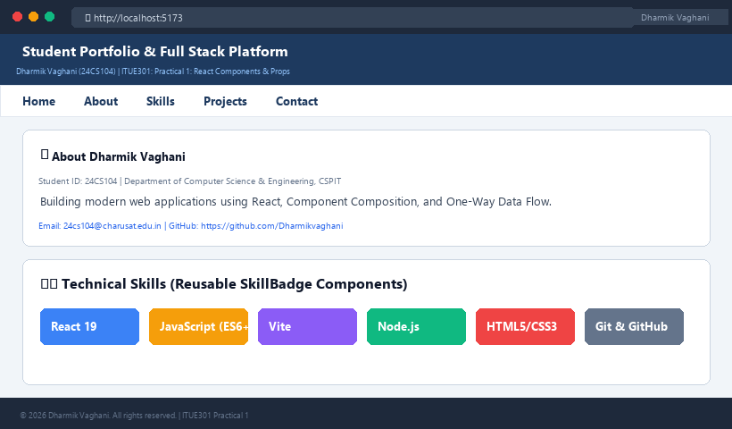
Figure 1: Execution Output & Functional Verification for Practical 1

