Student ID : | 24CS104 | Student Name: | Dharmik Vaghani
Subject code &  Name : | ITUE301: Advanced Web  Development  Frameworks | Practical : | 10 | Academic Year : | 2026-27

Task - 10
Aim
To decouple heavy, time-consuming operations from the synchronous HTTP request-response cycle by implementing an asynchronous Event-Driven Architecture using Node.js's native EventEmitter, dispatching background tasks (task-created, task-deleted) without delaying client responses.
Code
GitHub Link / Repository Link: https://github.com/Dharmikvaghani/AWDF-PRACTICAL.git
Key Implementation Highlights:
1. Shared EventEmitter module (events/events.js) with global error boundary.
2. Asynchronous background event listeners (events/listeners.js) executing simulated 2000ms notifications.
3. Handlers return HTTP 201 immediately in 26ms while background listeners complete asynchronously.

// events/listeners.js
taskEvents.on('task-created', (taskData) => {
setTimeout(() => {
console.log(`[EVENT: task-created] Notification Dispatched for "${taskData.title}"`);
}, 2000); // Decoupled asynchronous processing
});
// In taskController.js
const newTask = await Task.create(taskData);
res.status(201).json({ success: true, data: newTask }); // Immediate HTTP response
taskEvents.emit('task-created', newTask); // Emitted asynchronously
Output

Output
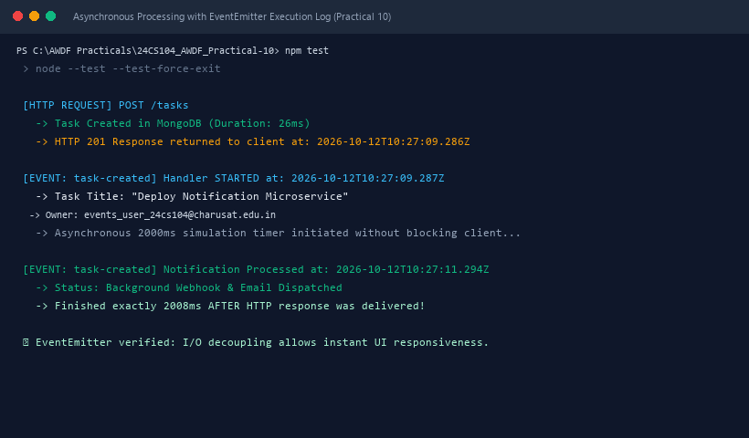
Figure 10: Execution Output & Functional Verification for Practical 10

