Student ID : | 24CS104 | Student Name: | Dharmik Vaghani
Subject code &  Name : | ITUE301: Advanced Web  Development  Frameworks | Practical : | 11 | Academic Year : | 2026-27

Task - 11
Aim
To containerize the full-stack web application using Docker and Docker Compose, designing a multi-stage Dockerfile for the frontend SPA served via Nginx, a lightweight Node.js backend container, an isolated bridge network, and persistent named volumes for MongoDB data retention.
Code
GitHub Link / Repository Link: https://github.com/Dharmikvaghani/AWDF-PRACTICAL.git
Key Implementation Highlights:
1. Multi-stage frontend Dockerfile: Node.js 20 build stage -> Nginx Alpine production runtime.
2. Backend Dockerfile: Node.js 20-alpine with production dependency caching and 0.0.0.0 binding.
3. docker-compose.yml: Coordinates frontend (8080), backend (5000), and mongodb (27017) over app-network.

// docker-compose.yml
services:
mongodb:
image: mongo:7.0
volumes: [ awdf-mongodb-data-practical11:/data/db ]
backend:
build: ./backend
environment:
MONGO_URI: mongodb://mongodb:27017/taskdb_docker
depends_on: [ mongodb ]
frontend:
build: ./frontend
ports: [ "8080:80" ]
depends_on: [ backend ]
Output

Output
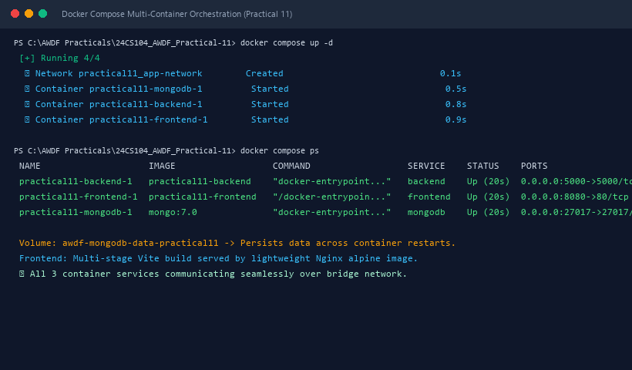
Figure 11: Execution Output & Functional Verification for Practical 11

