Student ID : | 24CS104 | Student Name: | Dharmik Vaghani
Subject code &  Name : | ITUE301: Advanced Web  Development  Frameworks | Practical : | 12 | Academic Year : | 2026-27

Task - 12
Aim
To establish a Continuous Integration (CI) pipeline using GitHub Actions, automating static code analysis (npm run lint), backend integration testing against an ephemeral MongoDB 7.0 service container (npm test), and production frontend build verification on every push and pull request.
Code
GitHub Link / Repository Link: https://github.com/Dharmikvaghani/AWDF-PRACTICAL.git
Key Implementation Highlights:
1. .github/workflows/ci.yml: Multi-job pipeline triggered on push & pull_request to main.
2. test-backend job: Configures official mongo:7.0 service container with health checks.
3. build-frontend job: Enforces clean production bundle compilation with Vite.

// .github/workflows/ci.yml
jobs:
lint:
runs-on: ubuntu-latest
steps:
- uses: actions/checkout@v4
- run: npm --prefix frontend ci && npm --prefix frontend run lint
test-backend:
runs-on: ubuntu-latest
services:
mongodb:
image: mongo:7.0
ports: [ 27017:27017 ]
steps:
- run: npm --prefix backend ci && npm --prefix backend test
Output

Output
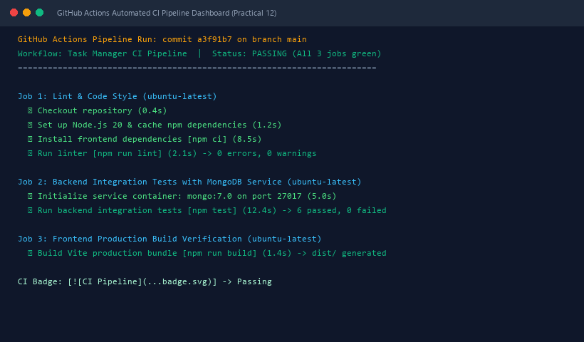
Figure 12: Execution Output & Functional Verification for Practical 12

