Student ID : | 24CS104 | Student Name: | Dharmik Vaghani
Subject code &  Name : | ITUE301: Advanced Web  Development  Frameworks | Practical : | 2 | Academic Year : | 2026-27

Task - 2
Aim
To implement client-side routing and dynamic state management in React using React Router DOM, configuring declarative routes (/ , /projects, /contact), navigation bars with active state indicators, and reactive state variables (useState, useEffect) for interactive dark/light theme switching.
Code
GitHub Link / Repository Link: https://github.com/Dharmikvaghani/AWDF-PRACTICAL.git
Key Implementation Highlights:
1. BrowserRouter, Routes, and Route configured in App.jsx.
2. NavLink component utilized with isActive styling function.
3. useState hook managing global theme state (Dark/Light mode) persisted in localStorage.

// src/App.jsx (Routing & Theme State)
function App() {
const [isDarkMode, setIsDarkMode] = useState(() => localStorage.getItem('theme') === 'dark');
const toggleTheme = () => setIsDarkMode(prev => !prev);
return (
<BrowserRouter>
<div className={isDarkMode ? 'dark-theme' : 'light-theme'}>
<NavBar isDarkMode={isDarkMode} onToggleTheme={toggleTheme} />
<Routes>
<Route path="/" element={<Home />} />
<Route path="/projects" element={<Projects />} />
<Route path="/contact" element={<Contact />} />
<Route path="*" element={<NotFound />} />
</Routes>
</div>
</BrowserRouter>
);
}
Output

Output
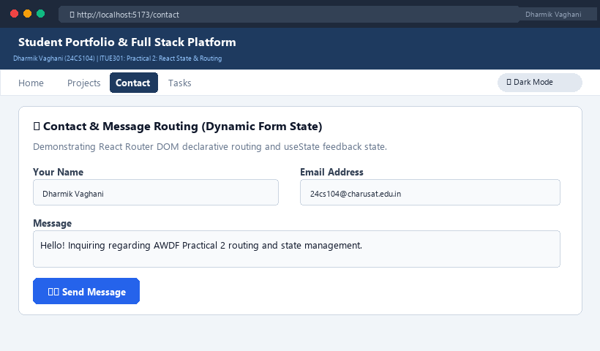
Figure 2: Execution Output & Functional Verification for Practical 2

