Student ID : | 24CS104 | Student Name: | Dharmik Vaghani
Subject code &  Name : | ITUE301: Advanced Web  Development  Frameworks | Practical : | 3 | Academic Year : | 2026-27

Task - 3
Aim
To integrate external RESTful APIs into a React application using asynchronous HTTP requests (fetch / axios) within the useEffect lifecycle hook, implementing robust data rendering, client-side search filtering, loading state skeletons, and defensive error handling boundaries.
Code
GitHub Link / Repository Link: https://github.com/Dharmikvaghani/AWDF-PRACTICAL.git
Key Implementation Highlights:
1. Asynchronous fetch from GitHub REST API (https:

//api.github.com/users/Dharmikvaghani/repos).
2. Defensive state management handling loading skeletons, HTTP error statuses, and empty search arrays.
3. Real-time text filter allowing dynamic querying across repository names and topics.
// src/pages/Projects.jsx
function Projects() {
const [repos, setRepos] = useState([]);
const [loading, setLoading] = useState(true);
const [search, setSearch] = useState('');
useEffect(() => {
fetch('https://api.github.com/users/Dharmikvaghani/repos')
.then(res => res.json())
.then(data => { setRepos(data); setLoading(false); })
.catch(err => { console.error(err); setLoading(false); });
}, []);
const filtered = repos.filter(r => r.name.toLowerCase().includes(search.toLowerCase()));
return (
<div className="projects-container">
<input value={search} onChange={e => setSearch(e.target.value)} placeholder="Filter..." />
{loading ? <Skeleton /> : filtered.map(r => <RepoCard key={r.id} repo={r} />)}
</div>
);
}
Output

Output
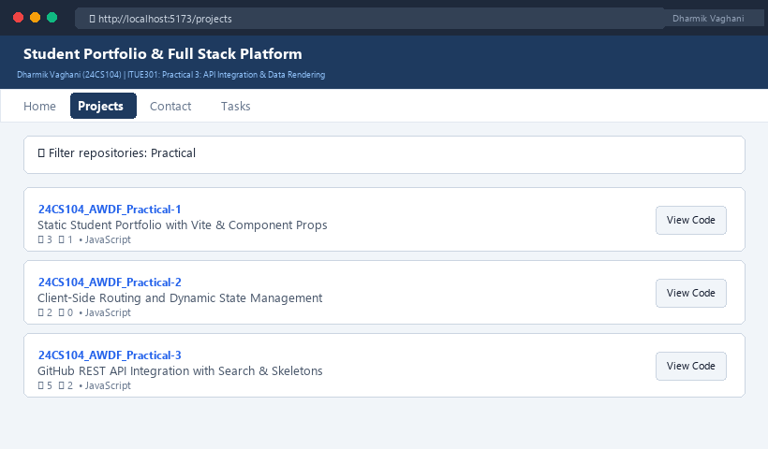
Figure 3: Execution Output & Functional Verification for Practical 3

