Student ID : | 24CS104 | Student Name: | Dharmik Vaghani
Subject code &  Name : | ITUE301: Advanced Web  Development  Frameworks | Practical : | 4 | Academic Year : | 2026-27

Task - 4
Aim
To design and implement a RESTful backend API using Node.js and the Express framework, defining structured routing architectures, request parsing middleware, custom request logging, and complete CRUD endpoints (GET, POST, PUT, DELETE) with appropriate HTTP status codes and centralized error handling.
Code
GitHub Link / Repository Link: https://github.com/Dharmikvaghani/AWDF-PRACTICAL.git
Key Implementation Highlights:
1. Express router modularization: routes/taskRoutes.js and controllers/taskController.js.
2. Middleware pipeline: express.json(), requestLogger, errorHandler.
3. Complete HTTP status code contract adherence (200 OK, 201 Created, 400 Bad Request, 404 Not Found).

// routes/taskRoutes.js
router.get('/tasks', getTasks);
router.post('/tasks', createTask);
router.put('/tasks/:id', updateTask);
router.delete('/tasks/:id', deleteTask);
// controllers/taskController.js
export const createTask = (req, res) => {
const { title, priority } = req.body;
if (!title) return res.status(400).json({ error: 'Title required' });
const newTask = { id: Date.now(), title, priority: priority || 'medium', completed: false };
tasks.push(newTask);
res.status(201).json({ success: true, data: newTask });
};
Output

Output
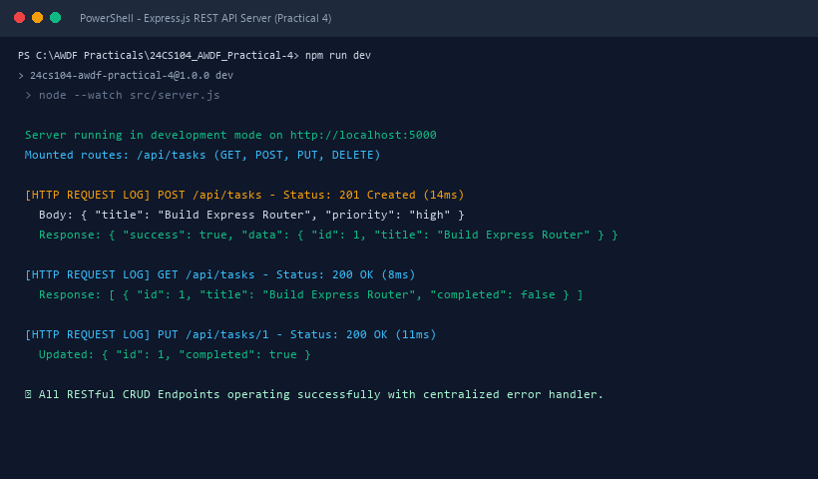
Figure 4: Execution Output & Functional Verification for Practical 4

