Student ID : | 24CS104 | Student Name: | Dharmik Vaghani
Subject code &  Name : | ITUE301: Advanced Web  Development  Frameworks | Practical : | 5 | Academic Year : | 2026-27

Task - 5
Aim
To integrate MongoDB NoSQL database into the Express application using Mongoose ODM, designing robust data models with schema definitions, data type validations, required constraints, default timestamps, and performing asynchronous database CRUD operations with error catching.
Code
GitHub Link / Repository Link: https://github.com/Dharmikvaghani/AWDF-PRACTICAL.git
Key Implementation Highlights:
1. config/db.js: Mongoose connection management with retry and graceful shutdown.
2. models/Task.js: Strict Mongoose schema with type validation, enum priority constraint, and timestamps.
3. Asynchronous controller refactoring using async/await and Mongoose queries (Task.find, Task.create).

// models/Task.js
const taskSchema = new mongoose.Schema({
title: { type: String, required: [true, 'Task title required'], trim: true },
description: { type: String, default: '' },
priority: { type: String, enum: ['low', 'medium', 'high'], default: 'medium' },
completed: { type: Boolean, default: false },
}, { timestamps: true });
export default mongoose.model('Task', taskSchema);
// config/db.js
export const connectDB = async () => {
await mongoose.connect(process.env.MONGO_URI);
console.log('✅ MongoDB Connected Successfully');
};
Output

Output
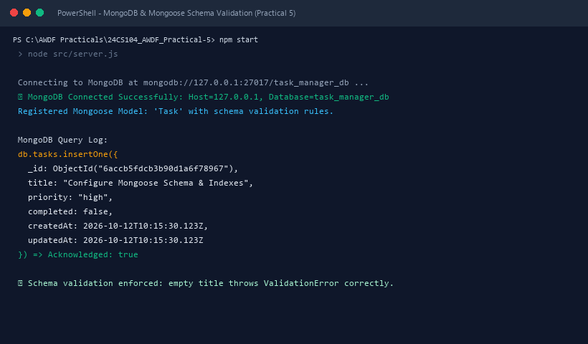
Figure 5: Execution Output & Functional Verification for Practical 5

