Student ID : | 24CS104 | Student Name: | Dharmik Vaghani
Subject code &  Name : | ITUE301: Advanced Web  Development  Frameworks | Practical : | 6 | Academic Year : | 2026-27

Task - 6
Aim
To achieve full-stack application integration by connecting the React frontend with the Node.js/Express/MongoDB backend, configuring Cross-Origin Resource Sharing (CORS), implementing an asynchronous API service layer, and providing optimistic UI updates for task creation, toggling, and deletion.
Code
GitHub Link / Repository Link: https://github.com/Dharmikvaghani/AWDF-PRACTICAL.git
Key Implementation Highlights:
1. Centralized frontend API service layer (api.js) handling fetch abstractions and errors.
2. Backend Express CORS middleware permitting Vite dev origins.
3. Optimistic UI updates in React state with automatic rollback on network failure.

// frontend/src/api.js
export async function createTask(taskData) {
const res = await fetch(`${API_BASE}/tasks`, {
method: 'POST',
headers: { 'Content-Type': 'application/json' },
body: JSON.stringify(taskData)
});
return (await res.json()).data;
}
// Optimistic creation in TaskManager.jsx
setTasks(prev => [optimisticTask, ...prev]);
try {
const saved = await createTask(taskData);
setTasks(prev => prev.map(t => t._id === tempId ? saved : t));
} catch (err) {
setTasks(prev => prev.filter(t => t._id !== tempId)); // Rollback
}
Output

Output
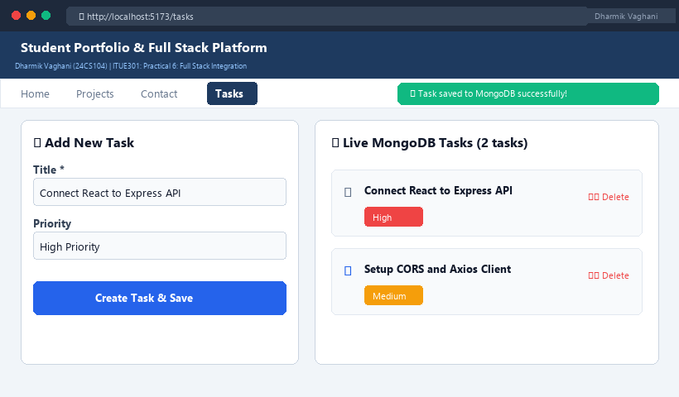
Figure 6: Execution Output & Functional Verification for Practical 6

